CONSERVATION

Memo
WITHOUT PREJUDICE
To: Marcelina Rejwerska
From: Buju (Burcu) Can Cetin, Conservation Officer
Date: 11/11/2024
Re: Conservation Officer response
Application Number: PL/24/0938
Application Type: Full Planning Application
Address: 152 OXFORD ROAD, READING, RG1 7PJ
Proposal: Change of Use from Estate Agent to Hot food takeaway

Summary
No objection subject to conditions and clarifications required – The proposal is acceptable in principle. However, it would remove the original chimney breast and insert a commercial kitchen with a new ventilation and extraction system, which requires further consideration and submission of details. Therefore, I suggest the following conditions:

- To provide structural support for the upper floors' chimney structure and chimney
- To submit the elevational drawing for the external elements of the proposed kitchen ventilation and extraction system (pre-commencement)
and
- Informative for the use of matching traditional materials after the removal of the chimney breast and for the external elements of ventilation/extraction system

Relevant policies and legislation
From the point of view of the historic environment, the main statutory tests are set out within the Planning (Listed Buildings and Conservation Areas) Act 1990. Section 66 of the Planning (Listed Buildings and Conservation Areas) Act 1990 requires ‘special regard’ to be given to the desirability of preserving a listed building or its setting.
Section 72 of the Planning (Listed Buildings and Conservation Areas) Act 1990 states that in the exercise of any functions, with respect to any buildings or other land in a conservation area, under or by virtue of any of the provisions mentioned in this Section, special attention shall be paid to the desirability of preserving or enhancing the character or appearance of that area.

National Planning Policy and Guidance
The NPPF outlines government policy, including its policy in respect of the historic environment. Chapter 16 of the NPPF (2023) 'Conserving and enhancing the historic environment' sets out the Government's high-level policies concerning heritage and sustainable development.
Paragraph 200 states, “In determining applications, local planning authorities should require an applicant to describe the significance of any heritage assets affected, including any contribution made by their setting. “ And Paragraph 201 says, “Local planning authorities should identify and assess the particular significance of any heritage asset that may be affected by a proposal (including by development affecting the setting of a heritage asset) taking account of the available evidence and any necessary expertise. They should take this into account when considering the impact of a proposal on a heritage asset, to avoid or minimise any conflict between the heritage asset’s conservation and any aspect of the proposal.”
Paragraph 205 of the NPPF requires that ‘when considering the impact of a proposed development on the significance of a designated heritage asset, great weight should be given to the asset’s conservation….’ And paragraph 206 says, ‘any harm to, or loss of, the significance of a designated heritage asset (from its alteration or destruction, or from development within its setting) should require clear and convincing justification’.
Paragraph 208 requires that ‘where a development proposal will lead to less than substantial harm to the significance of a designated heritage asset, this harm should be weighted against the public benefits of the proposal…’

National Planning Practice Guidance on Historic Environment provides context to the NPPF.

Local Planning Policy and Guidance
Policy EN1 ‘Protection and enhancement of the historic environment’ of the Reading Borough Local Plan sets out the Council’s aspirations for the historic environment. The policy requires that all proposals to protect and, where possible, enhance the significance of heritage assets and their settings, historic character and local distinctiveness of the area in which they are located. It echoes the NPPF by stating, “Proposals should seek to avoid harm in the first instance. Any harm to or loss of a heritage asset should require clear and convincing justification, usually in the form of public benefits”.
Applications that affect listed buildings are expected not to have an adverse impact on the elements that contribute to their special architectural or historic interest, including their settings.

Policy EN3 ‘Enhancement of conservation areas’ of the Reading Borough Local Plan requires that development proposals within Conservation Areas contribute positively to local character and distinctiveness. This policy further states “Positive consideration will be given to proposals which take opportunities to enhance the character of conservation areas.”

Policy EN6 ‘New development in a historic context’ also requires “New development will make a contribution to the historic character of the area by respecting and enhancing its architectural and visual qualities and considering how heritage considerations can influence the design of new development. When determining planning applications for new development, the following factors will be taken into consideration:
a. The positive contribution of the development to the existing historic townscape (scale, height, mass, proportion, plot size, street form, materials, significant vistas and views, and open space);
b. Sensitivity to historic context;
c. Reflection of borough-wide major heritage themes that contribute to local distinctiveness (e.g. patterned brickwork or former worker terraced housing);
d. Whether development promotes and/or improves access to previously undiscovered or neglected historic significance.”

Castle Hill/Russell Street/Oxford Road Conservation Area Appraisal is also a material consideration in determining applications for development.

Other Guidance
Historic England Advice Note 2 – Making changes to Heritage Assets illustrates the application of policies set out in the NPPF in determining applications for Planning Permission and Listed Building Consent.
English Heritage’s “Conservation Principles” provides policy and guidance for the “sustainable
management of the historic environment”.

Relevant heritage assets
The application site relates to a two-storey (with an attic) end-of-terrace property dating from the Mid- Late Victorian period. Located to the north of Oxford Road, the application site lies within the Castle Hill/Russell Street/Oxford Road Conservation Area, and it is opposed to the Grade II Listed terrace, Prospect Terrace, as illustrated below.
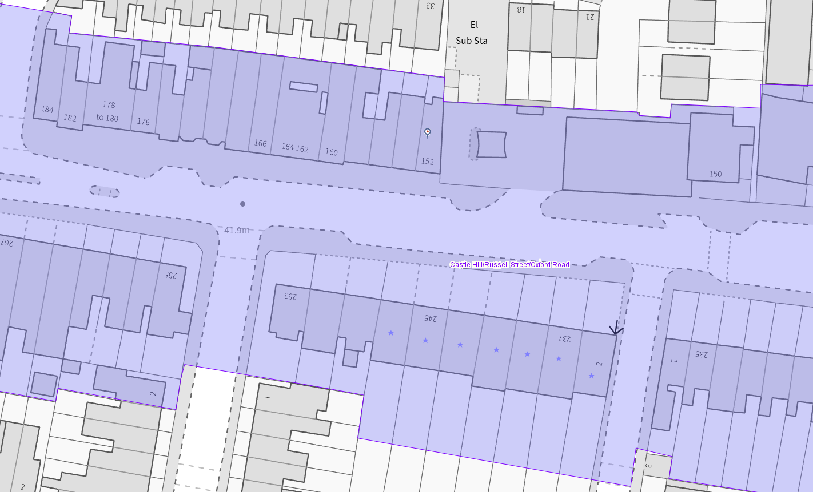
The application site (outlined in red) and listed buildings (purple starred) within the conservation area (light purple)

Significance of heritage assets
The NPPF defines significance as the “value of a heritage asset to this and future generations because of its heritage interest.”

The interest may be architectural or historic, as set out in the Town and Country Planning (Listed Building and Conservation Areas) Act 1990 Section 1.

“Significance derives not only from a heritage asset’s physical presence, but also from its setting.” (NPPF, 2023)

Historic England assesses significance in a similar manner, referring to evidential, historic, aesthetic and communal values of a place.

Located within the Character Area 2 Oxford Road, the subject attractive building is described as a building of townscape merit (BTM) by the conservation area appraisal and states:

“Further along the northern side of Oxford Road at the western end, the long terrace of c.1890 shops with residences above at nos. 152 to 180 has a vibrant, polychrome façade which largely retains its integrity and is unpainted. This terrace exhibits a high level of detail and is in better condition than other retail terraces further to the west beyond the railway bridge. Original bargeboards above centre dormers and polychromed chimneys largely remain. The colourful retail signs above modern altered retail frontages are a moderate detraction, but they also display the many diverse and long-standing local businesses that the Oxford Road is well-known for. Although many of the windows on the first floor have been converted to uPVC, and retail frontages blur an original storefront layout, the terrace is a credit to the street and deserves to be protected and enhanced where possible.”

The application site also forms part of the significant View 7 within the conservation area.

Impact of proposal upon heritage asset(s)
The proposed change of use from an estate agent to a hot food takeaway would not bring any external alterations to the subject property except for new external signage, which would be introduced under another/future application.

Because the proposal would require a commercial kitchen for the hot food preparation, a new ventilation system would be designed. From the submitted drawing, I note that the existing chimney breast is to be removed and made good. Because the chimney breast is a structural element going upper floors and supports the chimney, one of the major features of this unlisted terrace and building, as well as the conservation area, the applicant is strongly advised to provide support so that the upper floor chimney breasts and chimneys would be stable and making good work to include suitable materials (lime based) with the existing traditional materials.

Another note is about the submitted ‘Ventilation or extraction statement’ consists of the details of wall style extraction canopy, lighting for the canopy, stainless steel wall cladding for the canopy, and extract fan and ductwork, the last of which is mentioned to be 5m, but not shown on the proposed elevation(s). As such, the confirmation of the position/location of this ductwork should be submitted to the Council so that it would not disturb the front and side elevation and character and appearance of the conservation area.

Suggested Conditions
- To provide structural support for the upper floors' chimney structure and chimney
- To submit the elevational drawing for the external elements of the proposed kitchen ventilation and extraction system (pre-commencement) – or clarification is required

Conservation response
No objections
No objections subject to conditions attached
Clarification required
Object

Contact details
Buju Can Cetin, Conservation Officer
Burcu.CanCetin@reading.gov.uk
0118 9373125

