Waste Management 117-119 Oxford Road

ECO MARKET aims to minimise their impact on the environment, promoting good waste management practice.
The policy sets out their approach to managing their environmental impact from waste. And for Continual for the continual improvement in
mitigating direct environmental impact. Reducing use of natural resources and preventing pollution.
ECO MARKET will endeavour compliance with all environmental legislation applicable to their business and operations. Taking care of any waste created through the business will be disposed of in a safe and environmentally friendly manner.
Staff will be instructed to check hourly during busy times, and once in the morning (opening) afternoon and evening when (closing) around the premises to ensure that any litter left outside of the business (including visible rubbish on the footpath surrounding the site) will be collected and disposed of in our waste bins.
ECO MARKET stands firm in keeping areas clean for a safe environment for members of staff and the public.
With the aim of encouraging recycling .
Bung Plugs will be fitted in the bins to avoid build up, avoid rats, and enable effective cleaning of bins:
ECO MARKET will store commercial waste bins to the rear as shown on the plan submitted(A-1000).
1 x 1100L general waste bin
1 x 1100L recycling bin
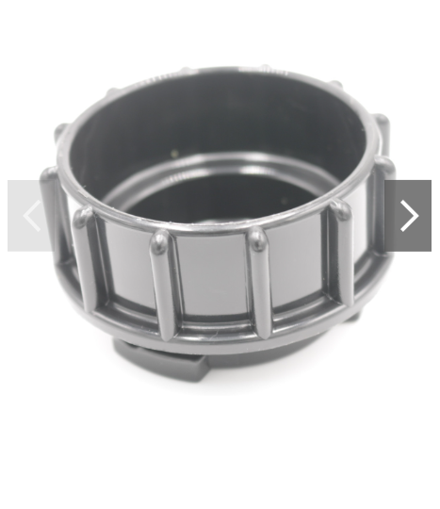
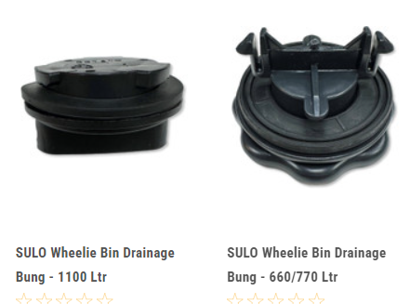
The trade waste and recycling will be collected by Reading Borough Council, waste collection service. All waste will be collected outside the gate similar dates to neighbouring properties.
If an increase of waste being consistently filled, an increased frequency of collection will be required.

