To: | Mr. Stuart Carr  32 Jamestown Road,  London,  NW1 7HW | Application No: PL/24/1247  Application type: Listed building consent (Alt/Ext)

Applicant: Mr. Shane Bailey

Proposal: Refurbishment of the existing Pumpkin unit to the new SSP brand, Cafe Local. This shall include fixtures, fittings, signage and minor M&E works

At: ROYAL BERKSHIRE HOSPITAL, LONDON ROAD, READING, RG1 5AN

The above application was WITHDRAWN by the applicant on 8 November 2024.

Date: 8 November 2024 | 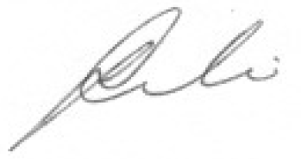
 | Assistant Director of Planning, Transport and Public Protection Services

