CONSERVATION

Memo
WITHOUT PREJUDICE
To: Marcelina Rejwerska
From: Buju (Burcu) Can Cetin, Conservation Officer
Date: 07/11/2024
Re: Conservation Officer response
Application Number: PL/24/1111
Application Type: Listed building consent
Address: 97 LONDON ROAD, READING, RG1 5BY
Proposal: Proposed restoration of brick boundary wall and paving of frontage and new bin store

Summary
Objection – Suggested Reasons for Refusal
The proposed alterations and new design to the front garden of the Grade II listed building would merge the front gardens of listed and unlisted properties, resulting in the loss of surviving natural features, historic layout and legibility of the listed curtilage. Because of its unsympathetic design, materials, and pastiche elements that are to be introduced without evidence, the proposed development would adversely affect the character and appearance of the front garden, listed curtilage, and setting of the listed building. The works would, therefore, cause less than substantial harm at the moderate-high level on the special architectural and historic interest of the heritage asset contrary to Paragraph 208 of Chapter 16 (conserving and enhancing the historic environment) of the NPPF 2023, Policies EN1 and EN6 of Reading Borough Local Plan 2019.
The application provides insufficient and contradictory information, so it is not possible to adequately assess the impact of the proposed development regarding the Listed Building status. In the absence of this information, it has not been possible to demonstrate that the proposal would comply with the NPPF and Local Plan.

Relevant policies and legislation
From the point of view of the historic environment, the main statutory tests are set out within the Planning (Listed Buildings and Conservation Areas) Act 1990. Sections 16(2) and 66 require that special regard be given to the desirability of preserving listed buildings, their settings or any features of special architectural or historic interest which they possess.

National Planning Policy and Guidance
The NPPF outlines government policy, including its policy in respect of the historic environment. Chapter 16 of the NPPF (2023) 'Conserving and enhancing the historic environment' sets out the Government's high-level policies concerning heritage and sustainable development.
Paragraph 200 states, “In determining applications, local planning authorities should require an applicant to describe the significance of any heritage assets affected, including any contribution made by their setting. “ And Paragraph 201 says, “Local planning authorities should identify and assess the particular significance of any heritage asset that may be affected by a proposal (including by development affecting the setting of a heritage asset) taking account of the available evidence and any necessary expertise. They should take this into account when considering the impact of a proposal on a heritage asset, to avoid or minimise any conflict between the heritage asset’s conservation and any aspect of the proposal.”
Paragraph 205 of the NPPF requires that ‘when considering the impact of a proposed development on the significance of a designated heritage asset, great weight should be given to the asset’s conservation….’ And paragraph 206 says, ‘any harm to, or loss of, the significance of a designated heritage asset (from its alteration or destruction, or from development within its setting) should require clear and convincing justification’.
Paragraph 208 requires that ‘where a development proposal will lead to less than substantial harm to the significance of a designated heritage asset, this harm should be weighted against the public benefits of the proposal…’
National Planning Practice Guidance on Historic Environment provides context to the NPPF.

Local Planning Policy and Guidance
Policy EN1 ‘Protection and enhancement of the historic environment’ of the Reading Borough Local Plan sets out the Council’s aspirations for the historic environment. The policy requires that all proposals to protect and, where possible, enhance the significance of heritage assets and their settings, historic character and local distinctiveness of the area in which they are located. It echoes the NPPF by stating, “Proposals should seek to avoid harm in the first instance. Any harm to or loss of a heritage asset should require clear and convincing justification, usually in the form of public benefits”.
Applications which affect Listed Buildings are expected not to have an adverse impact on the elements that contribute to their special architectural or historic interest, including their settings.
Policy EN6 ‘New development in a historic context’ also requires “New development will make a contribution to the historic character of the area by respecting and enhancing its architectural and visual qualities and considering how heritage considerations can influence the design of new development. When determining planning applications for new development, the following factors will be taken into consideration:
a. The positive contribution of the development to the existing historic townscape (scale, height, mass, proportion, plot size, street form, materials, significant vistas and views, and open space);
b. Sensitivity to historic context;
c. Reflection of borough-wide major heritage themes that contribute to local distinctiveness (e.g. patterned brickwork or former worker terraced housing);
d. Whether development promotes and/or improves access to previously undiscovered or neglected historic significance.”

Other Guidance
Historic England Advice Note 2 – Making changes to Heritage Assets illustrates the application of policies set out in the NPPF in determining applications for Planning Permission and Listed Building Consent.
English Heritage’s “Conservation Principles” provides policy and guidance for the “sustainable
management of the historic environment”.

Relevant heritage assets
The application site relates to the front gardens of two properties under the same ownership: 97 and 99 London Road, the former of which is a part of a Grade II listed semi detach pair of buildings - 95 and 97 London Road. The building at 97 London Road dates from the Mid-19th century and has a two-storey (with a basement) and Italianate architecture. The dwellinghouse at 99 London Road is also a two-and-a-half-storey Victorian building.
Whilst the application is not within a conservation area, it is situated on historic London Road, where many other listed buildings are located, and approximately 60m and 70m away from Eldon Square Conservation Area (to the north) and Alexandra Road Conservation Area (to the south), as illustrated below.
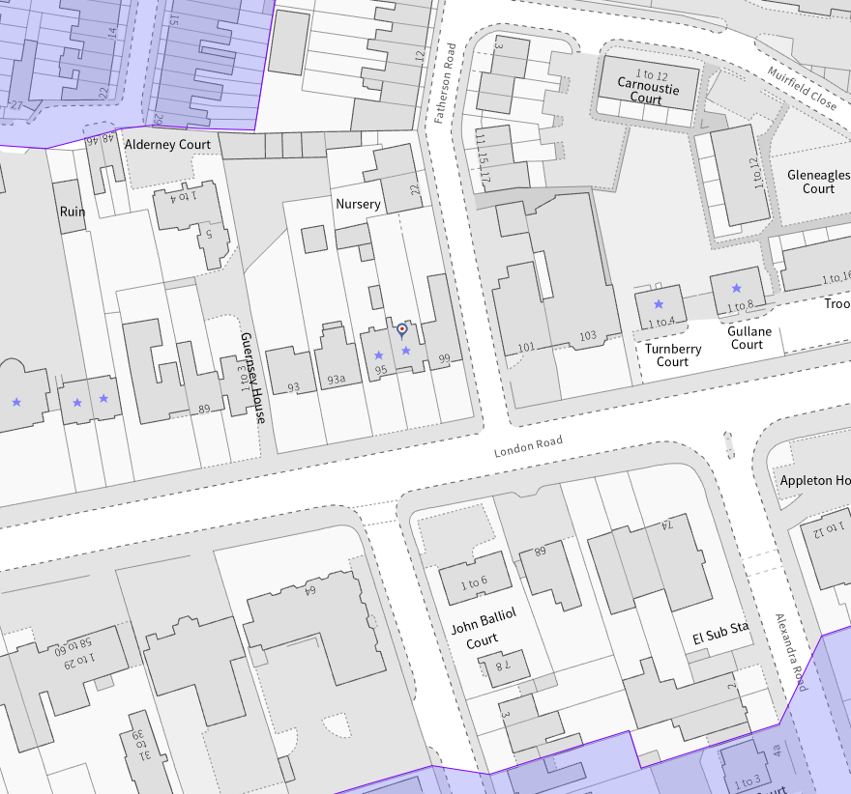
The application site (outlined in red), the land with the same ownership – blue lined, listed buildings (purple starred) and conservation areas (light purple)

Significance of heritage assets
The NPPF defines significance as the “value of a heritage asset to this and future generations because of its heritage interest.”

The interest may be architectural or historic, as set out in the Town and Country Planning (Listed Building and Conservation Areas) Act 1990 Section 1.

“Significance derives not only from a heritage asset’s physical presence, but also from its setting.” (NPPF, 2023)

Historic England assesses significance in a similar manner, referring to evidential, historic, aesthetic and communal values of a place.

The official listing of 95 and 97 London Road reads:“LONDON ROAD 1. 5128 (North Side) Nos 95 and 97 SU 7273 7/516 II GV 2. Mid C19 pair. Eldon Square type Italianate. 2 storeys stucco on brick. Band over ground floor. Slate roof with projecting eaves. 4 windows including gabled end breaks over porches. 1st floor paired narrow round headed sashes, in centre a grooved panel. French casements ground floor to verandah between outer breaks, cast iron guard and standards, tented canopy painted in alternate stripes. End bays have slight projection for round headed doorways and windows above which have dentil cornice and pediment capping. Recessed doors.
Listing NGR: SU7272273114”

As building lines slightly appear on the historic map dating 1853, in the OS Map of 1872-76 (published in 1879) No. 97 constituted part of ‘Mayfair Villas’ and No. 99 was known as ‘Cashiobury Lodge’ after they were constructed. This building is not listed. However, it has some historic character that contributes to the setting of the listed Mayfair Villas.

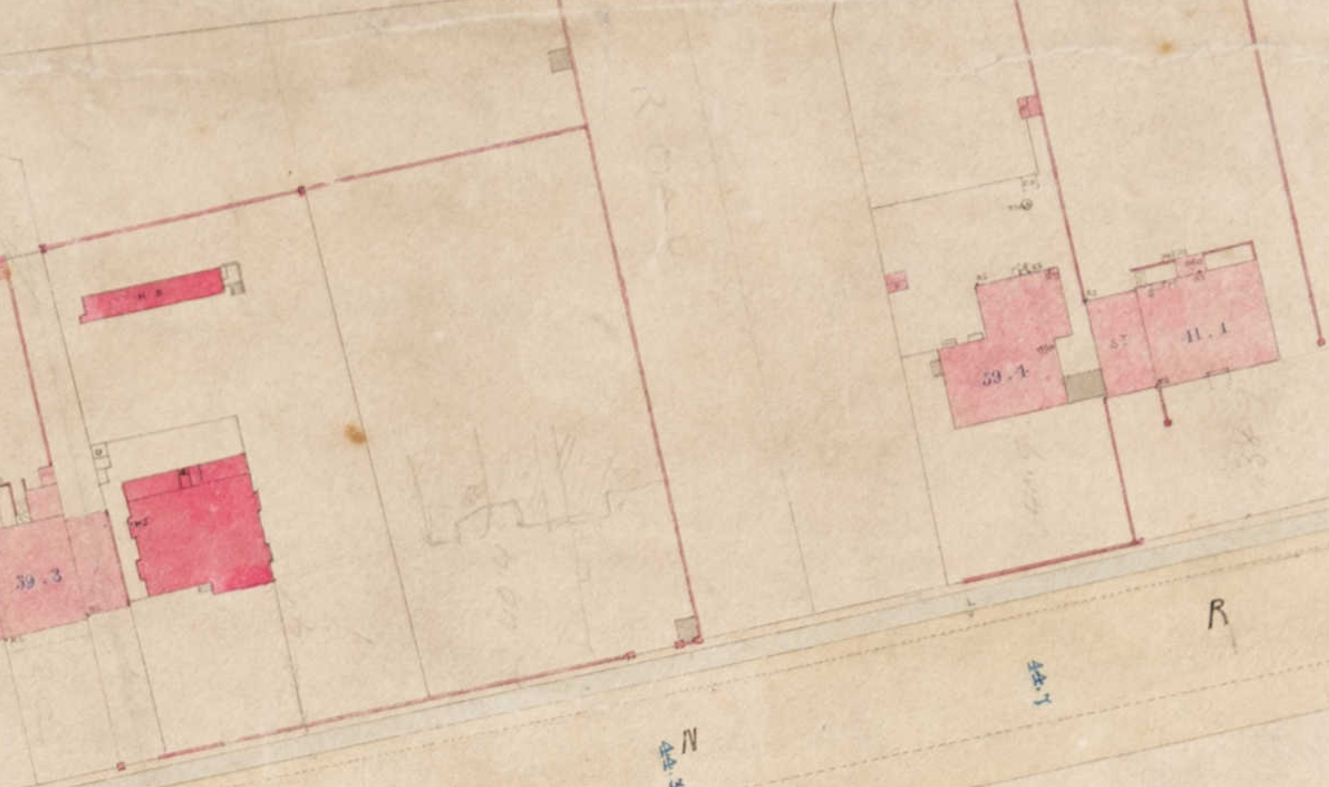
The footprints of buildings are visible on the historic map of 1853

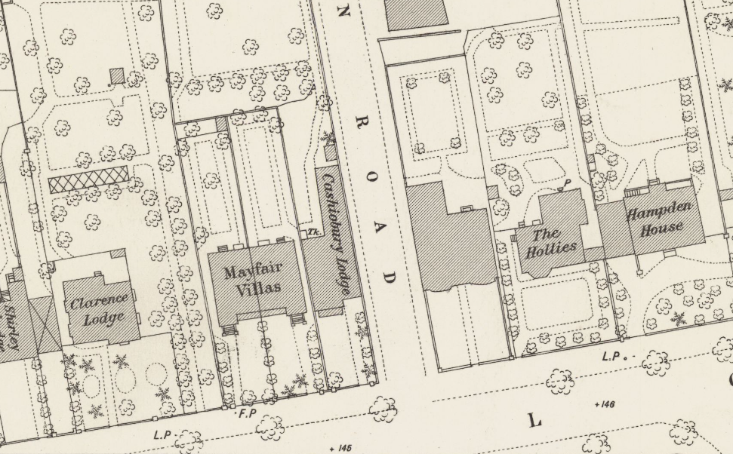
The historic OS Map of 1872-76 (published in 1879) provides information about the application site, listed buildings and their plot layouts

It should also be noted that they are situated on London Road, a wide but historic road connecting the town of Reading to London, which takes attention on Thomas Pride’s Map of Reading 1790.

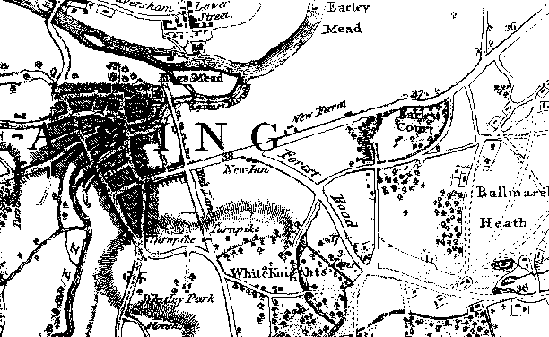
Thomas Pride’s Map of Reading 1790

Impact of proposal upon heritage asset(s)
Given the proposal includes works to the front gardens of two properties, I noted the following regarding the change in the gardens (and listed curtilage) as well as the appearance of the sites from London Road:

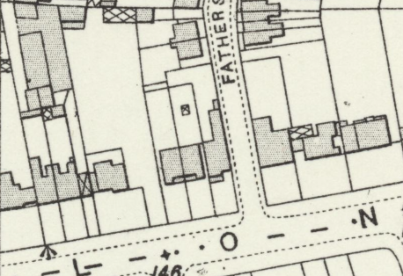
Application Site in 1910 (OS Map published in 1912)

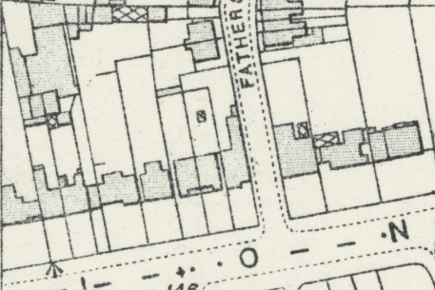
Application Site On the OS Map of 1932 to 1934 (published in 1934)
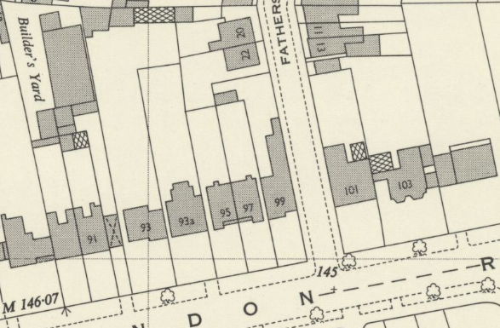
Application Site in 1956 (OS Map published in 1957)

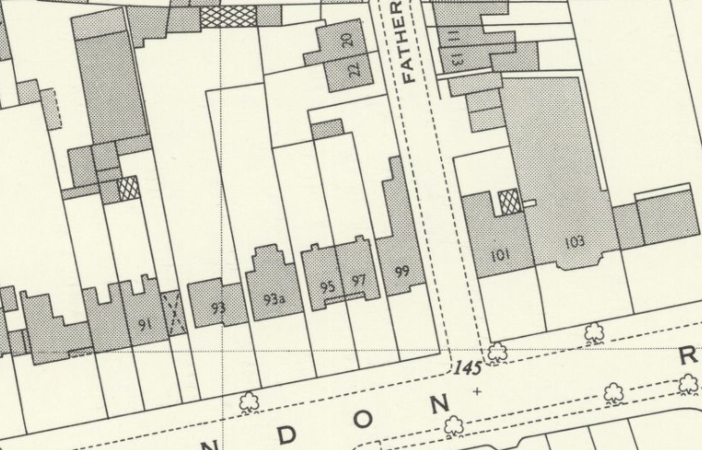
Application Site in 1965 (OS Map published in 1966)
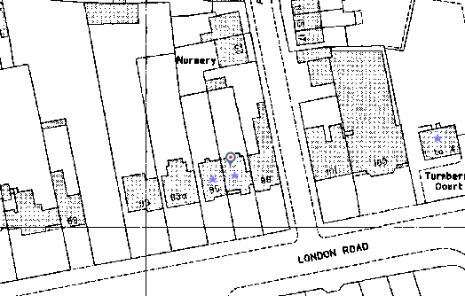
Application Site in the 1980s after listing (14 Dec 1978) (from the Council’s Historic Mapping Tool)

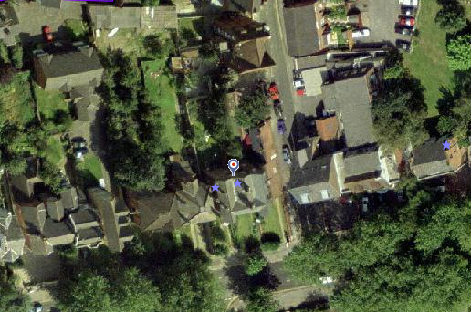
Application site on the Aerial Photograph of 2002

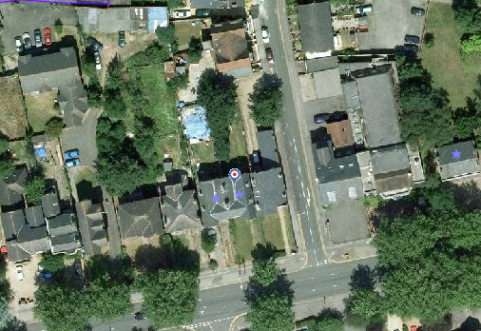
Application Site on the Aerial Photograph of 2006

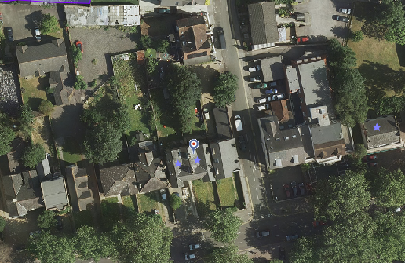
Application Site on the Aerial Photograph of 2013

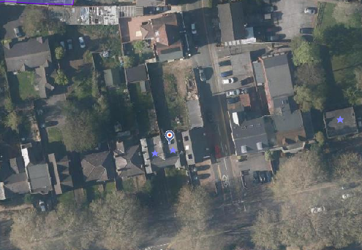
Application Site on the Aerial Photograph of 2021

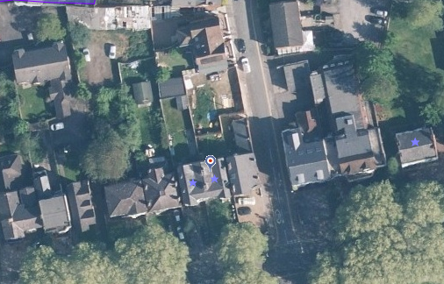
Application Site on the Aerial Photograph of 2024

It is evident from the historic maps and aerial photographs it is the beginning of the 2020s when the natural features of the front gardens of the properties started to be altered to form hard surfaces. The Google Streetview photographs also show the loss of original garden walls and soft landscaping of No. 99 after August 2021.

For No. 97, on the other hand, the date of the loss of boundary walls is not known; as such, their design could not be determined yet. However, the historical photograph from the Reading Library’s Online Catalogue gives a general view of London Road; it has continuous greenery in harmony with the softly landscaped front gardens of houses. In addition, as the official listing notes, it is a high possibility that the building at 97 London Road used to have Eldon Square-type boundary treatment as well: low brick walls and railings above. There is a piece of evidence on the street view dating November 2022 that a decorative raining standard partially survived. Considering the rich decoration of the ironwork of the verandah, the original railings must also have been highly pleasing.
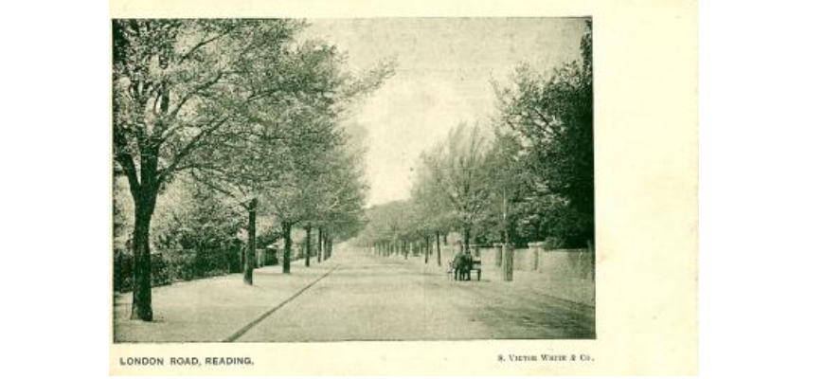
“View along London Road, Reading, c. 1905. No buildings are visible - just fences and walls with garden gates in them. There are trees planted at regular intervals on both sides. The road is deserted, apart from two men pushing a hand-cart in the distance. 1900-1909: postcard by S. Victor White and Company, with the caption, "London Road, Reading." (from Reading Library Catalogue)

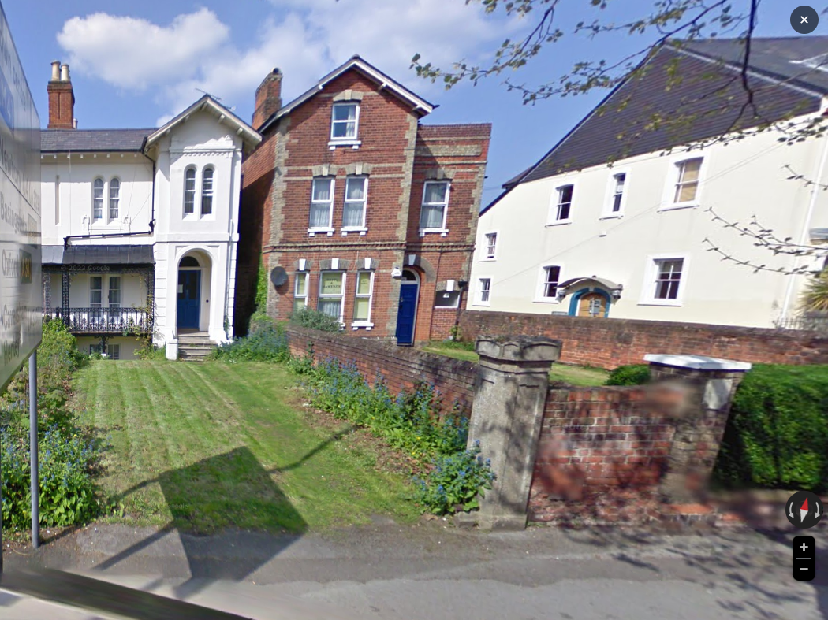
Street View of April 2009 – the original boundary treatment – reflecting the boundaries of listed curtilage - was intact, enhancing the setting of the adjacent listed building and its setting

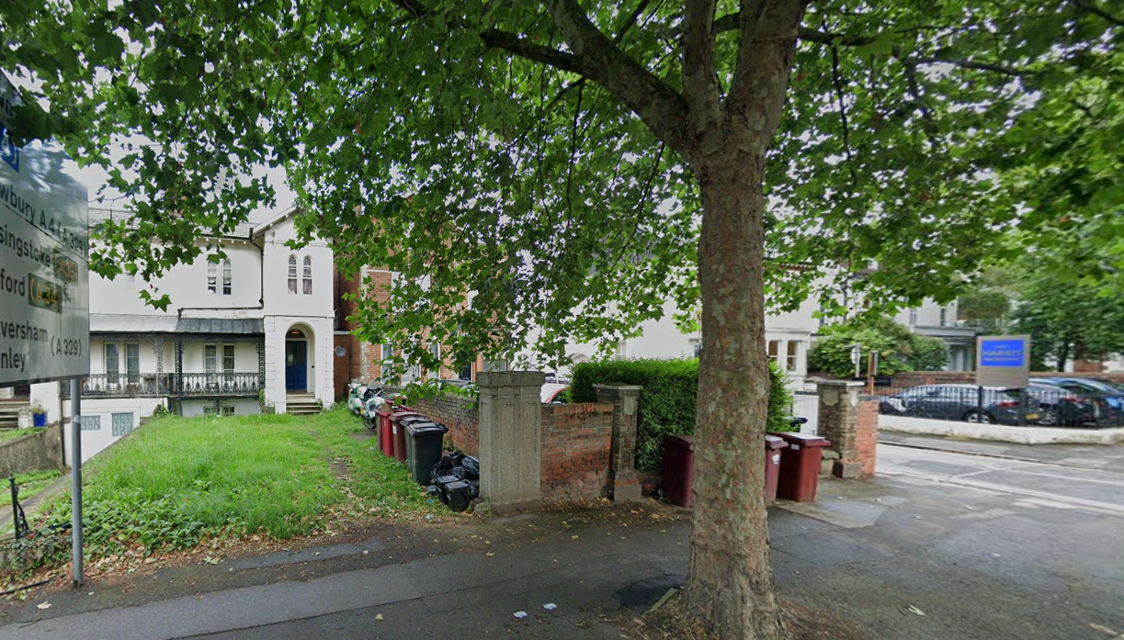
Street view of August 2021: no significant change is noticed

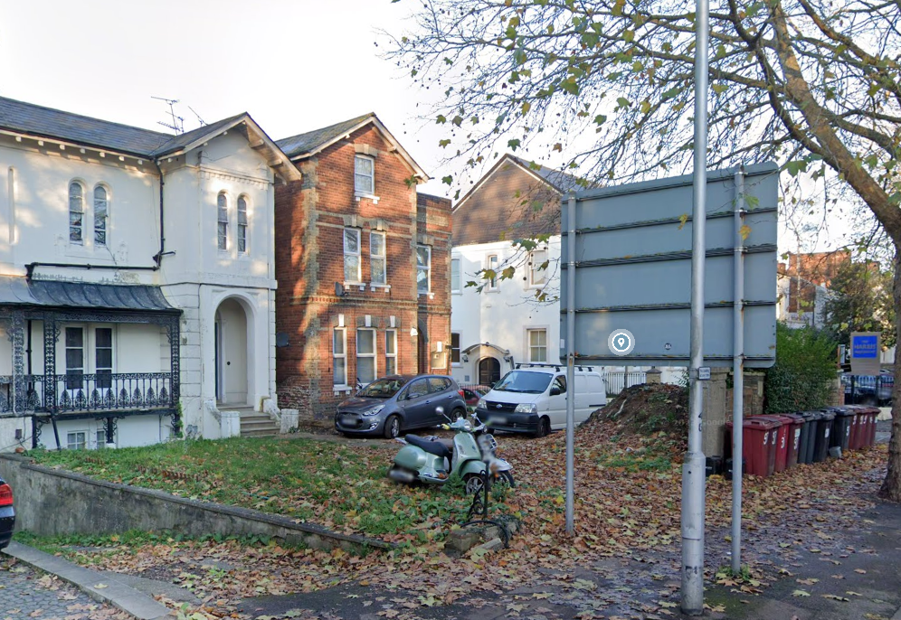
Street view of November 2022, demolition of boundary wall between No. 97 and No. 99 and use of front garden for parking resulting in harm to the listed curtilage and setting of the listed building

From the submitted application form and Planning & Heritage Statement about the proposal, I noted the below and put my comments for each.

From Application Form:
- Proposed external walls would be red brick with dog tooth detail. “Proposed Brick walls to match the existing to restore lost historic features on the street (see plans).” – Evidence is required for the design, height, and details of the original boundary walls of No. 97 (listed building). The proposal removes the existing original element and natural features of No.99 (unlisted building) and copies them arrogantly for the listed building, resulting in the loss of legibility of the listed curtilage and creating a false history without evidence. This would result in less than substantial harm at the highest level on the listed curtilage and setting of the listed building(s), as well as the appearance of London Road. Therefore, this work cannot be supported.

From the Statement:
- match the paving within 99 London Road, which is about to be approved. – Same approach and problem. This would again result in the replacement of the soft landscaping with unsympathetic design and material. The ‘design’ should have been inspired by the original layout of the listed curtilage and should refer to the original elements and enhance & reflect the greenery of being ‘front garden’ of 19th century with minimal contemporary touches.
- Refuse Storage - Formal refuse storage is proposed in the rear as shown on the site plan. There are already refuse stores on the London Road frontage for the existing buildings as shown on the site plan. – The proposed storage should be incorporated into the expected design approach (as described in the previous paragraph)
- Parking - No off street parking is proposed on site as it is a highly sustainable area on the fringe of the Town centre. Parking is shown on no 99 London Road. – Merging two gardens is not acceptable, so is the proposed design. Although the side boundary wall between the two properties was removed by the applicant, the soft landscaping, with its form and simplicity, still indicates the front garden of the listed building in a natural way, enhancing its significance and setting. Creating such a large open space to the front of two properties fails to respect the original form, scale, layout and legibility of the listed curtilage.
Further notes:
- the wording of ‘dropped curve’ on the submitted block plan is incorrect
- the individual needs of a particular owner should not impose on the needs of the historic environment
- the heritage statement is not sufficient; the refusal reasons should also include its being against Paragraph 200 of the NPPF, which requires a heritage expert to assess the heritage significance and impacts proportionately

The proposed alterations and new design to the front garden of the Grade II listed building would merge the front gardens of listed and unlisted properties, resulting in the loss of surviving natural features, historic layout and legibility of the listed curtilage. Because of its unsympathetic design, materials, and pastiche elements that are to be introduced without evidence, the proposed development would adversely affect the character and appearance of the front garden, listed curtilage, and setting of the listed building. The works would, therefore, cause less than substantial harm at the moderate-high level on the special architectural and historic interest of the heritage asset contrary to Paragraph 208 of Chapter 16 (conserving and enhancing the historic environment) of the NPPF 2023, Policies EN1 and EN6 of Reading Borough Local Plan 2019.
The application provides insufficient and contradictory information, so it is not possible to adequately assess the impact of the proposed development regarding the Listed Building status. In the absence of this information, it has not been possible to demonstrate that the proposal would comply with the NPPF and Local Plan.

Conservation response
No objections
No objections subject to conditions attached
Clarification required
Object

Contact details
Buju Can Cetin, Conservation Officer
Burcu.CanCetin@reading.gov.uk
0118 9373125

