Site address: 10 IAN MIKARDO WAY, CAVERSHAM, READING, RG4 5BZ
Description: Single storey flat roof rear extension to provide ground floor accommodation for wheelchair user.
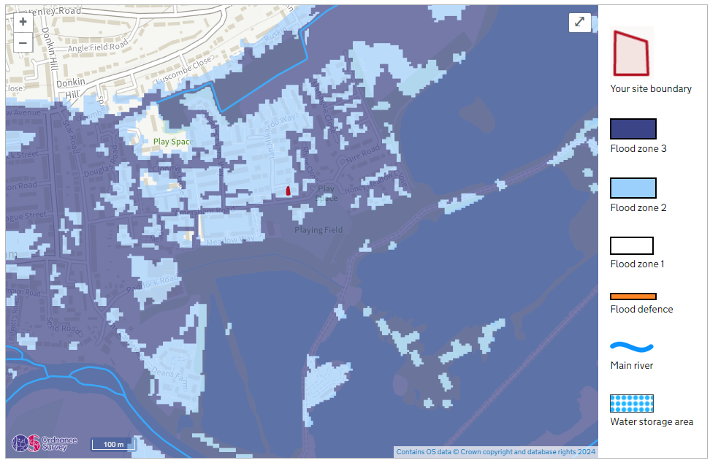
Details of the finished floor levels:
This assessment has considered raising floor levels, however, this application is part of a plan to better adapt the accommodation to meet the needs of a wheelchair user. Keeping steep inclines and differences in levels to a minimum is fundamental to what this application is trying to achieve. This application will not lower the floor level.
Similarly, moving vulnerable uses to upper floors is not viable in this instance for the same reasons as stated above.
Other flood resistance and resilience measures are discussed below.
Details of flood resistance and resilience plans:
- Flood resistant materials with low permeability to be used to at least 600mm above the estimated flood level.
- All doors, windows, and other openings will be flood resistant to at least 600mm above the estimated flood level.
- Flood resilient materials (for example lime plaster) to at least 600mm above the estimated flood level.
- Raising all sensitive electrical equipment, wiring, and sockets to at least 600mm above the estimated flood level. However, the level of electrical sockets will not exceed a height which could be comfortably reached by the wheelchair user.
- All sensitive electrical equipment, wiring, and sockets are to include any appropriate waterproofing/anti-flood measures.
- All spaces will be accessible to enable drying and cleaning.
- All soil pipes will be protected from back-flow with measures like using non-return valves.
- All relevant standards will be followed including:
  - the installation and retrofit of resistance measures - British Standard 851188-1:2019+A1:2021
  - speeding the recovery of buildings after a flood - British Standard 85500:2015
  - dealing with and preventing water from the surrounding ground entering below ground structures such as basements - British Standard 8102:2022
- As is required, all relevant building regulations in Part P will be followed. Where building regulations require measures counter to those discussed above, the building regulations will take precedence while still trying to achieve these aims as best as practicable.
- All paving will be permeable, however, accessibility considerations of materials will take precedence. If permeable materials do not offer a suitable surface for the easy operation of a wheelchair in this area, then they are not required in that instance.
- As changing floor levels was not appropriate in this instance, the owner will endeavour to make temporary or demountable flood barriers available/deployable in case of flooding.
- The flood escape plan includes leaving through the front door as soon as it is safe to do so. The nearest area not in a flood zone is the Rothwell Walk Playground which could be accessed without a vehicle provided footpaths remain open and not obstructed.

