54 Eastern Avenue, Reading RG1 5SE
Tree audit Oct 2024
1. Pathway to house
Pyracanthus - Trim
Holly - Trim
Yew Tree - reduce top leaving 2m from ground - this is damaging party wall see picture below:
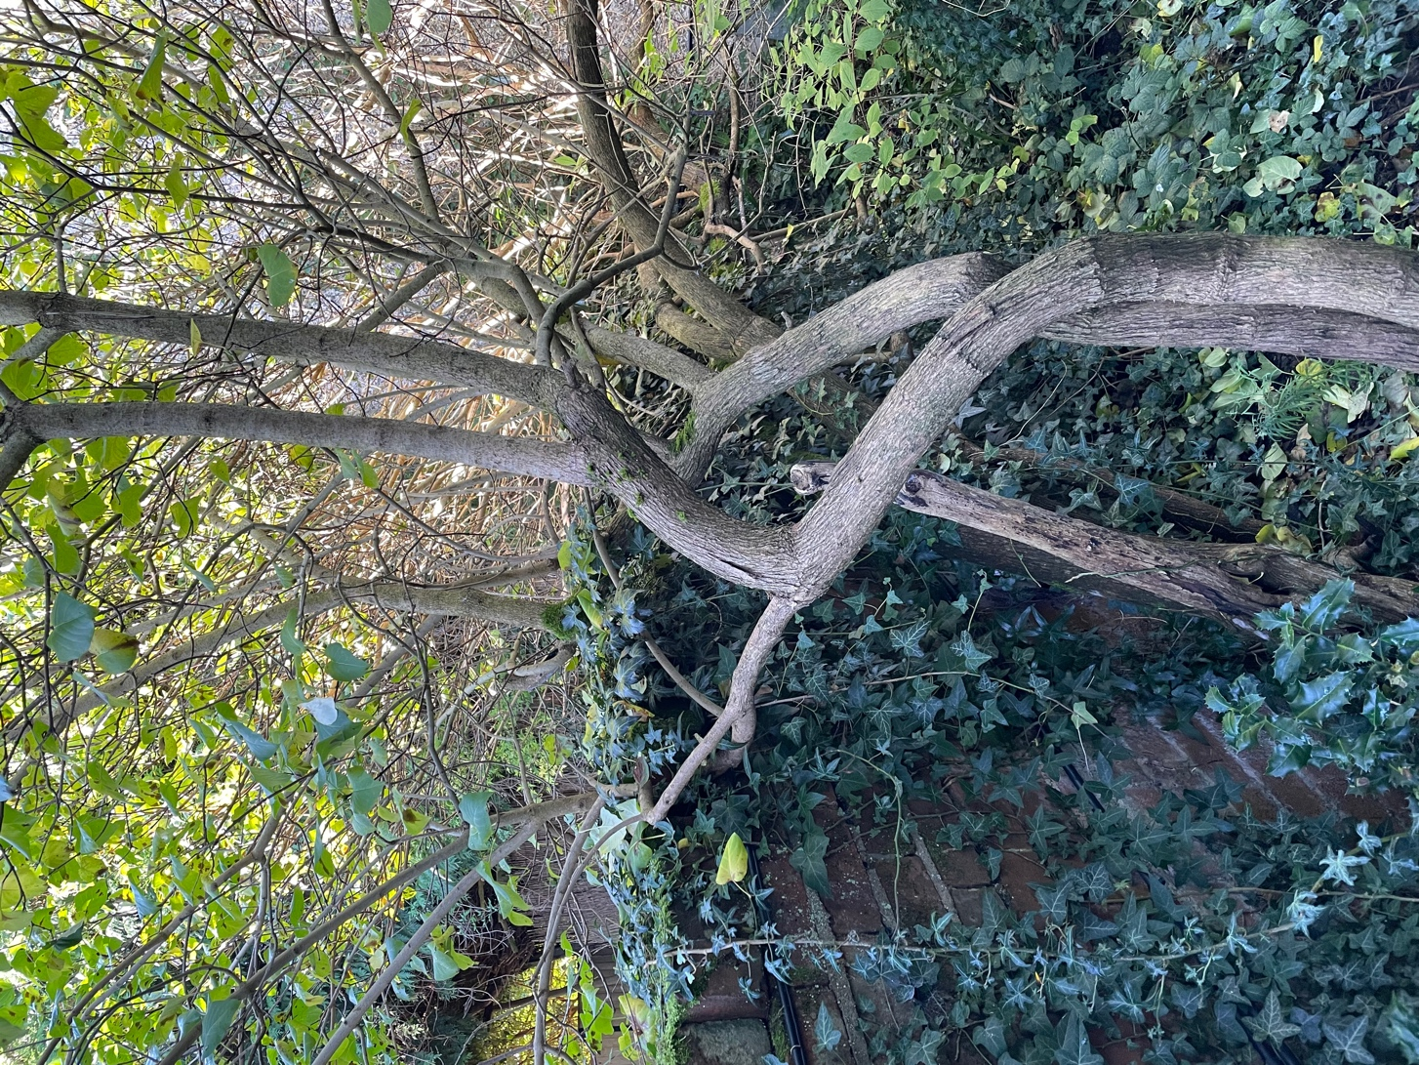

2. Front Garden
Quince - cut back
Climber - cut to ground level and cut back to boundary
Apple tree - fell - Bad specimen overgrown by climber – see picture of apple tree(s) and climber:

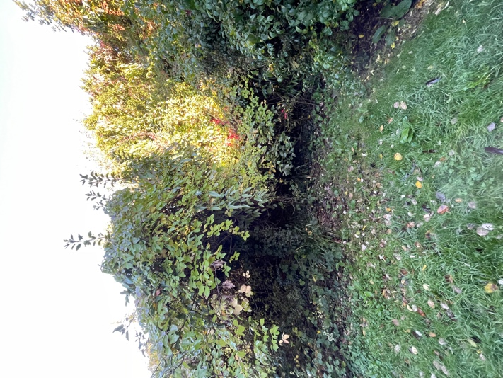
Fig tree - cut back from building by 1 m see below
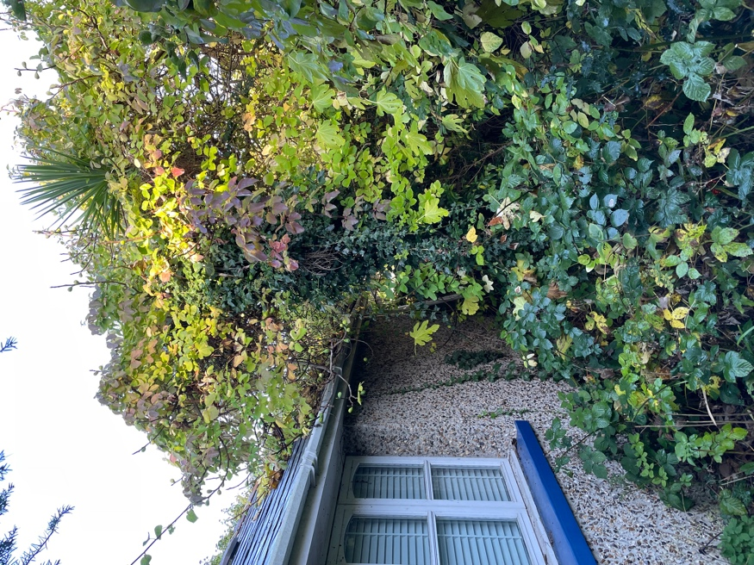
3. Back garden
Palm tree - remove ivy
Holly tree - Fell (suppressed by climbers for light and now bad specimen) see picture
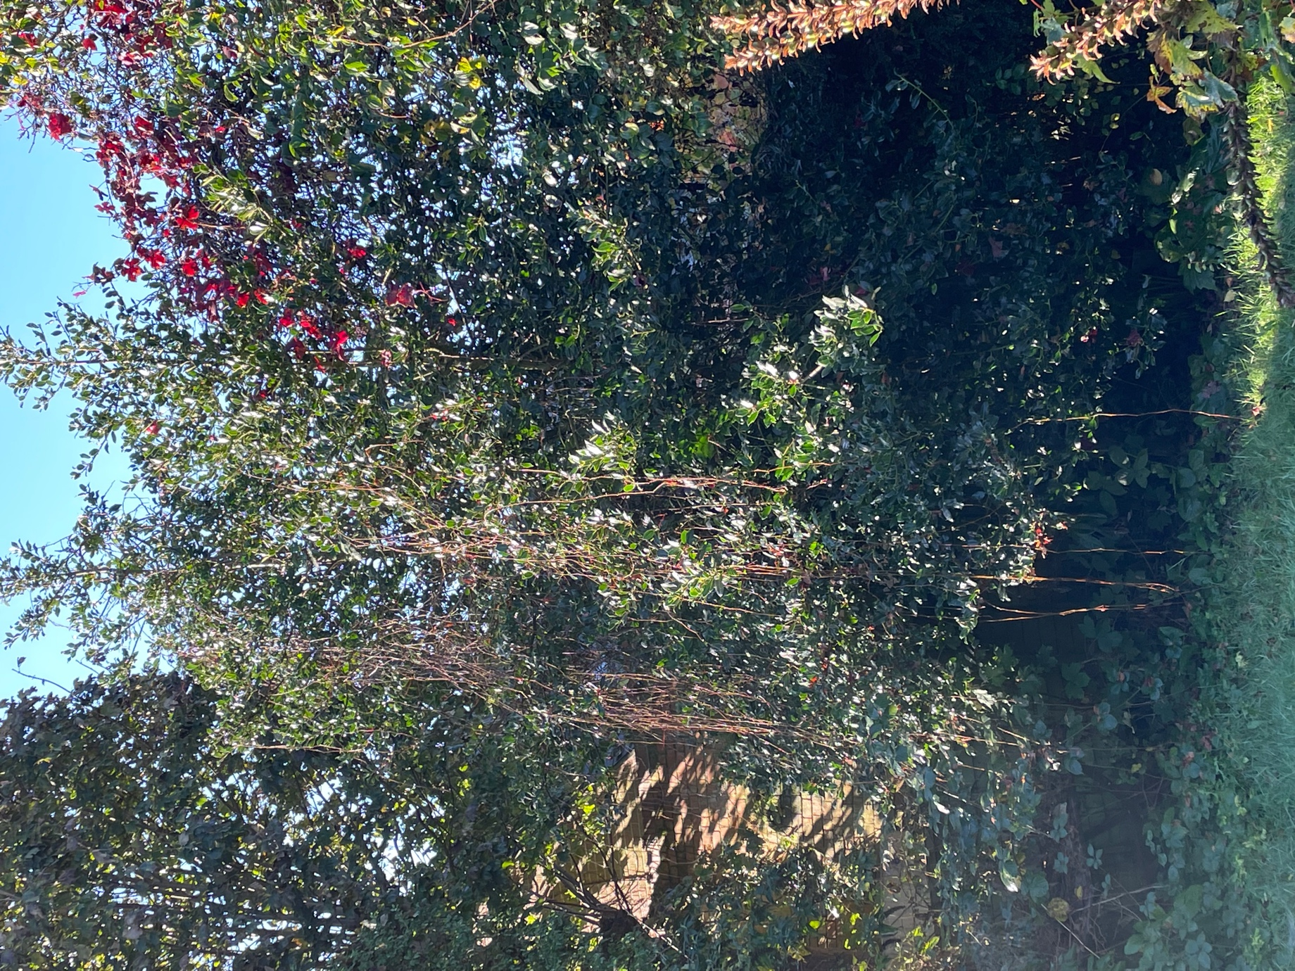

4. Rear courtyard and neighbour’s pathway
Conifer hedge - Fell - overgrown and causing serious damage to neighbour’s fence. See picture
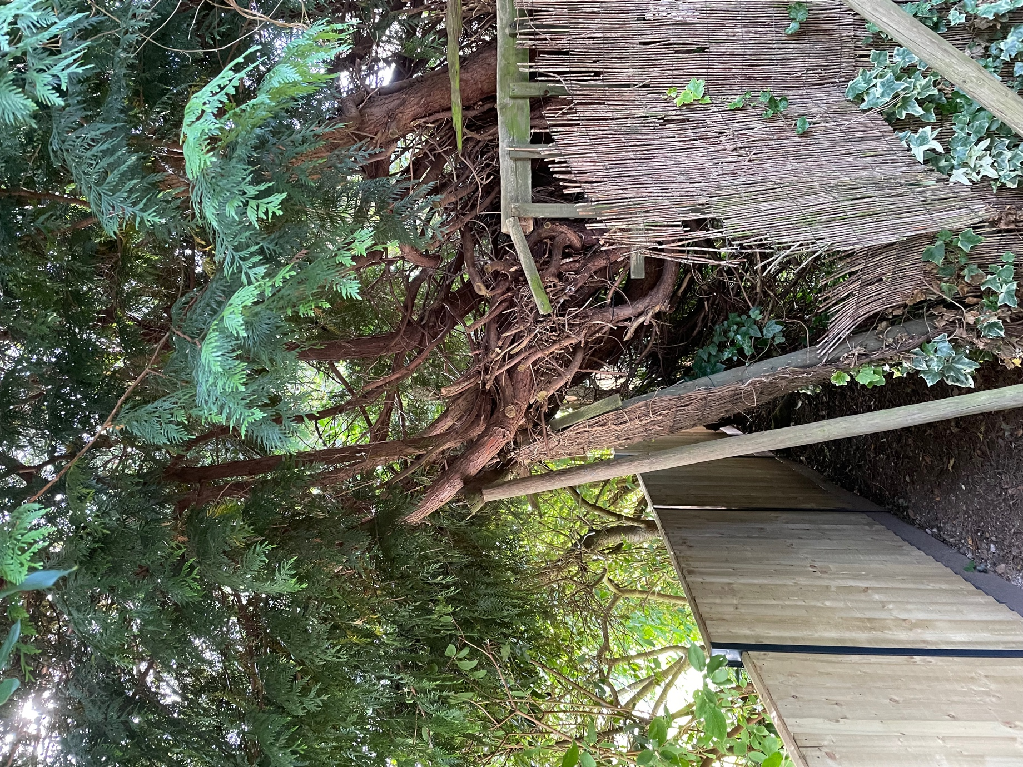

Lilac tree - Fell - overgrowing building reducing light and causing damage. see picture
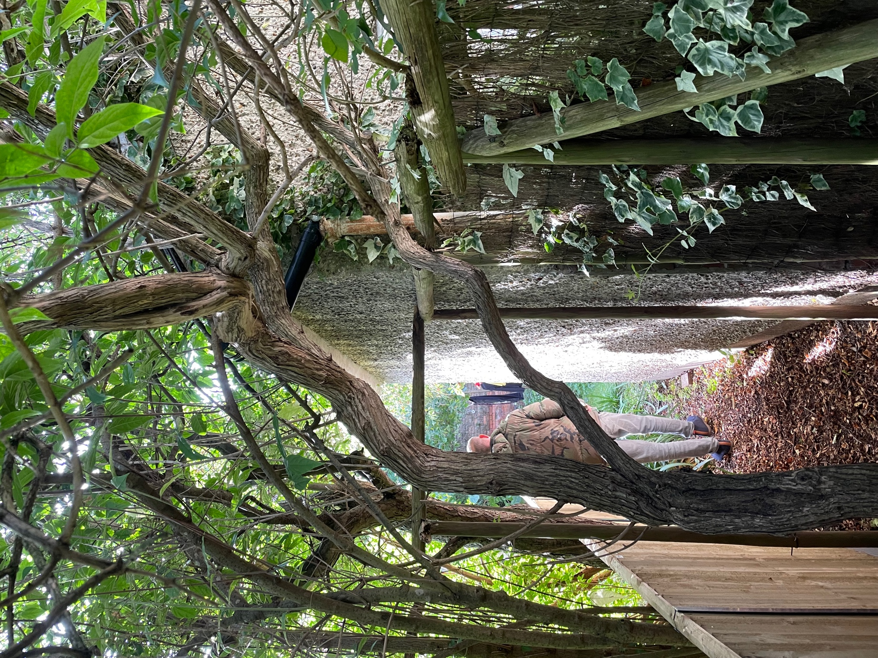

Jonathan did provide a sketch - not sure if it helps but I’m using his as at least you can see the authenticity!
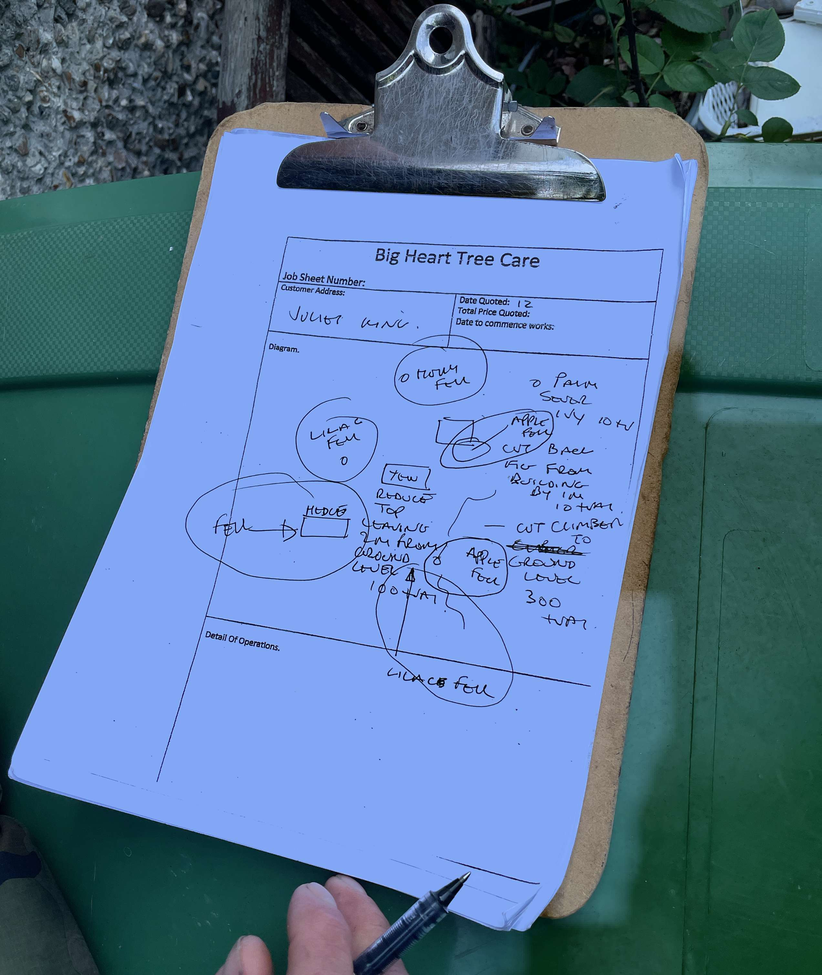

Please let me know what else you need to see.
Jeremy

