FLOOD RISK ASSESSMENT FOR DEVELOPMENT LOCATED WITHIN FLOOD ZONE 2

Applicant’s address: 74 Champlain Street, Reading, RG2 6AF

This FRA Statement has been prepared by Anglian Home Improvements in support of the Planning Application for the Erection of a conservatory to the rear of the property.
The application site is situated within Flood Zone 2.
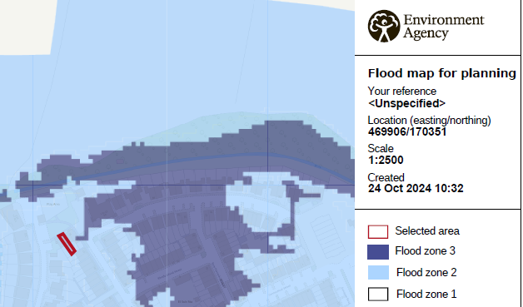
Flood risk map – not to scale – Flood map for planning from gov.uk
Surface Water Drainage/Mitigation measures
The proposed installation, albeit of increased surface area will not impact upon the drainage and or potential flood risk area. All drainage will be dispersed of via the existing sewer system and the construction of the foundations and base works will be of solid construction and completed with horizontal and vertical DPMs and won’t cause any additional drainage onto any neighbouring properties. In the event the existing system is already at capacity water will be to be directed to a new soakaway located maximum 5m from the property with capacity that would accommodate the minimal additional volume of surface water due to the proposed increase in roof area.
There have been no flooding issues on this elevation and no issues have been experienced in the past. All measures have been undertaken to ensure there is minimal risk in terms of flooding within the area. The proposed conservatory finished floor level will be in line with the existing property. “Using surface water as resource” from http:// www.susdrain.org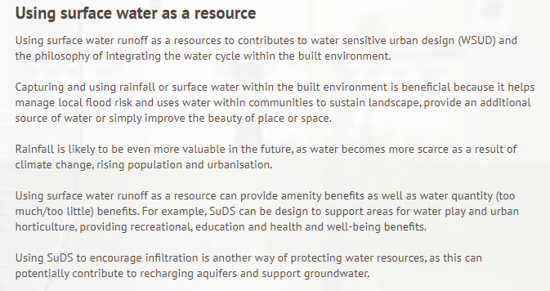

Technical Guidance to the National Planning Policy Framework advises that in this zone, developers should seek opportunities to reduce the overall level of flood risk in the area through the layout and form of the development.
Using SuDS to encourage infiltration in another way of protecting water resources, as this can easier option for many developments. By dealing with runoff at source the volume of water and the potential amount of contamination is less. Often source control components are within the curtilage of properties and maintained by the property owner and can include green roof and rainwater harvesting.

Conclusion
The proposed installation, albeit of increased surface area will not impact upon the drainage and or potential flood risk of the area. All drainage will be dispersed of via the existing sewer system and the construction of the foundations and base works will be of solid construction and completed with horizontal and vertical DPMs.

