CONSERVATION

Memo
WITHOUT PREJUDICE
To: Marcelina Rejwerska
From: Buju (Burcu) Can Cetin, Conservation Officer
Date: 11/10/2024
Re: Conservation Officer response
Application Number: PL/24/0661
Application Type: Full Planning Application
Address: Folk House, Church Street, Reading
Proposal: Replacement of timber windows with UPVC windows.

Summary
Objection – The proposal would result in the loss of original windows of the building of townscape merit (non-designated heritage asset), which highly contributes to the settings of listed buildings on Church Street and the character and appearance of the Market Place/London Street Conservation Area. The proposed double-glazed UPVC windows would combine contemporary materials into a property that remains largely intact from a historical perspective resulting in diminishing the overall character of the building and undermining the historic integrity and significance of this non-designated heritage asset within the Conservation Area. Therefore, the proposal would fail to preserve or enhance the character and appearance of the Conservation Area, resulting in less than substantial harm to the significance of the conservation area, settings of listed buildings and non-designated heritage assets, conflicting with EN1, EN3 and EN6 of the Reading Borough Local Plan, which aims to protect, conserve, and enhance the historic context and character of heritage assets.

Relevant policies and legislation
From the point of view of the historic environment, the main statutory tests are set out within the Planning (Listed Buildings and Conservation Areas) Act 1990. Section 66 of the Planning (Listed Buildings and Conservation Areas) Act 1990 requires ‘special regard’ to be given to the desirability of preserving a listed building or its setting.
Section 72 of the Planning (Listed Buildings and Conservation Areas) Act 1990 states that in the exercise of any functions, with respect to any buildings or other land in a conservation area, under or by virtue of any of the provisions mentioned in this Section, special attention shall be paid to the desirability of preserving or enhancing the character or appearance of that area.

National Planning Policy and Guidance
The NPPF outlines government policy, including its policy in respect of the historic environment. Chapter 16 of the NPPF (2023) 'Conserving and enhancing the historic environment' sets out the Government's high-level policies concerning heritage and sustainable development.
Paragraph 200 states, “In determining applications, local planning authorities should require an applicant to describe the significance of any heritage assets affected, including any contribution made by their setting. “ And Paragraph 201 says, “Local planning authorities should identify and assess the particular significance of any heritage asset that may be affected by a proposal (including by development affecting the setting of a heritage asset) taking account of the available evidence and any necessary expertise. They should take this into account when considering the impact of a proposal on a heritage asset, to avoid or minimise any conflict between the heritage asset’s conservation and any aspect of the proposal.”
Paragraph 205 of the NPPF requires that ‘when considering the impact of a proposed development on the significance of a designated heritage asset, great weight should be given to the asset’s conservation….’ And paragraph 206 says, ‘any harm to, or loss of, the significance of a designated heritage asset (from its alteration or destruction, or from development within its setting) should require clear and convincing justification’.
Paragraph 208 requires that ‘where a development proposal will lead to less than substantial harm to the significance of a designated heritage asset, this harm should be weighted against the public benefits of the proposal…’

National Planning Practice Guidance on Historic Environment provides context to the NPPF.

Local Planning Policy and Guidance
Policy EN1 ‘Protection and enhancement of the historic environment’ of the Reading Borough Local Plan sets out the Council’s aspirations for the historic environment. The policy requires that all proposals to protect and, where possible, enhance the significance of heritage assets and their settings, historic character and local distinctiveness of the area in which they are located. It echoes the NPPF by stating, “Proposals should seek to avoid harm in the first instance. Any harm to or loss of a heritage asset should require clear and convincing justification, usually in the form of public benefits”.
Applications that affect listed buildings are expected not to have an adverse impact on the elements that contribute to their special architectural or historic interest, including their settings.

Policy EN3 ‘Enhancement of conservation areas’ of the Reading Borough Local Plan requires that development proposals within Conservation Areas contribute positively to local character and distinctiveness. This policy further states “Positive consideration will be given to proposals which take opportunities to enhance the character of conservation areas.”

Policy EN6 ‘New development in a historic context’ also requires “New development will make a contribution to the historic character of the area by respecting and enhancing its architectural and visual qualities and considering how heritage considerations can influence the design of new development. When determining planning applications for new development, the following factors will be taken into consideration:
a. The positive contribution of the development to the existing historic townscape (scale, height, mass, proportion, plot size, street form, materials, significant vistas and views, and open space);
b. Sensitivity to historic context;
c. Reflection of borough-wide major heritage themes that contribute to local distinctiveness (e.g. patterned brickwork or former worker terraced housing);
d. Whether development promotes and/or improves access to previously undiscovered or neglected historic significance.”

Market Place/London Street Conservation Area Appraisal is also a material consideration in determining applications for development.
Other Guidance
Historic England Advice Note 2 – Making changes to Heritage Assets illustrates the application of policies set out in the NPPF in determining applications for Planning Permission and Listed Building Consent.
English Heritage’s “Conservation Principles” provides policy and guidance for the “sustainable
management of the historic environment”.

Relevant heritage assets
The application site relates to a three-four storey Late Victorian building located on the northern part of Church Street in the Market Place/London Street Conservation Area. The application site shares boundaries with the Grade II Listed Reading Quaker Meeting House, and it also faces Grade II listed buildings at 11 Church Street (late 18th century) and 7-9 Church Street (early 19th century).
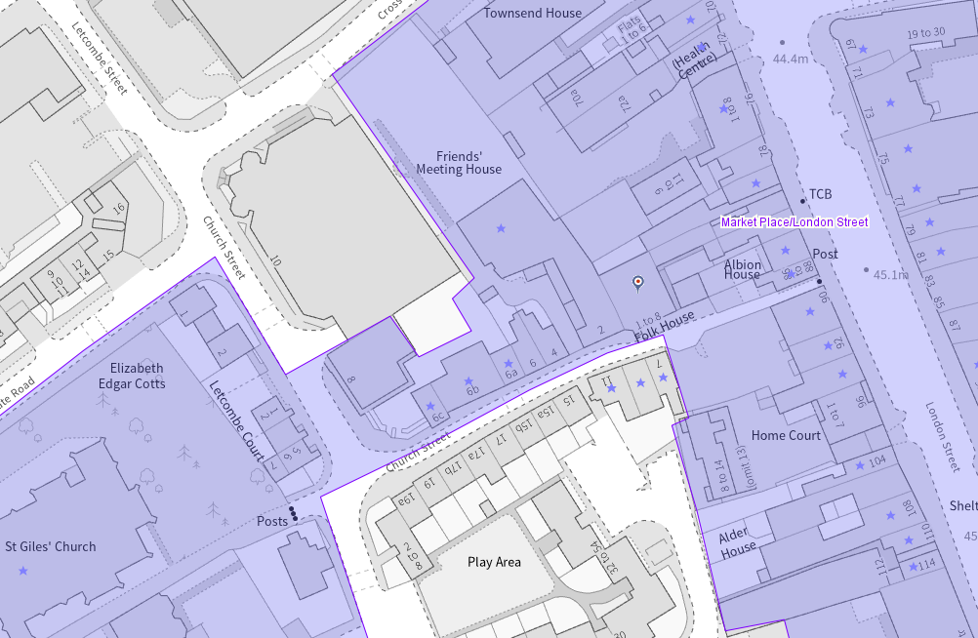
The application site (outlined in red) and listed buildings (purple starred) within the conservation area (light purple)

Significance of heritage assets
The NPPF defines significance as the “value of a heritage asset to this and future generations because of its heritage interest.”

The interest may be architectural or historic, as set out in the Town and Country Planning (Listed Building and Conservation Areas) Act 1990 Section 1.

“Significance derives not only from a heritage asset’s physical presence, but also from its setting.” (NPPF, 2023)

Historic England assesses significance in a similar manner, referring to evidential, historic, aesthetic and communal values of a place.

Located within the Character Area 2 Church Street and environs of St Giles’ Church of the Market Place/London Street Conservation Area, the subject building, building of townscape merit (BTM), due to its scale, height, having period characteristics of stucco horizontal bands and quoins, timber sash window with a single sheet of glass and prominent chimneys is an attractive building designed by Brown and Albury, opened in 1880 as a mission hall and classroom block for the Quaker meeting house (stated within the official listing description of Reading Quaker Meeting House). As such, the building has not only a highly contributing element to the special interest of the conservation area but also a functional relationship with the meeting house.

Regarding the significance of the area the appraisal states: “Reading’s early street pattern and the close relationship of medieval church, market place and river crossing place can still be traced today in the Market Place/London Street Conservation Area.(…)
The earliest map of Reading, published in John Speed’s atlas of Great Britain in 1611 shows that the plan of the town in the early 17th century resembled a triangle with a church roughly at each corner: St Mary’s, St Giles’ and St Laurence’s. (…)
There is an enticing glimpse of the spire of St Giles’ looking eastward along Church Street from London Street, framed between two listed buildings the most northerly of which, no. 88, has a jettied first storey. (…)
London Street is unusually wide whilst the entrance to Church Street and the short length of High Street are narrow and enclosed and have the feel of town alleys.”

The Folk House is also within an important view towards one of the three medieval churches of Reading, St Giles. About the Character 2, the appraisal noted the following positive and negative elements on the significance of the area.

“Features that make a positive contribution to the historic character and appearance of the conservation area:
• Narrow entrance from London Street with attractive view of St Giles’ church spire;
• St Giles’ Church and vicarage;
• Friends Meeting House and secluded burial ground;
• Row of 19th century houses on north side;
• Prevalent use of brick;
• Tranquil atmosphere;
• Green open space of St Giles’ churchyard;
• Remnants of historic floorscape (stone setts and kerbs at edge of carriageway);
• Typical early 20th century parish hall (Southampton Street);
• Trees and greenery adjacent to St Giles’ Church and Friends Meeting House;
• Pedestrian friendly area with infrequent traffic.”

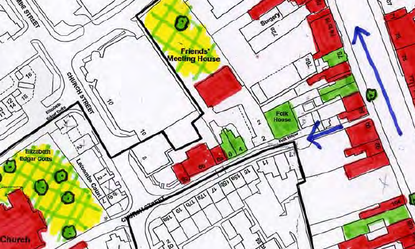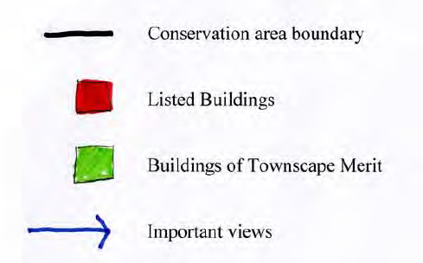
Partial map of the conservation area – the subject building is circled in orange

In addition, among the issues related to the loss of architectural features within the conservation is the replacement of original windows with uPVC or aluminium:

“Many of the unlisted, and some of the listed, buildings in the conservation have been adversely affected by the use of inappropriate modern materials or details. Common faults include:
• the replacement of original timber sash windows with uPVC or aluminium;
• the loss of original panelled front doors and their replacement with stained hardwood, uPVC or aluminium doors;
• loss of chimney stacks and clay pots;
• the replacement of clay tile or Welsh slate roofs with concrete tiles;” (Pages 20-21).

The Official listings of the aforementioned Grade II listed buildings are read below:
Reading Quaker Meeting House:
“Summary
Reading Quaker Meeting House, built in 1835.

Reasons for Designation
Reading Quaker Meeting House of 1835 is listed at Grade II for the following principal reasons:

Historic interest:
* as the third purpose-built meeting house serving Reading’s Quaker community, established by 1655.

Architectural interest:
* as a modest but dignified early-C19 meeting house, demonstrating the simplicity characteristic of Quaker buildings; * the meeting room has a restrained elegance, with distinctive features illustrative of its historic use, including the central arch which formerly held a dividing screen, and blocked doorways which led to separate rooms for women’s and men’s business meetings; * the meeting room retains original joinery, including the stand with its fixed bench, and dado panelling; the building’s sash windows also survive.

Group value:
* with the attached Quaker burial ground of 1715 to the rear, as well as with C18 houses in Church Street.

History
The Quaker movement emerged out of a period of religious and political turmoil in the mid-C17. Its main protagonist, George Fox, openly rejected traditional religious doctrine, instead promoting the theory that all people could have a direct relationship with God, without dependence on sermonising ministers, nor the necessity of consecrated places of worship. Fox, originally from Leicestershire, claimed the Holy Spirit was within each person, and from 1647 travelled the country as an itinerant preacher. The year 1652 was pivotal in his campaign; after a vision on Pendle Hill, Lancashire, Fox was moved to visit Firbank Fell, Cumbria, where he delivered a rousing, three-hour speech to an assembly of 1000 people, and recruited numerous converts. The Quakers, formally named the Religious Society of Friends, was thus established.

Fox asserted that no one place was holier than another, and in their early days, the new congregations often met for silent worship at outdoor locations; the use of members’ houses, barns, and other secular premises followed. Persecution of Nonconformists proliferated in the period, with Quakers suffering disproportionately. The Quaker Act of 1662, and the Conventicle Act of 1664, forbade their meetings, though they continued in defiance, and a number of meeting houses date from this early period. Broad Campden, Gloucestershire, came into Quaker use in 1663 and is the earliest meeting house in Britain, although it was out of use from 1871 to 1961. The meeting house at Hertford, 1670, is the oldest to be purpose built. The Act of Toleration, passed in 1689, was one of several steps towards freedom of worship outside the established church, and thereafter meeting houses began to make their mark on the landscape.

Quaker meeting houses are generally characterised by simplicity of design, both externally and internally, reflecting the form of worship they were designed to accommodate. The earliest purpose-built meeting houses were built by local craftsmen following regional traditions and were on a domestic scale, frequently resembling vernacular houses; at the same time, a number of older buildings were converted to Quaker use. From the first, most meeting houses shared certain characteristics, containing a well-lit meeting room with a simple arrangement of seating. In time a raised stand became common behind the bench for the Elders, so that traveling ministers could be better heard. Where possible, a meeting house would provide separate accommodation for the women’s business meetings, and early meeting houses may retain a timber screen, allowing the separation (and combination) of spaces for business and worship. In general, the meeting house will have little or no decoration or enrichment, with joinery frequently left unpainted.

Throughout the C18 and early C19 many new meeting houses were built, or earlier buildings remodelled, with ‘polite’, Classically-informed designs appearing, reflecting architectural trends more widely. However, the buildings were generally of modest size and with minimal ornament, although examples in urban settings tended to be more architecturally ambitious. After 1800, it became more common for meeting houses to be designed by an architect or surveyor. The Victorian and Edwardian periods saw greater stylistic eclecticism, though the Gothic Revival associated with the Established Church was not embraced; on the other hand, Arts and Crafts principles had much in common with those of the Quakers, and a number of meeting houses show the influence of that movement.

By 1655, Quakers were meeting in Reading at the house of Thomas Curtis in Sun Lane, and in 1671, a purpose-built meeting house was constructed in Curtis’s garden. A burial ground at the Orts on Wharf Lane, off the London Road, was bought in the C17, remaining in use until 1716. In 1684, a schism occurred in the Reading meeting due to national dispute among Quakers (known as the Wilkinson-Story Controversy) over a number of points: at Reading the group led by Curtis objected to the influence and authority of George Fox, and the establishment of separate business meetings for women, thought to offer excessive independence; the orthodox contingent was led by Leonard Cole. The resulting two meetings initially had joint meetings for worship but separate business meetings in the same meeting house, but in 1686, the meeting house closed and the Curtis group met in private houses, while the other group met in the yard of the meeting house. In 1693, the meeting house reopened for the Curtis group, the orthodox group using a leased building in Sim’s Court. Following Curtis’s death in 1712, the two groups were reconciled and bought the present site at Church Street in 1715 where a new meeting house was built in 1716. In 1835, this was demolished and replaced by the current building. A lower entrance block was added to the south elevation in the mid-C19, encasing a smaller frontage block containing separate rooms for women's and men's business meetings. In 1879, an adjoining plot to the south was purchased, and a mission hall and classroom block was erected there by the architects Brown & Albury, opening in 1880, now known as the Folk House, and in separate ownership. The buildings immediately to the south of the meeting house were demolished in 1964 when a new lobby and entrance block was built by Austin & Partners. This was further extended, to the west, in 1994.

To the north of the meeting house is a burial ground, which formed part of the site acquired in 1715, and is still in occasional use. It contains numerous modest round-headed grave markers, including members of the Huntley and Palmer families – local biscuit manufacturers – and Alfred Waterhouse, father of the architect Alfred and accountant Edwin. The walls surrounding the burial ground belong to a number of different phases.

Details
Quaker meeting house of 1835. A 1964 addition along the south (front) elevation, enclosing the forecourt to the east, extended in 1994, and a small C20 WC block against the east elevation are not of special interest, and are excluded from the listing.

MATERIALS: the original meeting house is built of red brick laid in Flemish bond, having a pitched slate roof with coped gables on stepped brick kneelers. All four chimney stacks have been removed. The later extensions are of brown brick laid in stretcher bond.

PLAN: the meeting house is set at the north end of a forecourt. The original meeting house has a rectangular plan, set on a west/east alignment.

EXTERIOR: the south elevation of the meeting house is now partly obscured by the single-storey 1964 extension; above this the tops of the meeting room’s four windows can be seen, the openings having flat brick arches, and containing what appear to be original sash frames. The two central windows are set higher, rising to just below the eaves, to allow for the original frontage block, now lost. The two chimneys which formerly rose from the south side of the roof have been removed. The unencumbered north elevation has four tall windows with twelve-over-twelve sash frames. Memorial plaques for Quakers with ashes placed in the burial ground are affixed to the lower part of the north wall. The west elevation has a central entrance approached by two steps with original panelled double doors set within a moulded doorcase with a shallow, console-bracketed hood. To either side are window openings blocked with burnt bricks in header bond, and in the gable above is a circular opening with ventilation slats. The east elevation has a similar circular opening, and is otherwise blind.

INTERIOR: at the centre of the meeting room is a three-centred arch, which formerly held a counterweighted screen to divide the room or rise into the roof space above; related machinery is understood to survive within the roof space, not inspected. A similar arch frames the stand at the east end of the room. The ceilings to either side of the central partition have cornices, and circular ventilation openings with grilles. The south, east and west sides of the room have plain recessed dado panelling. The stand has a balustrade with turned balusters in front of a fixed bench. The northern corner of the stand incorporates a flush door giving access to a ladder leading to the roof space. Against the west wall is another raised dais with curved partitions to either side of the western entrance. Here there are no fixed benches; there is later shelving fixed to the wall panelling. The dais appears to have been altered from three steps to a single deep platform (Butler, p 15). Butler’s plan showing the internal arrangement as it was in 1879, the west dais has been altered from three steps to one deeper platform. In the south wall is the central entrance from the lobby, with 1960s doors, flanked by two smaller door openings, formerly leading to the women’s and men’s retiring rooms, and now blocked. To the east is a framed arched recess which formerly contained a cast-iron stove; there were originally two of these in the south wall and two in the north wall. The lower portions of the outer windows in the south wall are blocked, probably at the time the mid-C19 lobby was constructed.”

7 and 9, Church Street
“Details
CHURCH STREET 1. 5128 (South Side) Nos 7 and 9 SU 7172 NE 4/450 5.10.77. II GV 2. Early C19. 2 storeys, attic and cellar. Red brick on plinth. Brick block eaves course. Tiled roof with one dormer. 4 windows on 1st floor, glazing bar sashes with moulded surrounds. Ground floor windows blocked. 2 central round headed doorways, plain fanlights, 6 panel doors.

Listing NGR: SU7177872985”
11, Church Street
“Details
CHURCH STREET 1. 5128 (South Side) No 11 SU 7172 NE 4/451 5.10.77. II GV 2. Late C18. 2 1/2 storeys. Grey brick headers with red brick dressings and quoins. Plinth. Brick dentil cornice. Parapet. Mansard tile roof, hipped to right. 2 ranges of glazing bar sash windows with slightly cambered heads, blocked on ground floor. Central 6 panel door.

Listing NGR: SU7176972982”

Impact of proposal upon heritage asset(s)
The proposal is for the replacement of all original single-glazed timber sash windows of the building with similar design double, glazed uPVC ones. The Council disagree with the conclusion of the submitted heritage statement as given below.

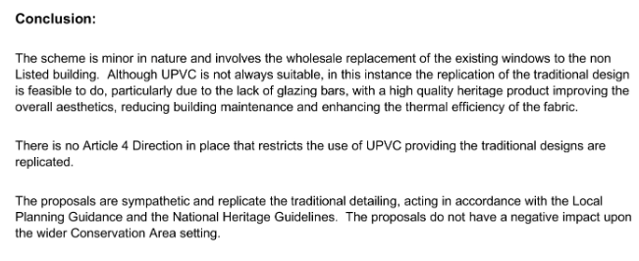
First of all, there is no evidence that all existing/original windows are rotten. The officers conducted a site visit and noted that the windows on the front elevation were in good condition. Secondly, the proposal does not resolve the existing problem of loss of architectural features in the conservation area but devaluates and brings unsuitable elements to the character and appearance of the conservation area and the building of townscape merit, this would then have a negative impact on the important view and settings of the listed buildings on Church Street. Lastly, because the proposal would lead to the replacement of windows, which is a material change for the building and the conservation area, the non-existence of Article 4 direction does not matter.

Therefore, replacing all existing timber-framed sash windows with uPVC sliding sash windows made from modern materials would not accurately replicate their original appearance, particularly in terms of finish and intricate details. Introducing uPVC double glazing would bring contemporary materials into a property that remains largely intact from a historical perspective. This change would remove significant historical elements and fail to provide a true ‘like for like’ replacement. Additionally, given the provided details do not include existing and proposed joinery details, the uPVC frames would be noticeably thicker than the current slender timber frames, altering the proportions of the windows and negatively affecting the principal elevation of the building of townscape merit. This alteration would diminish the overall character of the building, undermining the historic integrity and significance of this non-designated heritage asset within the Conservation Area.

The agent provided photographs of two buildings to support the proposal. However, none of the buildings are located within the conservation area; they have different urban contexts. One of them dates back to the 1970s, and the fact that some placements occur in historic buildings does not justify this being acceptable for this particular building.

Hence, the proposal would fail to preserve or enhance the character and appearance of the Conservation Area, resulting in less than substantial harm to the significance of this designated heritage asset. According to Paragraph 208 of the Framework, such harm must be weighed against the public benefits of the proposal. While the heritage statement argues that the proposal does not cause a negative impact, there is insufficient justification for the condition of existing windows or the joinery details of existing and proposed windows. Accordingly, the use of uPVC would primarily serve private interests rather than providing wider public benefits.

Given the importance of conserving the designated heritage asset, I conclude that the identified less than substantial harm is not outweighed by any public benefits. By failing to preserve or enhance the character or appearance of the Conservation Area and settings of listed buildings the proposal would detract from the significance of this non-designated heritage asset, conflicting with EN1, EN3 and EN6 of the Reading Borough Local Plan, which aims to protect, conserve, and enhance the historic context and character of heritage assets.

Conservation response
No objections
No objections subject to conditions attached
Clarification required
Object

Contact details
Buju Can Cetin, Conservation Officer
Burcu.CanCetin@reading.gov.uk
0118 9373125

