Applicant: Sykes Capital Ltd

Proposal: Application for removal or variation of a condition 6 (Opening Hours)
following grant of planning permission. (181351)

At: 70
Whitley Street
Reading
RG2 0EQ

The above application was WITHDRAWN by the applicant on .

Date: | 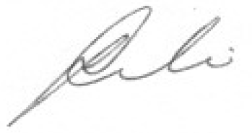
 | Assistant Director of Planning, Transport and Public Protection Services

