25/09/24
Planning Application Ref: 241098
Application Type: Full planning permission
Address: 10B BRIDGE STREET, CAVERSHAM,
Proposal: Partial demolish of rear extension and new rear extension
to create ground floor flat and shop and 5 bedroom HMO to first and second floor. Shop access door position changed with access ramp.

Previous application for this site (240417) was for the partial demolition and construction of a new rear extension to create a 7 bedroom HMO while still retaining a commercial element on the ground floor.

The site is located just outside the Reading Town Centre and is close to Caversham Centre. It falls within the Zone 2, the primary core. This zone directly surrounds the Central Core and extends to walking distances of 2 kilometres from the centre of Reading. This zone is well served by public transport, with buses continuing either into or out of the Central Core Area via this zone and other local centre facilities.

As per the previous application there is no off-road parking associated with this site. There are extensive parking restrictions in place in the vicinity of the site. The Councils residential parking permit scheme also operates in the area. Under the Borough’s current parking standards, this proposal would generate additional pressure for parking in the area. There should be an assumption that any future occupants of the proposed HMO will not be issued with resident or visitor parking permits which would be covered by condition and an informative applied. This will ensure that the development does not harm the existing amenities of the neighbouring residential properties by adding to the already high level of on street car parking in the area.

In accordance with the Council’s Parking Standards and Design SPD, cycle storage for 5 bedroom HMO should be provided at a ratio of 0.5 secure cycle storage spaces for each letting room in the form of a Sheffield type stand within a lockable store. This equates to 3 (rounded up from 2.5) cycle storage spaces. Plans illustrate 6 vertical cycle stands. Provision is in excess of standards, however the use of vertical stands would are not appropriate for long term use and would not be supported by Transport. Revised plans are required.

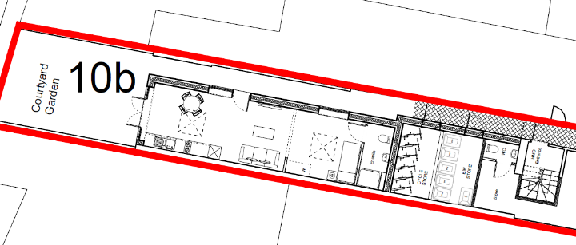

Bin storage should comply with Manual for Streets and British Standard 5906: 2005 for Waste Management in Buildings and should be located no further than 15m from the access point of the site to avoid the stationing of service vehicles on the carriageway for excessive periods. Plans illustrate bin storage adjacent to the cycle store. Details of how the refuse will be presented for collection has been provided but confirmation should be sought from the Councils refuse team to agree arrangements are acceptable.

Given the sites location a CMS will be required to ensure there is no disruption or impact on the highway and to pedestrians.

Please ask the applicant to provide revised plans for cycle storage provision.

N. Hussain
Transport Development Control Advisor

