Planning Officer: Marcelina Rejwerska
Planning Application Ref: PL/24/1054
Application Type: Full planning permission
Address: 11 NEWCASTLE ROAD, READING, RG2 7TN
Proposal: Change of use from a dwelling (class c3) to 7 person house in multiple occupation (sui generis) and associated works

19th September 2024
This proposal consists of the conversion of the existing single dwelling house to create a 7 bedroom HMO. This application seeks to incorporate previously approved application 240693 for a 2-storey rear extension.
The site is located in Zone 2, Primary Core Area, of the Revised Parking Standards and Design SPD. This zone directly surrounds the Central Core Area and extends to walking distances of 2 kilometres from the centre of Reading. Typically this zone is well served by public transport, with buses continuing either into or out of the Central Core Area via this zone.

In accordance with the adopted Parking Standards and Design SPD, the development would be required to provide a parking provision of 0.25 parking spaces per bedroom. This equates to a total of 2 car parking spaces for the development. The property is served via an existing access directly from Newcastle Rd. 2 parking spaces are to be created by removing existing metal gates, removal of boundary wall and landscaping to create a wider vehicular access. However, there is a telegraph pole on the property boundary with No 13 which has not been illustrated on plans and a utility cover in the footway. The extended access must have a minimum distance of 1m from the telegraph pole. Revised plans illustrating the width of the extended vehicle access in relation to the location of the telegraph pole and utility cover are required. A license will be required to undertake all works on the public highway, this includes the widening of an existing dropped kerb and reinforcing (if required) of the footway, this would be for Highways to determine. Should the telegraph pole require relocating then the cost would be fully met by the applicant.

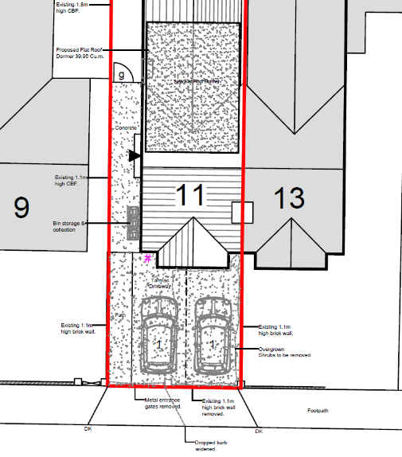
Secure and covered cycle storage has been illustrated at the rear of the site, utilising Sheffield type stands. Storage will be accessed via the side of the property. Proposed provision is in excess of the standards and is deemed acceptable.

Bin storage has been illustrated located at the side of the property, however this location would obstruct access to the rear garden area and cycle storage area. A storage area in the rear garden located at the rear of the site and brought to the front of the property to allow for kerb side collection would be appropriate but the location must not block access to parking spaces.

Please ask the applicant to submit revised plans illustrating parking layout, bin location and telegraph pole.

N. Hussain
Transport Development Control Advisor

