Listed Building Consent: Design + Access Statement
Cemetery Arch, Reading Cemetery, London Road, Reading, RG1 3AQ
OVERVIEW
This application seeks to gain listed building consent for alterations comprising solely of the reinstatement of the original window opening and the addition of an original specification 6 over 6 window on the rear elevation of the South Lodge of the Grade II Listed Bath stone Cemetery Arch building built in the 1840s.
Reading Borough Council as Planning Authority have previously granted Listed Building Consent for alterations comprising of internal reconfiguration, redecoration and recommissioning works (Application No: 231435).
A Heritage statement has also been submitted alongside the application to ensure that the works to the South Lodge of the building correctly consider the Grade II listed status of this historic and locally important Arch building and surroundings.

2.JAHA.Details of Proposed Internal external alterations.
Current condition of eastern elevation of ground floor of South Lodge
Between 1912 and 1932 (Evidenced by OS maps from those dates), an extension was constructed at the corner of the east and south elevations of the south lodge. It was large and rectangular in shape and ran in an east-west direction and was likely constructed as extra living accommodation for the Cemetery Superintendent and family. By 1967 the extension had been removed leaving the rear elevation of the Arch’s South Lodge in the condition shown in the photograph below.
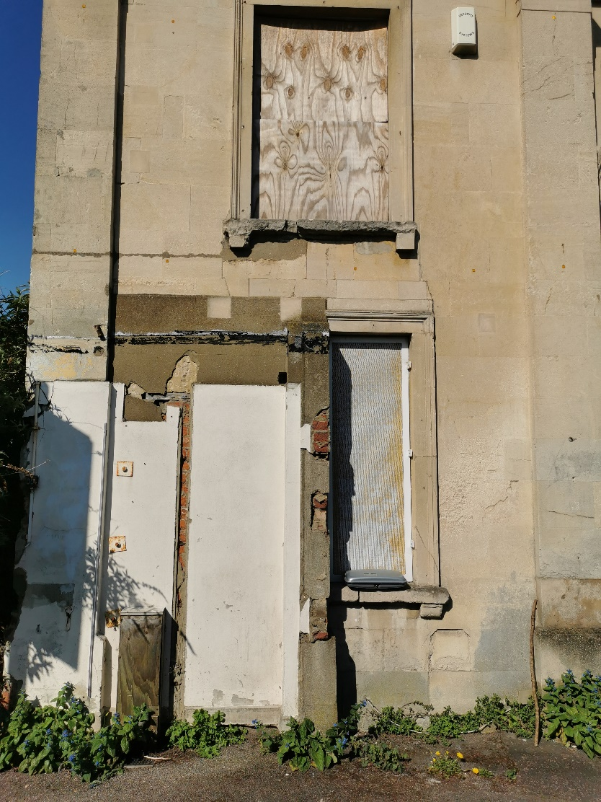
The damage to the original fabric of the Arch revealed by the extension’s removal consists of:
- a doorway cut into the wall through the ashlar and into the existing ground floor window opening,
- a timber lintel inserted above the door
- a wall nib built to serve as the door jamb on the right-hand side through the window opening, all rendered with a cementitious mortar
- windowsill is broke, window head curtailed.
- drainage pipes coming through the wall.

Proposal
The proposal is for the reinstatement of the original window opening and the addition of the original specification window, specifically:
- the removal of all evidence of previous doorway
- the reinstatement of the ashlar.
- The reinstatement of the 6 over 6 sash window to exactly match the existing windows of the Arch. The window will be doubled glazed.
The graphic below shows how the reinstatement of the window will enable the Arch to regain its original symmetry and also to be returned to how it would have looked in the 1840s when it was built. The new window will be built to the specification of the original ones that would have been installed in the Arch and to match the replacement ones that are currently fitted to the building. All seven of the current windows are doubled glazed and the new 6 over 6 unit will also be double glazed.
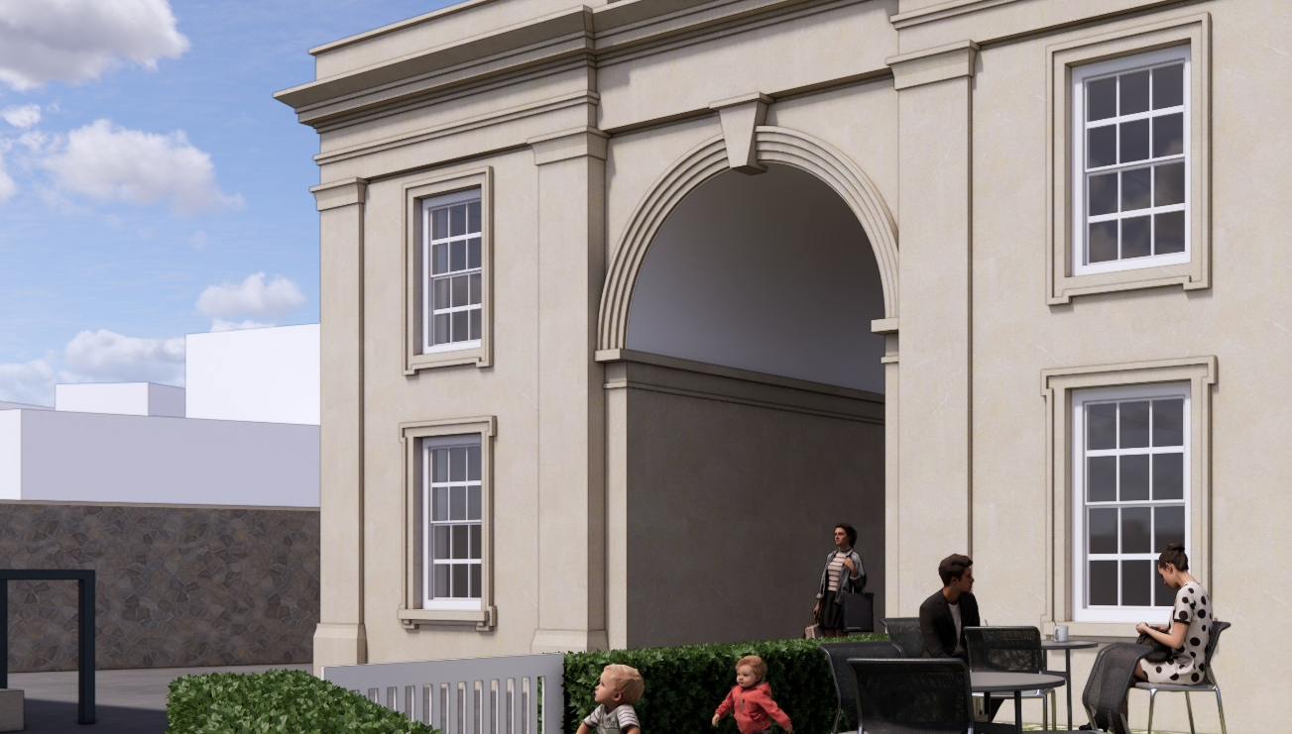

HERITAGE STATEMENT
Reading Borough Council Granted Listed Building Consent to Junction Arch Heritage and Arts CIC for application 231435 on the 8th of January 2024.
The works proposed in this application for Listed Building Consent will be complementary to and concurrent with those taking place in 231435.
Please refer to the Heritage Statement (HS) submitted with application 231435. Please see below for the Impact Statement for the new proposed external works

IMPACT STATEMENT
The proposed external works:
- the reinstatement of the original window opening on the rear elevation of the South Lodge.
- The reinstatement of a double glazed 6 over 6 sash window of the original specification.
With reference to ‘table 2’ on P32 of the HS, as the result of the above works will constitute a ‘comprehensive improvement to the asset through restoration or enhancement’, the Impact Magnitude of the above works is assessed to be ‘Substantial Beneficial’.

