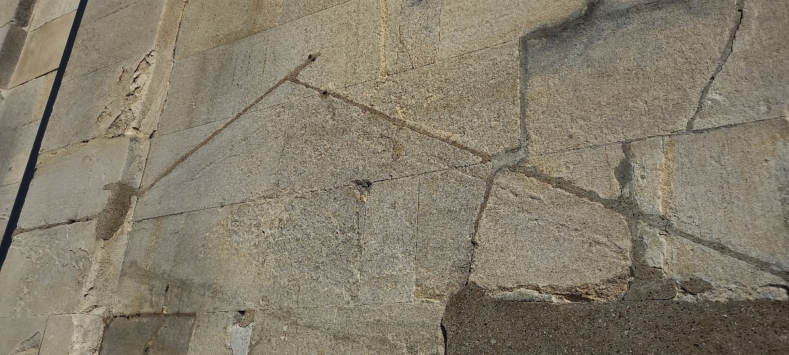
Plate 31: evidence of side extension (B3)
Flashing grove cut in across the ashlar and repointed with cementitious mortar visible cracks , some of which have been repointed with very grey cementitious mortar

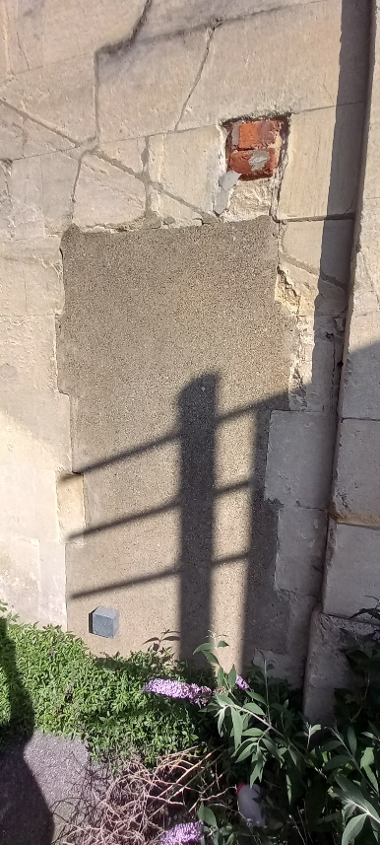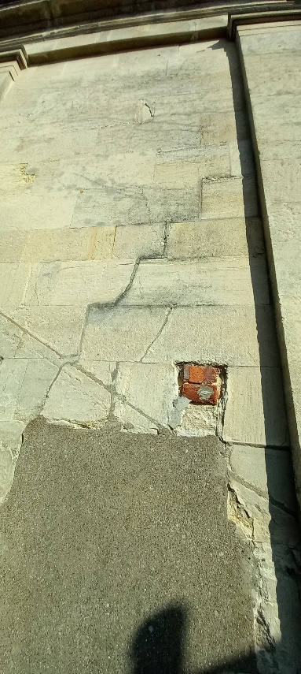
Plate 32: Door way bricked up and rendered Plate 33: Extent of crack above doorway
Extension doorway now bricked up and rendered with cementitious mortar also there is several cracks emanating from the doorway one roughly follows the jointing in a stepped pattern where as others travel diagonally across stones looking as if there is no active lintol.

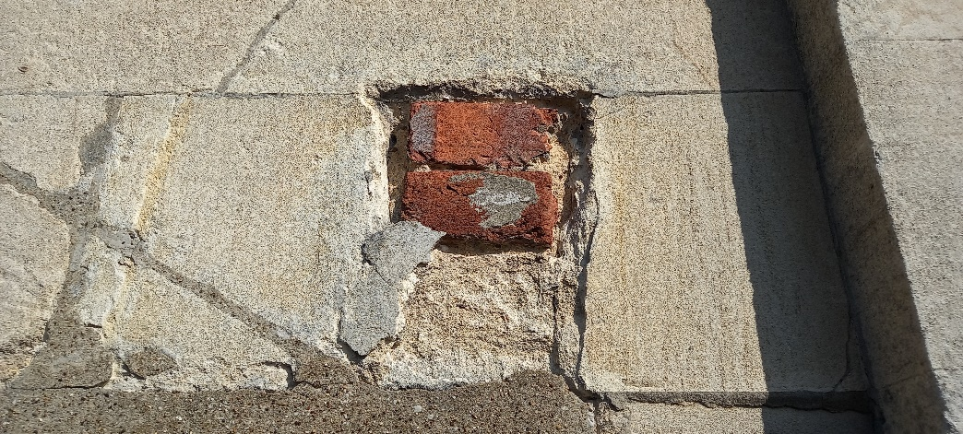

Plate34: Bricks inserted into holes
Round this extension there is three number holes that have been filled with bricks, some look as if they have been rendered over, the render having since fallen away

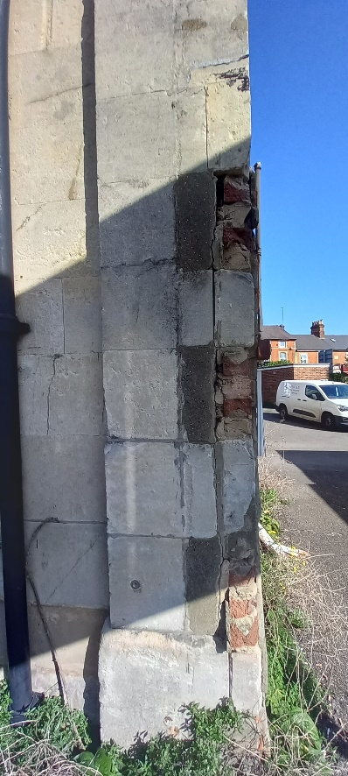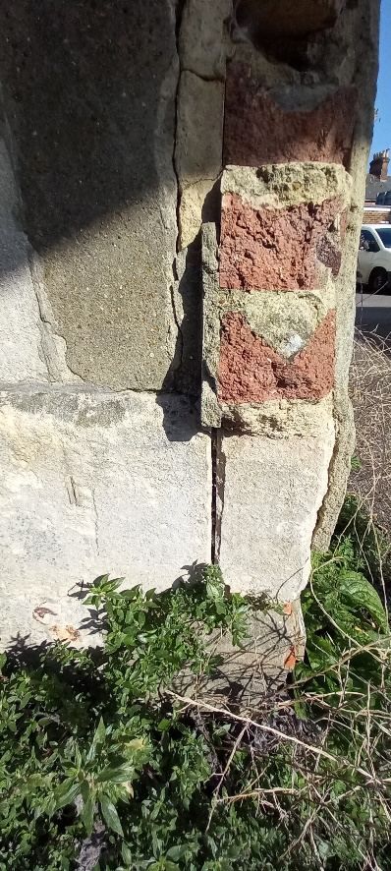
Plate : 35 Remains of corner extension (B4)
The remains of a corner extension is in evidence, on the Wokingham Road elevation where brickwork was bonded into the corner of the building, but larger stones have been removed that broke bond with the stones above this has weekend the corner and the ashlar from the rear elevation and this elevation have drifted apart, the larger returns removed have been rendered up (see rear elevation)

REAR ELEVATION (C)

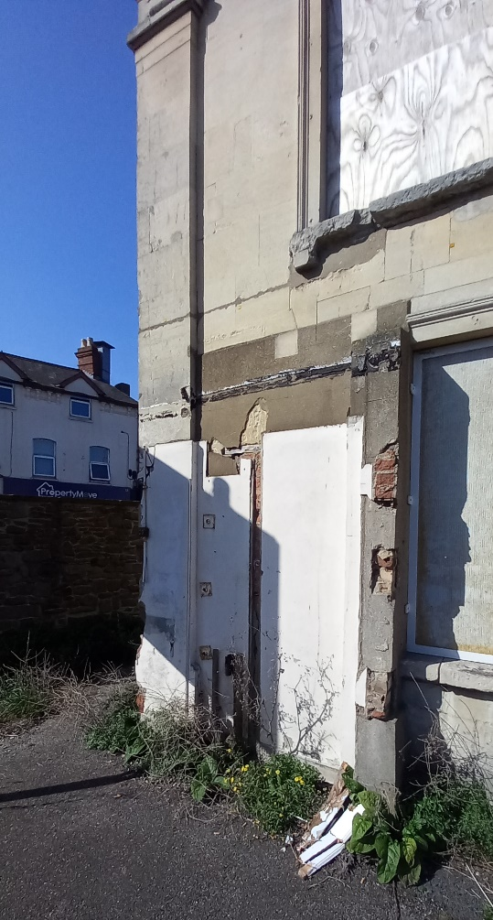
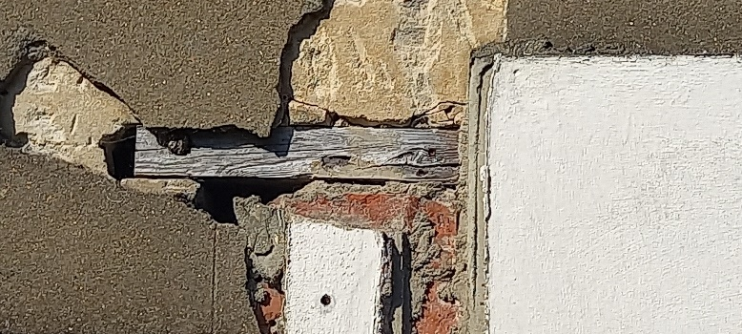
Plate37: Remains of corner extension
Render fallen away to reveal the remains of another door way

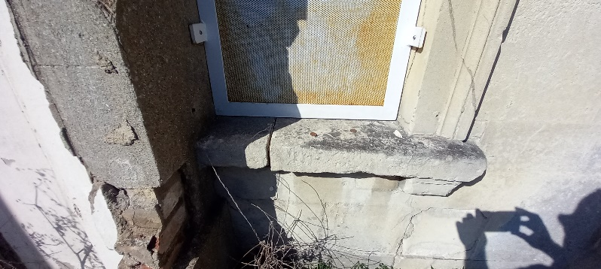
Plate 38: Original left hand window opening reduced (C2)

Plate 36: Remains of corner extension (C1 )
The remains of a corner extension obvious on the left hand side of the rear elevation, there has been a door way cut into the wall through the ashlar and into the existing ground floor window opening, a timber lintol has been inserted , a wall nib has been built to serve as the door jamb on the right hand side through the window opening, this has al been rendered with a cementitious mortar, the window cill is also broken, whether the rest of the window dressings are still there can’t be ascertained, but the head has been curtailed, there are drainage pipes coming through the wall along with evidence of wall plates tying walling back to frame

Information for listed building consent
When the two extensions were added further doorways were cut into the building, the proposal is to rebuild the corner, by carefully cutting out the quoins that have been cut through on at a time and are no longer tying the corner together as they are no longer bonded, each one being replaced would be cut out carefully one at a time and the ne stone bedded back in place tying back to the internal skin, once this section is completed the old doorway will be cut out one at a time removing the blocks or brickwork, this will then be rebuilt using bath stone ashlar to match existing bedding joints, again will be tied back to the interior skin if stable enough.

Internal plaster that is now on the external face will be carefully removed to allow inspection before any further work is carried out, the door to the rear will be carefully be removed on the right hand side enough to allow for the cill to the window to be replaced , acro supports will be used to support the ashlar above the window allowing for the head to be cut out, the left hand jamb can then be reinstated and the head can then be replaced.
The rest of the doorway can then be removed and rebuild using bath stone ashlar to match existing, all tied back to the internal skin, all restraints, brackets screws and pins will be made of stainless steel , all mortar would be hot lime aged “fine stuff” again to match the stone, localised repairs a mixture of render repairs and piecing’s dependant on size, all render repairs using a hot lime mix

