27/09/24
Planning Application Ref: PL/24/1035
Officer: Anthony Scholes
Application Type: Full planning permission
Address: 292 HENLEY ROAD, RG4 6LS
Proposal: New 4 bedroom residential dwelling on the land to the Rear of 292 Henley Rd, RG4 6LS.

Previous application for this site - 190592

The site is located within Zone 3, Secondary Core Area, of the Council’s adopted Parking Standards and Design SPD. Typically these areas are within 400m of a Reading Buses high frequency ‘Premier Route’, which provides high quality bus routes to and from Reading town centre and other local centre facilities.

The site was previously the rear garden for the property 292 on Henley Road. This proposal consists of the proposed erection of 1 x 4 bedroom dwelling on rear garden land belonging to No292 Henley Road. The property will front Maytree.

In accordance with the adopted Parking Standards and Design SPD, the development would be required to provide a parking provision of 2 parking spaces. Submitted proposed floor plan PL-01 (08/08/24) illustrates a garage; whilst the dimensions do not conform to the Councils current Parking Standards, where it is recommended that the internal dimensions of a single garage are 7m long x 3m wide, plans also illustrate 2 parking spaces provided on the frontage of the site; therefore the reduced size of the garage can be accepted in this instance.
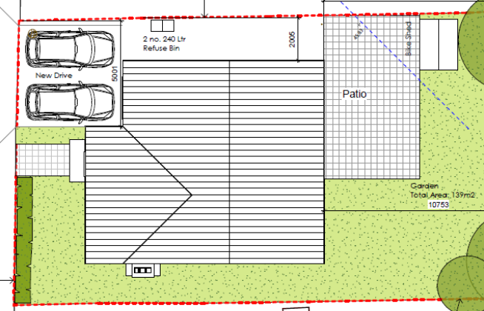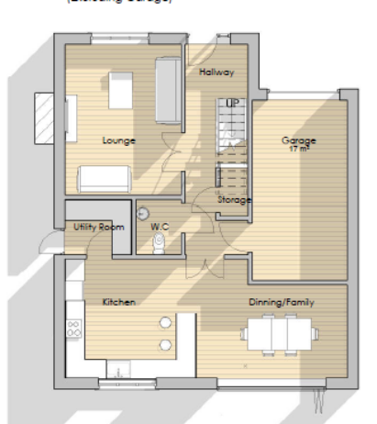

Looking at the location plan/red line plan and comparing it with Highway adoption only half the width of the grass verge is within the Highway adoption, the other is private/third party land and therefore confirmation is required that the applicant is the landowner all the way up to the Highway Boundary.

The dimensions of the road have been checked and while it is narrow it is an appropriate size for a closed access situation. A new dropped vehicle crossing is proposed from Maytree Walk which is deemed acceptable. A license will be required from the Councils Highway Department to undertake all works on the public highway

The Council’s Local Transport Plan 3 Strategy 2011 – 2026 includes policies for investing in new infrastructure to improve connections throughout and beyond Reading which include a network of publicly available Electric Vehicle (EV) charging points to encourage and enable low carbon or low energy travel choices for private and public transport. The Councils Local Plan was adopted in November 2019 and this includes a requirement at Policy TR5 for each new house to be provided with an electric charging point his will need to be illustrated on plans but can be dealt with by way of condition.

Cycle parking is provided in the rear garden area within a bike shed. This is deemed acceptable for a development of this nature.

Bin storage should not be located further than 15m from the access point of the site to avoid the stationing of service vehicles on the carriageway for excessive periods and should comply with Manual for Streets and British Standard 5906: 2005 for Waste Management in Buildings to avoid the stationing of service vehicles on the carriageway for excessive periods. Bin storage has been illustrated on plans and it is assumed that refuse bins will be collected kerb side as is the case for other dwellings on the road.

A CMS would be required for this development if the application was approved.

In principle there are no Transport objections for this application, given the proposal is only for one dwelling proposed trips generated would be low in the peak periods, however confirmation is required with regards to the ownership of the land between the highway boundary and the proposed development. Please ask the applicant to clarify.

N. Hussain
Transport Development Control Advisor

