
Supporting Planning Statement for 549, Oxford Road, Reading, RG30 1HJ

The previous use of the premises was as a class E Shop Magazine Mania. The Applicant wants to use as a takeaway hot food use ap permission is required.

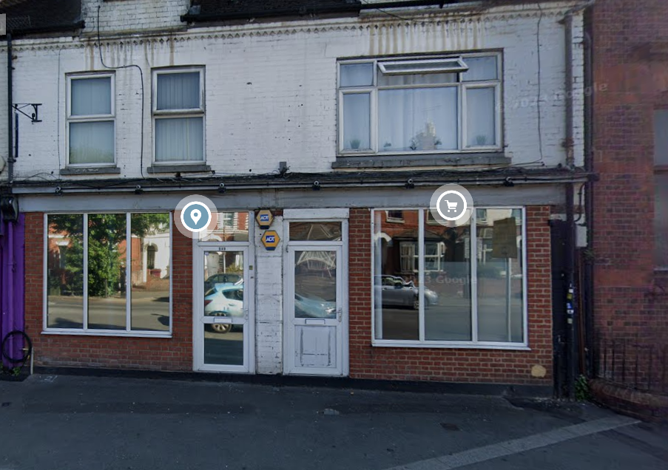

The cooking apparatus used would be an air fryer and small fryer for chips with recirculating hood, Neither of which would require external ducting.

The business would serve the daytime trade only.

