Doc Name: Works on TPO Trees at 23 Kentwood Close

Planning Application for Tree work on TPO Trees.

Applicant:

Location Plan

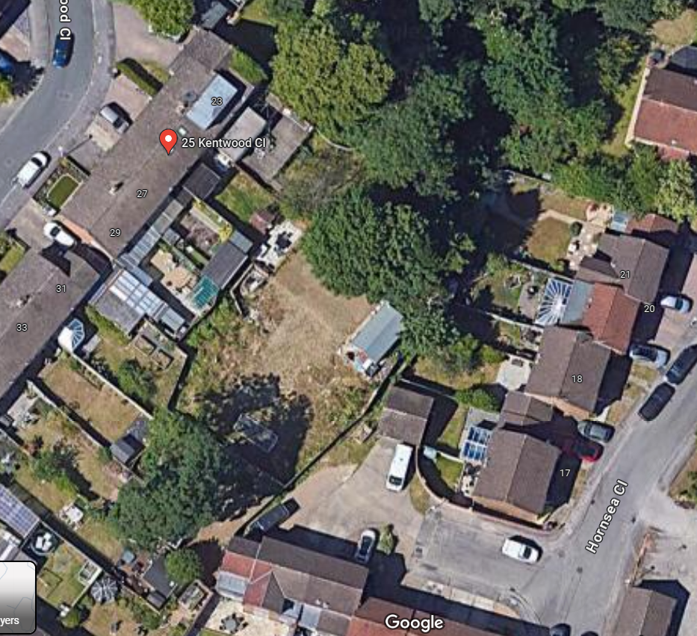
23 Kentwood Close

The trees are within the boundary of 23 Kentwood Close.
Will access the back garden of 25 Kentwood Close with permission, to remove the trimmings into the tree cutting removal lorry.
Lorry to exit via Hornsea Close.
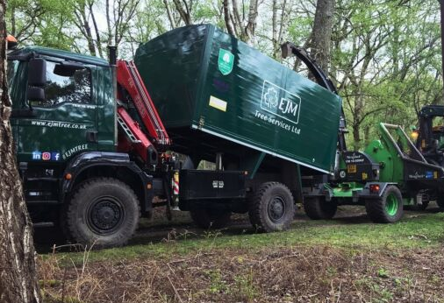
Tree cutting removal lorry

Site Plan
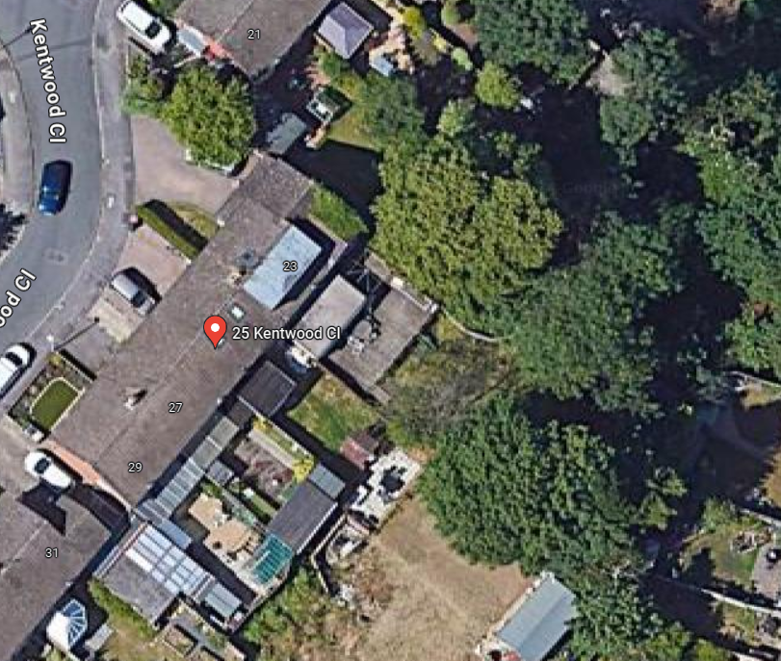
T6

T4

T5 T2
T3

G1

Item No

Item No | Item | Work Description
G1 | Silver Birch and Maple in the corner – both tree are dead | Fell to near ground level as possibly by carefully dismantling, stack wood at base of tree in manageable sections.  Remove all brushwood leaving site clean and tidy.
T2 | Fastigate Oak | Fell to near ground level as possibly by carefully dismantling, stack wood at base of tree in manageable sections.  Remove all brushwood leaving site clean and tidy.  Arborist proposed to re plant somewhere within the garden with either:  - Paper Birch  - Crab Apple  - Paper Bark Maple.
T3 | Maple | Remove major deadwood throughout whole crown area (Deadwood >25mm in diameter)
T4 | Conifer | Reduce the height of tree by up to 4-5 metres and trim garden side, creating flat top and side
T5 | Norway Maple- snapped dominant stem. | Remove the broken half of the stem fallen on neighbour’s garden (#25 Kentwood Close)  Due to half of dominant stem snapping out, it has left the remaining section of that stem unsafe. Unfortunately, once that stem has been removed it will leave the tree unbalanced and unstable. Also, it will have a large wound close to the main fork which could cause future rot issues.  Fell to near ground level as possibly by carefully dismantling, stack wood at base of tree in manageable sections.  Remove all brushwood leaving site clean and tidy.  Arborist proposed to re plant somewhere within the garden with either:  - Paper Birch  - Crab Apple  - Paper Bark Maple.
T6 | Cherry- Dead. | Remove dead tree entirely

TREE PRESERVATION ORDER DIRECTORY
LOCATION | ORDER No | TYPE | SITE SPECIFIC
KENTWOOD CLOSE | 6/20 | (T1)(W1) | 21 & 23 and Land between Kentwood Close, Hornsea Close & Wealden Way

Appointed Tree Surgeon:

EJM Tree Services
Contact Person: Stuart Mitchell (Director)
Tel: 01635 524217
Email: info@ejmtree.co.uk
Location: Newbury, Berkshire
Website: Home - EJM Tree Services
Members of the Arboricultural Association (AA)

Photographs:

Damaged tree T5: 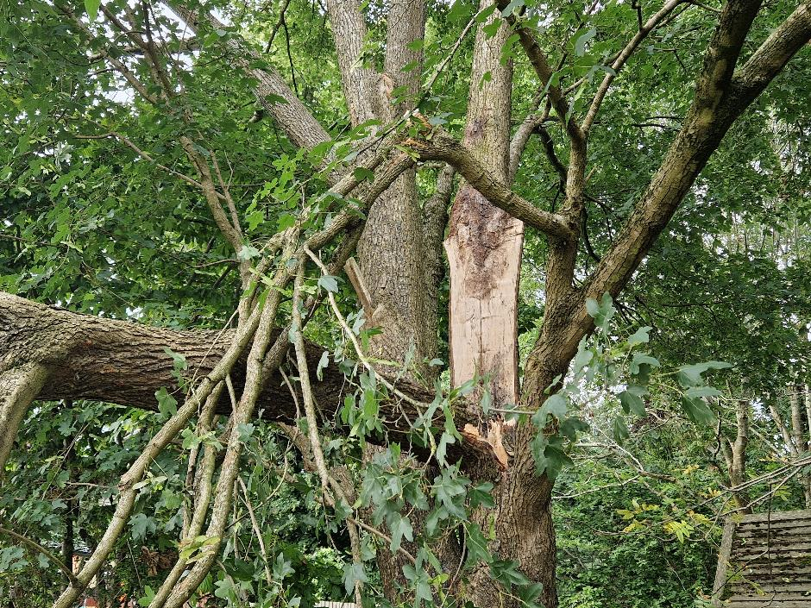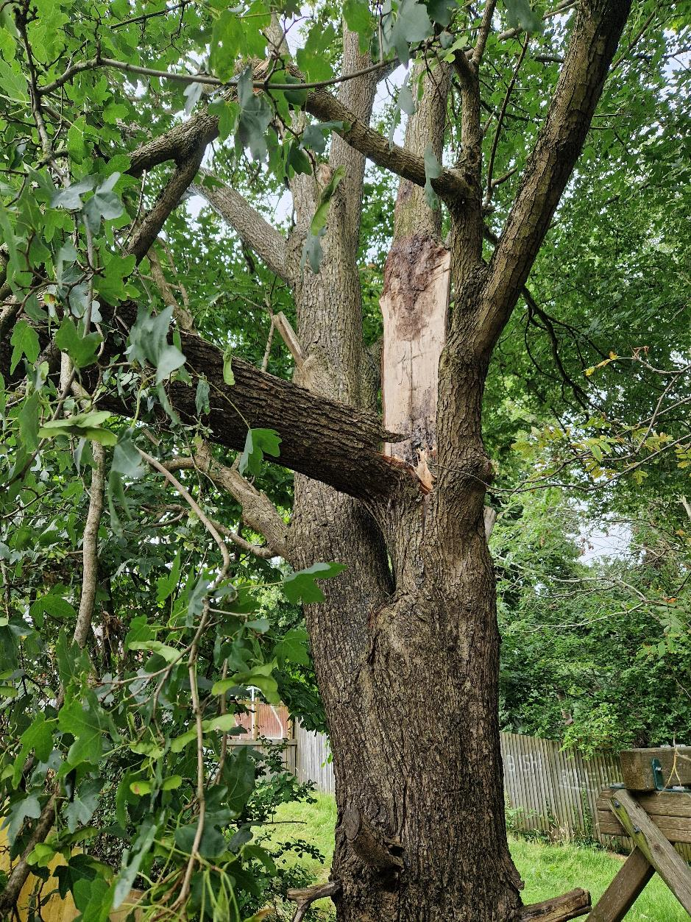

Tree branch fell into the back garden of 25 Kentwood Close

