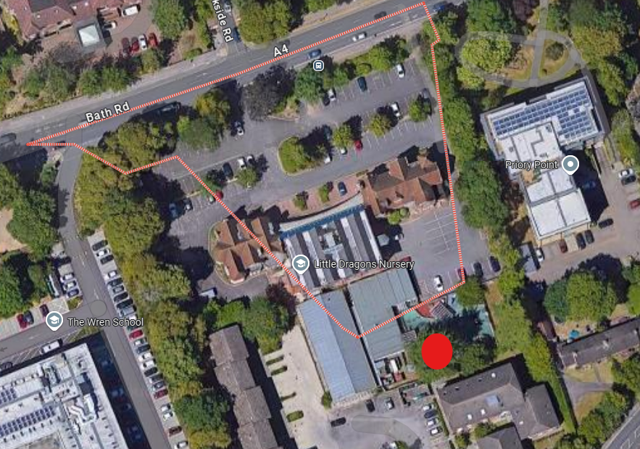
Site address – 57-59 bath road, reading, RG30 2BA
Red Circle outlines the tree that requires works.

Cedar to crown lift to 6m to gain clearance to the playground and play equipment.
Also, thin canopy by 10 percent removing secondary internal branches only and deadwood.
Reason for works is due to pest management over nursery play area and to reduce the likelihood of branch failure.

