Planning Application Ref: PL/24/0846
Officer: Matthew Burns
Application Type: Full planning permission
Address: Napier Court Napier Road Reading
Proposal: Demolition of existing buildings and erection of new buildings of 11 and 12 storeys, with amenity space at roof level (part indoor and set back), to provide 576 build to rent residential dwellings (Class C3) with residential amenity space, parking, landscaping and associated engineering works

The proposed development consists of the demolition of the existing buildings and the erection of new buildings providing 576 residential units consisting of:

- 56 x 3B5P apartments / (10% of total)
- 309 x 2B4P apartments / (53% of total)
- 211 x 1B2P apartments / (37% of total)

The site is located just outside the Reading Town Centre and is close to Caversham Centre. It falls within the Zone 2, the primary core. This zone directly surrounds the Central Core and extends to walking distances of 2 kilometres from the centre of Reading. This zone is well served by public transport, with buses continuing either into or out of the Central Core Area via this zone and other local centre facilities.

Given the size and nature of the application a Transport Assessment has been submitted to accompany the application and I comment on this as follows:

Access:
The development is providing a 6m depth to the frontage of to facilitate footway and cycle way improvements along with safeguarding land for any future bus provision at a later date, the area being initially landscaped. The footway cycle way will be a positive improvement to the existing cycle network.

The proposed footway/cycleway however does not align with the existing routes at either end of the development and as such requires revisions at the eastern and western access points to facilitate better crossing points details of which are included below under pedestrian crossing.

Further details are also required with regards to gradient levels across the 6m depth to ensure suitable footway, cycle way and bus lane provision can be provided whilst retaining access to the proposed development given that there are exiting level variations across the site frontage. This should be provided by way of a series of cross sections along the site frontage. One particular area of concern is at the western end of the site and the relationship with the trees that are to be retained.

The Design and Access and Transport Assessment state that vehicles would access the site via the eastern access point, travel through the site in a one-way arrangement and egress at the western junction, adjacent to the Thames Quarter development. A raised table is proposed to control speeds to the west of the site, this is deemed acceptable.

In principle the overall vehicle access arrangement is acceptable subject to information being provided on the access barriers that provide access and egress to the site to include details of how the barriers will be operated and to ensure there is sufficient space that allows for appropriate access and egress. The Transport Assessment document also shows a panel van entering the site on the western side of the site, however the insert drawing implies that vehicles will travel east bound along the rear access road, given a one-way system is being proposed how will vehicles be able to travel in this direction? Clarification is required as narratives are contradicting plans.

Pedestrian facilities:
The applicant must revise the pedestrian crossing at the eastern access to ensure that this is safe on initial implementation, i.e. ensure that the footpath aligns with the existing footpath to the east. (Please extract of western side below).

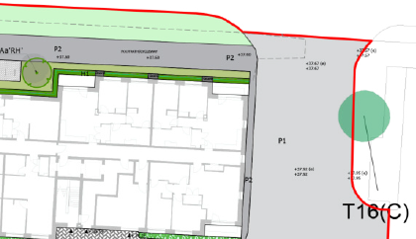

As can be seen from the attached the footway to the eastern side of the access runs along the kerb edge whilst the proposed footway / cycleway is set back. One option could be to provide the footway / cycleway as illustrated but it is taper towards to the existing facility closer to the access. Should an MRT/BRT route come forward in the future the footway/cycleway could be revised at that point.

It should also be noted the crossing point on the western side of the site also does not align with the dropped kerb within the adopted Highway and therefore the proposed crossing points need to be realigned so that they tie into the Public Highway, unless the applicant comes to an agreement with Thames Quarter to provide dropped kerbs on private land.

Gradients should also be illustrated on a plan for the length of the proposed footway / cycleway to ensure that the proposal would comply with the required national standards.

The development also includes the provision of a zebra crossing on Napier Road to provide access to Kings Meadow, an extract from the submitted Framework Travel Plan below illustrates the location of the proposed pedestrian crossing. This can be found below.

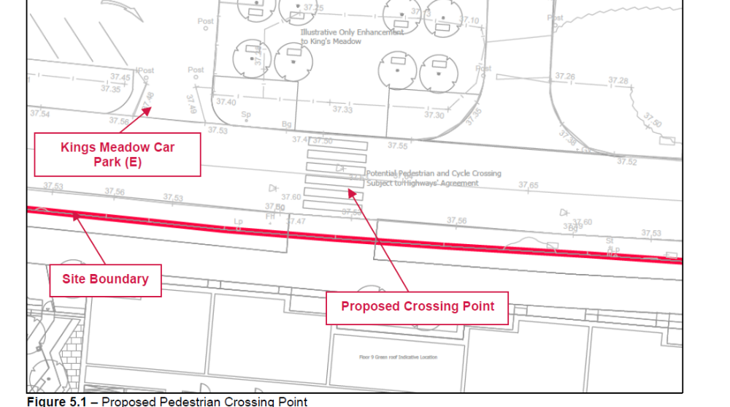

In principle this is acceptable, however a full detailed design of the proposed crossing facility is required so that it can be assessed as part of this application and can be secured via a S106 agreement. Also plans should show how the park area will be accessed as this may require consultation with the Councils Park and Recreation team.

Vehicle and Cycle Parking
In accordance with the Councils current Parking Standards and Design SPD the following provision would be required:

Type of Unit | Vehicle Provision as per Design SPD | Cycle Provision as per Design SPD
1 Bedroom Unit (211) | 1 space | 0.5
2 Bedroom Units (309) | 1 space | 0.5
3 Bedroom Units (56) | 1.5 | 1
Visitor Parking | 1 space per 10 dwellings

The development proposes 39 vehicle parking spaces, which includes 3 disabled parking bays, 6 motor bike spaces and internal storage for a total of 289 cycles and 20 external cycles spaces for visitors. It is clear that the proposed vehicle parking is well below the Councils current required standards however at the pre application stage it was confirmed that a lower provision could be considered if supporting information was provided and there was no detriment to Highway Safety. The applicant has submitted a Transport statement justifying the lower provision. Given the sites is in a highly sustainable location and the extensive parking restrictions in place on Napier Rd in the form of double yellow lines preventing unauthorised on street parking the proposed lower provision can be accepted on this instance.

The Councils residential parking permit scheme operates in the surrounding roads. Under the Borough’s current parking standards, this proposal would generate additional pressure for parking in the area: therefore, if this application is approved there should be an assumption that any future occupants of the proposed residential units will not be issued with resident or visitor parking permits which will covered by condition and an informative applied. This will ensure that the development does not harm the existing amenities of the neighbouring residential properties by adding to the already high level of on street car parking in the area.

The Council’s Local Transport Plan 3 Strategy 2011 – 2026 includes policies for investing in new infrastructure to improve connections throughout and beyond Reading which include a network of publicly available Electric Vehicle (EV) charging points to encourage and enable low carbon or low energy travel choices for private and public transport. The Councils Local Plan was adopted in November 2019 and this includes a requirement at Policy TR5 that communal car parks for residential and non-residential developments10% of spaces should be provided with an active charging point. EV charging points are being provide in excess of the required 10% and is therefore deemed acceptable.

With regards to the provision of cycle storage, in line with the Current standards the 1- and 2-bedroom units would require 260 storage spaces and the 3 bedroom units would require 56. Total provision required across the development would be 316 therefore the proposed provision of 289 falls well below current standards. Given that there is very limited on site vehicle parking and to provide sustainable and alternative methods of transport, the required number of storage spaces should be provided. The provision of visitor cycle stands is acceptable but is not part of our required standards and has therefore not been included in our assessment.

The applicant has undertaken an assessment of travel to work data which does indicate a low number of residents in the local area that travel to work via cycle. However, this does not automatically imply that residents do not own a bicycle. This assessment therefore cannot be accepted.

It is further added that the cycle provision would be reviewed through the travel plan however the travel plan for residential would be limited in relation to its assessment length and irrespective of that the site has no spare capacity to provide additional cycle parking should this be required.

The application should therefore increase the provision of cycle parking to meet the Councils required standards.

Applicant has stated that a 2-tier racking system is to be used to provide internal storage for the units. Confirmation/copy of the elevation plan for floor height is required to ensure there is sufficient clearance. Given the number of cycles spaces required dedicated cycle parking drawings will be required to ensure that the required spacing etc can be provided.

Trip Generation
The applicant has undertaken a trip rate analysis, however given the limited number of car parking spaces proposed it is likely that the development would generate similar and even less vehicle movements that the existing use. This therefore has a beneficial effect on the wider network.

Servicing Arrangements
Servicing arrangements have been provided and illustrated on plans and would take place along the internal access road. On-site management team will coordinate waste collection and site would be responsible for moving the bins to the collection point on collection day. This is deemed acceptable, however the Councils waste team should be contacted to ensure the correct types and capacity of bins are provided.

A Demolition and Construction management statement will be required for this site.

Given the above the Highway Authority would object on the following grounds.

The proposed development does not comply with the Local Planning Authority’s standards in respect of pedestrian/cycle provision at the vehicle access points and fails to demonstrate that the facility would meet the required standards in respect of gradients and, as a result, is in conflict with Reading Borough Local Plan Policies TR3, TR4 and TR5.

The proposal fails to demonstrate that the future bus provision within the land set aside by the development could be adequately provided and, as a result, is in conflict with Reading Borough Local Plan Policy TR2.

The proposed development does not comply with the Local Planning Authority's standards in respect of secure cycle storage provision. This is in direct conflict with Reading Borough Local Plan Policy TR5.

N. Hussain
Transport Development Control Advisor

