DELEGATED APPLICATION REPORT
Ward: Redlands
App Ref: PL/24/0405 Householder planning permission
Address: 19 Donnington Road, Reading,RG1 5NE
Proposal: Single storey rear extension replacing existing conservatory, loft conversion into habitable accommodation including rear dormer and 2 roof lights to front elevation.
Applicant: Ms Polly Graham
Received date: 28-03-2024
Target Decision date: 30-05-2024
Case Officer: Chukwudi Onwudinanti

- SITE DESCRIPTION
The proposed site is a mid-terrace two storey dwelling on the eastern side of Donnington Road. The road is characterised by long terrace dwellings on both sides of the road. Donnington Road intersects with London Road to the North and Erleigh Road to the south. It is predominantly residential.

The site is in Article 4 Area that restricts conversion from C3 to C4 Small HMOs.

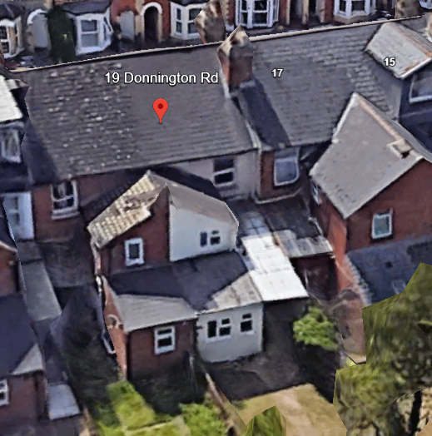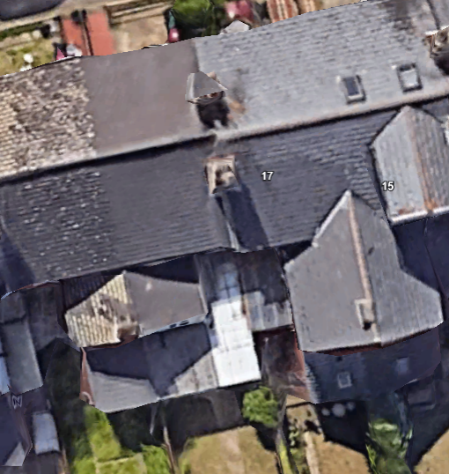

- PROPOSAL AND SUPPORTING INFORMATION
The application proposes a single storey rear extension replacing existing conservatory, measuring approximately 4.3m deep and 2.8m high, a loft conversion into habitable accommodation including rear dormer and 2 roof lights to front elevation.

Plans considered dated 12/03/2024 and received 2 April 2024.
Drawing No: 154-24-01 – Location Plan
Drawing No: 154-24-02 – Site Plan
Drawing No: 154-24-03 – Existing Plans and Elevations
Drawing No: 154-24-04 – Proposed Plans and Elevations

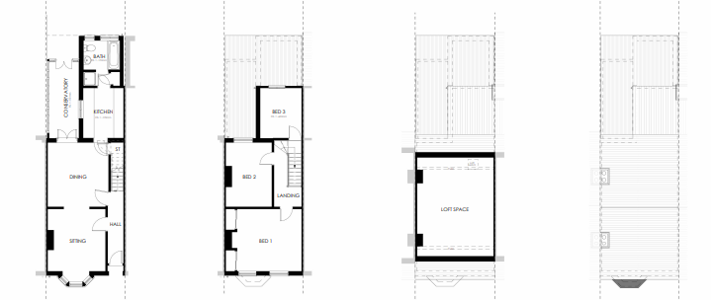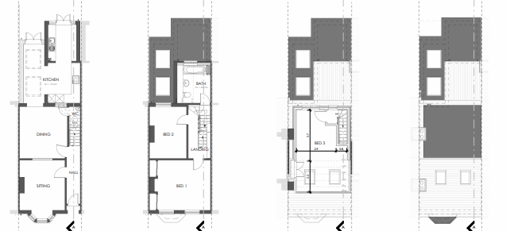
Existing Plans Proposed Plans

- RELEVANT PLANNING HISTORY
None

- CONSULTATIONS

The following addresses were consulted by letter:

- 14, Blenheim Road, Reading, Berkshire, RG1 5NQ
- 21, Donnington Road, Reading, RG1 5NE
- Flat 1, 17, Donnington Road, Reading, RG1 5NE
- Flat 2, 17, Donnington Road, Reading, RG1 5NE

No letters of representation have been received.

Equality Act 2010:
In determining this application, the Council is required to have regard to its obligations under the Equality Act 2010. However, there is no indication or evidence (including from consultation on the application) that the protected groups identified by the Act have or will have different needs, experiences, issues and priorities in relation to this particular planning application. Therefore, in terms of the key equalities protected characteristics it is considered there would be no significant adverse impacts as a result of the development.

- LEGAL AND PLANNING POLICY CONTEXT
Section 38(6) of the Planning and Compulsory Purchase Act 2004 requires that proposals be determined in accordance with the development plan unless material considerations indicate otherwise. Material considerations include relevant policies in the National Planning Policy framework (NPPF) - among them the 'presumption in favour of sustainable development'. The following local and national planning policy and guidance is relevant to this application:

National Policy
National Planning Policy Framework
National Planning Practice Guidance

Reading Borough Local Plan (2019)
CC7 (Design and the Public Realm)
CC8 (Safeguarding Amenity)
H9 (House Extensions and Ancillary Accommodation)
H10 (Private and Communal Outdoor Spaces)
SPD
Design Guide to House Extensions SPD (2021)

- APPRAISAL

Character and Appearance

Policy H9 states that an extension to a house will be acceptable where it respects the character of the house in terms of scale, location, materials, and design and respects the character and pattern of neighbouring properties and the street as a whole in terms of scale, location, materials and design, and any important existing building line. Policy CC7 also sets out relevant considerations for design.

The extensions proposed are to the ground floor, and to create a loft room. The overall footprint of the dwelling is not increased as the extension sits on the same footprint. The changes to the roof form to the rear does not alter to any significant degree, the character and shape of the existing dwelling. There are other examples of rear flat roof dormers within the area and it is a material consideration that this would likely have been possible under Permitted Development Rights.

The materials to be used would be a combination of matching materials and new materials but this is also not considered to be an unacceptable alteration to the original dwelling, as the dwellings on the street are of mixed external finishes and the changes are confined to the rear of the property, apart from the rooflight proposed for the front roof slope.

In general terms, it is considered that the scale of the extensions proposed is not disproportionate to the scale of the original dwelling and the resultant size would not be out of keeping with the general size of the existing dwelling and other dwellings on the street.

Residential Amenity

Policy H9 states that an extension will be acceptable where it does not result in an overbearing impact on neighbours. Policy H10 seeks to ensure that the amenity of gardens and other outdoor areas are not compromised. Policy CC8 states an extension to a house will be acceptable where it will not cause a significant detrimental impact to the living environment of existing or new residential properties.

The depth of the rear extension is the same as the existing conservatory and there are no side windows proposed on this extension and the dormer proposed. The flat roof would be restrained in terms of potential use by conditions to ensure that it does not present any overlooking or privacy issues.

Therefore, it is not considered that the extensions proposed here would negatively impact on the amenity of the properties to both sides, in terms of overlooking, massing, as well as access to daylight and sunlight.

- CONCLUSION
The proposed development has been assessed as set out above and is considered to be acceptable on that basis, subject to the following conditions.

- RECOMMENDATION: Grant
Recommended Conditions:
Approved Plans
Time Limit Standards
Materials To Match Existing
No New Openings to the sides
Use of Flat Roof

