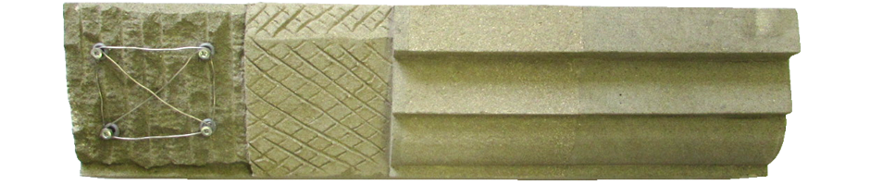
In-Situ Plastic Stone Repairs

- Access to the work area will be via ladder access onto the scaffold
- Surveyor to identify areas to be repaired.
- Site Manager to produce a repair schedule and record drawings of areas to be repaired.
- Using suitable lime and aggregate carry out sample mortar repairs to stone and brickwork for inspection and approval by Surveyor prior to carrying out main works.
- Isolate the defective areas using small cutters and hand tools and cut back to a minimum of 20mm to allow a suitable key for the new repair.
- De-dust and rinse with clean cold water.
- Saturate the cavity with clean cold water.
Using the approved mortar mix, Stone Premix, press in the repair material to a depth not exceeding 10mm in one visit. Allow repair to dry out and prior to repeating the process.
- Where repairs exceed 50mm in depth stainless steel or similar non-ferrous reinforcement to be introduced with a minimum of 20mm cover.
- Build up repair to achieve original line and profile and smooth off with a wood float, damp cloth or sponge.
- Protect the repair from direct sunlight to prevent rapid drying using Hessian or similar sheeting.

