Planning
Memo
To: Gary Miles, Planning
From: Andrei Nazare, Natural Environment Officer, Planning
Date: 3rd September 2024
Re: Consultation on an Application
Application No: PL/24/1025
Address: 99 Hartland Road
Proposal: Two storey side extension, single storey rear extension and renovation of existing dwelling to create an accessible house.
This site was subject to a similar planning application (ref. 230398) which was granted planning permission on 8/11/2023. Natural Environment comments provided during the application process confirmed the proposed development is agreeable in principle. However, comments were provided relating to the Tree Survey and Arboricultural Impact Assessment submitted with the application which required additional tree protection details – these were ultimately secured via condition.
With reference to the Tree Survey and Arboricultural Impact Assessment Ref. SL4864_770 dated 7/06/2023, the following are noted:
This is the same document submitted with the previous application. We acknowledge the survey date is 26/06/2023, less than 2 years ago, and is still relevant. However, the arboricultural impact assessment has not been amended to take into consideration the differences in proposed extensions – the two storey side extension is the main difference from the single storey side extension of the previous application.
In particular, the height of the proposed extension is now higher than the existing crown clearance height of the off-site T5 Ash tree (i.e. two storey side extension vs 4.5m crown clearance height). This probably creates the need for crown lifting or lateral reduction for the Ash tree as well as raises concerns with respect to future pressure to prune for clearance or to alleviate nuisance. Clarity should also be provided for the work specifications on G2: amount in metres must be stated for the necessary ‘face back’ and ‘crown lift’ works.
An amended AIA must be submitted prior to a decision to demonstrate the impact (or lack of) of development on existing trees (off-site T5 Ash tree in particular).
Our previous comments also remain relevant and I reiterate them below:
All the included plans are missing the red line site boundary. This should be included for clarity.
Are Google Street View Imagery still accurate? They show a hard standing drive up to the existing building. If this is the case, I wonder why is the Temporary Tree Protection fencing located in such a way as to cut across this drive? It appears to follow the extent of T5’s RPA, but why if the surfacing is hard standing?
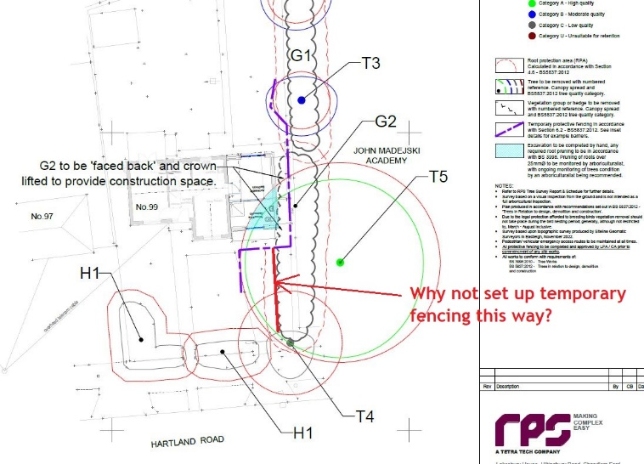

In conclusion, before we can provide final comments, we wait for an amended AIA document, as requested by the comments above.

