DELEGATED APPLICATION REPORT
Ward: Tilehurst
App Ref: PL/24/1030 Non-Material Amendment
Address: 94 HALLS ROAD, TILEHURST, READING, RG30 4PU
Proposal: Non-Material Amendment to application 231832 - Change of pebble dash render on the proposal and existing house to a smoother render system
Applicant: Mr and Mrs Stankard
Received date: 2024-08-09
Target Decision date: 2024-09-09
Case Officer: Huimin Chen

- PROPOSAL AND SUPPORTING DOCUMENT
Previously Approved Elevations:
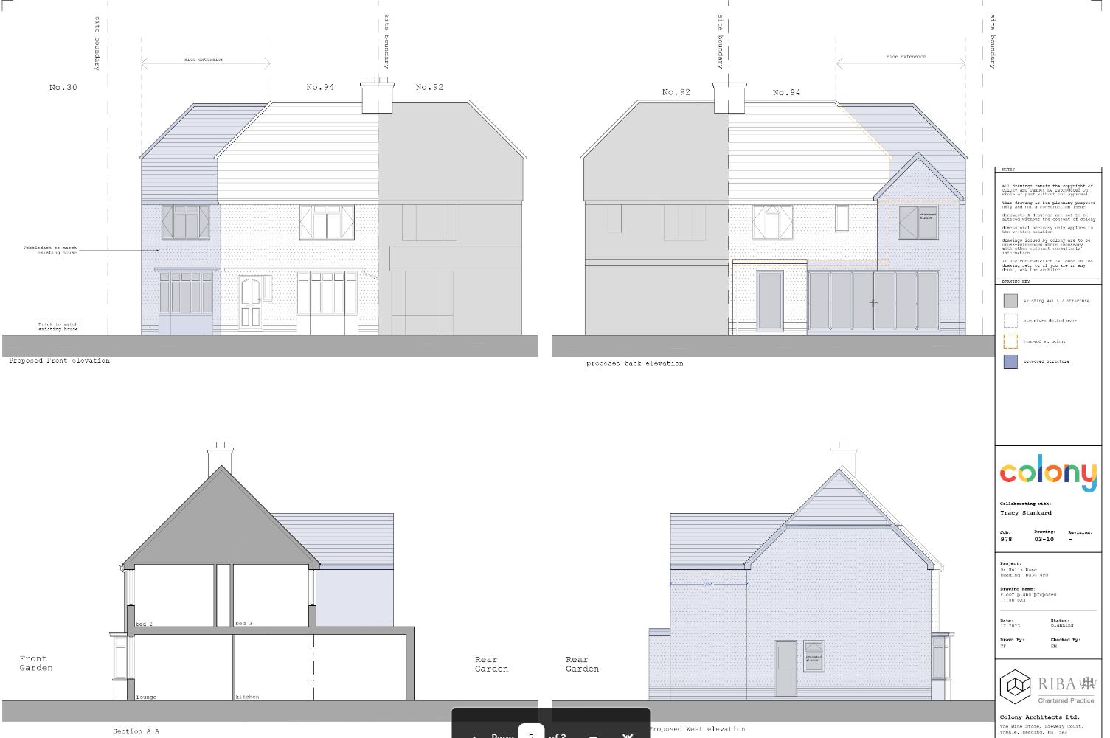
Amended Plans under PL/24/1030:
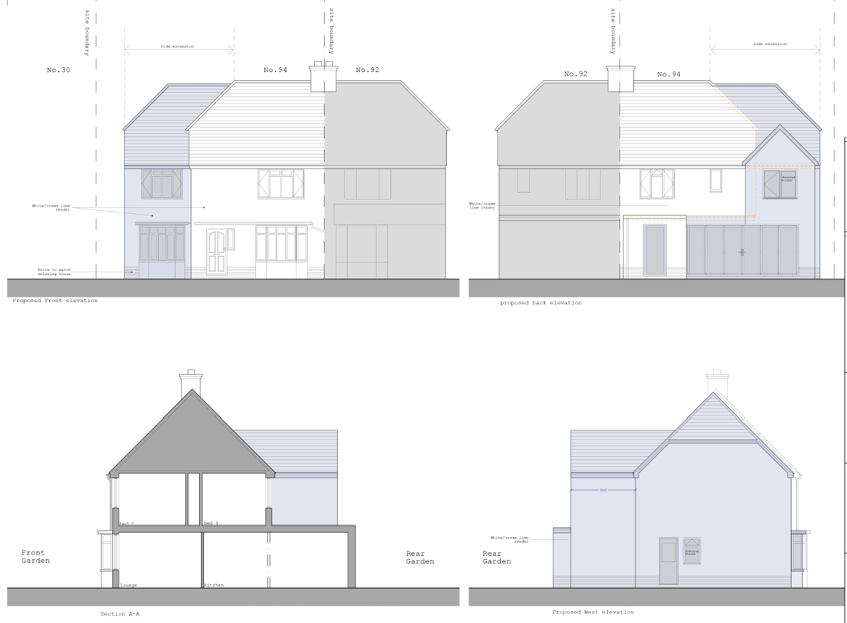

- PLANNING HISTORY
231832/HOU - Erection of two storey side extension with internal alterations on ground floor. – Permitted

- CONSULTATIONS
Not a statutory requirement for this type of application.

- LEGAL AND PLANNING POLICY CONTEXT

Whilst there is no statutory definition of what constitutes a ‘non-material’ amendment, Section 96A, part 2 of the Town and Country Planning Act 1990 (as amended) states that, "In deciding whether a change is material, a local planning authority must have regard to the effect of the change, together with any previous changes made under this section, on the planning permission as originally granted."

The proposed amendments are assessed for materiality – not on the basis of their planning merits. Planning policies therefore do not apply.

Equality Act 2010:

In determining this application the Council is required to have regard to its obligations under the Equality Act 2010. However, there is no indication or evidence (including from consultation on the application) that the protected groups identified by the Act have or will have different needs, experiences, issues and priorities in relation to this particular planning application. Therefore, in terms of the key equalities protected characteristics it is considered there would be no significant adverse impacts as a result of the development.

- ASSESSMENT
The proposed non-material amendment to application 231832 seeks to change the pebble dash render on the approved proposed extensions and existing house to a white/cream lime render. All other details remain the same as those approved under planning permission 231832.

The changes proposed are not deemed to represent a material change to the original permission as the changes would not have a material impact on the design and character of the property. It is not considered that this specific proposal raises any additional design concerns, over and above what has been considered appropriate previously.

The proposed alterations are not considered to alter the approved plans under application 231832 to the point that there may be planning concerns, such as harm to neighbouring amenity.

An informative is recommended which states that this permission relates only to the changes highlighted on the plans. Furthermore, it shall only be read in the context of the substantive permission and is bound by all conditions attached to that permission.

A further informative is recommended which states: In reaching this decision, the local planning authority is satisfied that the changes proposed by this application do not constitute material changes to the approved planning permission.

- CONCLUSION

The proposed amendments have been concluded to not be harmful to the character or appearance of the site or its surroundings and it would not have a detrimental impact on the original building or neighbouring properties. As such the proposal is considered to be in accordance with CC7 and H9 of the Reading Borough Local Plan (2019) and the Councils Supplementary Planning Document “Design Guide to House Extensions” (2021).

- RECOMMENDATION
Approve non-material amendment

Conditions
The drawings hereby approved as a non-material amendment to original planning permission 231832 are as follows:
Drawing no. 978-05-11 Rev. A – Elevations Proposed
Reason: To clarify which plans have been approved.

Informatives

1. This notice relates only to the changes to condition 2 of the substantive planning permission (Ref: 231832). It shall be read in the context of the substantive planning permission and is bound by all the conditions and obligations attached to that permission. That permission still stands and this notice (and any other notices issued under section 96a for this development) should be read together.

2. In reaching this decision, the local planning authority is satisfied that the changes proposed by this application do not constitute material changes to the approved planning permission.

3. The Local Planning Authority has worked positively and proactively with the applicant to determine the application under the non-material amendment procedure within the recommended timeframes.

