DELEGATED APPLICATION REPORT
Ward: Caversham Heights
App Ref: PL/24/0870 Householder planning permission
Address: 1 Briar Close, Caversham, Reading RG4 7QH
Proposal: New two storey side extension to existing detached house. Replacement of existing single storey attached garage in poor condition.
Applicant: Mr and Mrs B Ro Robson
Received date: 2024-07-08
Target Decision date: 2024-09-02
Case Officer: Huimin Chen

- SITE DESCRIPTION

The application site is a two-storey detached property dwelling located on the north-western side of the Briar Close cul-de-sac, off Hemdean Road. The existing house is predominantly in brick with a hipped roof and includes a single storey flat roofed garage along the western flank of the site. There is a significant change in levels across the plot, with the property set down from No. 2 to the east and set up from No. 305 and No. 307 to the west. The property is not listed, nor located within a conservation area. The surrounding area is predominantly residential.
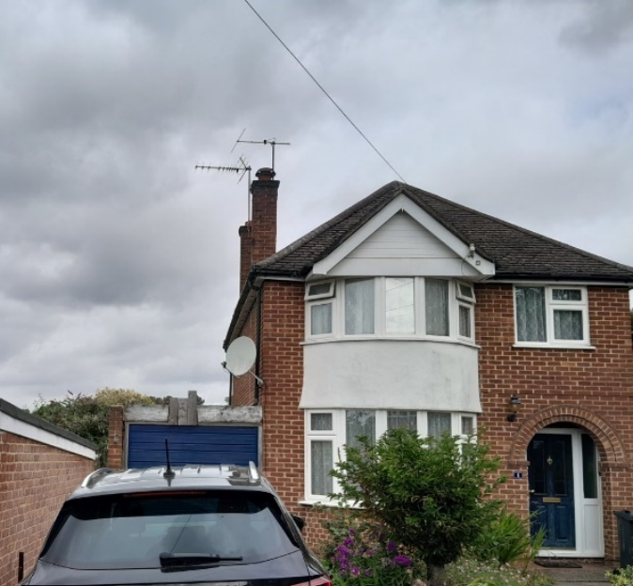
Officer site photo of 1 Briar Close during site visit on 8th August 2024

- PROPOSAL AND SUPPORTING INFORMATION

The proposed development seeks permission for the erection of a two storey side extension on the west side of the property, close to the boundary with No. 305 and No. 307 Hemdean Road. The existing single storey garage at this point would be demolished to make way for the proposed works.

The original proposal was considered unacceptable as it encroached on the land of No. 305 and No. 307 Hemdean Road, contrary to the Design Guide to House Extensions 2021. Additionally, it was considered potentially overbearing to the neighbouring properties due to the two-storey scale and the difference in ground levels. Following the communications with the agent, the proposed two storey side extension has been scaled down. The front and back walls of the proposed first floor would be set back, reducing the overall scale compared to the ground floor.

All proposed walls, roof, windows and doors are to match the existing dwelling. The proposed floor plans also show that a number of internal alterations are also proposed; given the property is not listed, these are not referenced within the description of development as planning permission is not required for internal alterations.

Further to the communications with the agent regarding the encroachment and scale issues, the following plans were considered:

- Drawing No. 2406_PLN_1000 Rev. B – Block Plans
- Drawing No. 2406_PLN_110 Rev. B – Proposed Plans
- Drawing No. 2406_PLN_210 Rev. C – Proposed Elevations
As received on 23rd August 2024.

Preliminary Ecological Appraisal by Urban Tree Experts, August 2024, ref: SPH/NP/PEA-24/31.07, dated 12/08/2024, as submitted 12/08/2024

- Drawing No. 2406_PLN_200 Rev. A – Existing Elevations
- Drawing No. 2406_PLN_240630_01 Rev. A – Existing Plans
- Drawing No. 2406_PLN_1001 – Location Plans
- Design and Access Statement
As received on 9th July 2024.

Existing Plans Existing Elevations
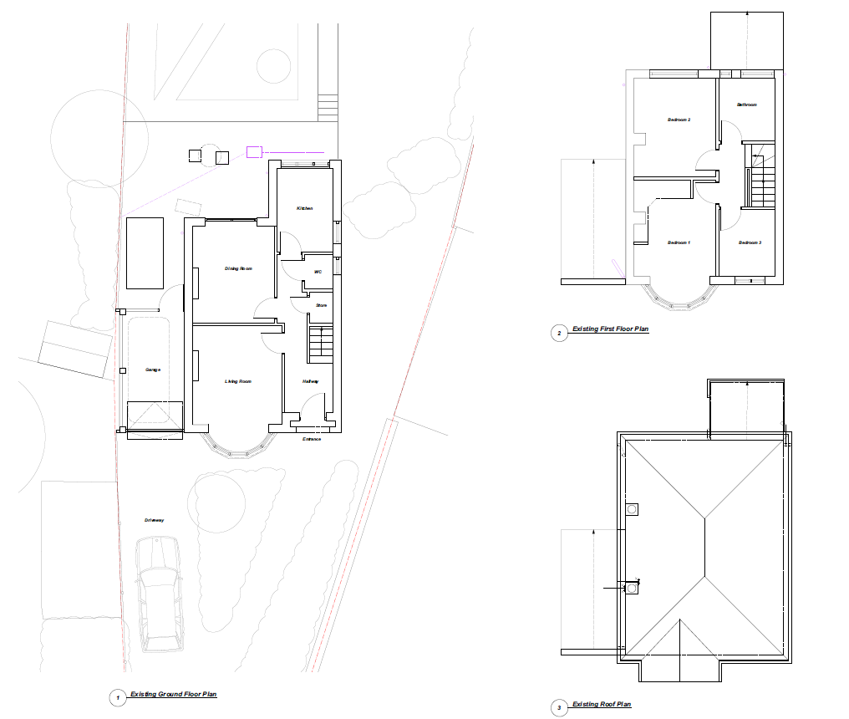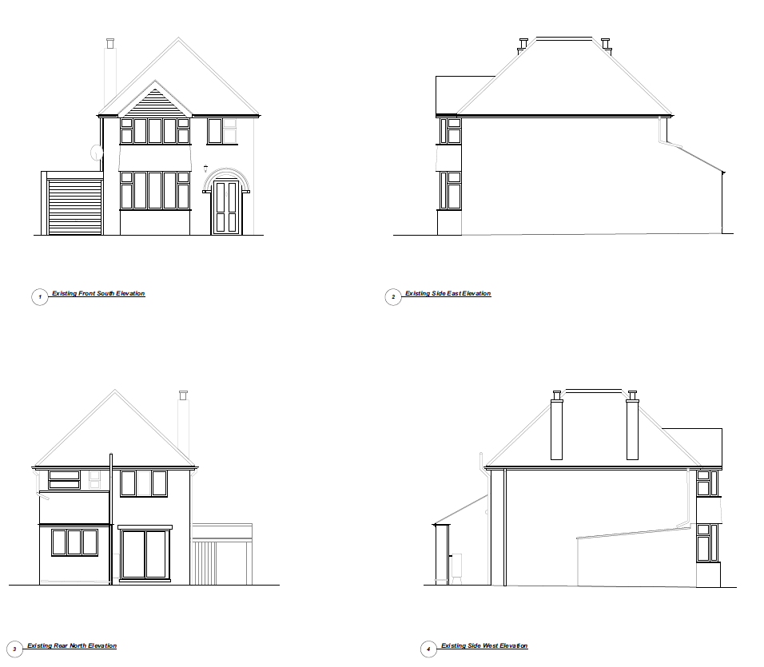
Proposed Plans Proposed Elevations
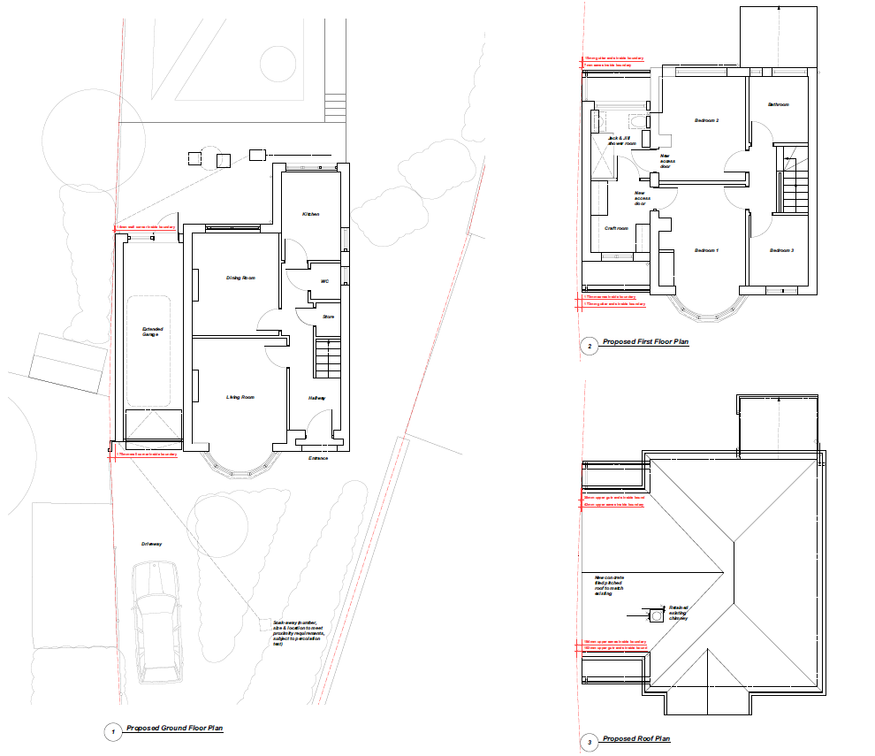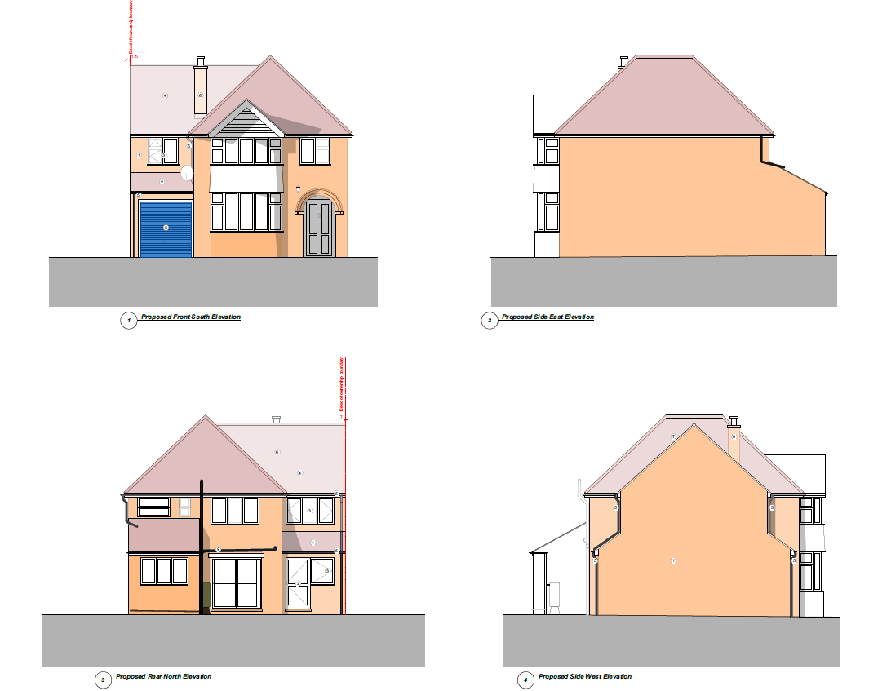

Relevant Planning History:

PL/21/0538: 8 Briar Close - Erection of two-storey side extension following demolition of existing garage and associated works – Approved 25/5/2021

- CONSULTATIONS

Internal consultation:
Transport consultee:
There are no Transport objections to this application as the proposed works do not change or impact the existing parking or access arrangements. Parking is provided in accordance with the Councils current adopted standards.

Ecology consultee:
The building may host roosting bats and to confirm whether this is the case, and if so, how bats will be affected by the proposals to convert the loft, a bat survey will need to be carried out. The survey will need to be provided prior to the application being determined.

Following communications with the agent, a bat survey report was submitted (Urban Tree Experts, August 2024, ref: SPH/NP/PEA-24/31.07) and Ecology confirmed that it had been undertaken to an appropriate standard. It concluded that the risk of bats being affected by the proposals would be minimal. The Ecology Officer confirmed that, there are, therefore, no objections to this application on ecology grounds.

The following addresses were consulted by letter:
- 303, Hemdean Road, Caversham, Reading, RG4 7QN
- 311, Hemdean Road, Caversham, Reading, RG4 7QN
- 20, Badgers Rise, Caversham, Reading, RG4 7QA
- 307, Hemdean Road, Caversham, Reading
- 9, Briar Close, Caversham, Reading, RG4 7QH
- 309, Hemdean Road, Caversham, Reading, Berkshire, RG4 7QN
- 4, Briar Close, Caversham, RG4 7QH
- 3, Briar Close, Caversham, Reading, RG4 7QH
- 5, Briar Close, Caversham, Reading, RG4 7QH
- 10, Briar Close, Caversham, Reading, RG4 7QH
- 2, Briar Close, Caversham, Reading, RG4 7QH
- 6, Briar Close, Caversham, Reading, RG4 7QH
- 7, Briar Close, Caversham, Reading, RG4 7QH
- 8, Briar Close, Caversham, Reading, RG4 7QH
- 301, Hemdean Road, Caversham, Reading, RG4 7QP
- 305, Hemdean Road, Caversham, Reading, RG4 7QN
- 313, Hemdean Road, Caversham, Reading, RG4 7QN
- 315, Hemdean Road, Caversham, Reading, RG4 7QN

Letters of representation have been received as follows:

- Member of the Public | 307 Hemdean Road, Caversham | Object
- Member of the Public | 307 Hemdean Road, Caversham | Object
- Member of the Public | 305 Hemdean Road, Caversham, Reading RG4 7QN | Object

The neighbours objected to the originally submitted proposed development due to concerns over property boundary encroachment, the extension's excessive scale and dominance compared to neighbouring single storey homes, potential negative impacts on light, privacy, and the lack of a legal easement and clear drainage details.

Officer note: Any construction activity that may require access to neighbouring land is not material to the planning consideration. Other relevant material planning matters are assessed in the report below.

- LEGAL AND PLANNING POLICY CONTEXT
Equality Act 2010:
In determining this application, the Council is required to have regard to its obligations under the Equality Act 2010. However, there is no indication or evidence (including from consultation on the application) that the protected groups identified by the Act have or will have different needs, experiences, issues and priorities in relation to this particular planning application. Therefore, in terms of the key equalities protected characteristics it is considered there would be no significant adverse impacts as a result of the development.

Section 38(6) of the Planning and Compulsory Purchase Act 2004 requires that proposals be determined in accordance with the development plan unless material considerations indicate otherwise. Material considerations include relevant policies in the National Planning Policy framework (NPPF) - among them the 'presumption in favour of sustainable development'. The following local and national planning policy and guidance is relevant to this application:

National Policy
National Planning Policy Framework
National Planning Practice Guidance

Reading Borough Local Plan (2019)
CC7 (Design and the Public Realm)
CC8 (Safeguarding Amenity)
H9 (House Extensions and Ancillary Accommodation)
H10 (Private and Communal Outdoor Space)

SPD
Design Guide to House Extensions SPD 2021

- APPRAISAL
The original proposal was considered unacceptable due to encroachment and potential overbearing issues. Following communications with the agent, revised plans were submitted on 23rd August 2024. The revised plans scaled down the proposal to ensure the development remains within the red line boundary of the application site. Therefore, the assessment below is with respect to the revised plans.
Character and Appearance
Policy H9 states that an extension to a house will be acceptable where it respects the character of the house in terms of scale, location, materials and design and respects the character and pattern of neighbouring properties and the street as a whole in terms of scale, location, materials and design, and any important existing building line. Policy CC7 also sets out relevant considerations for design.
The proposed two storey side extension is considered acceptable in terms of design and scale, given the set-back from the frontage, the set-down from the existing ridgeline and the use of matching materials. Although the proposed side works would be visible from the street scene, it is considered to respect the character and pattern of the neighbouring properties and the street as a whole in terms of scale, materials and design, as similar side extensions exist within the surrounding area. Additionally, the gable-roofed side extension, with its larger base and smaller top, is proportionate to the original house.
Residential Amenity
Policy H9 states that an extension will be acceptable where it does not result in an overbearing impact on neighbours. Policy H10 seeks to ensure that the amenity of gardens and other outdoor areas are not compromised. Policy CC8 states an extension to a house will be acceptable where it will not cause a significant detrimental impact to the living environment of existing or new residential properties.
The proposal does not include any windows in the side-facing elevation towards No. 305 and No. 307 Hemdean Road. A condition will prevent any first-floor openings from being added without the grant of a further separate application by the LPA, to help protect amenity. The orientation of the extension to the neighbouring plot, together with the offset from the boundary, separation distances, and change in land levels, means that although there will be some loss of day/sunlight to No. 305 and No. 307 Hemdean Road, this is not considered to be at a level to warrant refusal. There are also no identified risks of being overbearing given gap from the shared boundary and the separation distance.
Overall, the proposal is considered acceptable based on the reasons listed above.

- CONCLUSION
The proposed development has been assessed as set out above and is considered to be acceptable on that basis, subject to the following conditions.
- RECOMMENDATION

Approve with Conditions

Recommended Conditions:
Approved Plans
Time Limit
Materials (As Specified)
No New Openings

