DELEGATED APPLICATION REPORT
Ward: Emmer Green
App Ref: PL/24/0488 Householder planning permission
Address: 72 Buckingham Drive, Emmer Green, Reading, RG4 8SA
Proposal: Porch extension, single storey back extension
Applicant: Mr Krystian Kolenda
Received date: 2024-04-17
Target Decision date: 2024-09-02 (EXT)
Case Officer: Huimin Chen

- SITE DESCRIPTION
The application site is a two-storey mid-terraced house with a gable roof. It is located on the east of the Buckingham Drive. It is not a listed building, nor does it fall within conservation area. The surrounding area is predominantly residential.

Site visit date: 10 May 2024
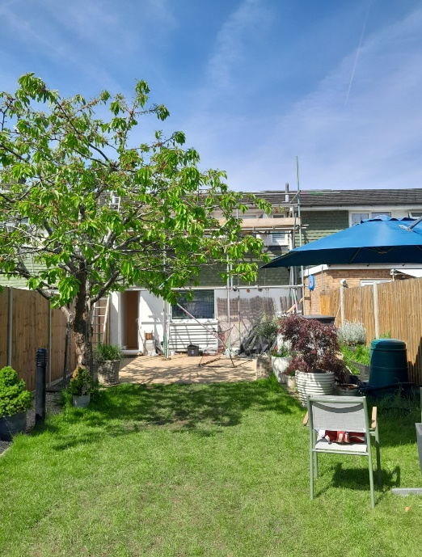

- PROPOSAL AND SUPPORTING INFORMATION
The planning permission is sought for the construction of a front porch and a single storey rear extension, both with flat roofs. The proposed front porch would measure ca 1.4m in depth and 2m in width, with a total height of ca 2.2m. The proposed rear extension would extend across the entire rear of the building, projecting 4m from the original rear wall. The total height would be ca 2.8m. The proposal includes one front-facing door and one rear-facing sliding door. All proposed materials are to match the existing house.
Further to the communications with the applicant, the following plans are under considerations:
- Existing Elevations received on 24th May 2024
- Proposed elevations received on 5th August 2024
- Existing and Proposed Floor Plans received on 5th August 2024
- Proposed Block Plan received on 23rd August 2024
& an email received on 26th July 2024 confirmed that all proposed materials are to match the existing house.

Existing Floor Plan Proposed Floor Plans
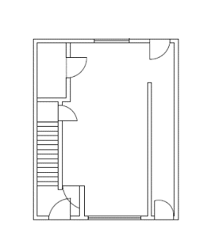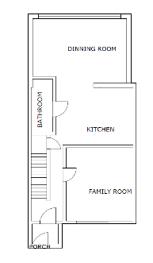
Existing Elevations:
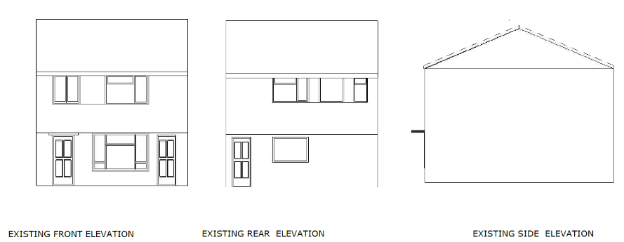

Proposed Elevations:
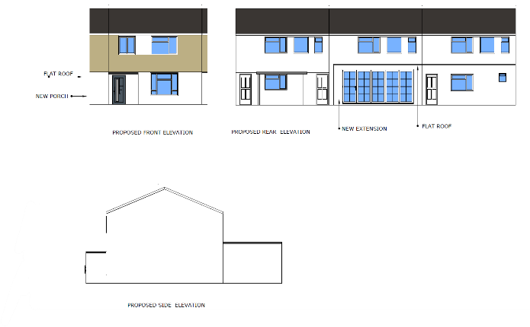
Relevant Planning History
Ref. 0000006860 -16 flats, 18 houses and 8 garages – unconditional consent granted on 31st July, 1959
- CONSULTATIONS

Internal consultation:
Natural Environment (Tree) Consultee:
After consulting the Natural Environmental (Tree) team, it is confirmed that the proposed rear extension would impact the existing tree. Further details would be discussed in the tree section within the appraisal below.

Transport Consultee:
The comments from Transport Officer stated that - ‘The proposed porch extension will result in the reduction of the front drive. However, plans have not been provided illustrating the parking layout. In accordance with the Councils current parking standards, a 3-bedroom property would require 2 off road parking spaces. Revised plans are required illustrating the proposed parking layout.’

Following communication with the applicant, a revised plan was received, illustrating two on-site car parking layouts. The Transport team confirmed it is acceptable. Additionally, it should be noted that vehicles are not permitted to overhang the public highway, as this can constitute an obstruction under the Highways Act 1980.

Public Consultation:
The following addresses were consulted by letter:
- 167, Peppard Road, Emmer Green, Reading, RG4 8TS
- 70, Buckingham Drive, Emmer Green, Reading, RG4 8SA
- 74, Buckingham Drive, Emmer Green, Reading, RG4 8SA
- 169, Peppard Road, Emmer Green, Reading

No letters of representation have been received. Site Notice has been affixed in front of the house for 21 days.

- LEGAL AND PLANNING POLICY CONTEXT
Equality Act 2010:
In determining this application the Council is required to have regard to its obligations under the Equality Act 2010. However, there is no indication or evidence (including from consultation on the application) that the protected groups identified by the Act have or will have different needs, experiences, issues and priorities in relation to this particular planning application. Therefore in terms of the key equalities protected characteristics it is considered there would be no significant adverse impacts as a result of the development.

Section 38(6) of the Planning and Compulsory Purchase Act 2004 requires that proposals be determined in accordance with the development plan unless material considerations indicate otherwise. Material considerations include relevant policies in the National Planning Policy framework (NPPF) - among them the 'presumption in favour of sustainable development'. The following local and national planning policy and guidance is relevant to this application:

National Policy
National Planning Policy Framework
National Planning Practice Guidance

Reading Borough Local Plan (2019)
CC7 (Design and the Public Realm)
CC8 (Safeguarding Amenity)
H9 (House Extensions and Ancillary Accommodation)
H10 (Private and Communal Outdoor Space)
EN14 (Trees, Hedges and Woodlands)

SPD
Design Guide to House Extensions SPD 2021

- APPRAISAL

Character and Appearance

Policy H9 states that an extension to a house will be acceptable where it respects the character of the house in terms of scale, location, materials and design and respects the character and pattern of neighbouring properties and the street as a whole in terms of scale, location, materials and design, and any important existing building line. Policy CC7 also sets out relevant considerations for design.

Following communications with the applicant, the proposed rear extension has been scaled down to a depth of 4m, in compliance with the guidance outlined in the Design Guide to House Extensions 2021. Additionally, the rear building line of the proposed rear extension would project approximately 60cm beyond no.74. All proposed materials are to match the existing house. Therefore, the proposed rear extension is considered acceptable in terms of design and scale, respecting the character and appearance of the host dwelling and neighbouring properties.

Although the proposed front porch would be visible from the street scene and is the only porch in this row of terraces, it is not considered to have a detrimental impact on the character and appearance of the host dwelling and the street scene, given its small scale, matching materials and set back from the highway.

Residential Amenity

Policy H9 states that an extension will be acceptable where it does not result in an overbearing impact on neighbours. Policy H10 seeks to ensure that the amenity of gardens and other outdoor areas are not compromised. Policy CC8 states an extension to a house will be acceptable where it will not cause a significant detrimental impact to the living environment of existing or new residential properties.

As the proposed rear extension does not include any side windows, there are no aspects of this proposal that would cause any negative privacy and overlooking. Following communications with the applicant, the proposed southern wall of the rear extension would be adjusted to be set back from the shared boundary by 30cm, which would pose a minimal overbearing effect on no.70. The proposed rear extension is not considered to block sunlight and daylight to no.70, as it would not extend beyond the 60-degree line drawn from the midpoint of the closest window of the habitable room in no. 70 Buckingham Drive. The orientation of the application site, east -west, also contributes to a low risk of blocking sunlight and daylight to the adjoining properties.

There are no aspects of the proposed front porch that would cause any harm in terms of residential amenity.

Tree

Policies CC7 and EN14 state that individual trees, groups of trees, hedges and woodlands will be protected from damage or removal where they are of importance, and Reading’s vegetation cover will be extended. The quality of waterside vegetation will be maintained or enhanced.

Further to the communication with the applicant, the existing tree would be removed. One replacement tree would be planted in the rear garden, approximately 14m away from the proposed rear extension. The Natural Environment Officer confirmed that it is acceptable. The details would be secured via a landscaping condition.

- CONCLUSION
The proposed development has been assessed as set out above and is considered to be acceptable on that basis, subject to the following conditions.

- RECOMMENDATION
Approve with Conditions

Recommended Conditions:
Approved Plans
Time Limit
Materials (To Match)
Use of Roof Restricted
Landscaping Small Scale (To Be Approved)

