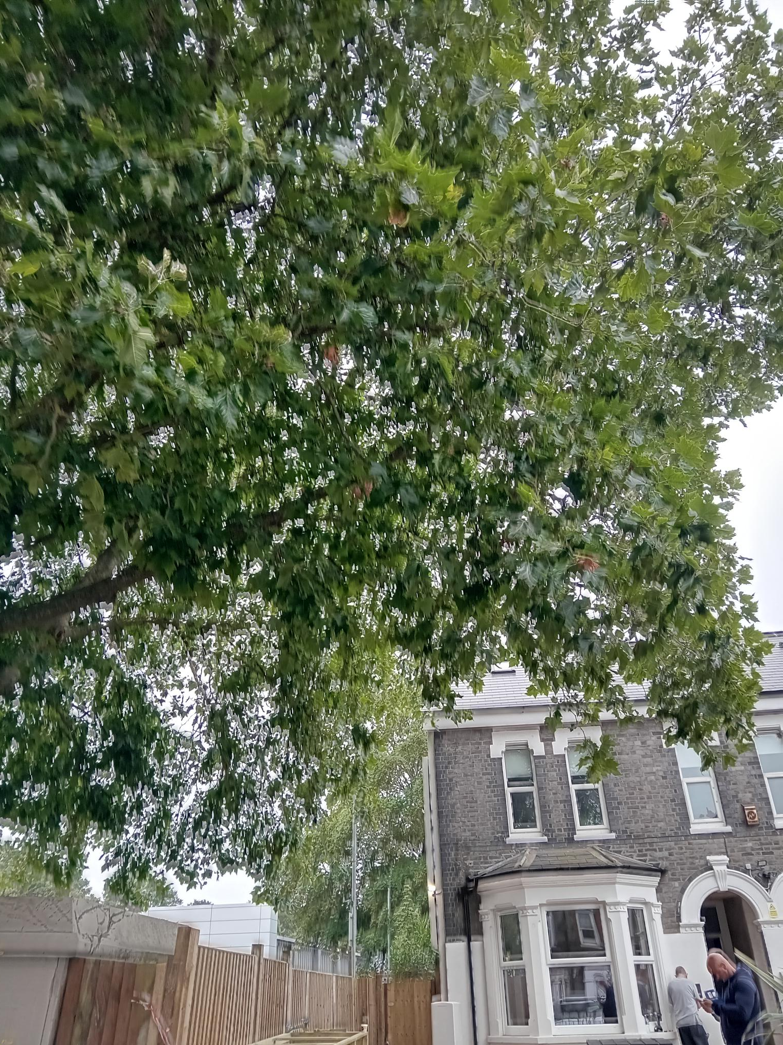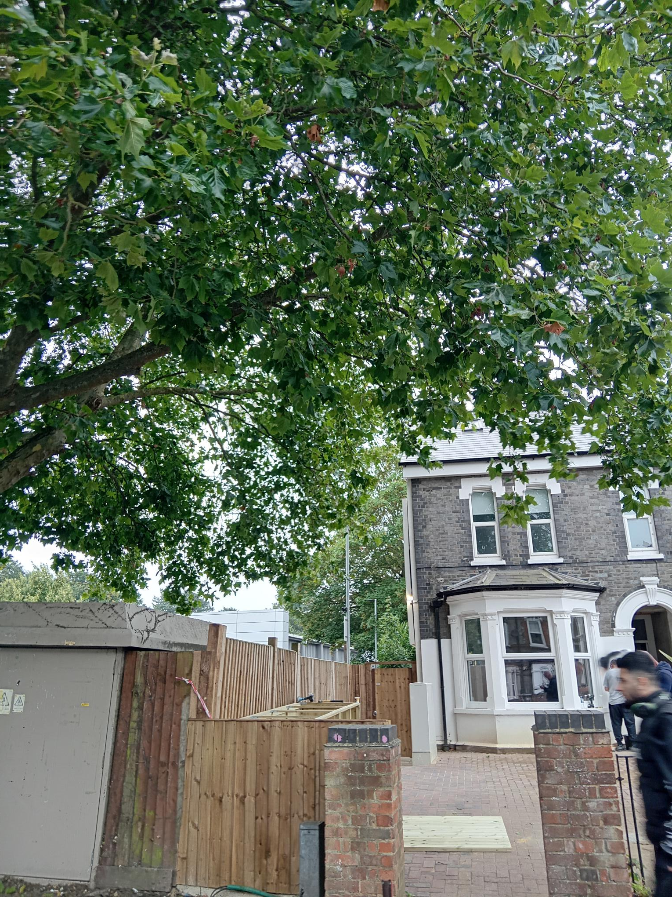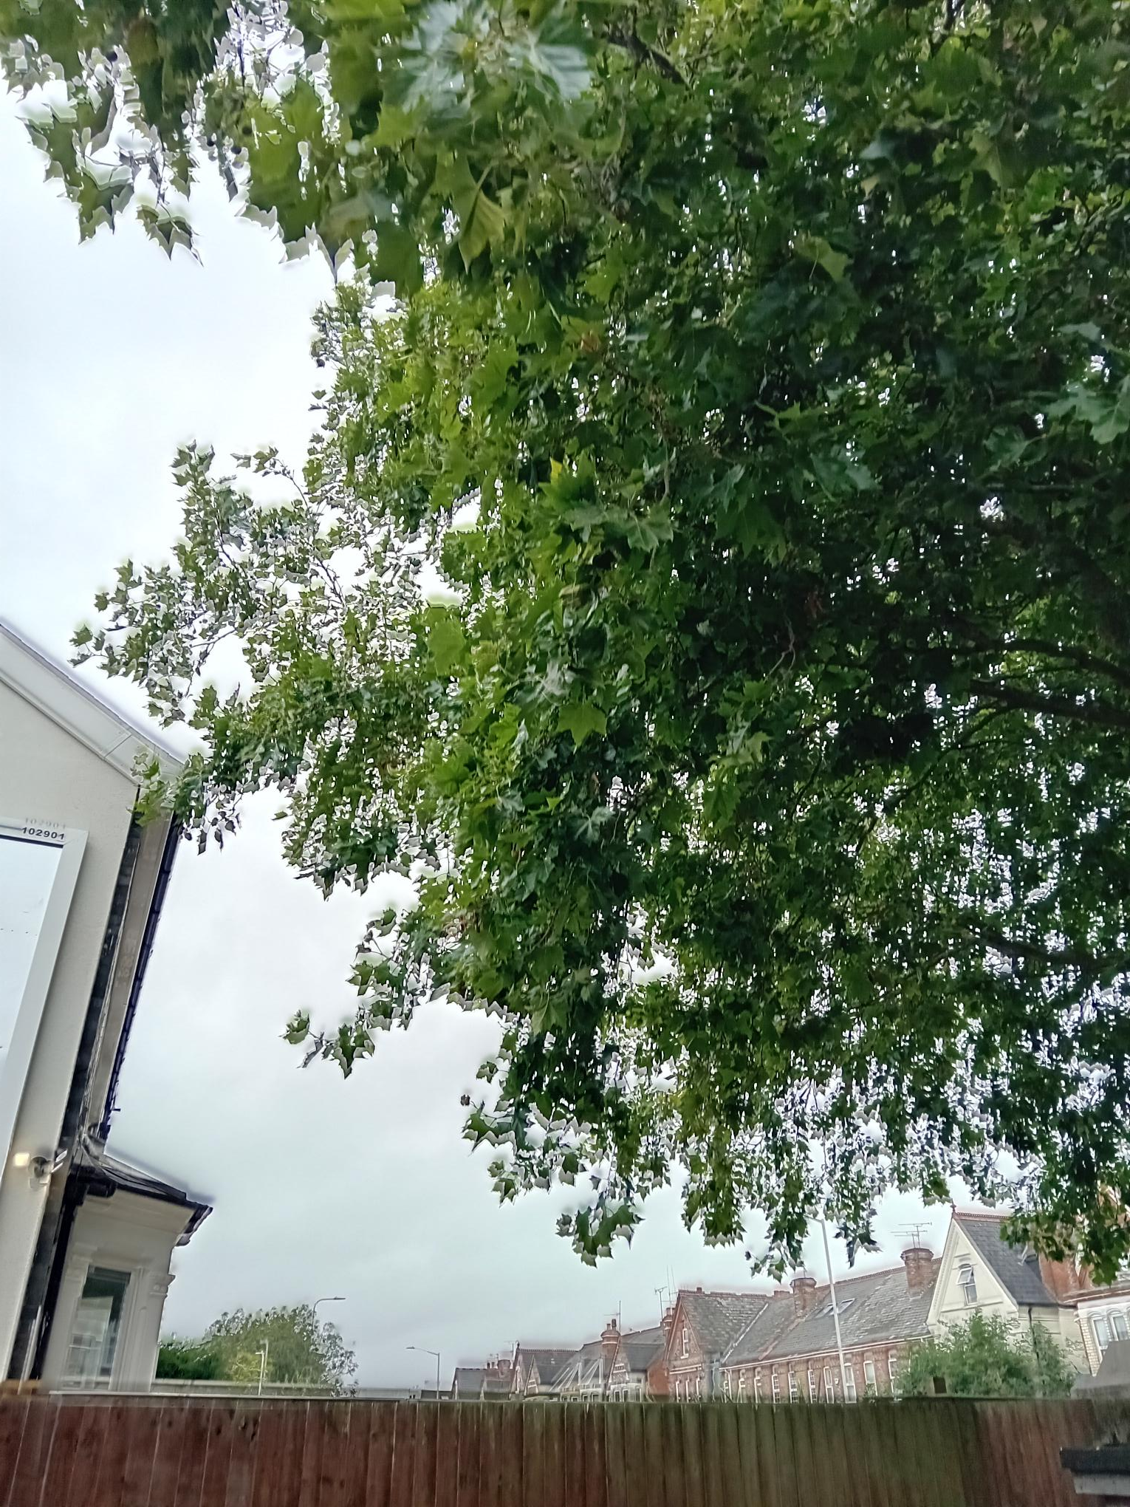
T1 Plane (T15 of application) – prune to give 2m clearance from property
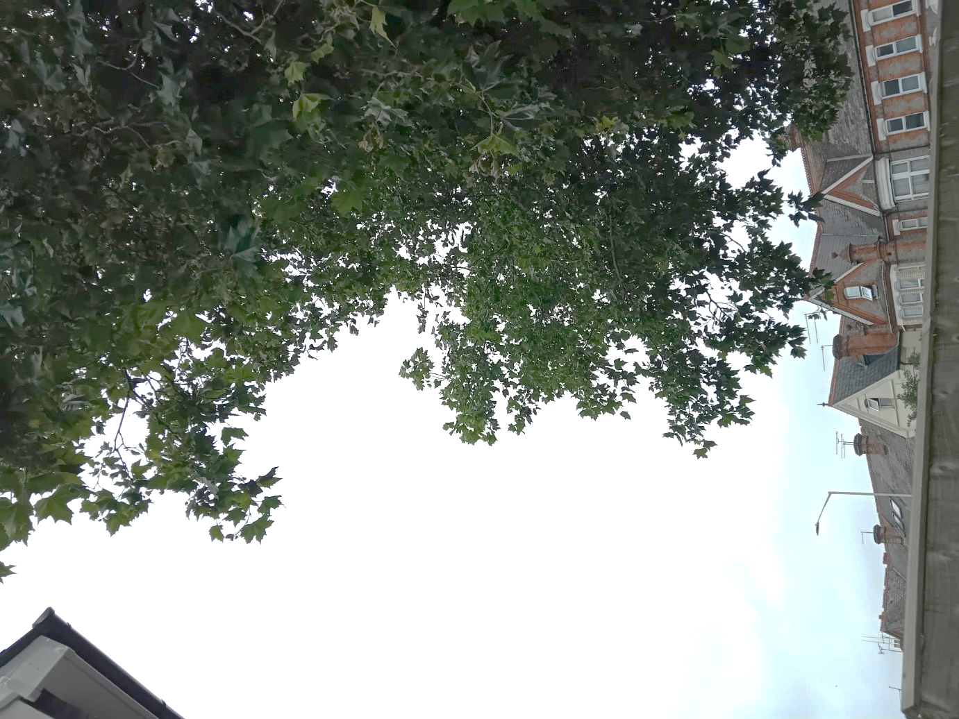
T1 Plane (T15 of application) – lower canopy
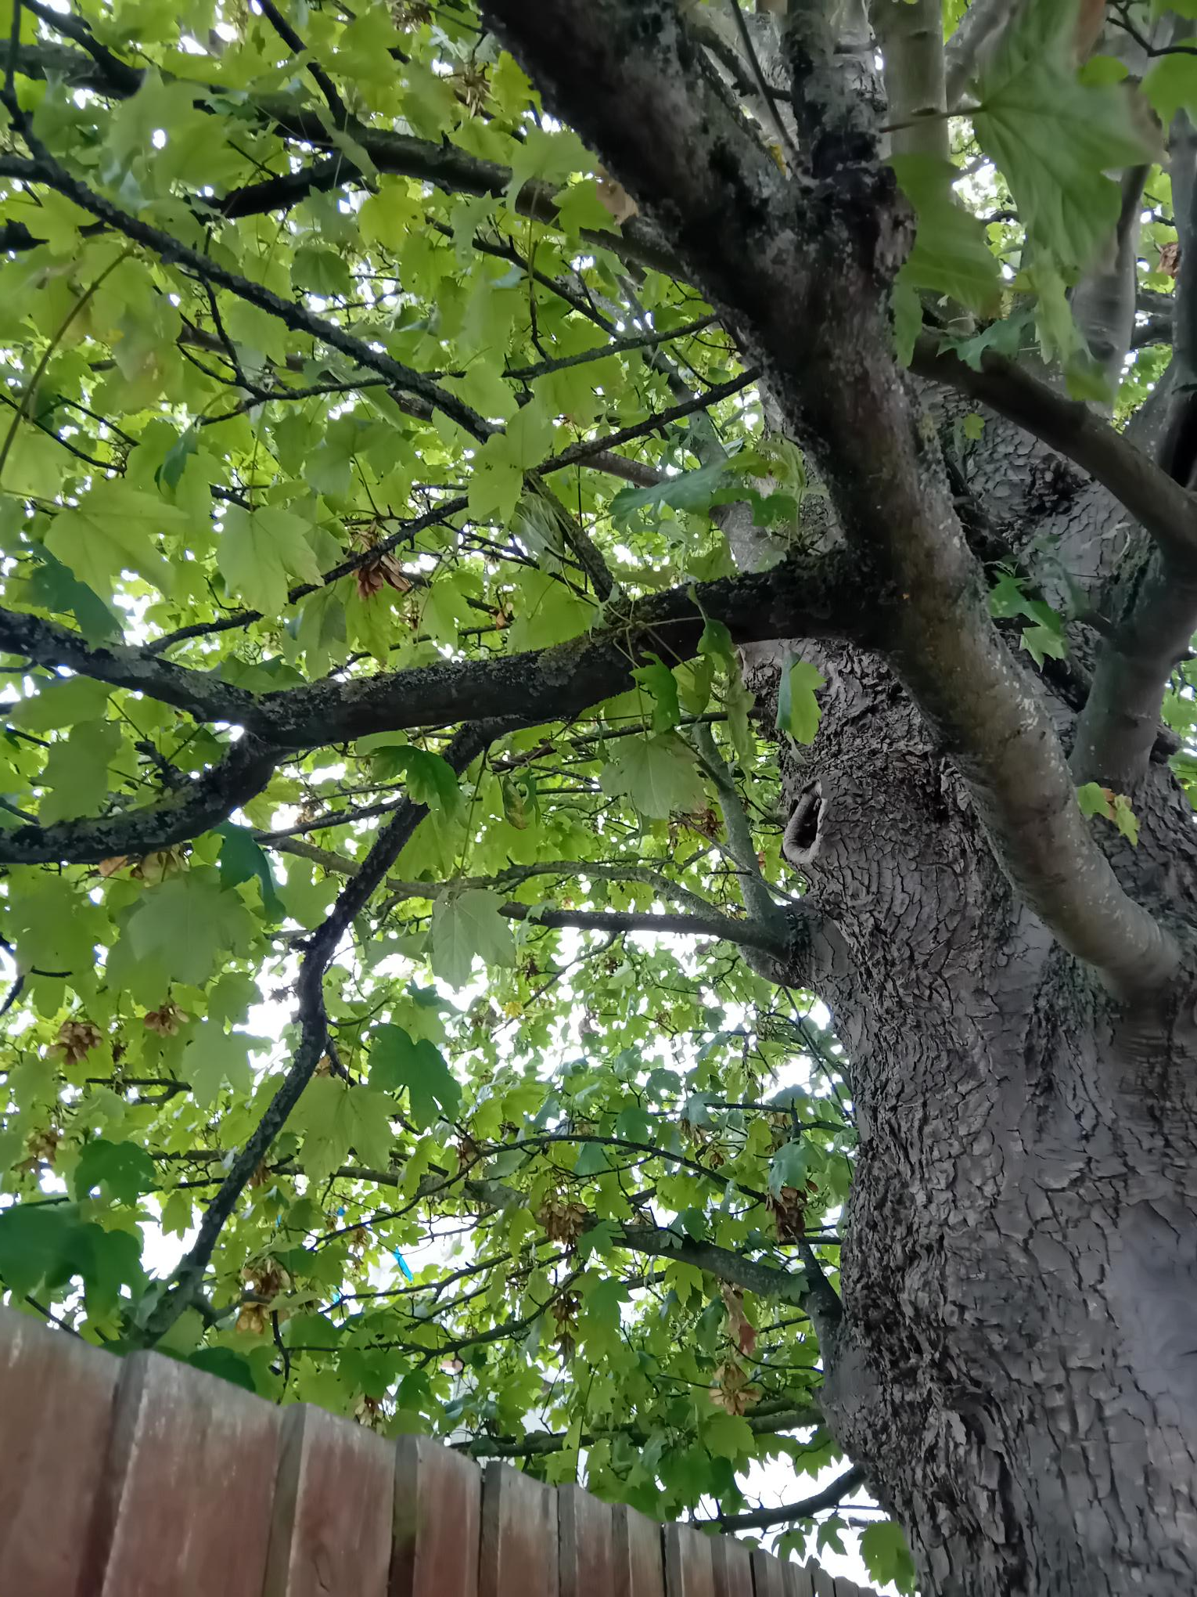
T4 Sycamore (T12 of application) – e.g. of low branches that can be removed
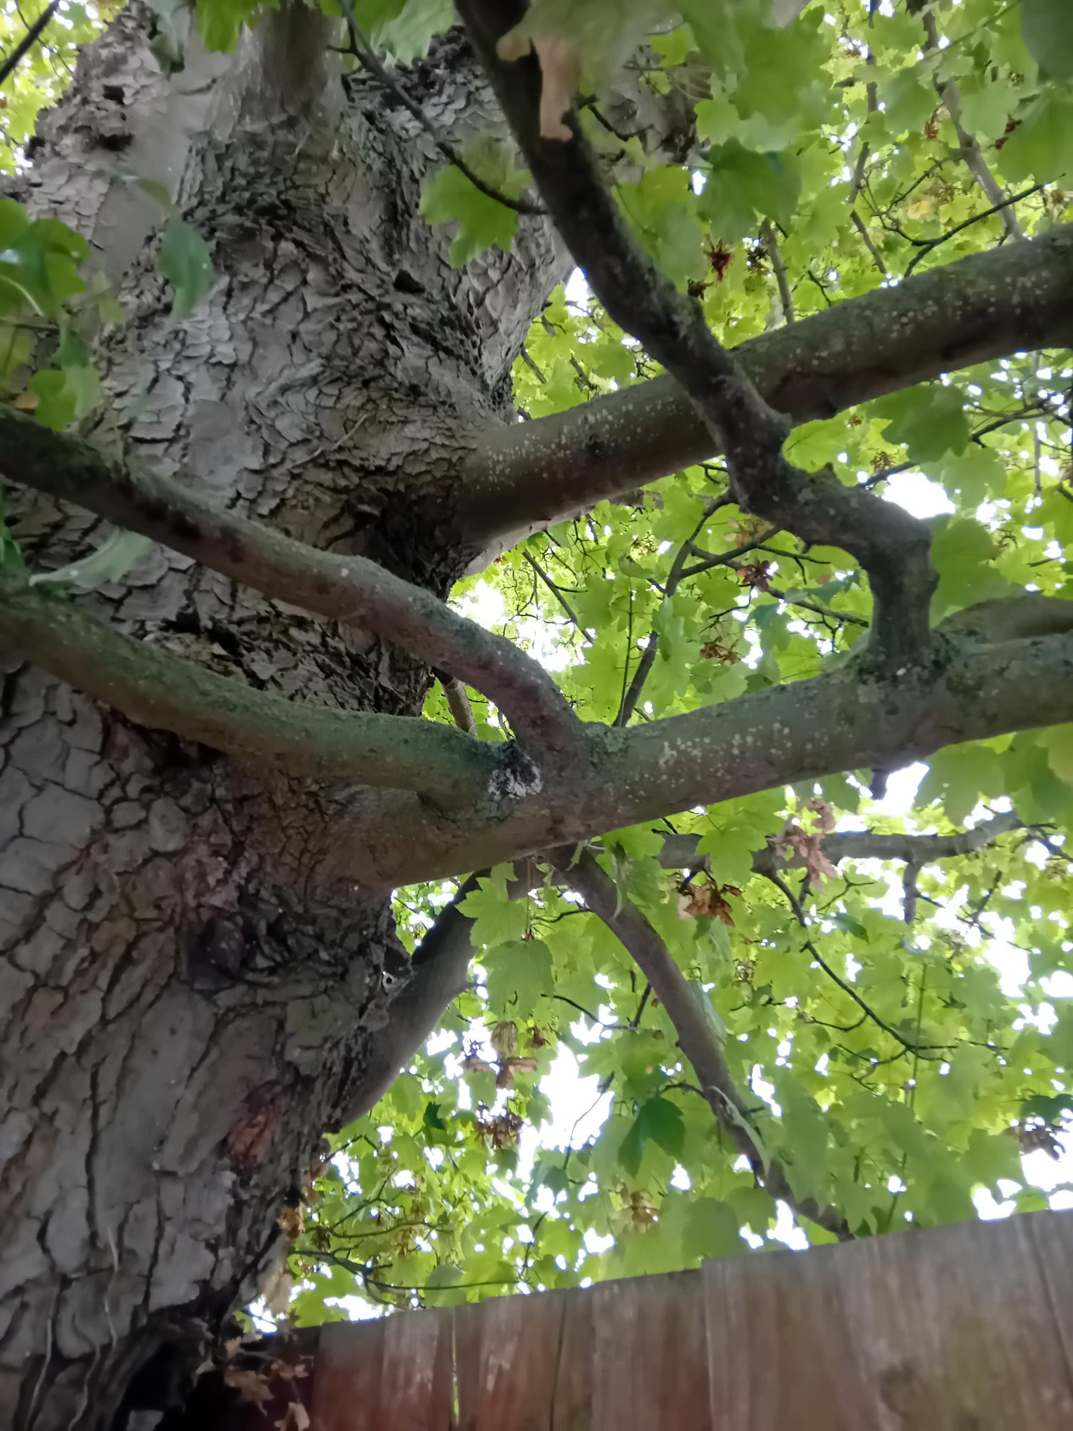
T4 Sycamore (T12 of application) – low branches that can be removed

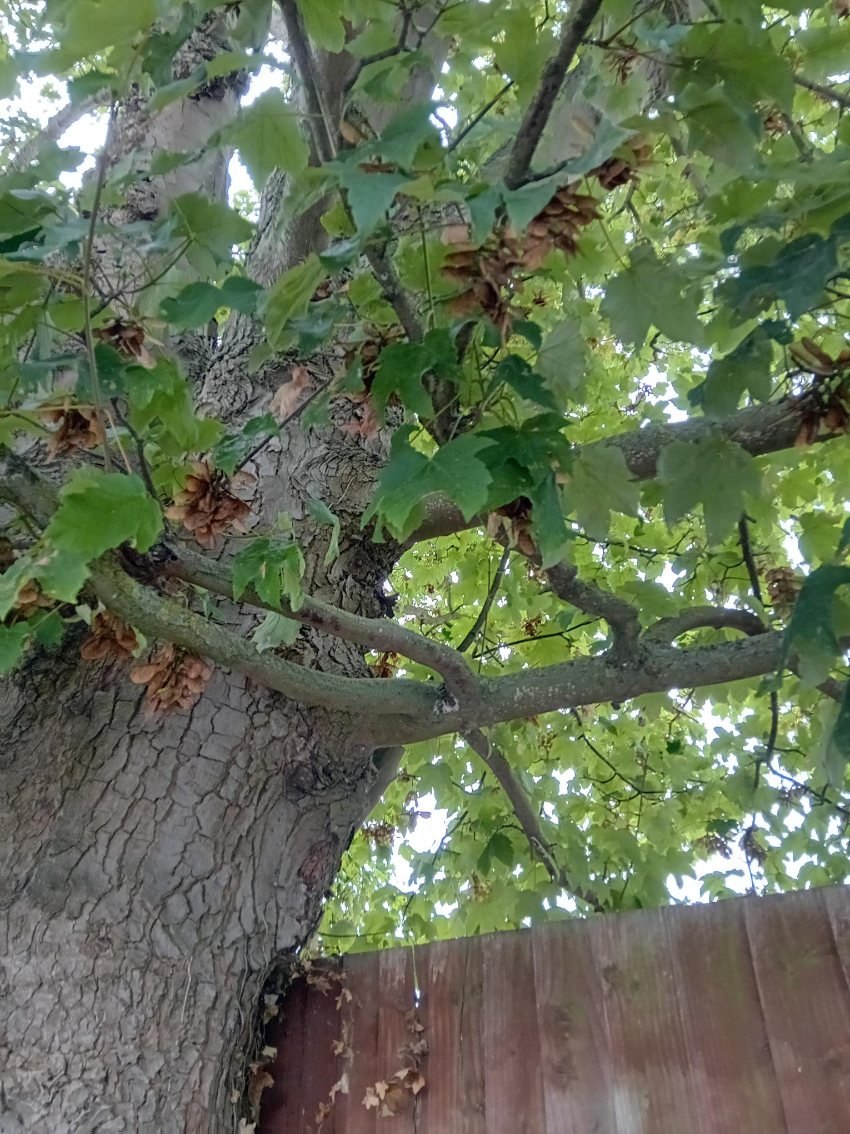
T4 Sycamore (T12 of application) – e.g. of low branches that can be removed

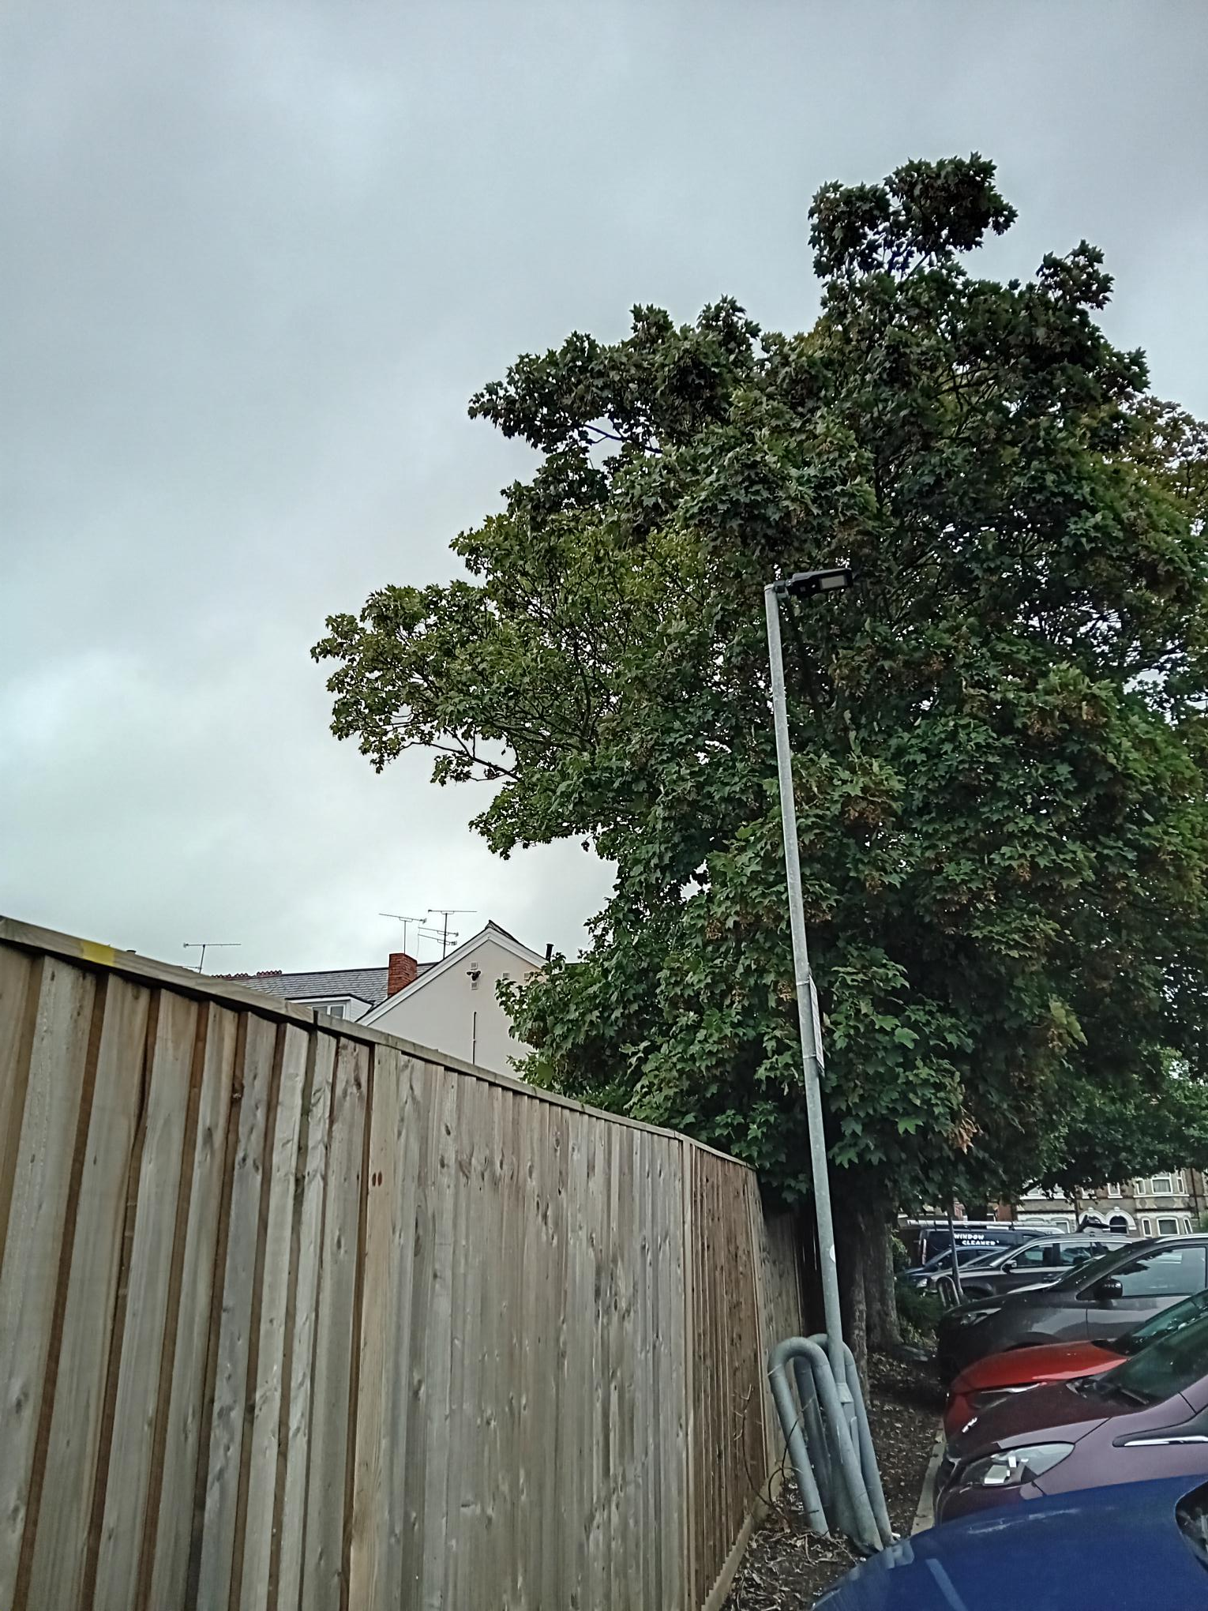

Lidl, 291 Oxford Road
22/8/24
PL/24/1056

