
ATWORTH ARBORICULTURE LTD

Arboricultural Method Statement
Arboricultural Implications Assessment

Land adjacent to 30 Tern Close,
Tilehurst,
Reading,
RG30 4AY.

Client:
Greg Farrell.

Atworth Arboriculture Ltd, 189 Purlpit, Atworth, Wiltshire SN12 8HJ.
Vincentcainey@yahoo.co.uk 01225 708508 07970 467918
Instruction
1.0 Site: Land adjacent to 30, Tern Close, Tilehurst, Reading, RG30 4AY.

Client: Greg Farrell

1.1 Atworth Arboriculture Ltd was instructed to supply an Arboricultural Method statement and Arboricultural Implications Assessment for the proposed development at the site above.

1.2 Local Planning Authority – Reading Borough Council

2.0 Arboricultural Method Statement Methodology.

2.1. The Arboricultural method statement provides the means by which areas of construction within or near to the Root Protection Area (RPA) of retained trees can be achieved whilst minimising the impact of construction activity on nearby trees.

2.2 This Statement is written assuming approved Preliminary Management Recommendations
(if any) to trees stated in the Tree Schedule Table have since been carried out.

2.3 The excavation of foundations for any structure on sites where trees are present may result in root damage and removal. Where root loss is likely to occur, it is important that a method of construction that minimises the impact on tree roots is utilised.

2.4 Copies of this document will be available for inspection on site.

3.0 Tree Protection Measures
3.1 Before the commencement of any works on site, protective fencing will be erected as specified by the planning conditions to be imposed. The local planning authority will be notified in writing once the fencing is in place. The position of the fencing is shown on the appended Tree Protection Plan (TPP), AA/TPP-15.07.20.v2

3.2 The purpose of the protective fencing is to minimize damage to the tree’s roots and the soil structure surrounding them. Construction activities such as trenching, changing of levels and the storage of spoil and materials is particularly damaging to tree roots, either directly (by physical damage) or indirectly (through the destruction of nearby soil structure through compaction or ‘capping’ which inhibits further root function)
3.3 The specification of the tree protection fencing is illustrated within BS5837:2012 and is a suitable fencing design which should resist light vehicular impact and be difficult to remove casually. The British Standard also provides a more practical, less costly fencing specification which may be suitable for smaller sites. See Figure 1 and 2 below, which provides an example of both RPA protective fencing specifications, in line with BS5837:2012.
3.4 All-weather notices with the words “CONSTRUCTION EXCLUSION ZONE - NO ACCESS” should be attached securely to the barriers in prominent places.

Figure 1

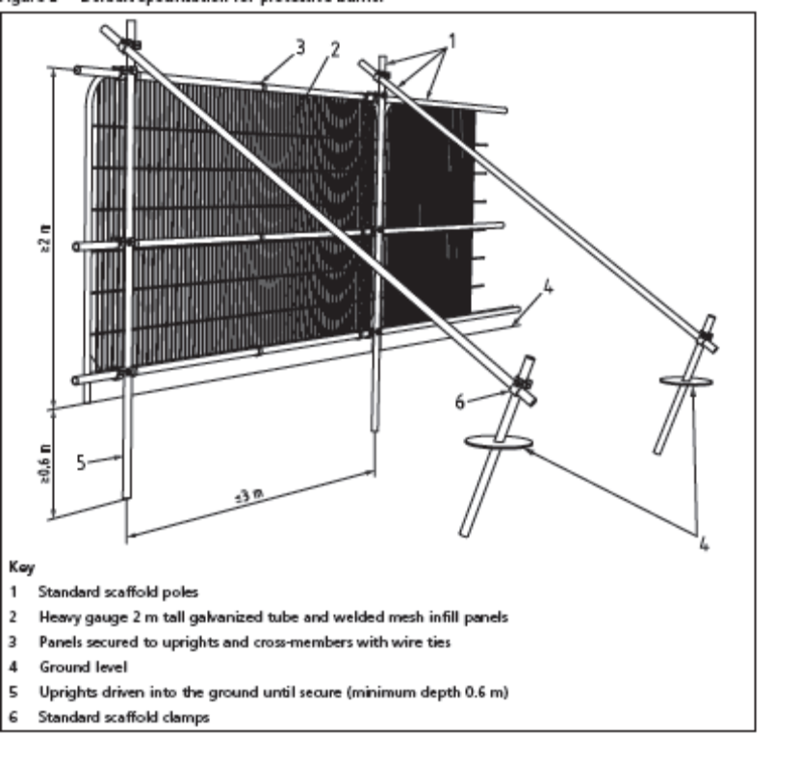
Figure 2 – suitable specifiation for smaller sites:

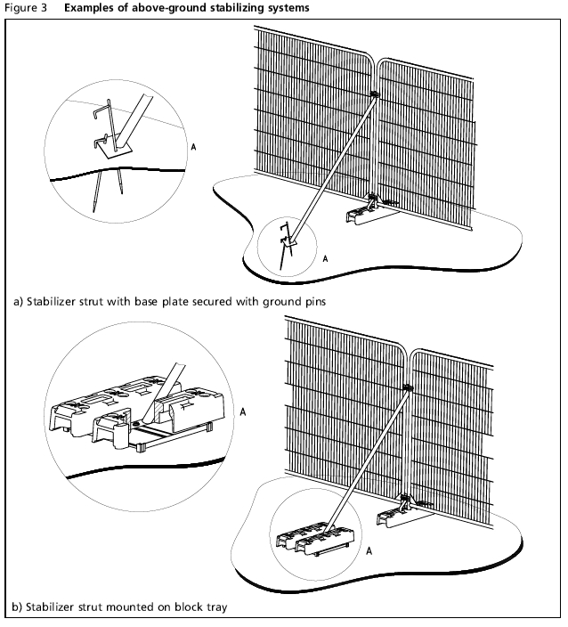

4.0 Works within the RPA

4.1 The existing entrance to the site is off a small roundabout on Tern Close. There is a tarmacked drive leading up to the derelict garages although this is mostly obscured by overgrowth and debris.

4.2 The existing tarmac should be left in situ while the site is developed. As a late part of the development, possibly while the landscape work is undertaken, the installation of a no-dig driveway should be installed within the RPA of T1.

5.0 No dig driveway specification

5.1 The development proposes to replace the existing tarmac driveway as it is damaged.

5.2 Construction of the driveway should be undertaken in dry weather between May and October, when the ground is driest and therefore least prone to compaction.

5.3 Lay an appropriate geotextile ‘Terram’ matting across the full width of the access. This will prevent the future intrusion of roots into the sub-base whilst still allowing nutrients and gaseous exchange to occur.

5.4 Lay a selected Cellular confinement system (such as Terram 100 Geocell) which can be cut with a Stanley knife on site to the length, width and profile of the driveway required.

5.5 The driveway is to be supported against a minimum 150 x 20mm tantalized boarding and 300mm long tantalized softwood pegs driven into the ground at 1000mm centres.

5.6 Using hand shovels, carefully push 20mm - 40mm gravel chippings (no fines) into the Geo-grid matting to form an aggregate sub-base.

5.7 The chippings should be placed at one end of the matting and pushed/spread across the mat to prevent compacting the soil, working on either side of the driveway.

5.8 Ensuring that all the confinement cells are full and left slightly proud, compact the sub-base to ensure binding with the geo-grid and to minimise future rutting.

5.9 Lay second layer of ‘Terram’ geotextile matting across the full width of the path. This will prevent the intrusion of fines into the gravel chippings.

5.10 Add layer of no fines, sharp sand and compact if using bonded gravel as a surface treatment.

5.11 Place proposed surface treatment (such as bonded gravel) on top of the compacted sub-base to form the finished surface to the driveway and bank up the edging with topsoil which is to be grass seeded in spring/autumn. This will form a gentle slope from the edging back onto the existing ground level.

5.12 The specification laid out above will ensure:
- Roots will not be severed, since no excavations will take place
- Soil should not be excessively compacted due to even distribution of forces
- Free movement of oxygen and carbon dioxide into and out of the soil will be maintained
- Water infiltration into the soil will not be significantly impeded

5.13 Since the driveway is designed to exist within the RPA of protected trees, there is a preliminary requirement to protect the ground throughout the development process up until immediately before the driveway specified above is to be laid. This is to ensure that the ground is not irreparably damaged before the new driveway is installed.

5.14 Where this is required an arboriculturist should be present on site for all works within the RPA in order to communicate with the site manager the best method in which to carry out any excavations or installations to minimise damage to the Tree’s roots, as well as inform the LPA that these conditions are being met.

Arboricultural Implications Assessment (AIA)

6.0 Above Ground Constraints

6.1 Effects of new buildings on amenity value on or near the site
The proposed development is on the site where some old garages were demolished. The site is full of rubbish, fly tipping’s and wild re-growth.

6.2 Pruning and felling works to facilitate development

T1 a mature silver birch is on land adjacent to the site and is to be retained.
.
T2, a self-seeded sycamore is growing through the boundary fence. It is a poor quality tree and is to be removed, not to facilitate the development but because it is of poor quality.

A response from the Local Planning Authority implied that there was a significant broadleaf tree in the rear garden of 30, Tern Close that could have an impact on the development. This tree was not there when we first visited the site and we can assume it had been felled by the occupiers of 30, Tern Close

The site was originally the location of a block of garages that have been demolished. The site was left vacant for some years and self-seeded buddleia goat willow and other wild shrubs established. The site was brush cut to the ground in 2018 but not since so the wild shrubs and bushes have re-established.

Tree 2 growing through boundary fence

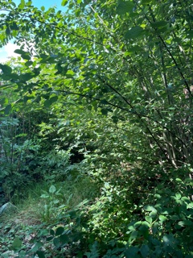

7.0 Below Ground Constraints

No Services are to be routed through the RPA of any tree.

8.0 Re-planting

Once the site has been fully developed, as part of the landscaping, the arboriculturalist and landscaper will devise a planting scheme to include trees suitable to the site.

9.0 Precautionary Measures

9.1 It should be the arboriculturist’s duty to monitor site works relating to trees and where necessary take photographs to inform the LPA that the works are taking place in accordance with LPA planning conditions in relation to trees. It remains the responsibility of the LPA to enforce any breach in conditions.

9.2 Any relocated or removed fencing should be replaced as soon as is practicable (once approved works within it are complete) and once again treated as the Construction Exclusion Zone. Any excavations within the RPA that are to be backfilled should be lightly tamped and left proud. Prior to backfilling, retained roots should be surrounded with topsoil or un-compacted sharp sand (builders’ sand should not be used because of its high salt content, which is toxic to tree roots), or other loose inert granular fill, before soil or other suitable material is replaced. This material should be free of contaminants and other foreign objects potentially injurious to tree roots.

9.3 Any tree roots whilst exposed should immediately be wrapped or covered to prevent desiccation and to protect them from rapid temperature changes. Hessian sacking is recommended. Any wrapping should be removed prior to backfilling, which should take place as soon as possible.

9.4 The proposed works within the RPA may be justified by implementing soil amelioration elsewhere if this is deemed suitable. We also recommend soil amelioration as a sound and beneficial tree care strategy. Once all works within the RPA have been completed, a 50-100mm layer of 1-year (minimum) seasoned woodchip mulch should be laid down in a circle of similar size to the tree’s RPA (where practical) in order to help improve the rhizosphere and soil medium in which the tree is growing. This will help ensure the tree’s vitality for the future and minimise the adverse effects of damage to the soil structure and any root removal that may have taken place during the works.

8.5 If roots are found to be in the way during works, they may be pruned back neatly with an appropriate hand saw or bypass secateurs so long as they are below 25mm in diameter. Roots larger than this require arboriculturist advice.

9.6 No materials that are likely to have an adverse effect on tree health such as oil, bitumen or cement (including cement washings) should be stored and handled well away from the outer edge of the RPA.

9.7 Fires on site should be avoided. When they are unavoidable, they should not be lit in a position where heat could affect foliage or branches. The potential size of fire and wind direction should be taken into account when determining its location and it should be attended at all times until safe enough to leave. Also take note of statutory litigations in force in the area before lighting fires.

9.8 No vehicles or pedestrian traffic will be allowed to enter areas once protected by fencing, unless permitted otherwise by the LPA and should be accompanied by the arboriculturist at all times.

.

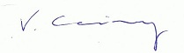
Vince Cainey BSc
8th September 2021.

