

LAND ADJACENT TO 80 MOUNT PLEASANT, READING, BERKS, RG1 2TD

ERECTION OF 3 STOREY 2 BED DWELLING HOUSE.

CMS Construction Method Statement

INITIAL WORKS

The appointed contractor shall be provided with all the documentation and be familiar with the project before work commences. A principal individual shall be nominated to administer requirements and a secondary operative shall be appointed in the absence of the primary appointee.

PARKING

Vehicular Parking for Site Operatives is available within the areas shown (see Parking Plan, Fig.1).
The public car park at Saxon Court is within walking distance of the site and there are weekly rates available Time Restricted On-Street Parking availability is also indicated for Visitors where indicated, however public transport will be encouraged where possible.
No Parking shall take place on the highway at any time throughout the duration of the project.

UNLOADING & LOADING OF PLANT AND MATERIALS
Due to the restricted nature of the Site, a limited area for storage of materials has been designated on the Site Layout Plan Due to the various type of vehicles that will be arriving on site including concrete lorries, material delivery and vans etc. Materials delivery will need to be programmed to arrive on site only when needed with a view to be used immediately. Vehicles arriving for delivery of materials shall have a Banksman in attendance for the purposes of Driving in/reversing from the site and re-entering the highway and ensuring the highway and footpath is kept clean and free of debris. Vehicles/Plant leaving the site shall be subject of a wash down procedure. The use of specific vehicles with crane attachement shall be required to enable materials to be safely positioned on site. Curent discussions with the owner of the adjacent car park are taking place for tempoary use of adjacent land and this is currently included in the Party Wall agreements.

TIMES & ROUTES

Deliveries to be scheduled with Site Manager to arrive to site outside of Peak traffic hours (8am to 9.30am and 4pm to 6pm) where possible to ensure minimal traffic disruption. Designated routes to site shall be stipulated to suppliers. Deliveries will not be made before 8am or after 6pm (Monday to Friday) and before 9am or after 1pm on Saturday and no work is permissible on Sundays, during public or bank holidays.

EXTERNAL WORKS

Utility & Services connections into site to be made by others as necessary (Electricity, Gas, Water) and may require temporary closure of Footpath in front of the site. Where applicable, works relating to these services will be carried out by the relevant service authority in accordance with their own detailed method statements. Applications will be made to the Highways Department as necessary and the conditions will be transferred to the appointed contractor to carry out as necessary. The locations and routes of all services will be agreed prior to work commencing. All agreements to be in place before work commences.

CDM REGULATIONS

The contractor who will be appointed by the client will be responsible for the day to day management of Health and Safety risks during the process of construction. He will need to review and approve method statements and risk assessments etc including monitoring construction phased operations including initial review of all operatives and subcontractors to ensure they have the skill to carry out the work as proposed. Liaison with the principle designed will be required as necessary

WATER SUPPLY

A new water supply (including a temporary standpipe) is to be brought into the site (Application to be made to Thames Water)
The minimum depth of the pipe will be 750mm (max. 1350mm) and it shall be ducted and insulated where it enters the building to BS 5422. External stop cock shall be placed in the footpath adjacent the principal Elevation. The internal stop valve shall be positioned so that it is easily accessible and close to the wash down of vehicle wheels as marked on plan.

ELECTRICITY & GAS SUPPLY

New supplies to site to be provided. The positioning, width of trench and depth of the new supplies relative to the reduced dig to be agreed with the main contractor.

NOISE CONTROL

The Contractors responsibilities will be to ensure the work is carried out with minimal impact on immediate residents. To do this noisy procedures such as excavations etc. shall be programmed
such that they only occur between the hours of 9.0am and 4.0pm. Plant shall be selected that provides appropriate suppression of noise and the process shall be monitored throughout the construction period (see below for further comments on this).

SITE SECURITY

Allow to provide Heras style self supporting mesh panels to replace existing Fencing/Hoarding around the Site Boundaries where necessary. Front access to be maintained with Lockable Site Gates to be secured as soon as work commences. Access into the site to be controlled by a Gateman/Site Manager with incoming/outgoing visitors recorded as necessary. Site Security Fencing generally to be kept clean & free of any Graffiti/Posters

WASTE & RECYCLING

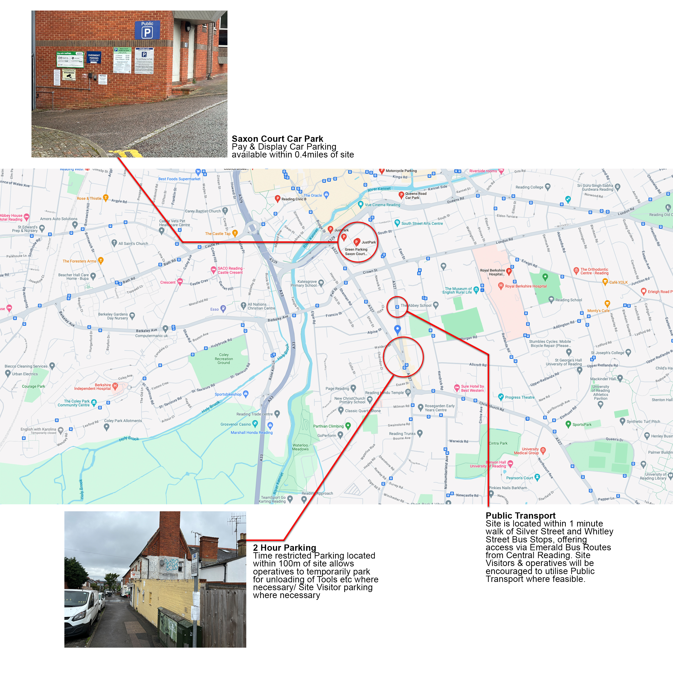
Provision shall be made for removal of waste materials for recycling, with a designated Waste Storage area (see Site Plan). Recycling to be managed by designated Waste Removal contractor who will be appointed before work commences (this element is currently out for tender) and the appropriate waste bins will be monitored by the site manager as work proceeds.

DUST & NOISE POLLUTION

Site operatives to appropriate PPE for the activities being performed. All operations likely to produce excessive dust to be subject to a ‘damping down’ procedure.
Noise (as discussed above) to be monitored throughout the construction. Activities to be risk assessed and controlled as necessary in accordance with BS5228-1. Activities likely to cause disturbance to residents are to be restricted to 9am to 4pm Monday to Friday, and 9am to 1pm Saturday (No works to take place on Sunday or Bank Holidays)

Fig. 1 Parking Plan

