


Planning Statement to support the construction of 5 no 3bedroom town houses to land adjacent to 24 George Street Caversham Reading RG4 8DG

Date. April 24

Project Ref. 9220

  - Site Description

The site is located to the north of 24 George Street, close to the junction with Gosbrook Road. The
site comprises an undeveloped area of land that is currently enclosed by hoarding.

The site is within an air quality management area and Flood Zones 2 and 3 as designated by the
Environment agency.

2.0.0. Relevant planning history

The site has recently been the subject of a pre application for the construction of 6no town houses which will be discussed along with this application below.

221187/TPO T2-T3-T4 Black poplars to be felled as structurally unstable. Approved.
T5 removal of Ivy for further inspection.

3.0.0. Relevant Policies

Relevant Policies
Any planning application at the site would be considered within the context of the Reading Borough
Local Plan 2019. RBC Supplementary Planning Documents would also be applied where relevant,
together with national guidance (the NPPF). Please use this link to view the local policies:
https://www.reading.gov.uk/planningpolicy

4.0.0. Appraisal

Reading Borough Council go on to say;

Land Use Matters and Design Considerations
Paragraph 119 of the NPPF states that: “Planning policies and decisions should promote an effective
use of land in meeting the need for homes and other uses, while safeguarding and improving the
environment and ensuring safe and healthy living conditions. Strategic policies should set out a clear
strategy for accommodating objectively assessed needs, in a way that makes as much use as possible
of previously-developed or ‘brownfield’ land”. The land in question is not considered to be previously
developed land and as such the priority for development should be on other sites.

Paragraph 120 of the NPPF goes on to state “Planning policies and decisions should…recognise that
some undeveloped land can perform many functions such as for wildlife, recreation, flood risk
minimisation, cooling/shading, carbon storage or food production”.

Furthermore, Policy EN8 (Undesignated Open Space) of the Reading Borough Local Plan 2019 goes into
more detail specific to Reading and states that “There will be a presumption in favour of retention of
undesignated open space…Development should not result in the loss of or jeopardise use and
enjoyment of undesignated open space…The quality of existing open space should not be eroded by
insensitive development on adjoining land”. Whilst the site is in private ownership, the supporting
text to the Policy in paragraph 4.2.30 explains that “Reading has many areas of open space not
identified in Policy EN7 (Local Green Space and Public Open Space) in both public and private
ownership. It is important that these areas are retained where possible”. The definition of open
space in the glossary to the NPPF does not limit it to land in public ownership, but all open space of
public value. Indeed, the NPPG (Ref: Paragraph: 001 Reference ID: 37-001-20140306) confirms that
open space can take many forms, including being an important part of the landscape and setting of
built development.

Further to the above, the immediate rear of the site (west) forms part of the Thames Valley Major
Landscape Feature Area. Policy EN13 (Major Landscape Features and Areas of Outstanding Natural
Beauty) states that “Planning permission will not be granted for any development that would detract
from the character or appearance of a Major Landscape Feature Area’. This area is also a designated
Local Green Space – Christchurch Meadows (ENC7a). Policy EN7 (Local Green Space and Public Open
Space) states that ‘Proposals that would result in the loss of any of these areas of open space, erode
their quality through insensitive adjacent development or jeopardise their use or enjoyment by the
public will not be permitted’.

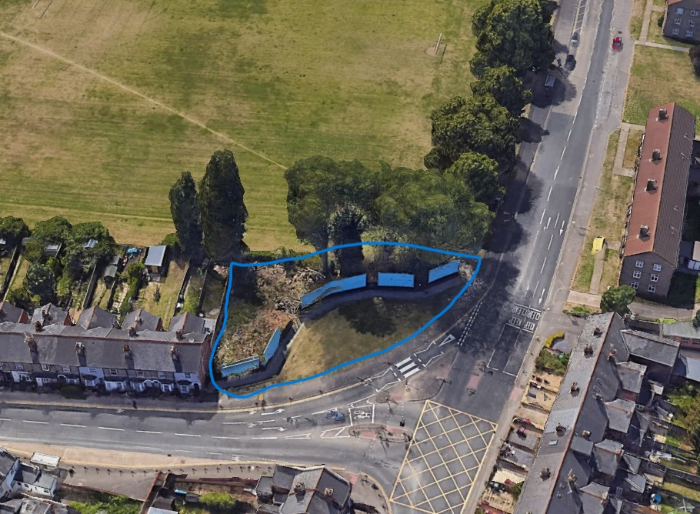

This picture above edged in blue shows the site in question, before the poplar trees were removed.

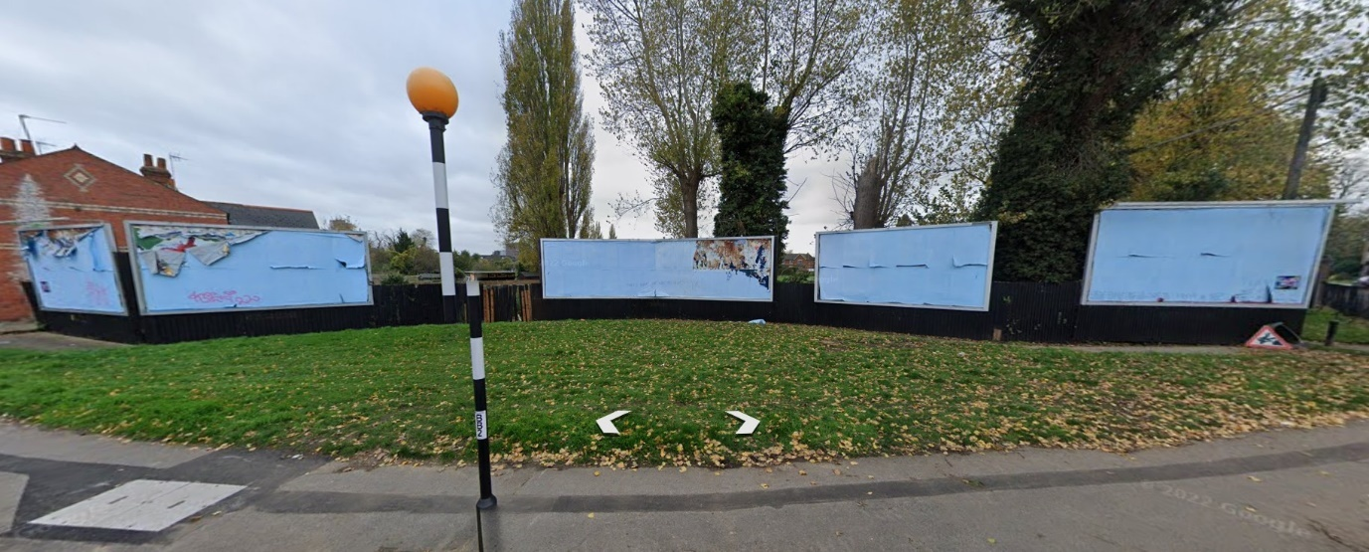

The site has been used for many years to advertise via the hoardings shown which are now no longer viable, therefore the land was subsequently sold on for potential other uses.

Christchurch Meadows is clearly shown in the picture below, the land in question is clearly not part of Christchurch Meadows which is fenced off behind the hoardings.
This parcel of land has been in existence as seen for some considerable time due to the size of the trees to the perimeter of the site.
The application site is indicated by the blue arrow.

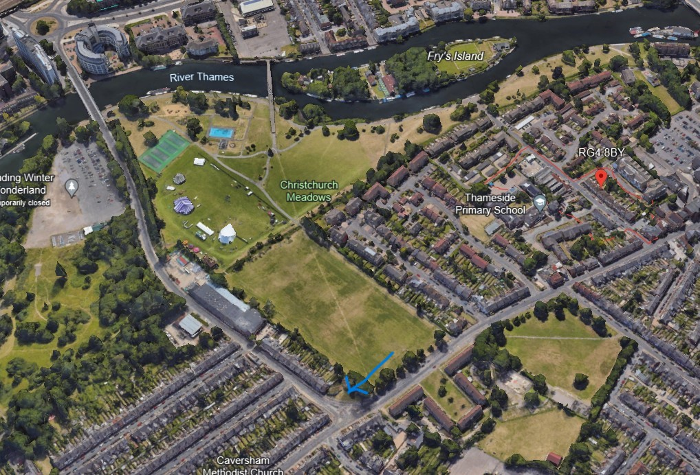

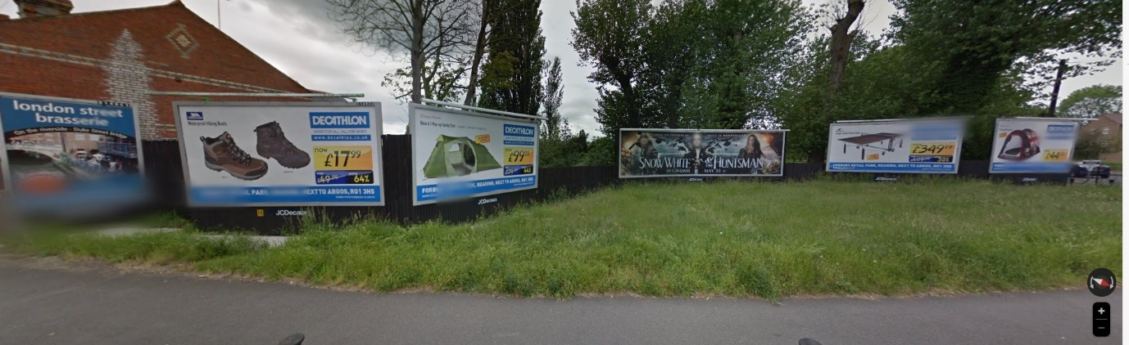

Picture of site in March 2009

The green stretch of land to the front of the hoardings is to allow them to be seen by motorists & the general public when walking past.
The land is not suitable for recreation, Christchurch Gardens adjacent fulfils this function.

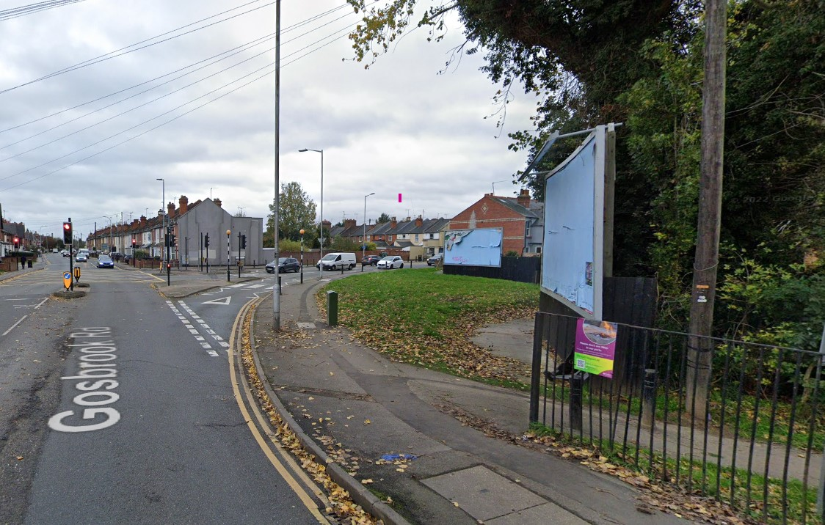

View from Gosbrook Road looking up George St from the West.

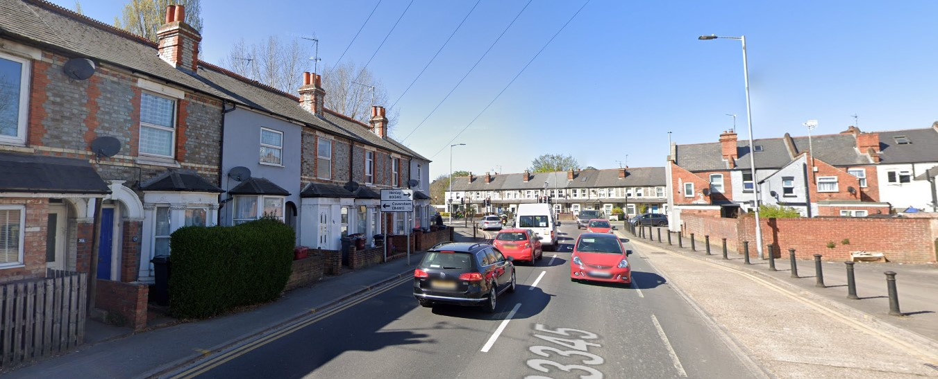

View of site looking down George St

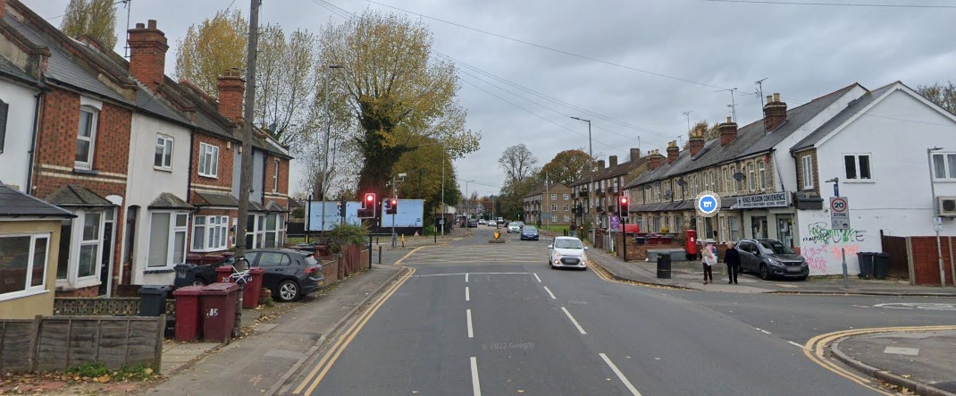

View of site looking down Gosbrook Road looking from the East

Reading Borough Council consider this parcel of land provides an important contribution to the visual amenity of the area adjacent to the busy Gosbrook Road -George St junction.

When one drives down George St the land in question cannot be seen until one passes no 24.
When one drives along Gosbrook Road in either direction the most important part of the site that is mostly seen is the northern tip.

Having regard to the surrounding residential development & Christchurch Meadows the development of the Southern section will make little difference as long as the section of land on the northern point is carefully landscaped.

Reading Borough Council go on to say ;

Paragraph 130 of the NPPF details that decisions should ensure that developments are visually
attractive as a result of good architecture, layout and appropriate and effective landscaping and are
sympathetic to local character including the surrounding built environment.

The Council considered that the pre app scheme for 6 houses was an over development of the site with the loss of the open feel of this site.

The scheme has been reduced by one unit & now only two storey in height.
The proposed houses are positioned adjacent to the footpath incorporating small front gardens which continues the terraced house theme along George Street.

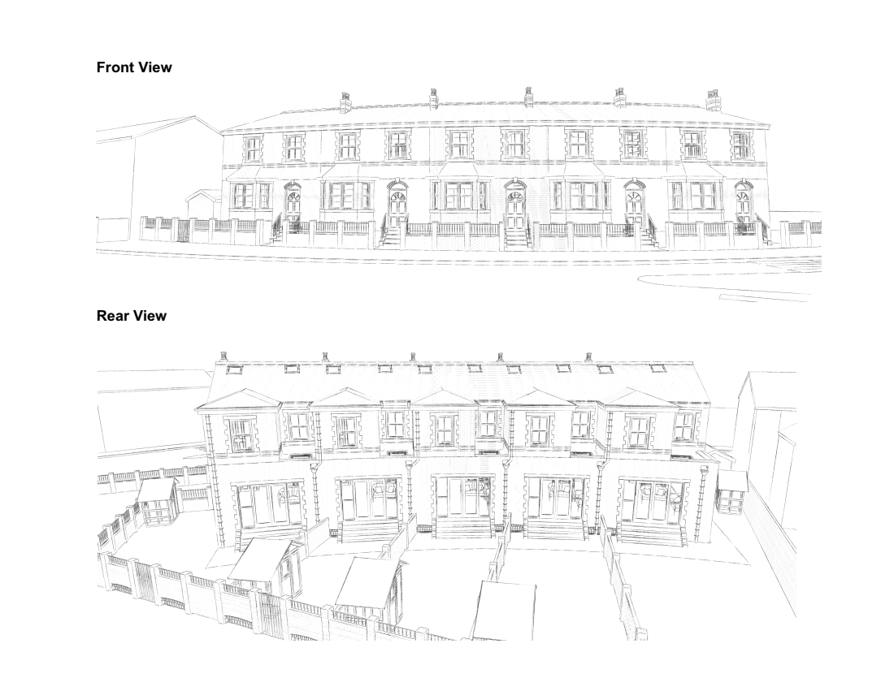

This would in our opinion be in keeping with the character of this road & the surrounding area whilst providing a landscaped corner to Gosbrook Road.
The proposals would not harm the visual amenity value of the open area, the proposals are therefore not considered to be contrary to Policies EN8 and CC7 and would comply with
guidance of the NPPF in terms of making effective use of land.

5.0.0. Flood Risk

The site is located in both flood zone 2 & 3 as shown within the Flood Risk Assessment by Oakshire Ltd.
The Sequential & Exception tests are included for consideration.
A SUDS report is also enclosed by Oakshire Ltd.

The Council said within their pre application advice:

The Council’s latest Housing Trajectory as published in the Annual Monitoring Review 2021
demonstrates that the Council has a greater than 5 year housing land supply and that the total supply
of housing exceeds the figure for identified need and therefore sufficient land at a lower risk of
flooding exists and the sequential test would be unlikely to be passed and permission unlikely to be
granted. However, a closer examination of the figures reveals that whilst the need for family housing
(3 beds or more) makes up over half the identified need, the supply falls well short based on current
figures. Similarly, there is a significant undersupply of affordable housing when measured against the
identified need. Provision of affordable housing would also be sequentially preferable. Therefore, the
availability of land for these particular types of housing (3 bed + and affordable housing) is unlikely to
be met in areas of lower risk of flooding. Therefore, in respect of this specific proposal – and
especially if it were to offer affordable housing - it may be possible to demonstrate that an
application for residential development on the site could pass the sequential test. However, the onus
is on you to present a detailed sequential test for this particular development and demonstrate the
case to the Council.

In this case the affordable housing requirement equates to 10% which is one dwelling or a financial contribution of 10% of the total Gross Development Value.

Our consultant has also made contact with the EA.

Impact on trees & landscaping

A planning application was made Ref. 221187 to remove T2-T3-T4 from the TPO listing which was approved

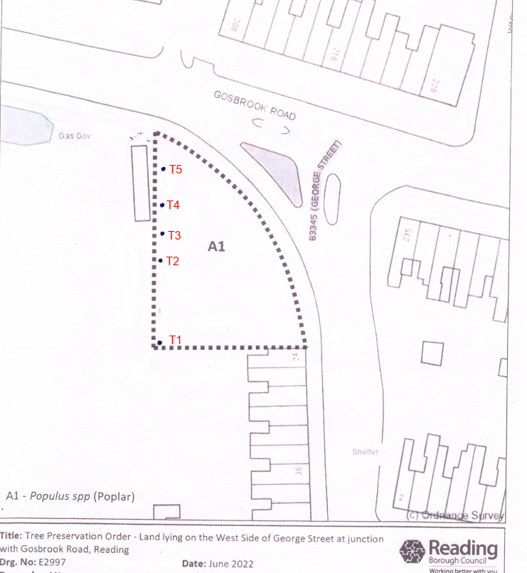

The consent allowed felling of these trees due to structural defects & the replanting of 3no replacement broadleaf trees within the plot of land during the planting season (Nov-March) following the felling.

It is appreciated that the tree planting has not yet been undertaken.
It was considered that a comprehensive planting scheme would be advantageous for the site prepared by a qualified arboriculturist which is enclosed for consideration.

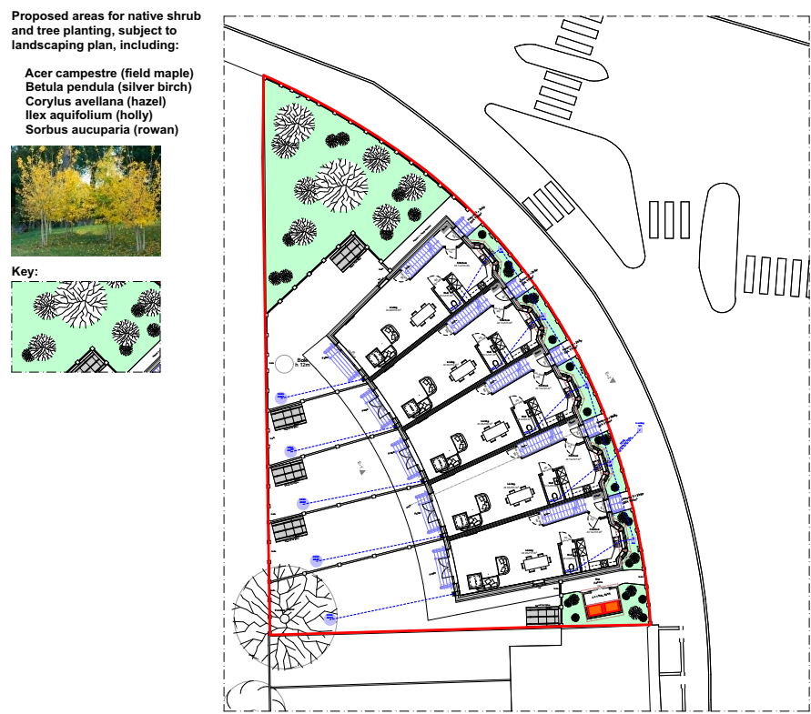

See above for soft landscaping proposed within the front gardens & to the northern corner of the site on the Gosbrook/George Street Junction.

6.0.0. Ecology

An Ecology Phase 1 habitat & protected species survey has been carried out together with the Biodiversity assessment which is enclosed with this application.

7.0.0. Ecological Enhancements

The Ecology report deals with this along with the planting scheme from David Williams.

Impact on Neighbour Amenity

Policy CC8 (Safeguarding Amenity) seeks to ensure development does not cause harm to the living
environment of existing properties, in terms of loss of privacy, overlooking and visual dominance,
amongst other things. Policy EN16 (Pollution and Water Resources) seeks to protect surrounding
occupiers form the impact of pollution.

The proposed dwellings have now been moved away from 24 George St & although the 45`sight line is breached slightly as the new dwellings are north of no 24 we do not believe there is any significant loss of light to this particular window serving the rear bedroom.

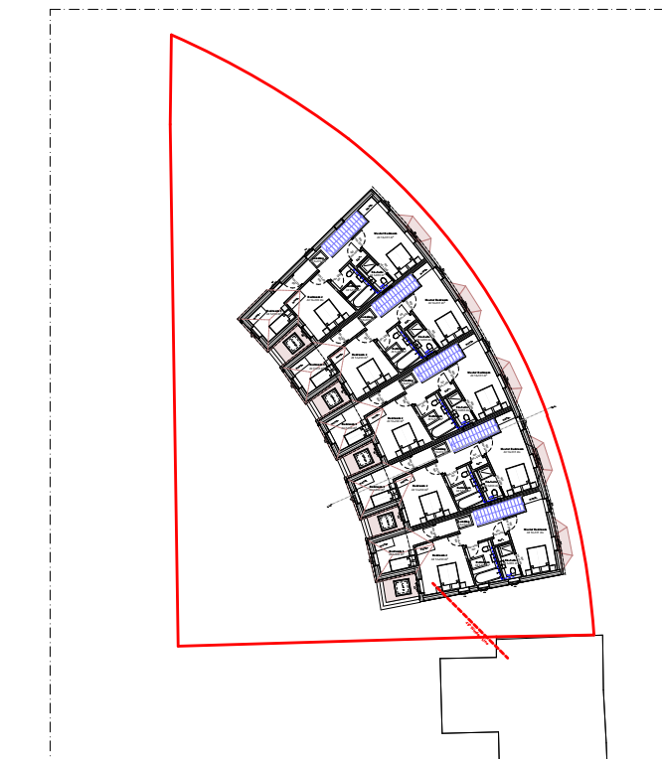

8.0.0. Quality of residential accommodation

Each property is 114sqm over two floors & provides for a 3B- 5P dwelling which exceeds the National Standard by 11sqm & is therefore generous.

Each property is provided with good quality private garden space, beyond these rear gardens is Christchurch Meadow which is easily accessible.

A communal bin store is provided between no 24 & plot 1 to allow easy access for disposal right next to where the bin lorry would pick up from no 24 George St.

Cycle storage is provided for within each rear garden.

Site plans showing bins & cycle storage.

9.0.0. Environmental protection.

A noise assessment is enclosed for consideration.
An air quality assessment is enclosed for consideration.

10.0.0. Contaminated Land

A desk top assessment has been carried out & is enclosed with this application.

11.0.0. Construction & Demolition phases.

A CMS will be submitted as part of the planning conditions application.

12.0.0.Transport & parking

A car free development is proposed.
A transport statement has been prepared by Chris Saunders from Motion.

13.0.0. Sustainability

The development will achieve a minimum of 19% improvement in the dwelling emission rate over the target emission rate.
An Energy statement is enclosed for consideration.

14.0.0. Affordable Housing

As detailed above the scheme will be compliant with Policy H3.
The actual figure required is 10% of GDV as an off site contribution.

The applicant is willing to enter into a legal agreement with RBC & pay their reasonable legal fees in the process.
A title plan is enclosed with this application.

15.0.0. CIL

A CIL form is enclosed.

16.0.0. Conclusion.

The main bone of contention is the question of whether this small parcel of land is seen as a harmful loss of undesignated land.

The land in question is a very small parcel of land situated on the corner of George St & Gosbrook Road directly in front of Christchurch Meadow.
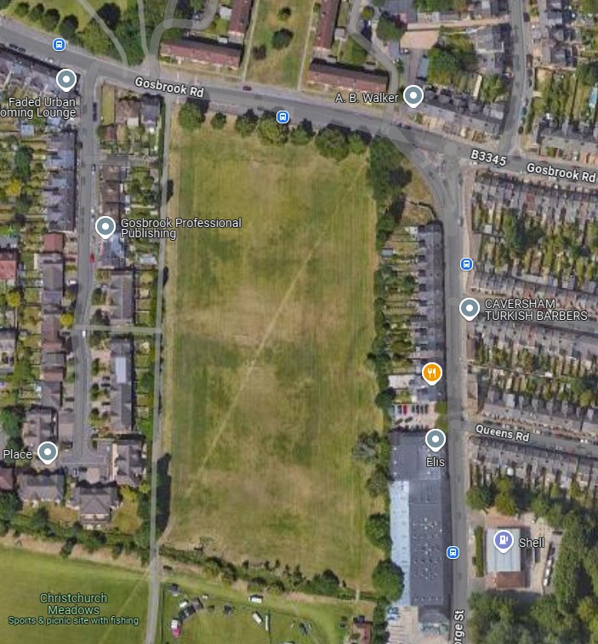

Looking at this Google Map the parcel of land was never intended to form part of the park as trees were planted on its boundary (some of which were subject to removal). I suspect the only reason the terraced properties did not extend any further North was due to the curved front boundary.

There is a need for family housing within the urban location of Reading which currently has a serious shortfall in numbers coming forward, whilst 1000`s of flats are currently under construction or approved which are not ideal family homes. These are, as the location is highly sustainable close to the Caversham Centre to the West, on main bus routes into Town & an easy walk to the main Reading Train Station.

Apart from being provided with good quality private amenity, there is a large park directly to the rear.

A wedge of Green space is being retained on the corner which will be planted with native species to provide visual attraction.

As the land is privately owned, there is a responsibility to up keep it.
If the land proves difficult to develop for housing the site will have to be fenced with a 2m high metal fence to stop fly tipping & other unsavory activities.

If this proves to be unacceptable a 1m fence could be erected on the front boundary with a 2m closed fence 1m back with planting between without the need for formal consent.

This would in effectively remove the parcel of land from the public realm including the green wedge we are proposing to retain with the tree planting to the rear & deny a home for 5 families in Reading.

The site has never flooded, the dwellings are raised above the flood plain as recommended within the FRA & flood water will be allowed to pass through (if it ever floods).

We would hope that the Council would reconsider its negative points relating to this site & approve what we consider to be a well designed scheme of 5 family houses.

