152 Oxford Road, Reading, RG1 7PJ
Change of Use from Estate Agent to Hot food takeaway
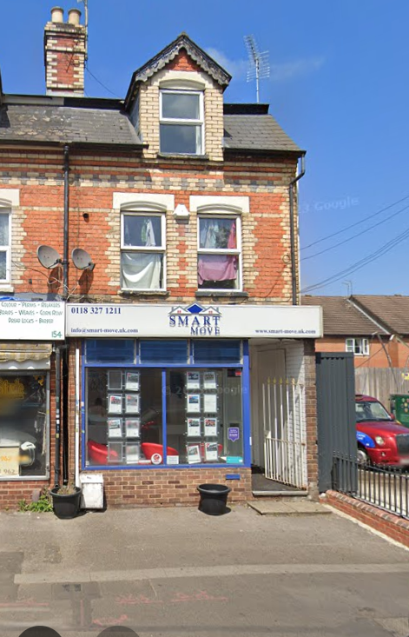
Supporting statement

Site and Surroundings
The site comprises a three storey property located on the northern side of Oxford Road, Reading. The site is located on the end of a long retail frontage. To the south is Oxford Road with retail units located on the opposite of the road, to the west is the remainder of the retail frontage, to the east is a petrol filling station and to the north are residential properties. The site is currently used as an estate agent with residential above on the upper floors.
Proposed Development
The proposal is for a change of use from an estate agent to a hot food takeaway. The alterations to the building are purely internal. The shop frontage will remain the same. The only external change would be to the sign, which would be subject to a separate advertisement consent. The proposal therefore purely relates to the change of use from Class E to Sui Generis.
Planning Policy
A new Reading Borough Local Plan was adopted on 4th November 2019. The proposals map locates the site within Oxford Road West district centre. The proposals map (see below) shows the extent of the District Centre, in particular the area of the District Centre close to the centre of Reading. The plan below shows the location of the application site and is identified within a shopping frontage.

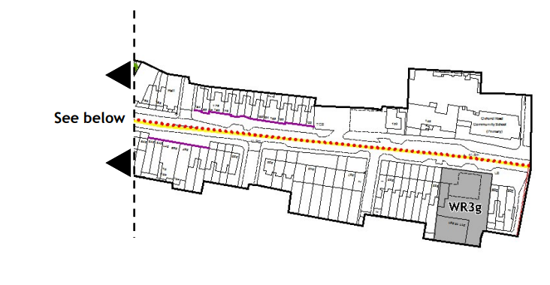
Given the site is located within the boundary of an identified centre Policy RL1 is of relevance. Policy RL1 is set out below.

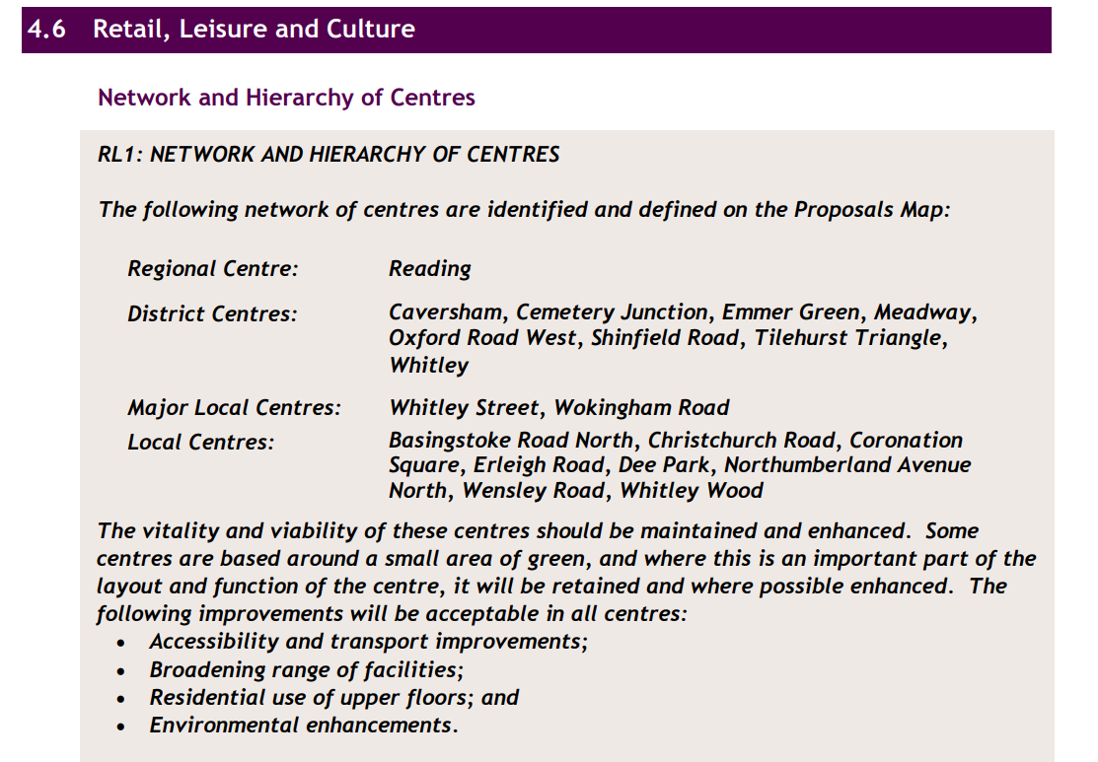
The policy states that Oxford Road West is identified as a District Centre. Furthermore, the site is located within a key frontage and therefore Policy RL3 is of relevance to the proposal. Policy RL3 is set out below. The policy has two elements, firstly within the Key frontage there shall be no more than three consecutive units in non-retail use. Secondly as the site is located within Oxford Road West there shall be no more than 50% of the units within the frontage being in non-retail use.

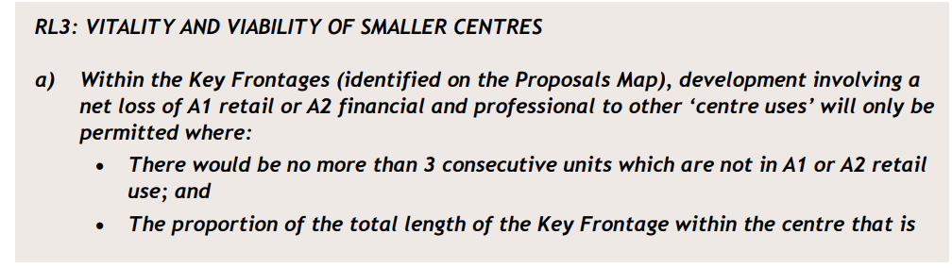
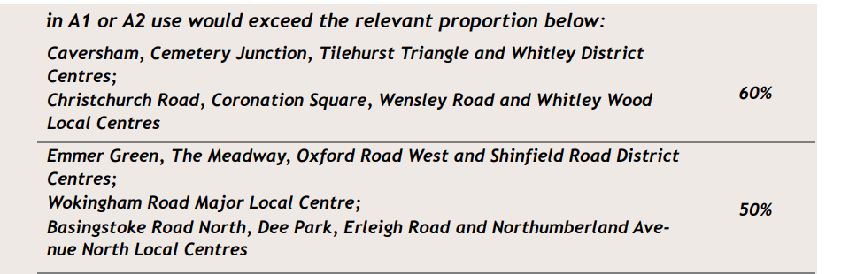

Assessment
The above policy quotes old use classes, which has now been superseded by the updated Use Class Order, which came into being in August 2021. An estate agent is now a Class E unit and a hot food takeaway is Sui Generis.
The site forms the end unit at No 152. The units forming the remainder of the frontage are as follows:
152 Proposed HFTA Sui Generis
154 Hairdresser Class E
156 Mobile Phone shop Class E
158 Perfect Fried Chicken Sui Generis
160 Clothes shop Class E
162/164 Food Superstore Class E
166 Devils kitchen Pizza Sui Generis
168 Food shop Class E
170 Food shop Class E
172 Momo 2 Go Restaurant/Takeaway Sui Generis
174 Barber Class E
176 Mr Cod Chip shop Sui Generis
178/180 Solicitors Financial Planners Class E
182 Hair Salon Class E
184Coffee Shop Class E as the food and drink appears to be mostly consumed on the premises
From this assessment, the frontage comprises 17 units of which if the proposal was allowed this would provide five units, which are in non-retail use. This represents 29%, which is well below the threshold of 50%. Furthermore, the proposal would not create three consecutive non retail units, as they appear to be reasonably spread out throughout the frontage. For the above reasons the proposal complies with Policy RL3.
With regard to the parking provision there is restricted parking in front of the unit for two hours between the hours of 8am to 8pm. Most of the trade would probably be after 8pm where there are no restrictions on parking, however two hours is more than sufficient to visit a hot food takeaway. The applicant considers there would be no issues of highway safety with the proposal.
Although the site is located on a busy street as one of the main routes entering Reading, there are residential properties located above the unit and to the rear of the frontage. The neighbouring properties above and to the rear of the unit already experience noise and disturbance from traffic using the main road and cooking smells from neighbouring HFTA’s. The applicant considers that the proposal would not add to the noise and disturbance already experienced by neighbouring residents and therefore it would not be harmful to their living conditions.
For the above reasons the Council are requested to approve the planning application.

