

DELEGATED HOUSEHOLDER APPLICATION REPORT

Ward: Whitley
App Ref: 240725/HOU
Address: 59 Blandford Road, Reading, RG2 8RP
Proposals: Proposal for single storey rear/side extension, Conversion of garage into habitable space and internal alterations
Case Officer: Chukwudi Onwudinanti
Applicant: Asmawa Aissa L. Djoboungue
Date received (valid from): 4 June 2024
Target Decision date: 30 July 2024

1. SITE DESCRIPTION
The site is a semi-detached two storey dwelling on the eastern side of Blandford Road, in a predominantly residential area, with dwellings of similar as well as varied styles and sizes on both sides of the road. The dwellings are a mix of brick finishes and white render to the external walls. The dwellings on the road have considerable sized rear gardens.

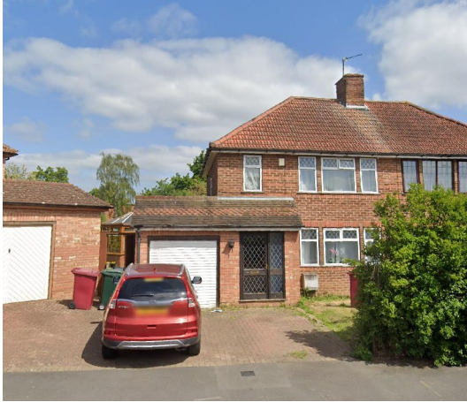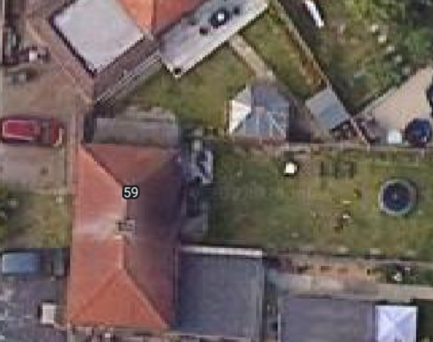

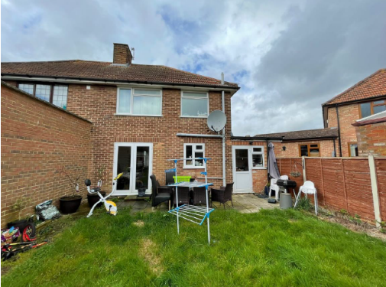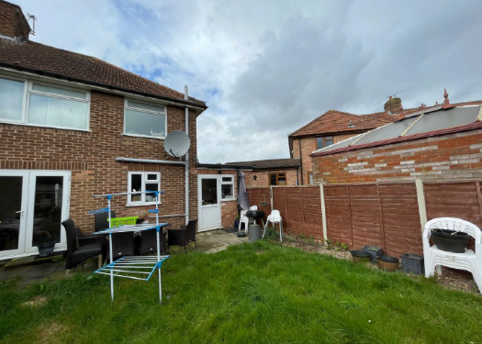

2. PROPOSAL AND SUPPORTING INFORMATION

The proposal is for a single storey rear/side extension, measuring 4m to the rear, on the same width as the existing, whilst converting the garage into habitable space. Also proposed are internal alterations

Plans considered dated 18th March 2024 received 05/06/2024
Drawing No 59BR/18032024/REV-C-1/2: Existing and Proposed Plans and Elevations
Drawing No 59BR/18032024/REV-C-2/2: Existing Site Plan, Proposed Site Plan and Location Plan

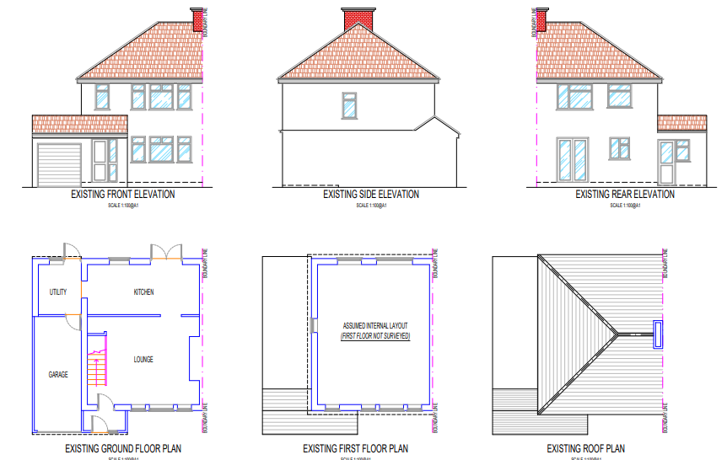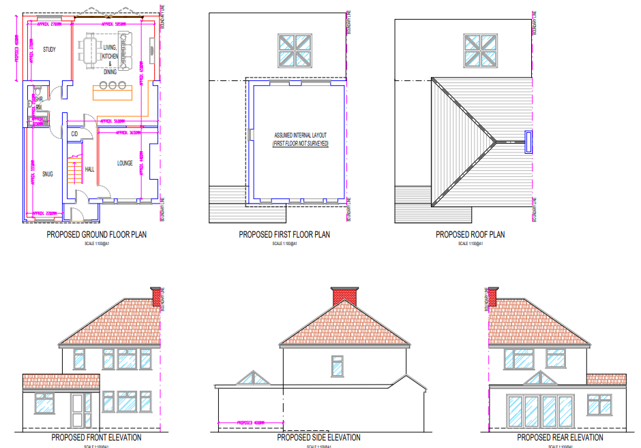
Existing Plans and Elevations Proposed Plans and Elevations

- RELEVANT PLANNING HISTORY
Application Ref: 901147
Description: Single storey side extension for utility room and garage. Front extension to porch.
Decision: Permitted
Decision Date: 18/6/1990

4. CONSULTATIONS

The following addresses were consulted by letter.

52 Blandford Road, Reading, Berkshire, RG2 8RN
57 Blandford Road, Reading, RG2 8RP
61 Blandford Road, Reading, RG2 8RP
54 Blandford Road, Reading, RG2 8RN

No letters of representation have been received as follows:

Equality Act 2010:
In determining this application the Council is required to have regard to its obligations under the Equality Act 2010. However, there is no indication or evidence (including from consultation on the application) that the protected groups identified by the Act have or will have different needs, experiences, issues and priorities in relation to this particular planning application. Therefore in terms of the key equalities protected characteristics it is considered there would be no significant adverse impacts as a result of the development.

- LEGAL AND PLANNING POLICY CONTEXT

Section 38(6) of the Planning and Compulsory Purchase Act 2004 requires that proposals be determined in accordance with the development plan unless material considerations indicate otherwise. Material considerations include relevant policies in the National Planning Policy framework (NPPF) - among them the 'presumption in favour of sustainable development'. The following local and national planning policy and guidance is relevant to this application:

National Policy
National Planning Policy Framework
National Planning Practice Guidance

Reading Borough Local Plan (2019)
CC7 (Design and the Public Realm)
CC8 (Safeguarding Amenity)
H9 (House Extensions and Ancillary Accommodation)
H10 (Private and Communal Outdoor Space)
TR3 (Access Traffic and Highway-related Matters)
TR5 (Car and Cycle Parking)

SPD
Design Guide to House Extensions 2021
Revised Parking Standards and Design SPD 2011

6. APPRAISAL
Character and Appearance

Policy H9 states that an extension to a house will be acceptable where it respects the character of the house in terms of scale, location, materials and design and respects the character and pattern of neighbouring properties and the street as a whole in terms of scale, location, materials and design, and any important existing building line. Policy CC7 also sets out relevant considerations for design.

The proposal presents a ground floor extension of the existing dwelling approximately 4m to the rear, pulling the existing side extension by the same depth to the rear, to create a wrap-around extension to the left and rear of the dwelling. All aspects of the extension would be covered by a flat roof, with a skylight installed in the centre of the rear extension.

The extension to the side and rear would be of a maximum height of 2.9m and all external walls would be finished with materials to match existing materials.

It is considered that the alterations presented by this proposal, including the internal alterations would not alter the appearance and character of the dwelling or the general appearance and character of the street scene in terms of scale, location, materials and design. The building line to the front would also not be moved forward as a result of the extensions proposed.

Residential Amenity

Policy H9 states that an extension will be acceptable where it does not result in an overbearing impact on neighbours. Policy H10 seeks to ensure that the amenity of gardens and other outdoor areas are not compromised. Policy CC8 states an extension to a house will be acceptable where it will not cause a significant detrimental impact to the living environment of existing or new residential properties.

The height of the extensions proposed are limited to approximately 2.9m and are covered by a flat roof. There are no side windows proposed and the angle of orientation of the proposed site in relation to the adjoining property mean that there would not be any negative amenity impacts caused by the extensions on the adjoining properties.

No 61 has an existing rear extension which also serves to limit any cumulative effect of the proposed extension on the amenity of that property. The application property has a considerable sized rear garden and there would not be such encroachment on this garden space that would have a negative impact on the amenity of the users of No 59.

- CONCLUSION
The proposed development has been assessed as set out above and is considered to be acceptable on that basis, subject to the following conditions.

8. RECOMMENDATION: Grant
Recommended Conditions:
Approved Plans
Time Limit Standards
Materials to Match Existing

