PANEL INFORMATION:
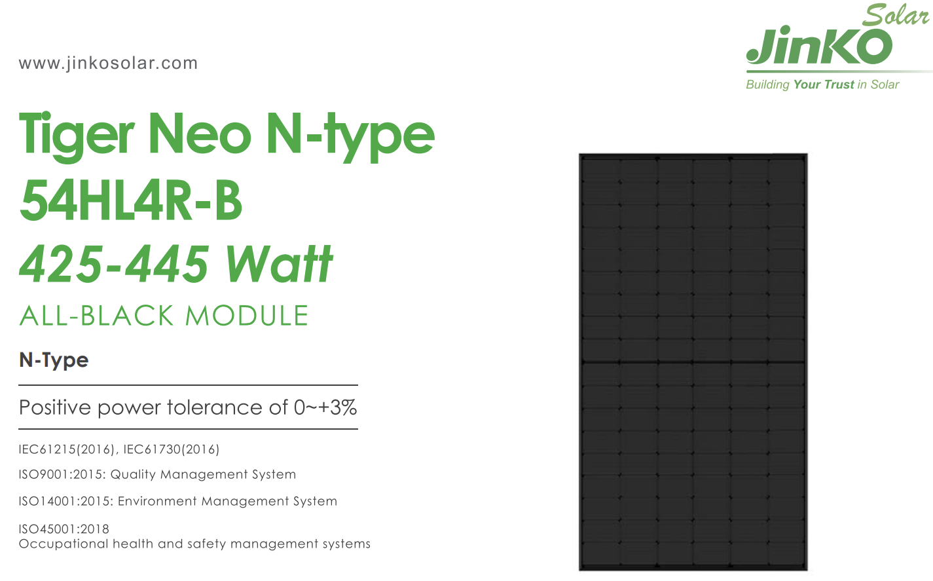

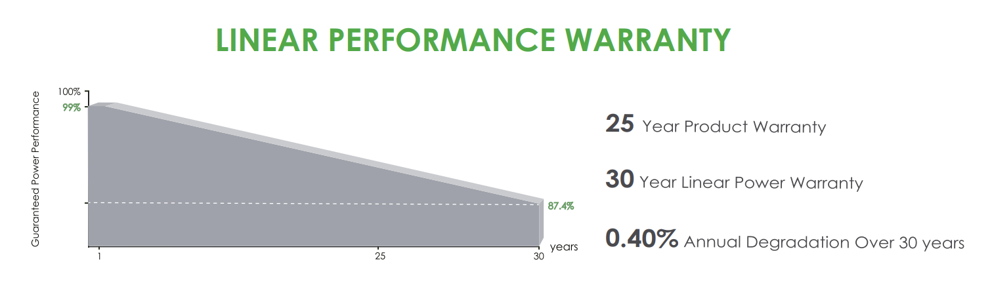
SIZE: 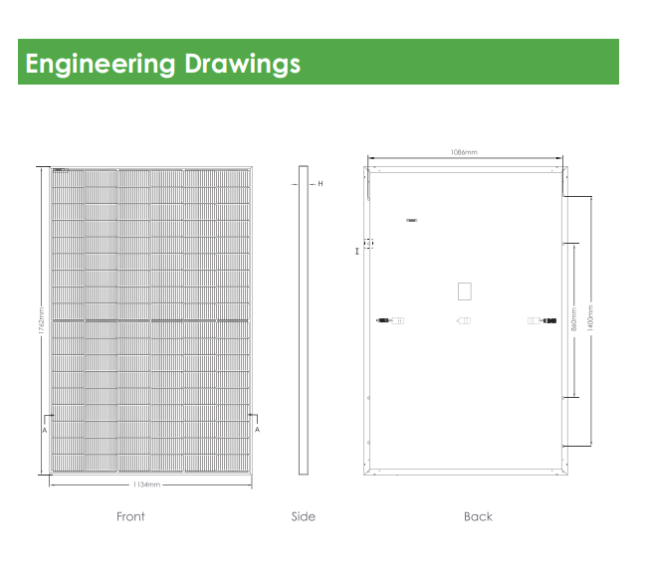
Where distance H in the diagram is the depth of the panel and is 65mm

