

DELEGATED HOUSEHOLDER APPLICATION REPORT

Ward: Kentwood
App Ref: 231833/HOU
Address: 10 Chepstow Road, Tilehurst, Reading, RG31 6LS
Proposals: Rear single storey extension and two-storey side extension
Case Officer: Chukwudi Onwudinanti
Applicant: Mr Jeanne-Clive Daniel Labonne
Date received (valid from): 18 December 2023
Target Decision date: 15 March 2024 (EXT)

1. SITE DESCRIPTION
The proposed site is a semi-detached two storey dwelling on the southern side of Chepstow Road, facing the intersection with Brooksby Road. There is an existing detached pitched roof single storey garage and store to the side of the dwelling set well back from the property front building line.

It is in a predominantly residential area, characterised by dwellings of similar style and size. (red boxes denote the locations of the proposed scheme)

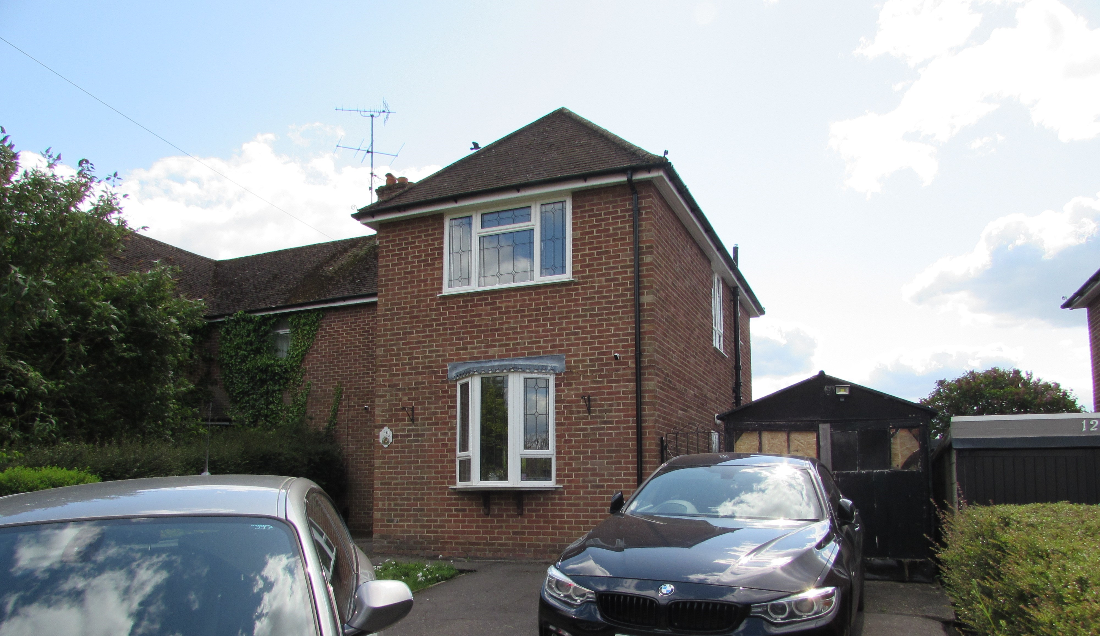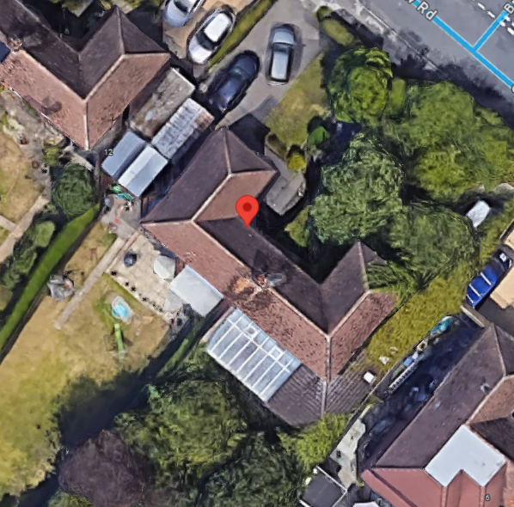

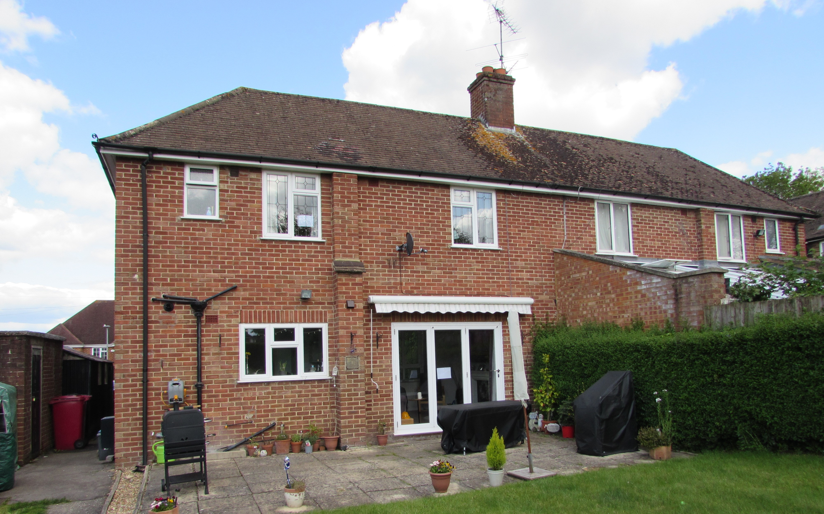
Google Map Photos & Site Photos

2. PROPOSAL AND SUPPORTING INFORMATION
Flat roofed rear single storey extension measuring 4.4m deep and 9.6m wide (the whole width of the existing dwelling and partially behind the two storey side extension) and with a roof light. Also a hipped and pitched roof two-storey side extension aspect increasing the width of the dwelling by approximately 3.3m, running to a depth of 7.8m on the existing right side of the dwelling (as facing). The two storey extension aspect is stepped back by approximately 0.8m on the first floor and 0.2m on the ground floor, from the front line of the Principal Elevation, with this gap covered by a single pitch lean-to roof.

Plans considered
Drawing No 01: Plans and Elevations as Existing dated December 2023 received 19/12/2023
Drawing No 05 A: Plans and Elevations as Proposed dated December 2023 received 06/03/2024
Drawing No 06: Location and Site Plans dated December 2023 received 19/12/2023

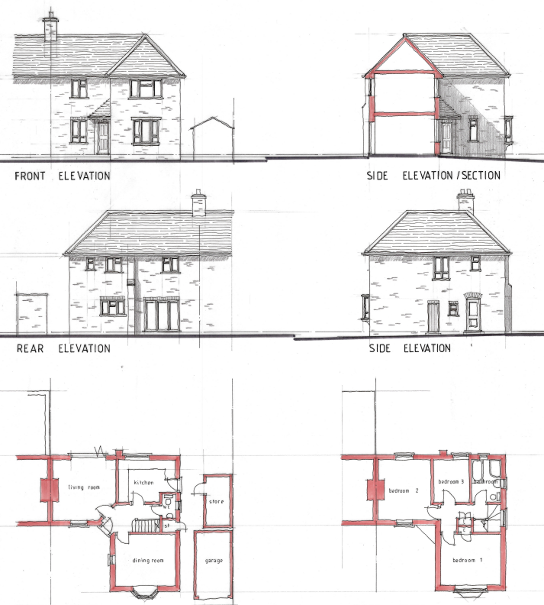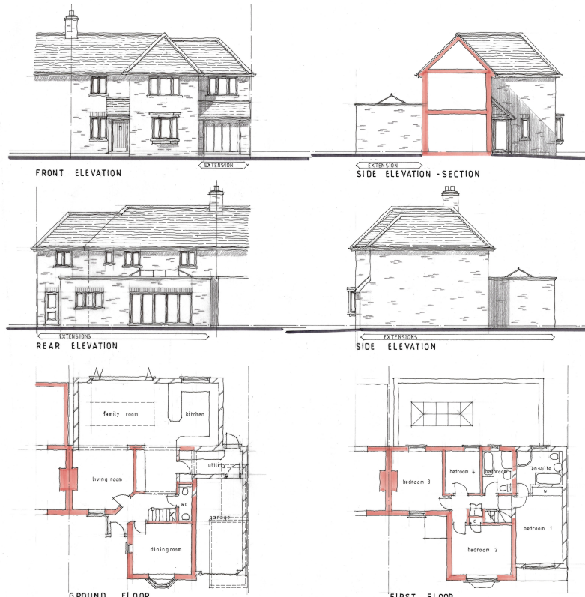
Existing Plans and Elevations Proposed Plans and Elevations

- RELEVANT PLANNING HISTORY
None

4. CONSULTATIONS

The following addresses were consulted by letter.

5 Pikeshaw Way, Tilehurst, Reading, RG31 6PJ
8 Chepstow Road, Tilehurst, Reading, RG31 6LR
12 Chepstow Road, Tilehurst, Reading, RG31 6LS

No letters of representation have been received.

Equality Act 2010:
In determining this application the Council is required to have regard to its obligations under the Equality Act 2010. However, there is no indication or evidence (including from consultation on the application) that the protected groups identified by the Act have or will have different needs, experiences, issues and priorities in relation to this particular planning application. Therefore in terms of the key equalities protected characteristics it is considered there would be no significant adverse impacts as a result of the development.

- LEGAL AND PLANNING POLICY CONTEXT

Section 38(6) of the Planning and Compulsory Purchase Act 2004 requires that proposals be determined in accordance with the development plan unless material considerations indicate otherwise. Material considerations include relevant policies in the National Planning Policy framework (NPPF) - among them the 'presumption in favour of sustainable development'. The following local and national planning policy and guidance is relevant to this application:

National Policy
National Planning Policy Framework
National Planning Practice Guidance

Reading Borough Local Plan (2019)
CC7 (Design and the Public Realm)
CC8 (Safeguarding Amenity)
H9 (House Extensions and Ancillary Accommodation)
H10 (Private and Communal Outdoor Space)

SPD
Design Guide to House Extensions 2021

6. APPRAISAL
Character and Appearance

Policy H9 states that an extension to a house will be acceptable where it respects the character of the house in terms of scale, location, materials and design and respects the character and pattern of neighbouring properties and the street as a whole in terms of scale, location, materials and design, and any important existing building line. Policy CC7 also sets out relevant considerations for design.

The ground floor rear extension would be a similar depth to the neighbouring extension and only just larger than the 4m guidance within the Design Guide SPD, and on the basis of the size of the plot this would be acceptable in overall scale. The two storey aspect to the side would be stepped back from the front building line and would be set down. The roof form would match the existing and the materials would match existing materials.

Whilst the overall form of the existing dwelling would be altered, as seen from the street scene it is considered that the side extension would be subservient to the original dwelling. The agent has made substantial changes to the original design, stepping the first floor aspect further back from the Principal Elevation, while dropping the ridgeline further, to ensure that there is adequate subservience to the original dwelling.

The character of the house in terms of scale, location, materials and design are therefore not considered to be so altered as to be unacceptable.

Residential Amenity

Policy H9 states that an extension will be acceptable where it does not result in an overbearing impact on neighbours. Policy H10 seeks to ensure that the amenity of gardens and other outdoor areas are not compromised. Policy CC8 states an extension to a house will be acceptable where it will not cause a significant detrimental impact to the living environment of existing or new residential properties.

The two storey side extension would bring built form closer to no.12 and the extension to the side would be imitating the existing side wall, closer to the neighbouring property on that side as it would be on the boundary. There are no side windows proposed on the side. The two storey side extension would not project beyond the line of the existing dwelling at the rear, so would not project beyond the back line of the neighbouring property on that side as well. The substantial alterations secured from the agent in terms of securing subservience to the original dwelling have been considered to mitigate any overbearing impacts on the neighbours at No 12. It was also confirmed that the window on the side of No 12 is to a stairway and not a habitable room.

The ground floor aspect of this proposal would not affect the area of the usable garden space in such a degree as to undermine the amenity enjoyed by the residents or any future users.

As there still would be a considerable distance between the new wall and the adjoining property, combined with the features highlighted above, it is not considered that the proposal would pose any adverse privacy and overlooking issues to the adjoining properties on both sides. There are also no overbearing effects, adverse sunlight and daylight access impacts on the adjoining properties on Nos 8 and 12. Conditions would be attached to ensure no side windows can be inserted at any time without consideration of the LPA.

- CONCLUSION
The proposed development has been assessed as set out above and is considered to be acceptable on that basis, subject to the following conditions.

8. RECOMMENDATION: Grant
Recommended Conditions:
Approved Plans
Time Limit Standards
Materials to Match Existing
No New Openings

