

DELEGATED HOUSEHOLDER APPLICATION REPORT

Ward: Emmer Green
App Ref: 231728/HOU
Address: 100 Lower Henley Road, Caversham, Reading, RG4 5LE
Proposals: Proposed part single, part two-storey rear extension and partial excavation of the undercroft to form habitable space.
Case Officer: Chukwudi Onwudinanti
Applicant: Mr & Miss Wells & Peacock
Date received (valid from): 29 November 2023
Target Decision date: 27 March 2024 (EXT)

1. SITE DESCRIPTION
The site is a detached two storey dwelling on the southern side of Lower Henley Road, at the intersection with Henley Road, with the dwelling sited on grounds that slope away from front to back such that the dwelling presents as single storey to the front and 1.5-2 storeys to the rear. The site is at lower ground than no. 102. The dwelling is among dwellings of varying styles and sizes, in a predominantly residential area, with some commercial properties.

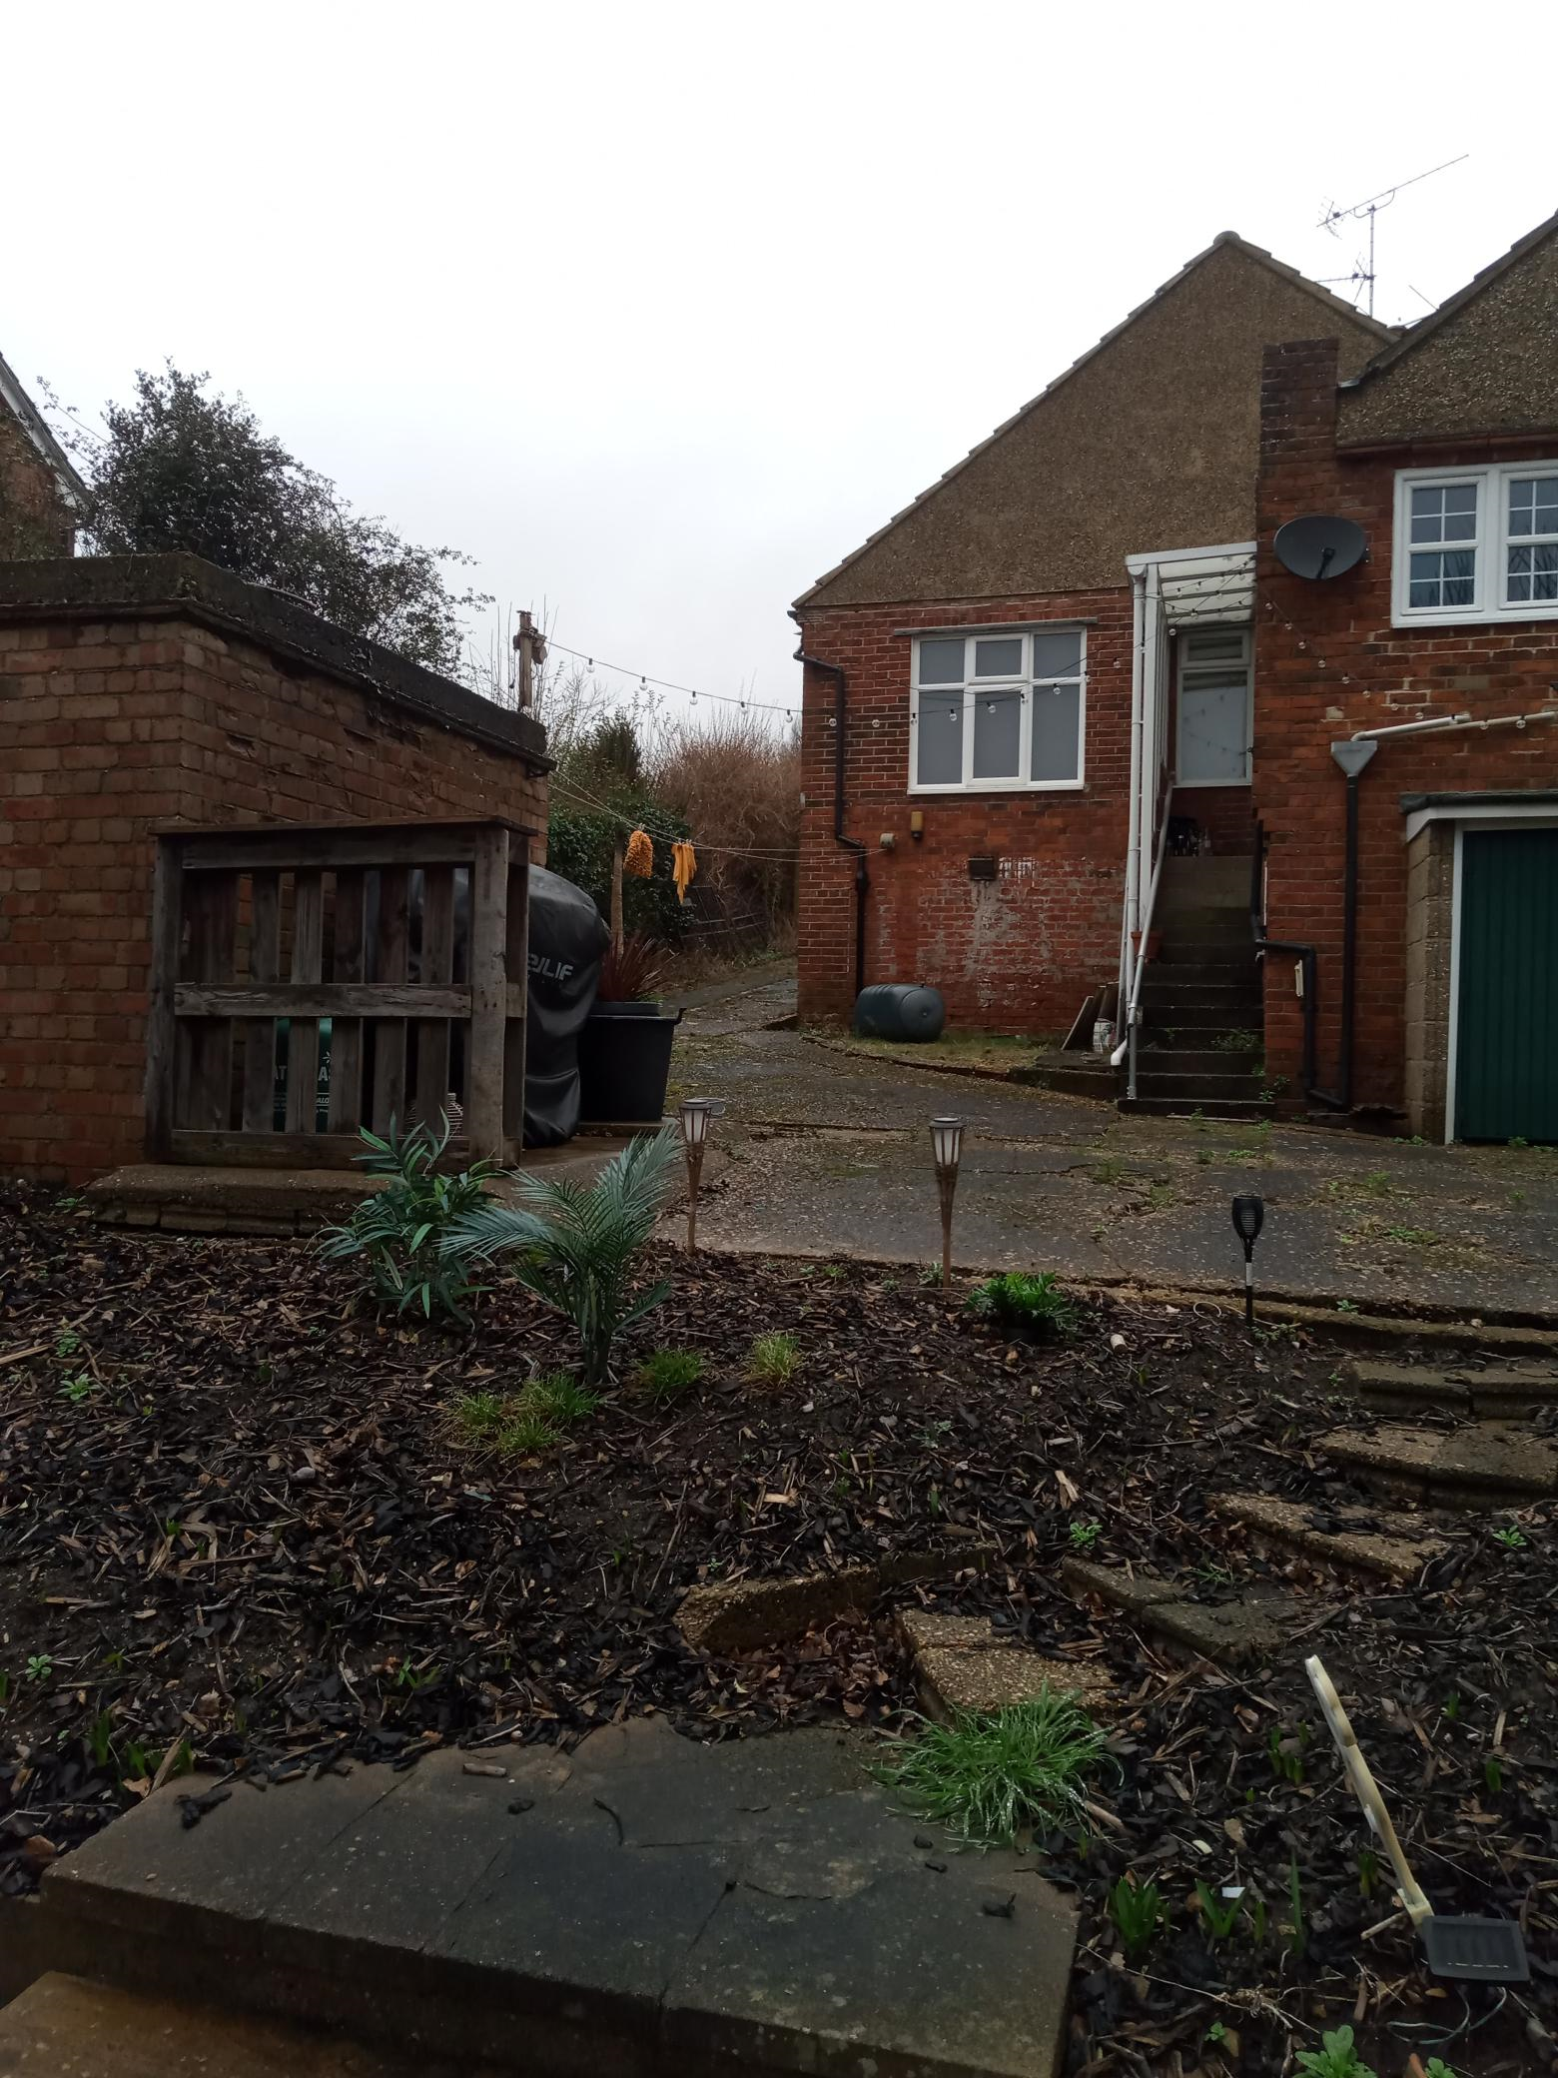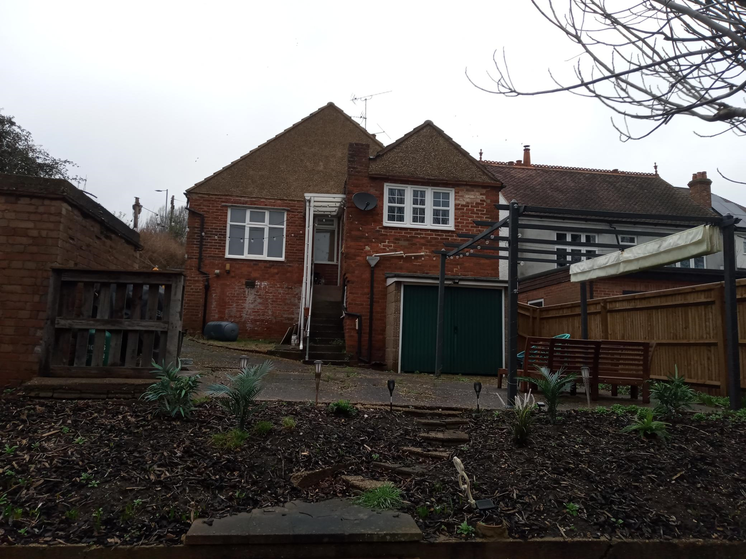
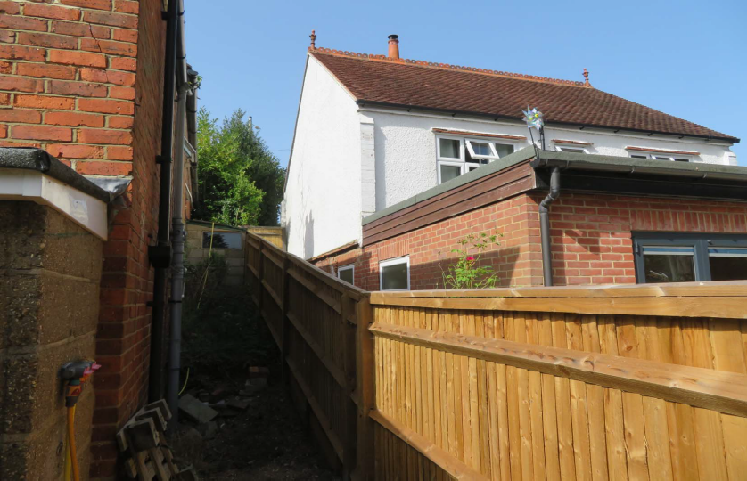
View towards the rear of no. 102

2. PROPOSAL AND SUPPORTING INFORMATION
Proposal comprises of the following:
- Part single storey extension to the rear, measuring 8.7m on one side and 5m on the other side, creating an L shaped extension on the ground floor, covered by a flat roof
- Part two-storey rear extension measuring 3.7m deep and 4.5m wide, closing an existing niche on the first floor level and extending the gable end roof, to form a hip roof on that side thereby increasing the overall height of the roof.
- Partial excavation of the undercroft to form and accommodate a habitable space.

Plans considered dated 29/11/2023 received 30/11/2023
P428-0823/PA/001: Existing Plans & Elevations
P428-0823/PA/002: Proposed Plans & Elevations
P428-0823/PA/003 Rev A: Site Location & Block Plans received 04/03/2024

The finished height of the ground floor extension proposed would be at the level of the existing outrigger to the rear, which would be at the same level (approximately 3.2m) as the existing rear ground floor extension on No 102.

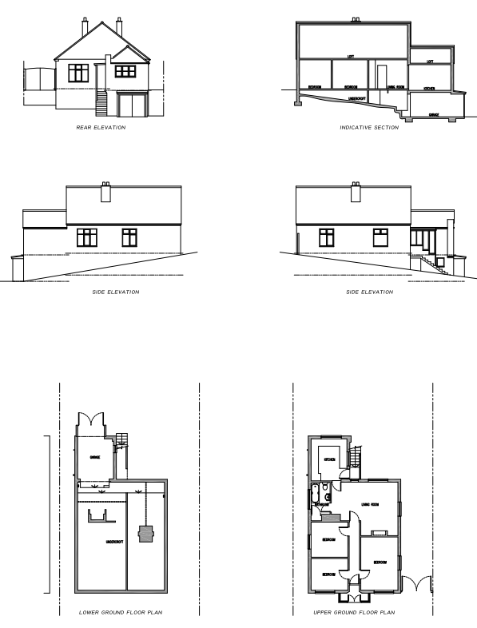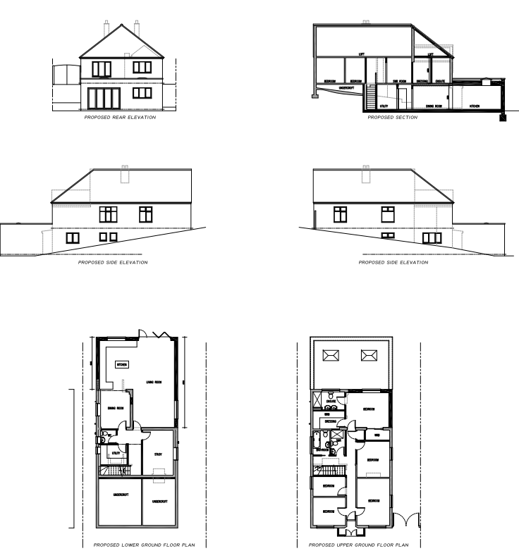
Existing Plans & Elevations Proposed Plans & Elevations

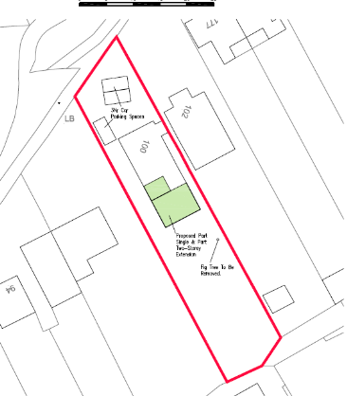
Proposed Block Plan

- RELEVANT PLANNING HISTORY
None

4. CONSULTATIONS

The following addresses were consulted by letter.

98 Lower Henley Road, Caversham, Reading, RG4 5LE
102 Lower Henley Road, Caversham, Reading, RG4 5LE
60 Ruskin, Caversham, Reading, RG4 6LF
71 Ruskin, Caversham, Reading, RG4 6LF

No letters of representation have been received.

Equality Act 2010:
In determining this application the Council is required to have regard to its obligations under the Equality Act 2010. However, there is no indication or evidence (including from consultation on the application) that the protected groups identified by the Act have or will have different needs, experiences, issues and priorities in relation to this particular planning application. Therefore in terms of the key equalities protected characteristics it is considered there would be no significant adverse impacts as a result of the development.

- LEGAL AND PLANNING POLICY CONTEXT

Section 38(6) of the Planning and Compulsory Purchase Act 2004 requires that proposals be determined in accordance with the development plan unless material considerations indicate otherwise. Material considerations include relevant policies in the National Planning Policy framework (NPPF) - among them the 'presumption in favour of sustainable development'. The following local and national planning policy and guidance is relevant to this application:

National Policy
National Planning Policy Framework
National Planning Practice Guidance

Reading Borough Local Plan (2019)
CC7 (Design and the Public Realm)
CC8 (Safeguarding Amenity)
H9 (House Extensions and Ancillary Accommodation)
EN14 (Trees, Hedges and Woodlands)
H10 (Private And Communal Outdoor Space)

SPD
Design Guide to House Extensions 2021

6. APPRAISAL

Character and Appearance

Policy H9 states that an extension to a house will be acceptable where it respects the character of the house in terms of scale, location, materials and design and respects the character and pattern of neighbouring properties and the street as a whole in terms of scale, location, materials and design, and any important existing building line. Policy CC7 also sets out relevant considerations for design.

The proposal seeks to create a rear extension on the lower ground floor level to increase the overall depth of the existing dwelling on that level to 5m on some parts and 8.7m on other parts. On the upper ground floor level, the depth is limited to approximately 3m, closing out an existing recess created by the existing outrigger to the rear, to create a new bedroom. The 5m resulting additional ground floor is covered by a flat roof of approximately 2.6m height.

As a consequence of the limitation of all aspects of these proposals to the rear and the gradient of the site, sloping to the rear, all parts of these extensions would not be visible from the street. The scale of the extensions would also not be out of keeping with the size of the existing dwelling. The character and pattern of the existing dwelling is therefore not considered to be so negatively impacted as to be unacceptable, even with the considerable depth of the lower ground floor extension.

Residential Amenity

Policy H9 states that an extension will be acceptable where it does not result in an overbearing impact on neighbours. Policy H10 seeks to ensure that the amenity of gardens and other outdoor areas are not compromised. Policy CC8 states an extension to a house will be acceptable where it will not cause a significant detrimental impact to the living environment of existing or new residential properties.

The overall finished height of the rear ground floor extension would be approximately 3.2m, which would be about the same height as the existing outrigger on the neighbouring property on No. 102. The depth of the existing first floor extension would be retained, but would the gable would be converted into a hip, without causing a significant rise in the existing ridgeline and which, it is not considered, would cause detriment with respect to amenity considerations for no. 102.

Whilst part of the lower ground floor aspect of the extensions go to a depth of 8.7m, a combination of the distance between the proposal site and the adjoining property at No 98, and the slope of the land mitigates any negative overbearing impact of the considerable depth on the adjoining property. On the side of the boundary with No 102, the extension is approximately 5m deep but the impact on No 102 is not considered to be significant as No. 102 has an existing outrigger, with a French window opening to the garden which would not be negatively impacted by the extension proposed here, due to the limited height. The proposed upper first floor aspect is limited to approximately 3m in depth closest to No. 98 and would cause no loss of light to No 98, the backline of which would be beyond the resulting line of the proposed first floor extension.

As stated above in this report, the first floor extension involves the alteration of the roof, creating a hip roof from the existing gable end to the rear. This would present a more elevated roof height as seen from the plot on No 102, however this additional impact is not considered to be of such significant change to the existing impact of the dwelling as it is now, on the neighbours on No 102.

The extension on the lower ground floor would still leave a back garden of considerable size, adequate to serve the users of the dwelling without any compromises.

- CONCLUSION
The proposed development has been assessed as set out above and is considered to be acceptable on that basis, subject to the following conditions.

8. RECOMMENDATION: Grant

Recommended Conditions:
Approved Plans
Time Limit Standards
Materials to Match Existing
No New Openings

