

DELEGATED HOUSEHOLDER APPLICATION REPORT

Ward: Caversham
App Ref: 240185/NMA
Address: 8 Pembroke Place, Caversham, Reading, RG4 5HU
Proposals: Non-Material Amendment to application 230353 (Proposed single storey porch to replace existing). Replace approved low-level circular window on the front elevation of the new Porch with a smaller, high-level window.
Case Officer: Chukwudi Onwudinanti
Applicant: Mr & Mrs Matt Beresford-Jones
Date received (valid from): 4 March 2024
Target Decision date: 1 April 2024

1. SITE DESCRIPTION

The application site is a two-storey, semi-detached dwellinghouse, located on cul-de-sac, Pembroke Place, Caversham. The surrounding street scene comprises of properties similar in character and design. The property is not located within a conservation area, nor is it listed.

2. PROPOSAL AND SUPPORTING INFORMATION
Non-Material Amendment to application 230353 (Proposed single storey porch to replace existing). Replace approved low-level circular window on the front elevation of the new Porch with a smaller, high-level window.

Originally Approved under 230353 Proposed under 240185

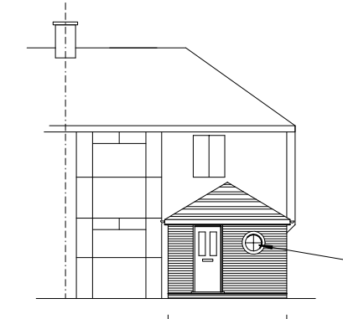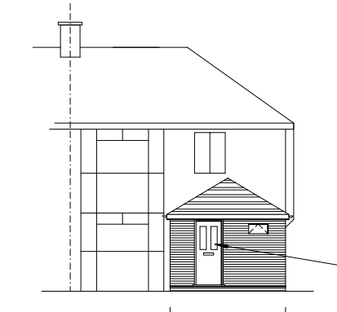

Original Elevation approved under 230353/HOU | Proposed Amended Elevation under 240185/NMA
MBJ-0323-02 Rev A Proposed Elevations received 13/02/2024 | MBJ-0323-02 Rev B Proposed Elevations received 13/02/2024

- RELEVANT PLANNING HISTORY

App Ref: 230353/HOU
Proposals: Proposed single storey porch to replace existing.
Outcome: Application: Permitted
Date of Decision: 29th June 2023

4. Plans Considered:
MBJ-0323-02 Rev A: Proposed Elevations received 13/02/2024
MBJ-0323-02 Rev B: Proposed Elevations received 13/02/2024

5 Appraisal:
The proposed changes to replace approved low-level circular window on the front elevation of the new Porch with a smaller, high-level window, would have a very limited effect on the overall appearance, and not one considered to be detrimental to the appearance of the overall scheme and would have no detrimental effect on residential amenity. The change would in context remain in accordance with Policy CC7.

Conclusion:
The changes as proposed are considered to be acceptable non-material alterations to the previously approved application 230353.

Recommendation:
Approve non-material amendment subject to conditions. Although Section 96(A) of the Act does not allow for the original decision to be re-issued, it does allow the modification of, or imposition of, conditions. In this respect it is considered appropriate to impose an additional condition:

Condition
The plans and statements put forward by the agent hereby approved by this Non-Material Amendment (under Section 96A of the Town and Country Planning Act 1990) are as follows:

MBJ-0323-02 Rev B: Proposed Elevations received 13/02/2024

