

DELEGATED APPLICATION REPORT

Ward: Southcote
App Ref: 230873/FUL
Address: Wren School, 61 Bath Road, Reading, RG30 2BB
Proposals: Change to perimeter fencing and gates around the school
Case Officer: Chukwudi Onwudinanti
Applicant: The Wren School
Date received (valid from): 9 August 2023
Target Decision date: 5 July 2024 (EXT)

1. SITE DESCRIPTION
The application site comprises The Wren School, located between Bath Road and Southcote Lane. Several trees subject to an Area TPO are located to the Bath Road frontage and western site boundary.

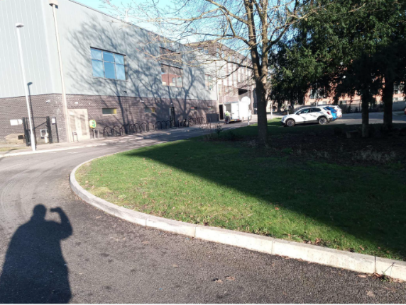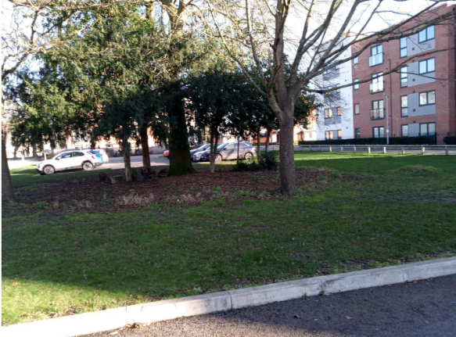

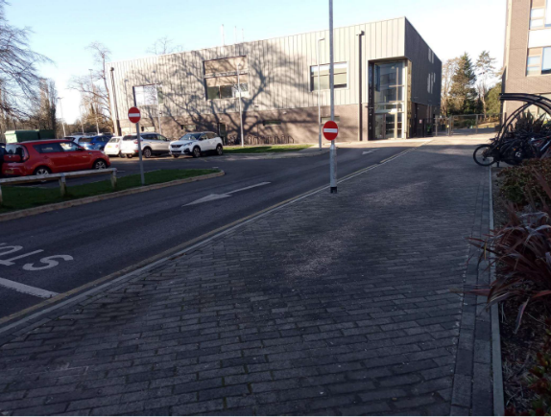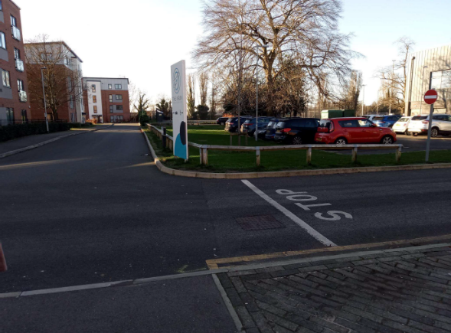
Site Photos

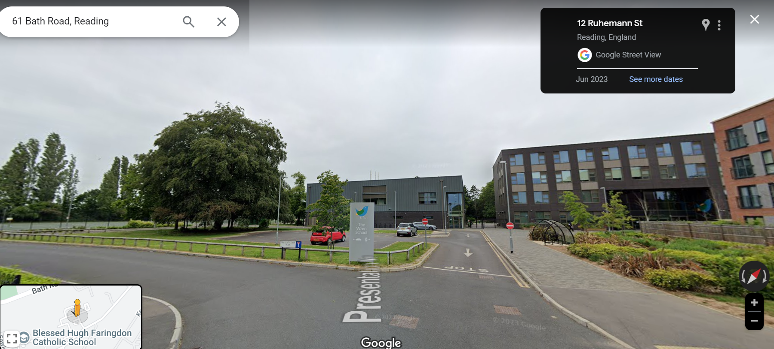
Google Map Photo

2. PROPOSAL AND SUPPORTING INFORMATION
Change to perimeter fencing and gates around the school on the Southcote Lane entrance. The fence would be made of black V Mesh measuring 2.4m in height, including the automated gates.

Plans considered
Drawing No P.1732_002 Rev A: Proposed Site Block Plan dated March 2024 received 28/03/2024
Drawing No P.1732_001 Rev A: Proposed Site Plan and Site Elevation dated March 2024 received 28/03/2024
Product Specifications received 05/05/2024
Technical Diagram and Specifications received 05/05/2024
The Wren School – Planning Application 230873
Response to Queries Raised to Planning Application dated 30/11/2023 received 12/12/2023
Subject: Perimeter Fencing & Gates Project at Wren School Application 230873’
Author: Lorraine Yearwood

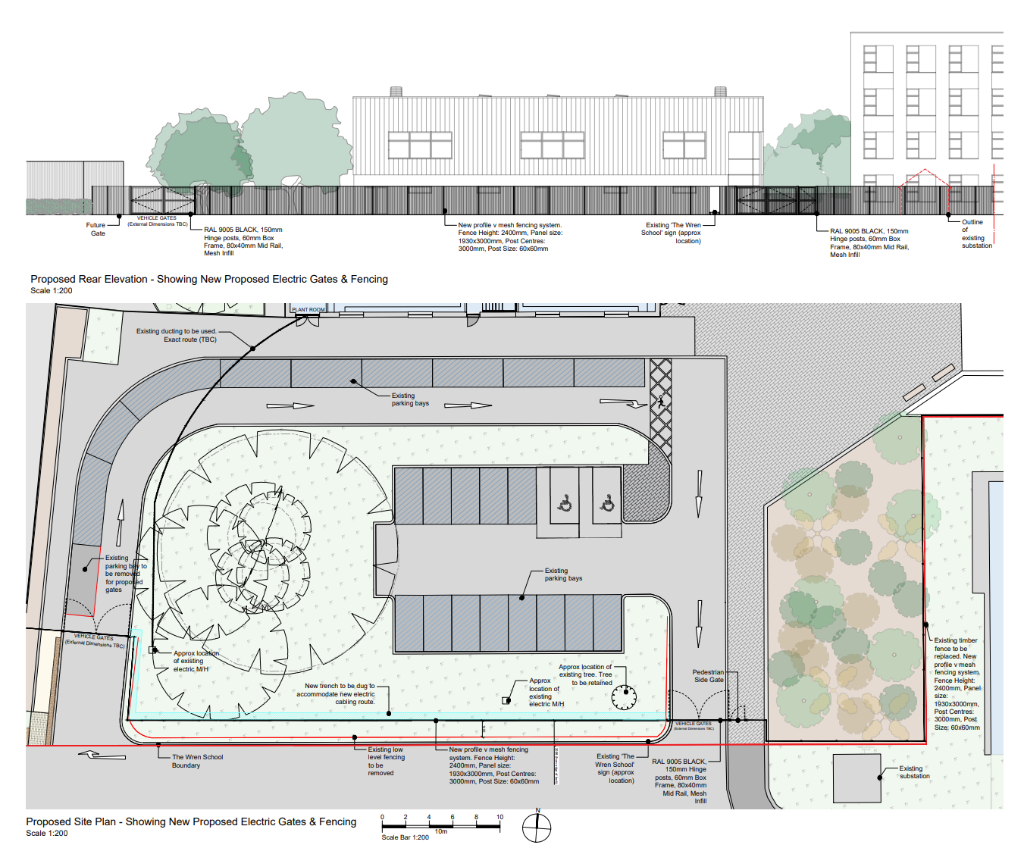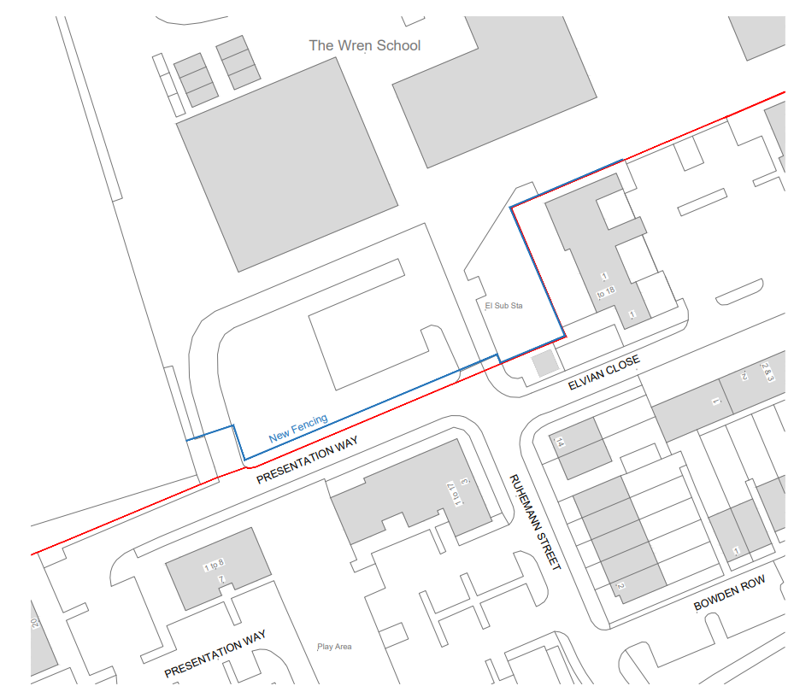
Proposed Site Plan and Elevation Proposed Site Block Plan

- RELEVANT PLANNING HISTORY

Application Ref: 120535
Description: Redevelopment to provide 193 residential units (173 new build and 20 through conversion) with associated access, parking, landscape and open space provision, following the demolition of existing school buildings.
Approved 12/9/2012

Application Ref: 121529
Description: Request for a Screening Opinion for 193 dwelling units with associated access, parking, landscaping and open space provision following demolition of existing school buildings.
Refused 1/11/2012

Application Ref: 151175
Description: A Hybrid application seeking outline planning permission for a new 6 form entry secondary school with all matters other than access reserved for consideration at a later date and detailed permission for 118 dwellings, access, car parking, landscaping and amenity space, following the demolition of the existing buildings
Permitted subject to Legal Agreement 4/4/2016

Application Ref: 160628
Description: Removal of the existing temporary classroom accommodation, the erection of eight no. temporary accommodation units to provide classroom and staff accommodation, temporary hard play space, access and parking arrangements, and the removal of a limited number of trees over a 2 year period.
Permitted 8/6/2016

Application Ref: 161068
Description: Discharge of condition 20 of planning permission 151175.
Decision: Conditions Discharged
Date: 3/8/2016

Application Ref: 161094
Description: Discharge of condition 9 of planning permission 151175.
Decision: Conditions Discharged
Date: 10/10/2016

Application Ref: 161367
Description: Application for the approval of conditions 7, 12,15, 18, 57, 60, 61 &
62 in respect of planning permission 151175.
Decision: Split
Date: 19/10/2016

4. CONSULTATIONS

The following addresses were consulted by letter.

1 Elvian Close, Reading, RG30 3FP
Flat 16, 1 Elvian Close, Reading, RG30 3FN
Flat 15, 1 Elvian Close, Reading, RG30 3FN
Flat 10, 1 Elvian Close, Reading, RG30 3FN

Letters of representation have been received as follows:
1. Flat 10, 1 Elvian Close
2. Flat 15, 1 Elvian Close
3. Flat 16, 1 Elvian Close

Points of objections from the neighbouring residential properties include:

- Traffic and parking
- Visibility
- Traffic congestion during school pickups
- Visual Amenity

Transport Comments

“As part of the school application, 10 drop off / pick up bays for parents / guardians were provided via Southcote Lane to avoid congestion and parking on the highway and on surrounding residential roads. The site plan illustrates that the drop spaces and visitor spaces will be enclosed within the new fencing. Therefore, clarification is sought regarding the operation of the gates to ensure that vehicles can still access the drop off spaces during school hours, and access the visitor parking spaces during the evening/weekends when the community facilities are available.

………….. the erection of new perimeter fencing and gates require further justification as the school already has perimeter fencing around the site. A detailed plan must also be submitted illustrating the exact location of the gates with the distance to the highway clearly marked.

Natural Environment Comments

Natural Environment objected to the original submission, as it did not adequately provide for the protection of the TPO trees on site. Following revised plans they confirmed that the proposal was acceptable subject to the condition that the trees on site would be protected during and after the development. Conditions are attached to the Decision Notice to secure this.

In the course of the application, the applicant was advised that the initial submissions were not acceptable as it was considered that the positioning of the fence line on the Southcoate Lane was impacting on the amenity of the neighbourhood users and residents. The agent was also advised to demonstrate with more clarity, how they intend to protect the TPOs on site during the construction of the gates and fence.

In terms of the use of the gates (automated), the agent was advised to demonstrate, with more clarity, how the use of the proposed gates would not impact negatively on the use of the existing parking in the school site and the adjoining residential properties.

The agent subsequently made revised submissions, setting the fence back from the kerbs to allow the continued use of the kerbs for walking and dog walking. The gates proposed have also been further recessed from the line of the proposed fence, ensuring that cars that are waiting to access the school site do not hang onto the road used by the residents.

It has also been revised such that the cabling for the supply of electricity to the gates close to the TPOs are shown to be run underground through the existing duct route under the trees, without needing any fresh excavations.

Equality Act 2010:
In determining this application the Council is required to have regard to its obligations under the Equality Act 2010. However, there is no indication or evidence (including from consultation on the application) that the protected groups identified by the Act have or will have different needs, experiences, issues and priorities in relation to this particular planning application. Therefore in terms of the key equalities protected characteristics it is considered there would be no significant adverse impacts as a result of the development.

- LEGAL AND PLANNING POLICY CONTEXT

Section 38(6) of the Planning and Compulsory Purchase Act 2004 requires that proposals be determined in accordance with the development plan unless material considerations indicate otherwise. Material considerations include relevant policies in the National Planning Policy framework (NPPF) - among them the 'presumption in favour of sustainable development'. The following local and national planning policy and guidance is relevant to this application:

National Policy
National Planning Policy Framework
National Planning Practice Guidance

Reading Borough Local Plan (2019)
CC1: Presumption in Favour of Sustainable Development
CC2: Sustainable Design and Construction

CC7 (Design and the Public Realm)
CC8 (Safeguarding Amenity)
TR3 (Access Traffic and Highway-related Matters)
TR5 (Car and Cycle Parking)
EN12 (Biodiversity and the Green Network)
EN14 (Trees, Hedges and Woodlands)

SPD
Revised Parking Standards and Design SPD 2011

6. APPRAISAL

Principle of Development

The principle of the development is acceptable, enabling the school to enclose the area within their site to provide additional security and safeguarding for the students. There would be no changes to the trees and soft landscaping already in existence within the site.

The initial areas of concern regarding transport, parking and tree protection have been mitigated in the revised submissions as assessed and discussed below. The amended proposal includes recessing the gates, and they would be kept open and accessible through the open hours of the school and any other times that the facilities within the school would be in operation.

Character and Appearance

Policy CC7 states that all development must be of high design quality that maintains and enhances the character and appearance of the area of Reading in which it is located as well as respond positively to their local context and create or reinforce local character and distinctiveness.

The original design presented has been revised to ensure that the fence proposed is moved back from the kerbs, and the entry and exit gates recessed to ensure that cars waiting to get into the parking areas do not cause any obstructions on the road which also serves the residential dwellings on the other side of the feeder road.

The proposed material would be black mesh, which would be in keeping with the materials used on the other sides of the site and appropriate for a school site location. Although the fencing would enclose the site and be 2.4m in height, very different to the existing low wooden single bar fence, the open mesh form would ensure visibility through it, and the more prominent appearance has been balanced against the requirements of the school to provide a secure and safe site.

Amenity

Policy CC8 stipulates that development will not cause a detrimental impact on the living environment of existing residential properties or unacceptable living conditions for new residential properties.

Neighbours have objected to the enclosure of the space which they consider functions as a green space for residents outside of school hours. It is noted that the area to be enclosed by this new fence is not a designated open space as it neither a Local Green Space (LGS) nor a Public Open Space (POS). It is also not considered to be undesignated open space, but more an area of landscaping within the curtilage of the school and a buffer to an important tree. The security and safeguarding issues are considered to outweigh the need to retain the area as a space accessible to non-users of the school. The revised design submitted has moved the fence line away from the kerb, so that a strip of grassed area would be maintained outside of the fencing, albeit still in the School’s ownership.

Trees

Policies EN14 states that individual trees, groups of trees, hedges and woodlands will be protected from damage or removal where they are of importance, and Reading’s vegetation cover will be extended.

As has been demonstrated by the revised drawings submitted by the agent (accepted by Natural Environment), the TPO trees and indeed the existing foliage on site are not affected by the development. The underground cabling to carry electricity to the proposed gates on the Southcote Lane axis would go through the existing duct on site which goes underground well below the existing root system.

Tree Retenion and Protection Measures have been attached to the Decision Notice to ensure that the TPOs on site are protected during development and in the future.

- CONCLUSION
The proposed development has been assessed as set out above and is considered to be acceptable on that basis, subject to the following conditions.

8. RECOMMENDATION: Grant
Recommended Conditions:
Approved Plans
Materials As Specified
Vehicle Parking As Specified
Tree Retention (Restriction)
Tree Protection Measures (As Specified)

