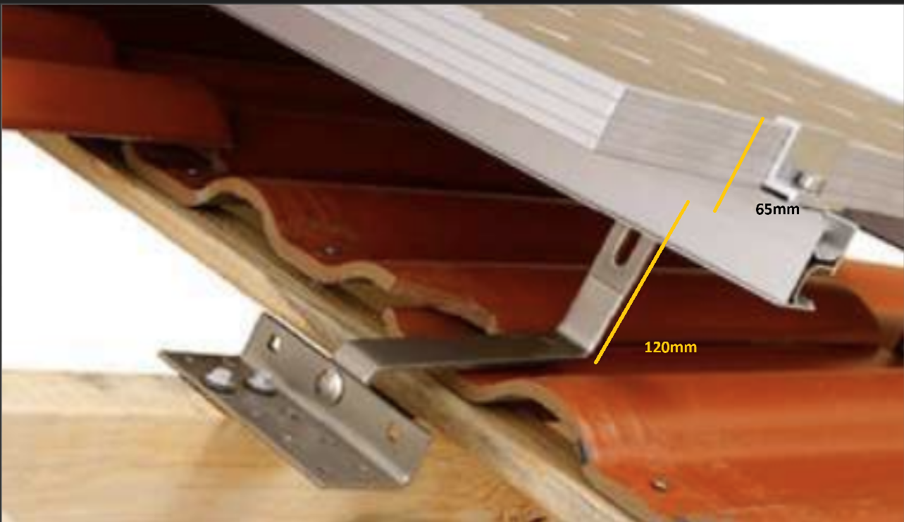

The height of solar panels above surface of roof slope measured perpendicular to the roof slope is the sum of the bracket length 120mm plus the dept of the panel 65mm, which gives a total of 185mm. That distance is 15mm below the maximum of 200mm allowed for permitted development.

