

DELEGATED HOUSEHOLDER APPLICATION REPORT

Ward: Katesgrove
App Ref: 240213/HOU
Address: 46 Elizabeth Walk, Reading, RG2 0AW
Proposals: Proposed single storey rear extension
Case Officer: Chukwudi Onwudinanti
Applicant: Mr J Hoque
Date received (valid from): 19 February 2024
Target Decision date: 20 May 2024 (EXT)

1. SITE DESCRIPTION
The site is a mid-terrace three storey modern dwelling on the western side of Elizabeth Walk, in a predominantly residential area. The area is characterised by terrace dwellings on both sides of the road, with the proposed site within a terrace of dwellings with staggered setbacks from the road.

Permitted Development Rights have been removed for conversion from C3 to C4 Small HMO.

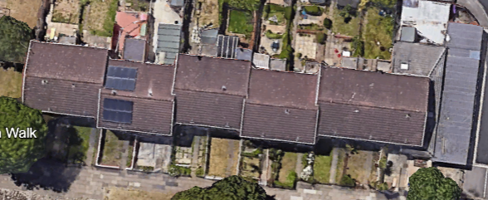
Google Maps Image
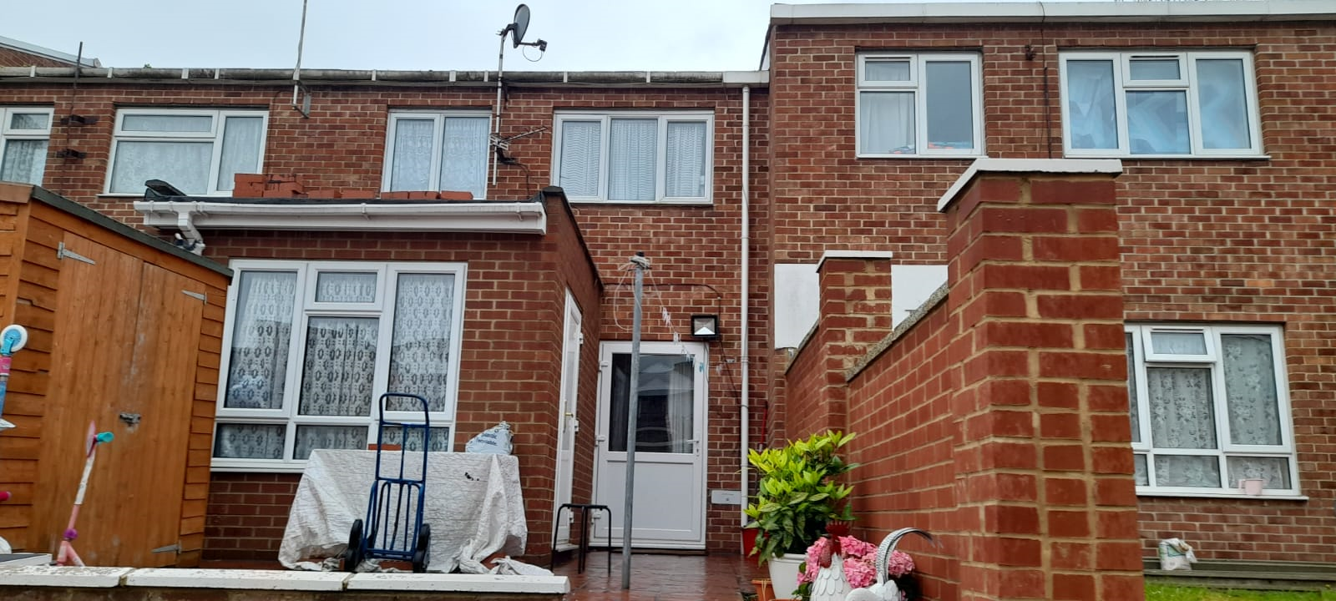
Site Visit Photos

2. PROPOSAL AND SUPPORTING INFORMATION
The proposal is for a single storey rear extension measuring 1.7m deep and 2.5m wide (the width of the existing outrigger to the rear) to the rear of an existing 3m deep extension. This extension creates a new bathroom accessed through the existing bedroom.

Plans considered received 20/02/2024
Location Plan
Drawing No 01: Existing Floor Plans dated Dec 2023
Drawing No 02: Existing Elevations dated Dec 2023
Drawing No 03: Existing Block Plan dated Dec 2023
Drawing No 11 Rev A: Proposed Floor Plans dated Feb 2024
Drawing No 12 Rev A: Proposed Elevations dated Feb 2024
Drawing No 13 Rev A: Proposed Block Plan dated Feb 2024

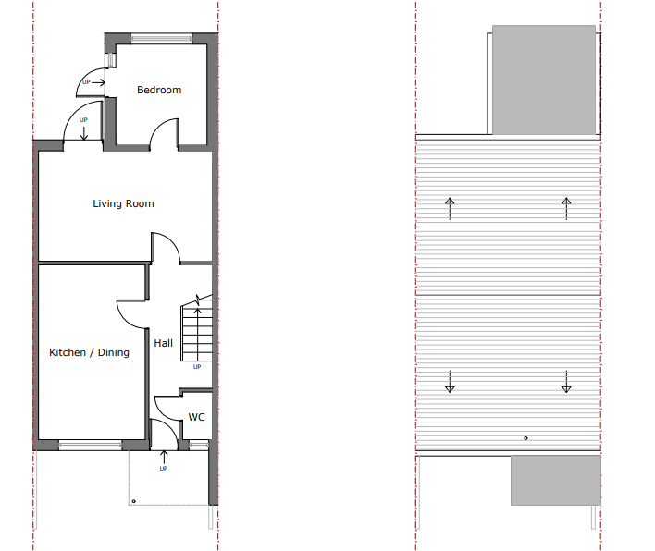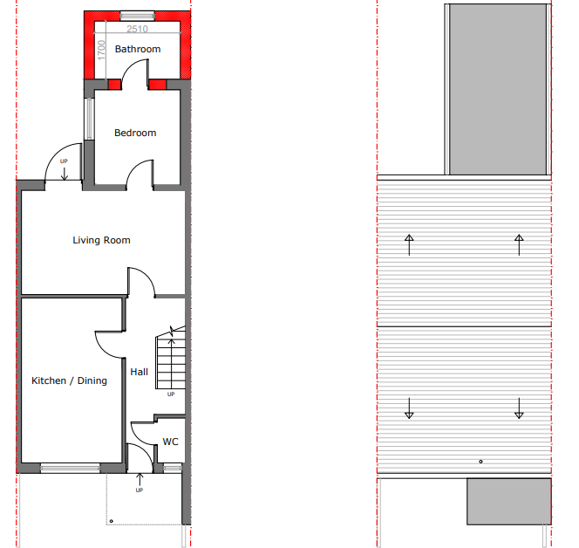
Existing Floor Plans Proposed Floor Plans

- RELEVANT PLANNING HISTORY
None

4. CONSULTATIONS

The following addresses were consulted by letter.

44 Elizabeth Walk, Reading, RG2 0AW
48 Elizabeth Walk, Reading, RG2 0AW

No letters of representation have been received.

Equality Act 2010:
In determining this application the Council is required to have regard to its obligations under the Equality Act 2010. However, there is no indication or evidence (including from consultation on the application) that the protected groups identified by the Act have or will have different needs, experiences, issues and priorities in relation to this particular planning application. Therefore in terms of the key equalities protected characteristics it is considered there would be no significant adverse impacts as a result of the development.

- LEGAL AND PLANNING POLICY CONTEXT

Section 38(6) of the Planning and Compulsory Purchase Act 2004 requires that proposals be determined in accordance with the development plan unless material considerations indicate otherwise. Material considerations include relevant policies in the National Planning Policy framework (NPPF) - among them the 'presumption in favour of sustainable development'. The following local and national planning policy and guidance is relevant to this application:

National Policy
National Planning Policy Framework
National Planning Practice Guidance

Reading Borough Local Plan (2019)
CC7 (Design and the Public Realm)
CC8 (Safeguarding Amenity)
H9 (House Extensions and Ancillary Accommodation)
H10 (Private and Communal Outdoor Space)

SPD
Design Guide to House Extensions (2021)

6. APPRAISAL
Character and Appearance

Policy H9 states that an extension to a house will be acceptable where it respects the character of the house in terms of scale, location, materials and design and respects the character and pattern of neighbouring properties and the street as a whole in terms of scale, location, materials and design, and any important existing building line. Policy CC7 also sets out relevant considerations for design.

The extension is 1.7m deep, which along with the existing extension brings the overall depth to ca 4.7m deep, and keeps the width of the existing outrigger (2.5m). The height is limited to approximately 2.8m and is of a flat design. The materials to be used externally are to match existing materials.

There are other examples of rear extensions within the locality and it is not considered that the changes proposed would adversely impact on the character of the house and the pattern of houses within the immediate environment.

Residential Amenity

Policy H9 states that an extension will be acceptable where it does not result in an overbearing impact on neighbours. Policy H10 seeks to ensure that the amenity of gardens and other outdoor areas are not compromised. Policy CC8 states an extension to a house will be acceptable where it will not cause a significant detrimental impact to the living environment of existing or new residential properties.

The neighbouring property would notice the additional depth, but it is not considered that there would be a significantly different impact compared to the existing extension. In terms of daylight and sunlight there is an existing impact from the existing extension and the additional depth would not have a significant detrimental further impact and the rear door is serving a non-habitable space.

There still remains ample garden space for use by the residents.

- CONCLUSION
The proposed development has been assessed as set out above and is considered to be acceptable on that basis, subject to the following conditions.

8. RECOMMENDATION: Grant
Recommended Conditions:
Approved Plans
Materials to Match Existing
Time Limit Standards

