/ Windows / Aluminium windows / Aluminium Window Imperial

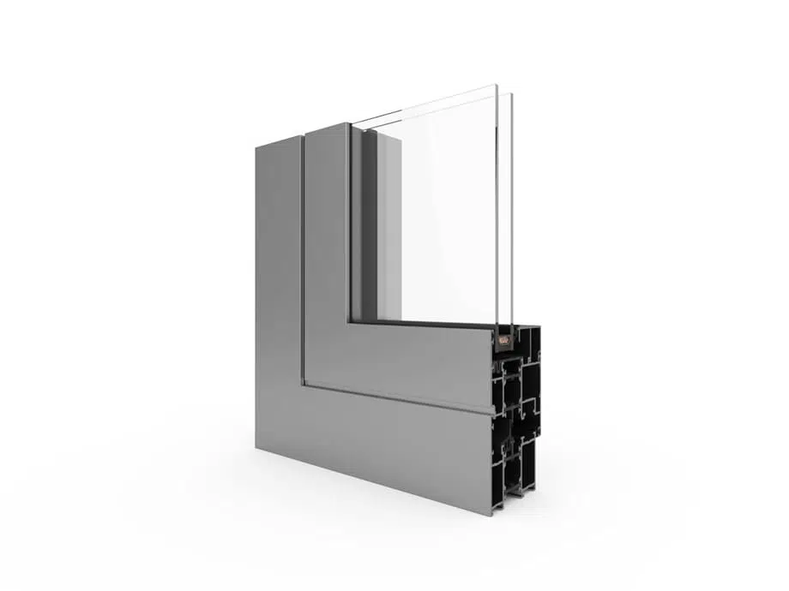

Aluminium Window Imperial
Brand: Aliplast
What you get
- High thermal insulation power due to special thermal inserts
- Large number of shapes for desired appearance and structural strength
- Glazing thickness up to 51 mm
Add to Compare
Get a free quote
Lead time: up to 8 weeks
Guarantee included at purchase
- Specifications
- Description
- Colours
- Pricelist
- Files to download
- Recently viewed products
- Realizations
- Similar products
Depth of the frame [mm] | 65
Brand | Aliplast
Maximum thickness of the glazing unit [mm] | 51
Number of chambers | 3
Number of gaskets | 2
Opening direction | Inwards
U-value | 1.5 - 2.1
Wind resistance | C4
Water resistance | 5A
Acoustic insulation | 29-38 dB
Air permeability | Class 3
Specifications
Modern and warm aluminium windows. Thanks to the available wide range of system sections, it guarantees the required aesthetics and strength of the structure. The use in the production of fixed display windows, single or double sash windows or arched windows.

Imperial – benefits:
- Window frame installation depth: 65 mm
- Sash depth: 74 mm
- Glazing thickness up to 51 mm
- The availability of Imperial IP system with increased thermal insulation
- The high thermal parameters achieved with special insulation inserts, installed between thermal separators and around the glass pane
- The profiles can be bent so the system is perfect for creating arched windows
- Profile drainage in two variants: traditional and hidden

Aluminum Door
Please follow the link below –
https://domadeco.co.uk/fargo-42.html?camp=drzwi_produktowa&=keyword=&matchtype=&network=g&targetid=pla-509674446874&placement=&click_type=search&creative=285451587350&device=c&mobile=no&campaignid=1493970391&devicemodel=&adposition=&adtype=pla&product_channel=online&gad_source=1&gclid=EAIaIQobChMIopizuLSAhgMVzpNQBh2J5wgeEAYYASABEgJ75PD_BwE#description

Skip to the end of the images gallery
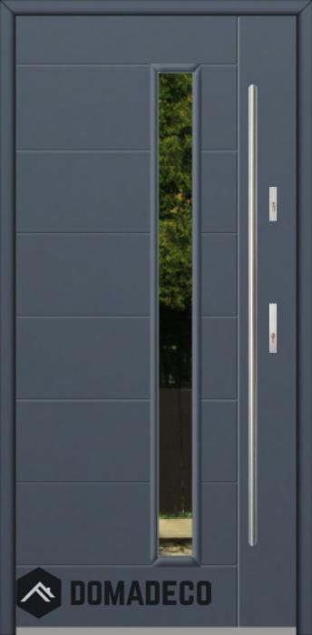
Fargo 42 - external front single door
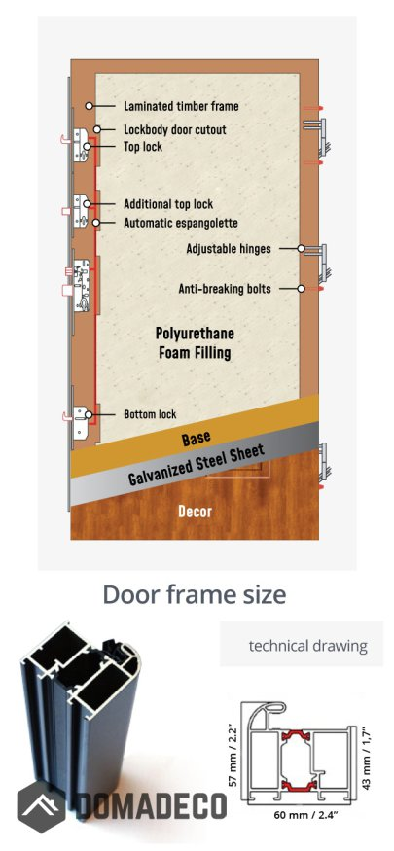
Fargo 42 - external front single door
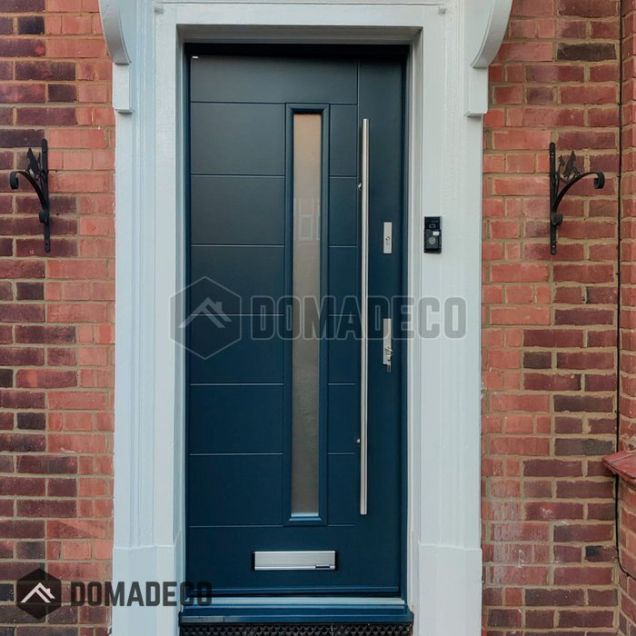
Fargo 42 - external front single door
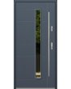
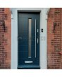
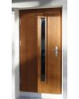
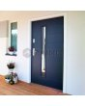
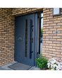
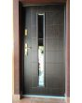
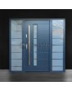
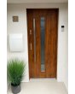
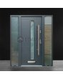
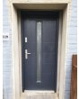
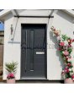
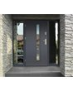
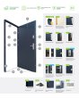
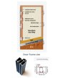
Skip to the beginning of the images gallery

Fargo 42 - external front single door
SKU
FARGO 42
RATING:
100% OF100

1 REVIEW ADD YOUR REVIEW
AVAILABLE
£1,120.00
The price includes VAT
CLICK HERE TO SELECT THE CONFIGURATION
Doors are manufactured after the order has been placed through the website.
Production time for our doors:
door named FARGO (stainless steel) - production takes 8 weeks
door named STA (stainless steel) - production takes 4 weeks
door named LIM (aluminium) - production takes 7 weeks
Door width with frame:
875mm(81cm door leaf)
925mm(86cm door leaf)
975mm(91cm door leaf)
1025mm(96cm door leaf)
1075 mm (101cm door leaf) j
1125mm(106cm door leaf)
Door height with frame:
from 2000mm to 2400 mm
You can order doors in a bigger size. View Lim or Pivot
Construction:
The door is made of stainless steel. Inside it is filled with PUR polyurethane foam and wood. The thickness of the door leaf is 54mm. Dual sealing system - one seal is in the dap of the frame and the other is located in the supporting part of the door leaf. They reduce vibration and protect your house from losing the heat. They don't change their volume under the influence of atmospheric conditions. The door frame has anti-burglar reinforcements in hinge parts and locking points.
The door set includes:
- Door and the door frame with two gaskets;
- Two independent locks (multi-point locking mechanism) providing anti-burglary security solutions;
- Two sets of inserts with the keys;
- Normal door handle (T-bar long handle as an additional option);
- Viewfinder (in the case of solid doors);
- 6x adjustable hinges (3x on each side) that provide anti-burglary protection;
- Aluminium threshold with the gasket;
- 3x anti-theft bolts.
Thermal and soundproof specification:
- for a full door leaf with 54 mm thickness, at Ud = 0,98 W/K*m2
- for glazed door leaf with 54 mm thickness, at Ud = 1.1 W/K*m2
- acoustic insulation 31 dB (applies to doors without glazing)
- glass doors are made of triple glazing packages.
FULL DOOR INFORMATION
The door is already mounted onto the frame (prehung door), which saves you all the work. The door is completely ready for installation.
The doors are available with one or two side panels
The picture showing how to take the measurement. Click here
The installation space between the frame and the wall can be between 5 mm to 20 mm on each side.
Frequently Asked Questions: click here to check
We provide the installation of our front door in England. Installation costs extra and depends on the type of door.

