

DELEGATED HOUSEHOLDER APPLICATION REPORT

Ward: Caversham Heights
App Ref: 240194/HOU
Address: 15 Rotherfield Way, Emmer Green, Reading, RG4 8PJ
Proposals: Existing conservatory to be replaced with single storey flat roof rear extension with bifold doors and flat rooflights.
Case Officer: Chukwudi Onwudinanti
Applicant: Mr Simon Adams
Date received (valid from): 14 February 2024
Target Decision date: 7 May 2024 (EXT)

1. SITE DESCRIPTION
The site is a semi-detached two storey dwelling on the north-eastern side of Rotherfield Way, among dwellings of similar style and size, in a predominantly residential area. There is an existing conservatory to the rear and the adjacent property has a large single storey rear extension.

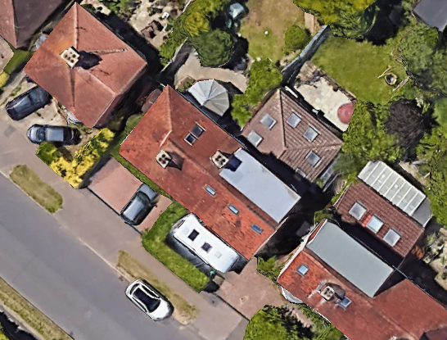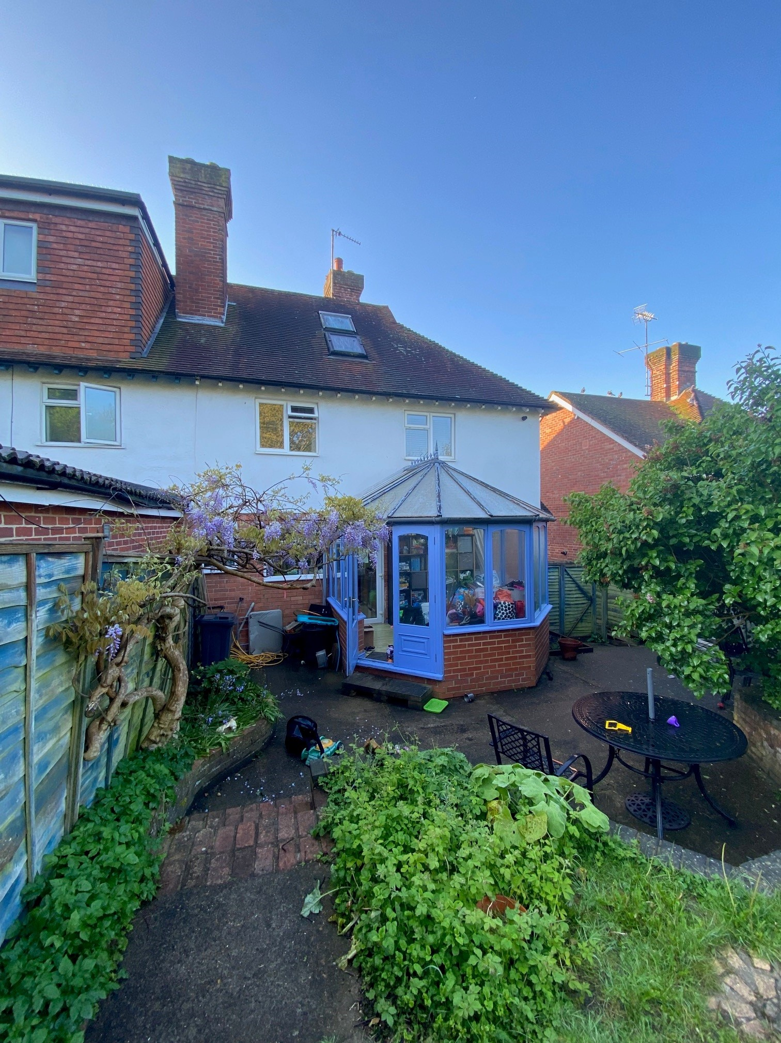

2. PROPOSAL AND SUPPORTING INFORMATION
- Existing conservatory to be replaced with single storey flat roof rear extension measuring 4.5m deep and across the whole width of the original dwelling.
- Bifold doors to be installed on the rear extension.
- Flat rooflights to be installed on the roof over the rear extension.

Plans considered received 14/02/2024
Drawing No ADAMS-0723-01 Rev A: Proposed Ground Floor Plan
Drawing No ADAMS-0723-02 Rev A: Proposed Elevations
Drawing No ADAMS-0723-03: Existing Plans and Elevations
Drawing No ADAMS-0723-04 Rev A: Proposed Section A-A
Drawing No ADAMS-0723-05: Location Plan
Drawing No ADAMS-0723-06: Block Plan

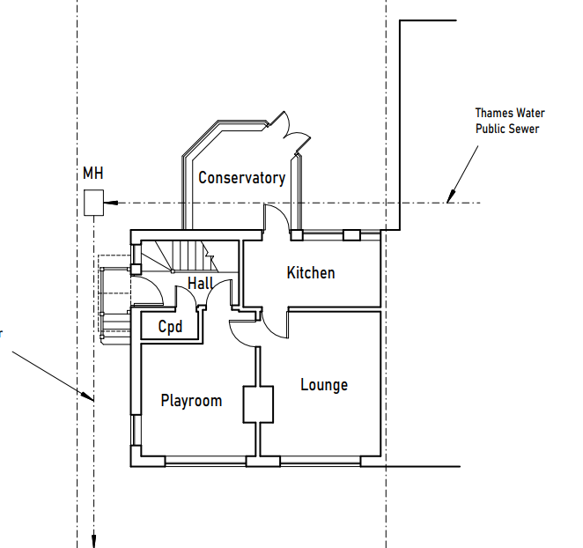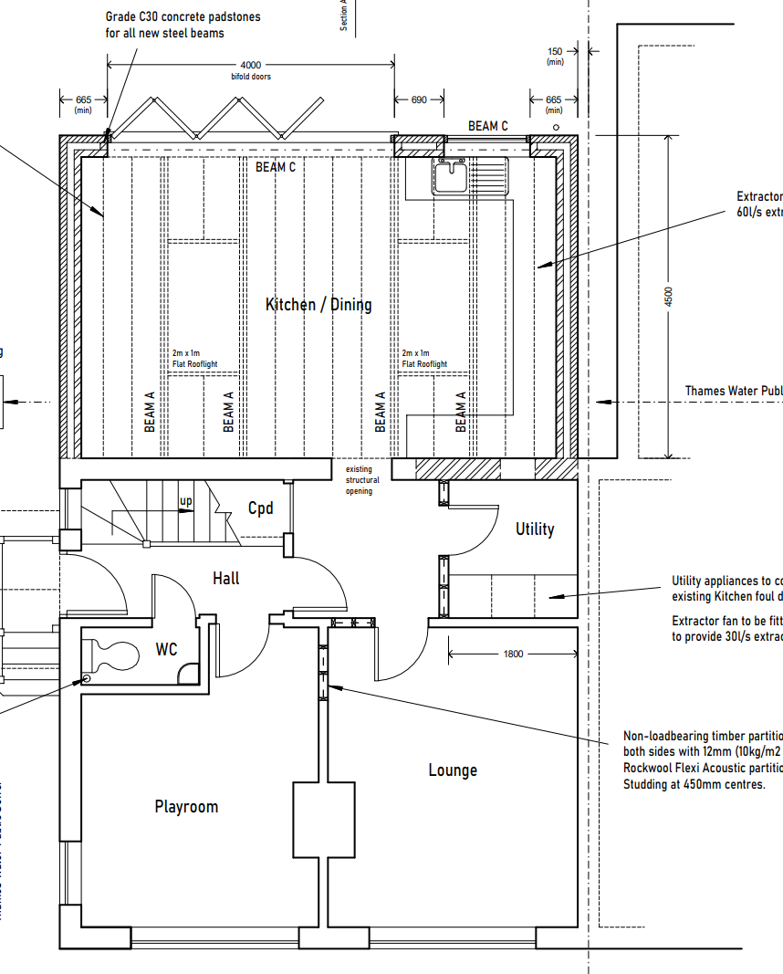
Existing Ground Floor Plan Proposed Ground Floor Plan

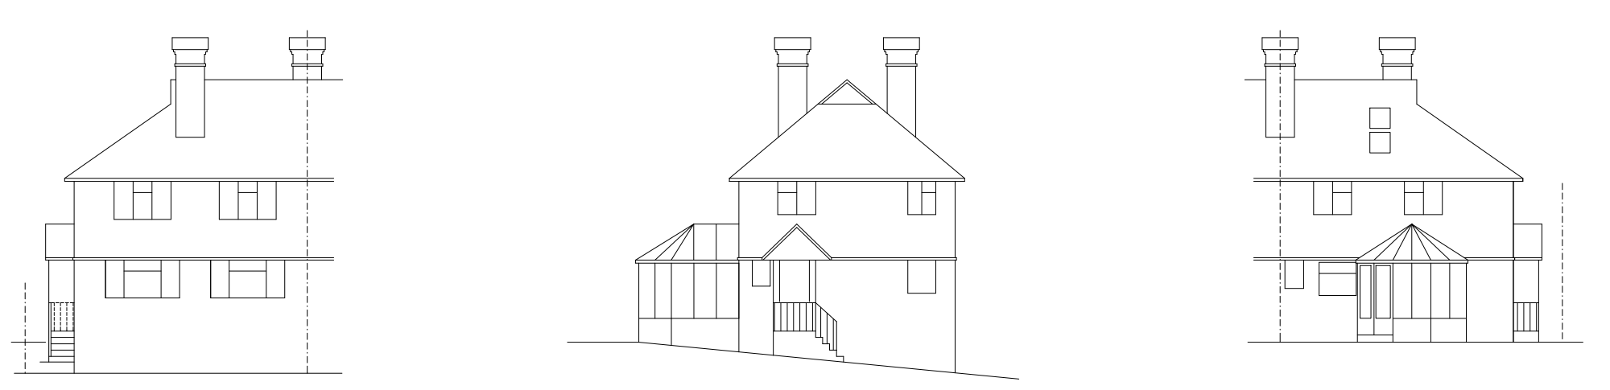
Existing Elevations

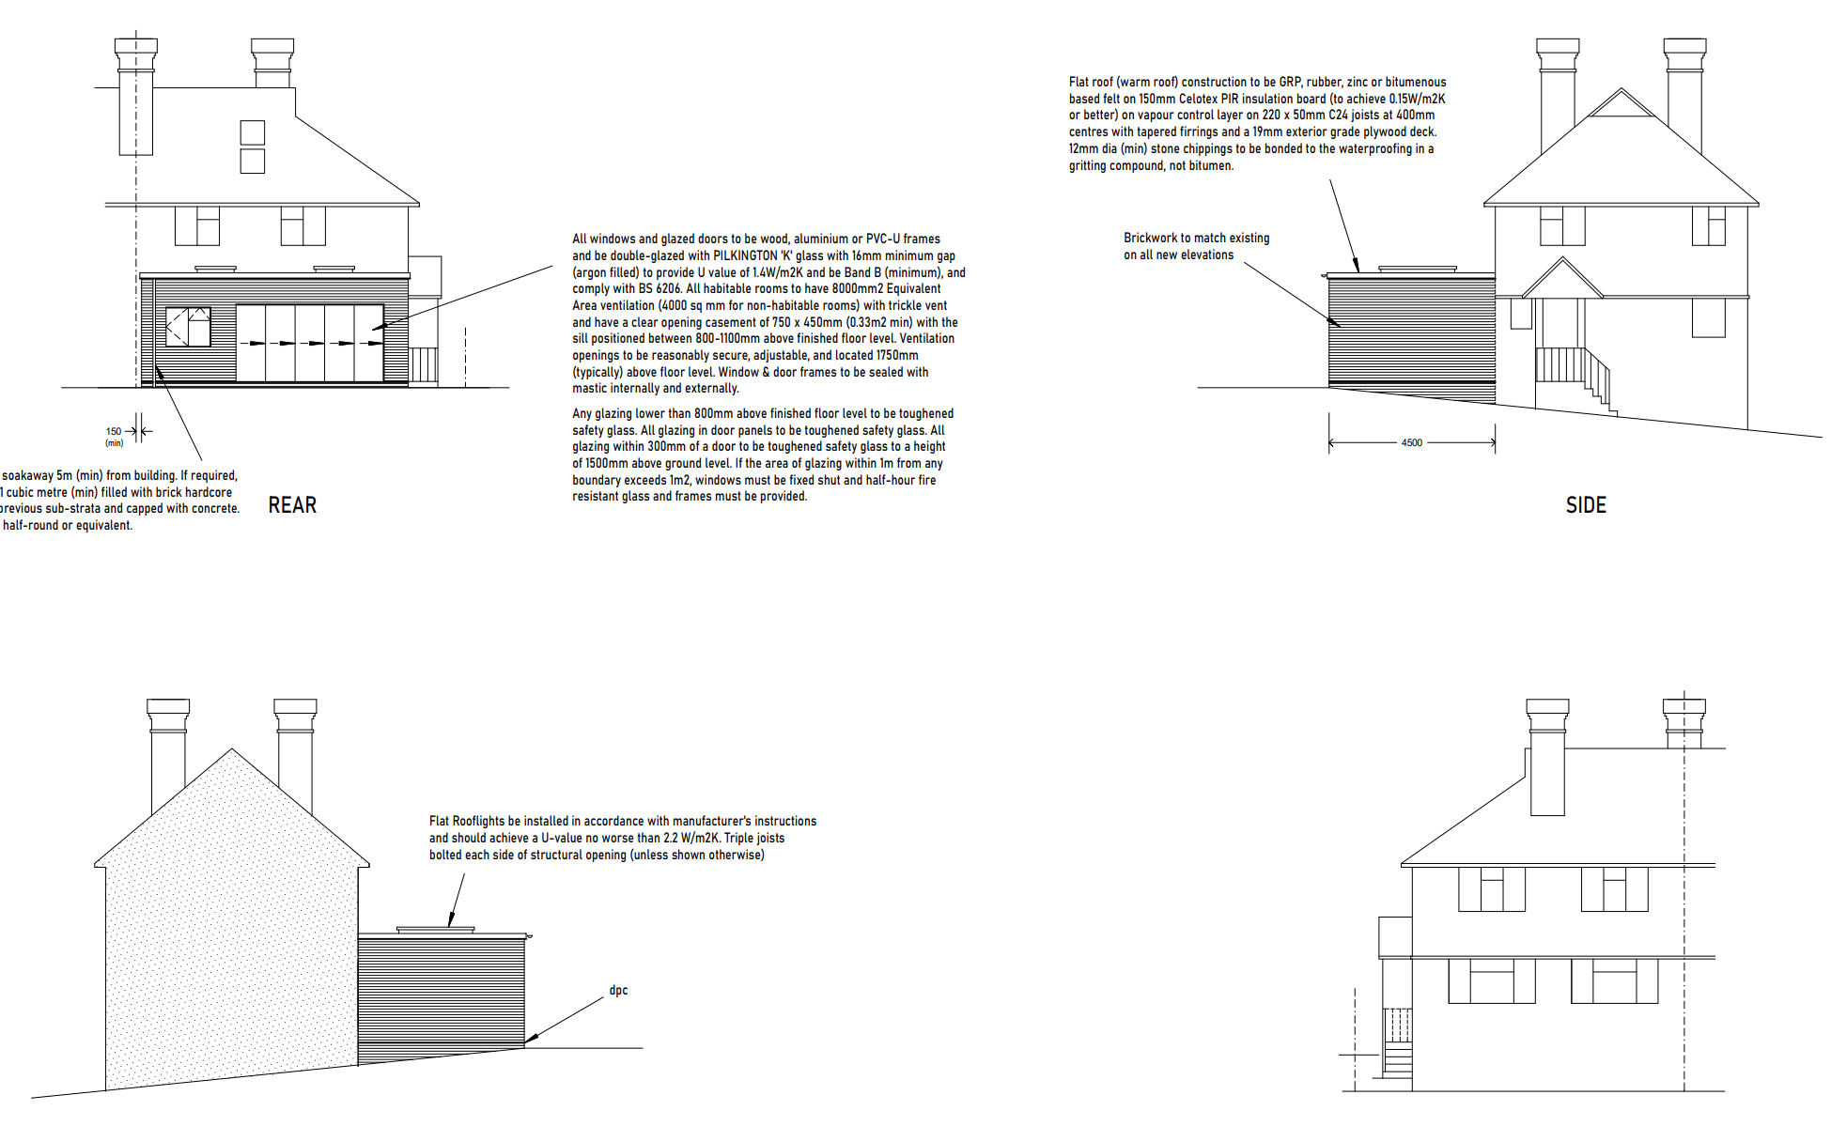
Proposed Elevations

- RELEVANT PLANNING HISTORY

None

4. CONSULTATIONS

The following addresses were consulted by letter.

23B Rotherfield Way, Emmer Green, Reading, Berkshire, RG4 8PJ
17 Rotherfield Way, Emmer Green, Reading, RG4 8PJ
13 Rotherfield Way, Caversham, Reading, RG4 8PJ
7 Rotherfield Way, Emmer Green, Reading, RG4 8PJ

Letters of representation have been received as follows:

There has been a letter of support from No 7 Rothefield Way.

Equality Act 2010:
In determining this application the Council is required to have regard to its obligations under the Equality Act 2010. However, there is no indication or evidence (including from consultation on the application) that the protected groups identified by the Act have or will have different needs, experiences, issues and priorities in relation to this particular planning application. Therefore in terms of the key equalities protected characteristics it is considered there would be no significant adverse impacts as a result of the development.

- LEGAL AND PLANNING POLICY CONTEXT

Section 38(6) of the Planning and Compulsory Purchase Act 2004 requires that proposals be determined in accordance with the development plan unless material considerations indicate otherwise. Material considerations include relevant policies in the National Planning Policy framework (NPPF) - among them the 'presumption in favour of sustainable development'. The following local and national planning policy and guidance is relevant to this application:

National Policy
National Planning Policy Framework
National Planning Practice Guidance

Reading Borough Local Plan (2019)
CC7 (Design and the Public Realm)
CC8 (Safeguarding Amenity)
H9 (House Extensions and Ancillary Accommodation)
H10 (Private and Communal Outdoor Space)

SPD
Design Guide to House Extensions (2021)

6. APPRAISAL
Character and Appearance

Policy H9 states that an extension to a house will be acceptable where it respects the character of the house in terms of scale, location, materials and design and respects the character and pattern of neighbouring properties and the street as a whole in terms of scale, location, materials and design, and any important existing building line. Policy CC7 also sets out relevant considerations for design.

The extension proposed in this application goes up to 4.5m deep to the rear, spanning the whole width of the existing dwelling. The roof would be flat, with a maximum height of 3m. The roof over the extension is to be installed with a pair of flat rooflights, projecting 0.18m from the roof plane. External finishes shall be of brick to match existing.

The extensions proposed would therefore be of limited height and constrained to the rear of the property, not visible from the street scene. The materials to be used shall also not be so varied from the existing materials that the character and pattern of the dwelling and the neighbouring properties would be considerably altered. It is, therefore, considered that in terms of scale, location, materials and design, the alterations proposed are respectful of the character and pattern of the existing dwelling and neighbouring properties.

Residential Amenity

Policy H9 states that an extension will be acceptable where it does not result in an overbearing impact on neighbours. Policy H10 seeks to ensure that the amenity of gardens and other outdoor areas are not compromised. Policy CC8 states an extension to a house will be acceptable where it will not cause a significant detrimental impact to the living environment of existing or new residential properties.

The height of the extension proposed is limited to 3m. The depth of the rear extension is also limited to 4.5m. There are no side windows proposed and the rooflights proposed would not project considerably from the plane of the roof over the extension.
There is already a much larger extension on No 17 and there would still be a considerable gap between the development and the fence of No 13.

There are no potential issues of overlooking and negative impacts of privacy on both sides of the proposal site, owing to the limited height and the absence of any proposed side windows. The limited height also mitigates any potential risks of overbearing impacts on the properties on No 13 and No 17.

It also considered that the combination of the limited depth and height of the rear extension would have minimal impact on the sunlight and daylight accessible to No 13, especially as the window to the rear kitchen window would not be adversely impacted.

- CONCLUSION
The proposed development has been assessed as set out above and is considered to be acceptable on that basis, subject to the following conditions.

8. RECOMMENDATION: Grant

Recommended Conditions:
Approved Plans
Time Limit Standards
Materials to Match

