

DELEGATED HOUSEHOLDER APPLICATION REPORT

Ward: Church
App Ref: 231805/HOU
Address: 82 Northcourt Avenue, Reading, RG2 7HQ
Proposals: Demolition of existing concrete garage building and construction of a new single storey side extension
Case Officer: Chukwudi Onwudinanti
Applicant: Mr & Mrs Rowell
Date received (valid from): 10 January 2024
Target Decision date: 6 March 2024

1. SITE DESCRIPTION

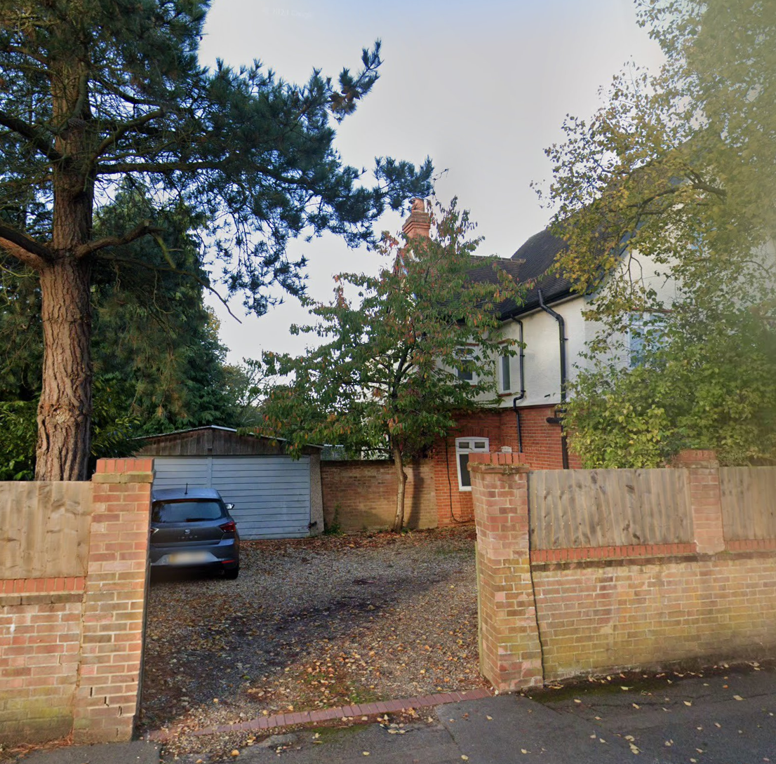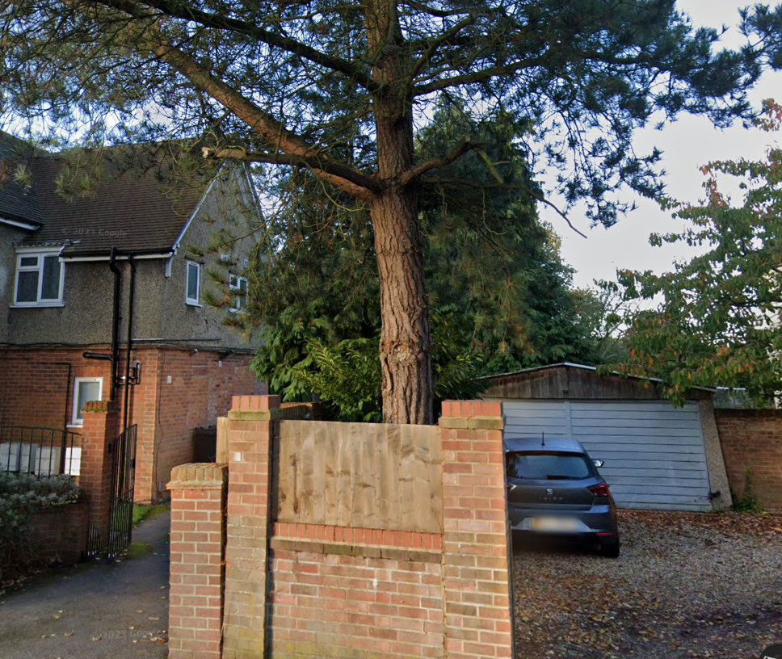

2. PROPOSAL AND SUPPORTING INFORMATION
Demolition of existing concrete garage building and construction of a new single storey side extension measuring approximately 7.5m wide and 6m deep, set back 0.6m from the boundary with No 84.

Plans considered
Drawing No 323-A1-00: Existing Plans + Elevations received 13/12/2023
Drawing No 323-A1-06: Proposed Plans + Elevations received 25/01/2024

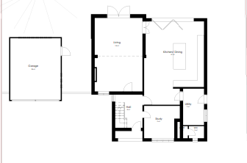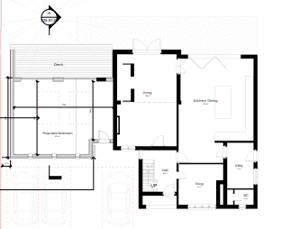
Existing Ground Floor Plan Proposed Ground Floor Plan

- RELEVANT PLANNING HISTORY
Application Ref: 150862
Description: Single storey side and rear extension, first floor rear extension
Decision: Permitted
Decision Date: 30/06/2015

4. CONSULTATIONS

The following addresses were consulted by letter.

101 Barnsdale Road, Reading, RG2 7JQ
86 Northcourt Avenue, Reading
80 Northcourt Avenue, Reading, RG2 7HQ

No letters of representation have been received.

Equality Act 2010:
In determining this application the Council is required to have regard to its obligations under the Equality Act 2010. However, there is no indication or evidence (including from consultation on the application) that the protected groups identified by the Act have or will have different needs, experiences, issues and priorities in relation to this particular planning application. Therefore in terms of the key equalities protected characteristics it is considered there would be no significant adverse impacts as a result of the development.

- LEGAL AND PLANNING POLICY CONTEXT

Section 38(6) of the Planning and Compulsory Purchase Act 2004 requires that proposals be determined in accordance with the development plan unless material considerations indicate otherwise. Material considerations include relevant policies in the National Planning Policy framework (NPPF) - among them the 'presumption in favour of sustainable development'. The following local and national planning policy and guidance is relevant to this application:

National Policy
National Planning Policy Framework
National Planning Practice Guidance

Reading Borough Local Plan (2019)
CC7 (Design and the Public Realm)
CC8 (Safeguarding Amenity)
H9 (House Extensions and Ancillary Accommodation)
TR5 (Car and Cycle Parking)
EN14 (Trees, Hedges and Woodlands)

SPD
Design Guide to House Extensions 2021
Revised Parking Standards and Design SPD 2011

6. APPRAISAL
Character and Appearance

Policy H9 states that an extension to a house will be acceptable where it respects the character of the house in terms of scale, location, materials and design and respects the character and pattern of neighbouring properties and the street as a whole in terms of scale, location, materials and design, and any important existing building line. Policy CC7 also sets out relevant considerations for design.

The new ground floor extension to be created would be for most part, on the footprint of the garage to be demolished. The height is limited to maximum height of 3m, with a flat roof over the extension. The materials to be used externally are proposed to be of timber cladding, with preformed aluminium coping to top and a flat roof finished with an EDPM (ethylene propylene diene monomer rubber)

The development is not considered to be of such material change to the overall fabric and pattern of the house in terms of scale, location, materials and design, as to be unacceptable.

Residential Amenity

Policy H9 states that an extension will be acceptable where it does not result in an overbearing impact on neighbours. Policy H10 seeks to ensure that the amenity of gardens and other outdoor areas are not compromised. Policy CC8 states an extension to a house will be acceptable where it will not cause a significant detrimental impact to the living environment of existing or new residential properties.

The height of the extension is a maximum of 3m, with a flat roof and has no windows to the side. The footprint does not exceed, to the rear garden or to the front of the dwelling, the original footprint of the existing garage. The limited height and the limits to the rear and front would mean it would not be overbearing on the adjoining dwelling. It would also not create any negative impacts in terms of the sunlight and daylight accessible to the adjoining neighbours to the side of the extension.

Car Parking.

As the development takes away the existing garage, car parking would be lost. However, the agent has provided evidence to show that there would be adequate parking in the front garden of the property to accommodate three cars. These provisions have been considered to be adequate.

Boundary Fence vertical Extension

The proposal includes an aspect that seeks to extend the boundary fence upwards by 1m, to a maximum height of 3m, on the boundary with No 84. The agent states that this is to protect the users of the proposal site from the glare of the garden light on the neighbouring property. It is not considered that this 1m increase would cause an overbearing impact on the neighbours on that side, especially as there are no windows on the side of the neighbouring property.

- CONCLUSION
The proposed development has been assessed as set out above and is considered to be acceptable on that basis, subject to the following conditions.

8. RECOMMENDATION: Grant
Recommended Conditions:
Approved Plans
Materials As Specified
Time Limit Standards
Vehicle spaces as Specified

