50 OAKLEY ROAD
CAVERSHAM
READING
BERKSHIRE
RG4 7RN
ECOLOGICAL SURVEY REPORT (BATS)
(Preliminary Roost Assessment/DBW)

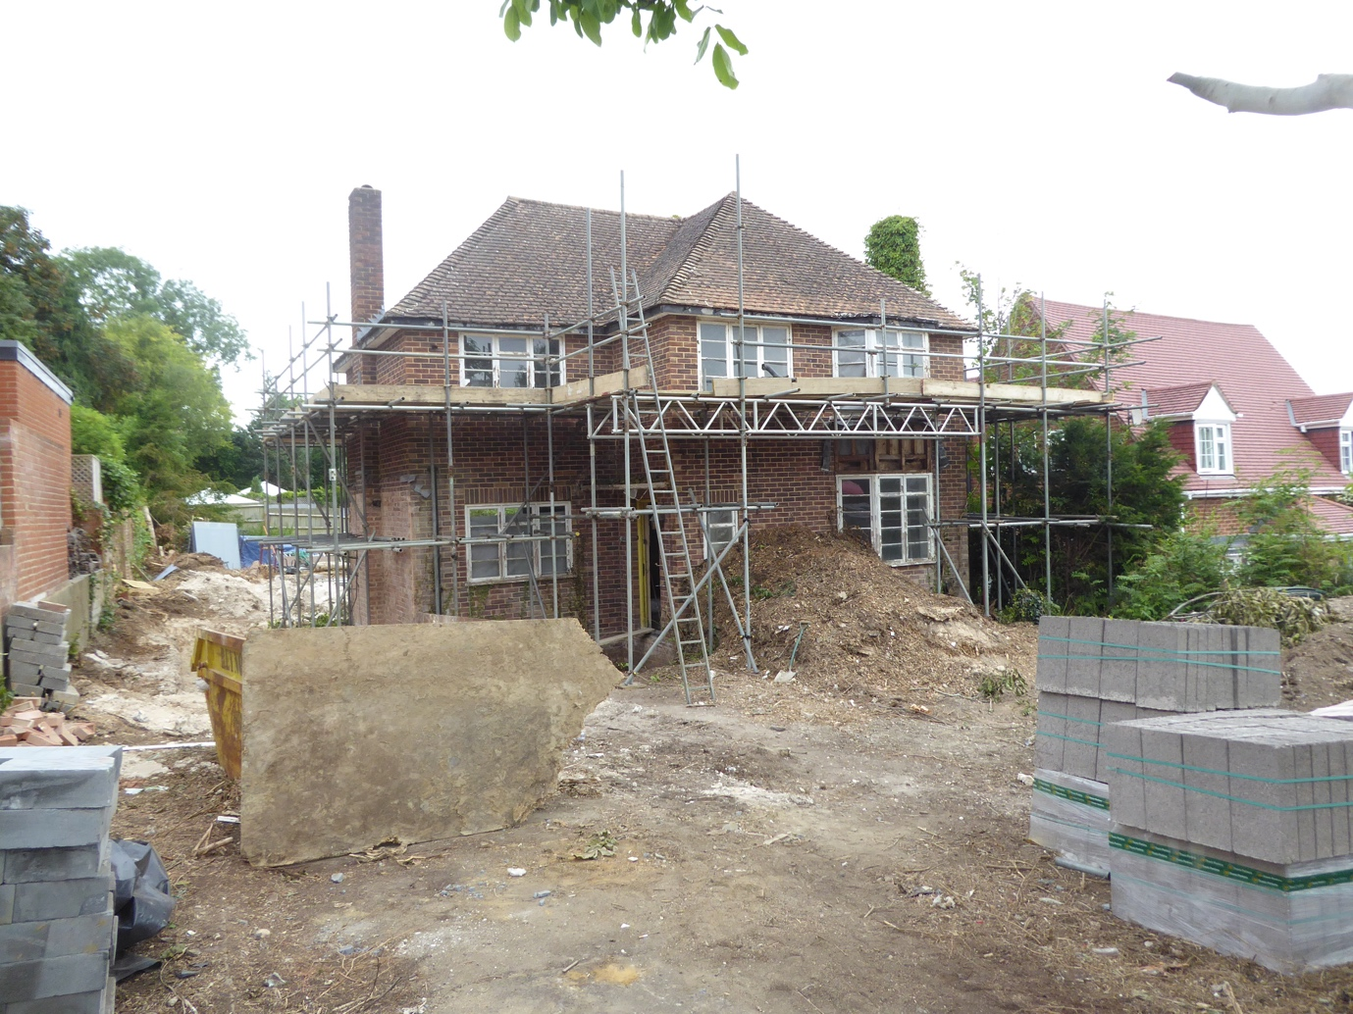

Prepared for:
Mr D. HUNT
50 OAKLEY ROAD
CAVERSHAM
READING BERKSHIRE
RG4 7RN
Date: 2ND JULY 2024.
Ref: NWP/ESR-2.7.24
CONTENTS
Executive Summary
- Introduction
1.1 Instruction
1.2 Aims and Objectives
1.3 Proposed works
1.4 Surveyor Background and Experience
- Legislation and Planning Policy
2.1 Legislative Background
- Site Location and Description
3.1 Site Location 3.2 Site Description
- Survey Methodology
4.1 Pre-Survey Data Search
4.2 Daylight Survey
4.3 Constraints
- Survey Findings
5.1 External Inspection 5.2 Internal Inspection
- Evaluation
- Conclusions
7.1 Interpretation
  - Contingency plan
8.References
9.Queries
Appendix 1

50 Oakley Road, Caversham, Reading, Berkshire RG4 7RN.
EXECUTIVE SUMMARY
BatCraft was commissioned Mr D.HUNT to conduct a preliminary ecological appraisal (daytime bat walkover [DBW]), of 50 OAKLEY ROAD, CAVERSHAM, READING, BERKSHIRE RG4 7RN. This is to support a planning application.
The site visit was carried out on 2/7/24, during daylight hours. An internal and external inspection of the property took place to look for signs of bats.
The preliminary ecological appraisal consists of a desk top study prior to the survey to review existing information about the site and its surroundings and to inform the design of subsequent bat surveys, if required. The desk top study was conducted based upon a 2km search radius and it revealed 2 statutory designated sits within, CLAYFIELD COPSE, classified as a local nature reserve and CHILTERNS, Area Outstanding Natural Beauty. There are 3 current European Protected Species Licences (EPSLs) for bats with licence end dates of 2025 (x2) and 2027 (x1). There are 14 expired EPSL’S for bats within 2km of the proposed development site. The close proximity of the River Thames, approximately 1200 metres would suggest good foraging and commuting, however the connectivity between this and the site is poor due to the urban environment where multiple roads and buildings are present.
The DBW comprised a detailed search of the exterior and interior of the buildings for bats, signs of bats and features suitable for use by roosting bats. This includes droppings, scratch marks, rubbing and staining at exit holes, live or dead bats and other features such as missing tiles, this list is not exhaustive.
The buildings suitability to support roosting bats was assessed and no bats or evidence of bats was identified during the preliminary inspection.
The main dwelling building has negligible potential roost features that could support bats.
When the findings are combined the main dwelling building was characterised as having a negligible potential1 to support roosting bats.
In line with best practice guidelines2, no further survey effort is required.
1-Table 4.1 Guidelines for assessing the potential suitability of proposed development sites for bats. Bat Surveys for Professional Ecologists Good Practice Guidelines 4th Edition. Page 44.
2- Collins, J. (ed) (2023) Bat Surveys for Professional Ecologists Good Practice Guidelines (4th Edition).

50 Oakley Road, Caversham, Reading, Berkshire RG4 7RN.
1.INTRODUCTION

  - Instruction

BatCraft was instructed by Mr D.Hunt to conduct a DBW of 50 OAKLEY ROAD, CAVERSHAM, READING, BERKSHIRE RG4 7RN to support a planning application.

1.2 Aims and Objectives
The DBW is designed to:
• Identify the presence/likely absence of bats within the building.
• Provide information on previous bat ecological surveys/reports.
• Provide information on the status of bats using the buildings currently or previously.
• To add confidence where no bats are found, or to categorise the nature of a roost where evidence of bats are found.
• To establish whether further surveys, mitigation or an EPSL is required.
The preliminary ecological appraisal (bats) and report writing were carried out in accordance with Bat Surveys for Professional Ecologists Good Practice Guidelines 4th edition.
  - Proposed Works
The survey was commissioned in connection with a planning application.
  - Surveyor Background and Experience
The preliminary ecological appraisal for bats was undertaken and the report written by Nicholas Powell. Nicholas holds a Class 2 Bat License (CLS-11742) and has received training in bat ecology and surveying, bat detector use, acoustic monitoring/sonogram analysis, architectural terms for bat workers, bats and development, H & S awareness for bat workers, legislation for bat workers, British bats their ecology and conservation, surveying trees for bats, Bat ID and handling, bat biology.

50 Oakley Road, Caversham, Reading, Berkshire RG4 7RN.
2. Legislation and Planning Policy
2.1 Legislative Background
All species of British bat are protected under the Conservation of Habitats and Species Regulations 2017 and the Wildlife and Countryside Act 1981, as amended. Under this legislation it is an offence to kill or injure a bat or interfere with any roosting or resting site. A bat roost is interpreted as “any structure or place used for shelter or protection” whether or not bats are present at the time. A summary of the main legislation and planning considerations are included at Appendix 1.
Seven species of bat are also Species of Principal Importance for nature conservation in England under Section 41 of the Natural Environment and Rural Communities Act 2006. This places a duty on all government departments to have regard for the conservation of these species and on the Secretary of State to further, or promote others to further, the conservation of these species.
All rights in this report are reserved. No part of it may be reproduced, edited or transmitted, in any form or by any means, electronic, mechanical, photocopying, recording or otherwise, or stored in any retrieval system of any nature, without our written permission. Its content and format are for the exclusive use of Mr.D.HUNT and their agents in dealing with this site. It may not be sold, lent, hired out or divulged to any third party not directly involved in this site without the written consent of BatCraft It may be reproduced as part of a planning application.
This report is valid for 12 months from the site inspection. The lifespan of this report may be subject to change if the site conditions change due to unspecified works that affect the site.

50 Oakley Road, Caversham, Reading, Berkshire RG4 7RN.
3. Site Location and Description
3.1 Site Location
The building is located at Grid Reference SU 71062 75670, see Figure 1 below. An overview of the immediate area is shown on Figure 2, courtesy of Bing Maps.
Figure1. 50 Oakley Road, Caversham, Reading, Berkshire RG4 7RN.
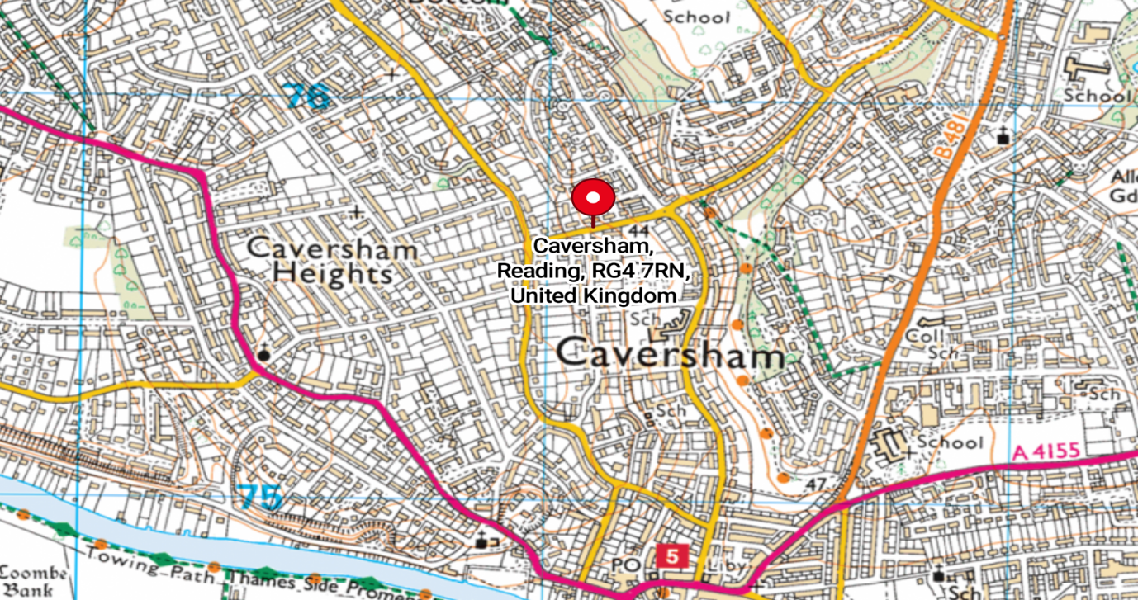
Figure 2. 50 Oakley Road, Caversham, Reading, Berkshire RG4 7RN.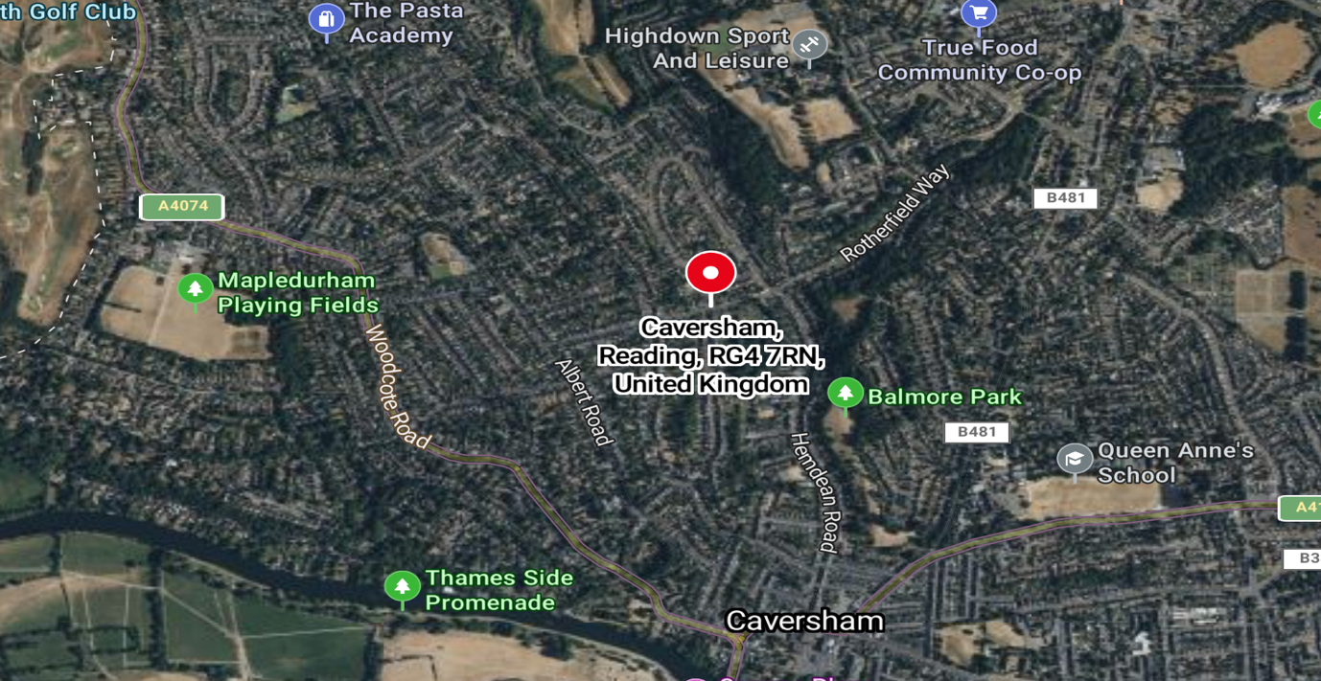

50 Oakley Road, Caversham, Reading, Berkshire RG4 7RN.
3.2 Site Description
The application site comprises a double storey detached brick-built dwelling.
To the front of the property is a driveway and parking area, currently mounded with topsoil and mulch. Figure 1.
To the rear of the property is an area which has topsoil and chalk mounds with some stacked/stored building material and tools. Figure 2/3.
The site itself offers a negligible amount of foraging and commuting habitat for bats, the sparsely scattered trees and hedges in surrounding premises and multiple roads and buildings would allow poor connectivity to the wider landscape.
Figure 1. Front garden.
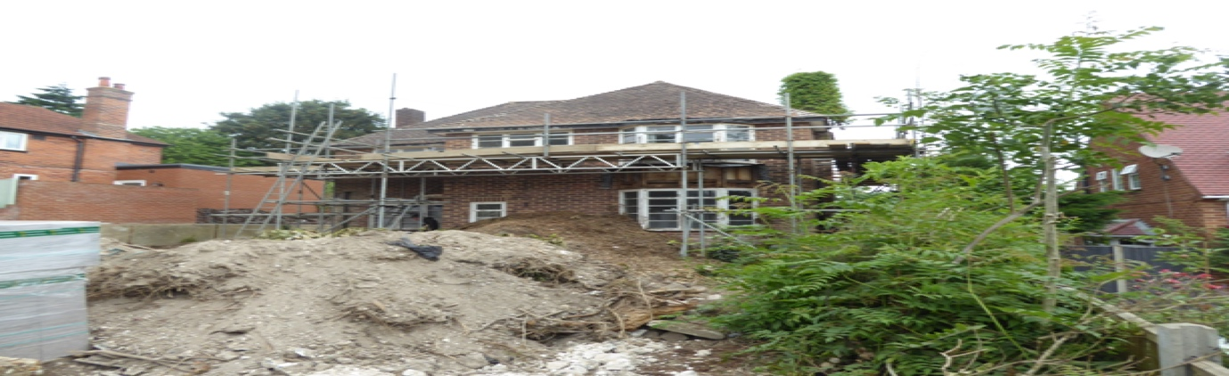
Figure 2. Rear Garden.
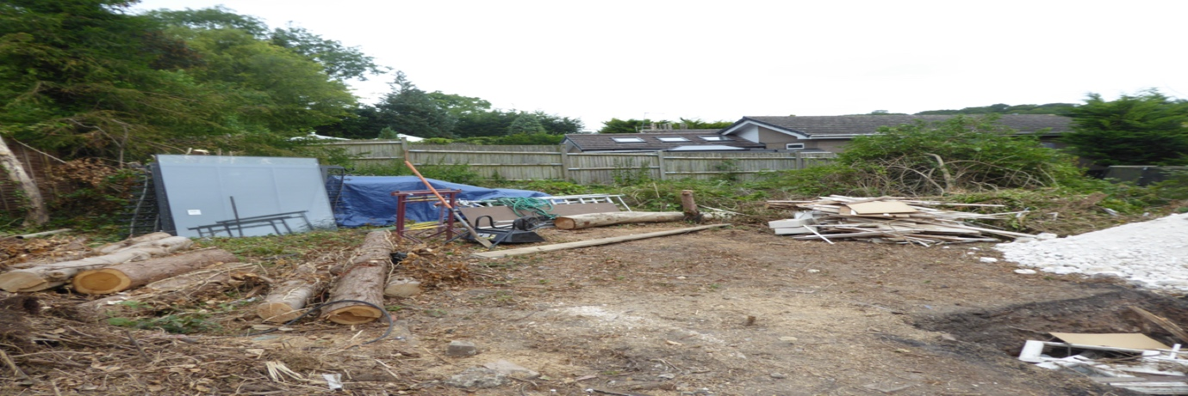
Figure 3. Rear Garden
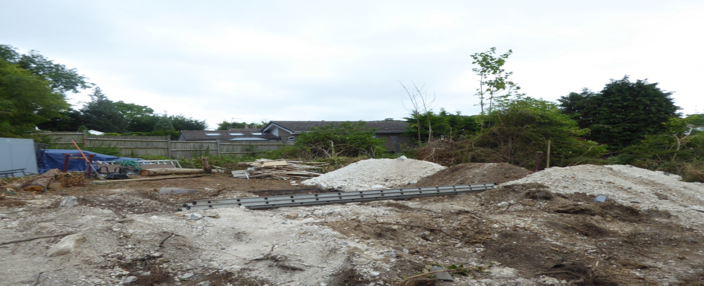

50 Oakley Road, Caversham, Reading, Berkshire RG4 7RN.
4.Survey Methodology

4.1 Pre-Survey Data Search
The client has advised that to their knowledge, no previous bat surveys have been undertaken on the site. Google Earth and MAGIC maps (magic.defra.gov.uk) websites were used prior to the survey to determine the suitability of the surrounding habitat to support roosting bats and to identify any statutory designated sites or EPSLs within 2km of the site. No data was sought from the local records centre at this time. A search of the Magic interactive website revealed that 2 statutory designated sites are located within, and 3 current EPSLs for bats have been granted within 2km of the site, Figure 1, and there are 14 expired licences, Figure 2. The statutory designations are Clayfield Cops Local Nature Reserve and Chilterns Area of Outstanding Natural Beauty.

The site is situated along a through road, in Caversham, Caversham is a village and suburb of Reading in Berkshire,there are properties lining either side of the road. The vast majority of these are two storeys with the occasional single storey dwelling. Some 600 metres to the north is the start of ‘BUGS BOTTOM, which is a park, to the south some 1200 metres is the River Thames, further afield to the northwest approximately 1800 metres is the Chilterns AONB, and northeast approximately 1900 metres is Clayfield Copse, a local nature reserve. These areas should be suitable to support roosting bats and would provide good foraging and commuting potential for a wide species of bats. The ecological connectivity of these sites to the dwelling is poor due to multiple properties and roads separating the sites.

Figure 1, Current licences within 2km of proposed development.
Case Reference of Granted Licence | Species on the Licence | Licensable Period | Licensable works
2020-44895-EPS-MIT | BLE, C-PIP,DAUB, S-PIP | Licence Start Date  25/02/2020  Licence End Date  25/02/2025 | Destruction of a resting place.
2020-44895-EPS-MIT-1 | BLE, C-PIP,DAUB, S-PIP | Licence Start Date  30/11/2020  Licence End Date  25/02/2025 | Destruction of a resting place.
2017-29064-EPS-MIT | S-PIP | Licence Start Date  01/09/2017  Licence End Date  01/09/2027 | Destruction of a resting place.  Destruction of a breeding site.

50 Oakley Road, Caversham, Reading, Berkshire RG4 7RN.
FIGURE 2, Expired Licences within 2km of proposed development.

Case Reference of Granted Licence | Species on the Licence |  |  | Licensable Period | Licensable works
2014-2980-EPS-MIT | C-PIP  S-PIP |  |  | Licence Start Date  12/09/2014  Licence End Date  01/10/2015 | Destruction of a resting place.
2015-13539-EPS-MIT | c-pip |  |  | Licence Start Date  02/09/2015  Licence End Date  01/09/2016 | Destruction of a resting place.
2015-14137-EPS-MIT | C-PIP  S-PIP |  |  | Licence Start Date  16/09/2015  Licence End Date  15/09/2020 | Destruction of a resting place.
2015-18560-EPS-MIT |  | BLE  S-PIP | Licence Start Date  25/01/2016  Licence End Date  31/01/2021 |  | Destruction of a resting place.
EPSM2013-6025 |  | BLE | Licence Start Date  26/07/2013  Licence End Date  31/12/2013 |  | Destruction of a resting place.
EPSM2011-3175 |  | C-PIP | Licence Start Date  10/07/2011  Licence End Date  31/08/2012
EPSM2012-4078 |  | BLE, DAUB, NATT | Licence Start Date  05/10/2012  Licence End Date  30/01/2014
2017-28045-EPS-MIT |  | DAUB | Licence Start Date  08/03/2017  Licence End Date  08/03/2022
2016-27061-EPS-MIT |  | BLE, C-PIP | Licence Start Date  03/01/2017  Licence End Date  03/01/2017 |  | Destruction of a resting place.
2018-33476-EPS-MIT |  | SER | Licence Start Date  07/03/2018  Licence End Date  21/02/2023 |  | Destruction of a resting place.
2018-38007-EPS-MIT |  | BLE, C-PIP | Licence Start Date  04/02/2019  Licence End Date  31/08/2021 |  | Damage of a resting place
2018-35917-EPS-MIT |  | C-PIP | Licence Start Date  27/06/2018  Licence End Date  30/11/2018 |  | Destruction of a resting place.
2014-3600-EPS-MIT |  | C-PIP | Licence Start Date  29/09/2014  Licence End Date  01/10/2019 |  | Destruction of a resting place.  Damage of a resting place
2014-1343-EPS-BDX |  | S-PIP | Licence Start Date  01/10/2014  Licence End Date  30/10/2014

50 Oakley Road, Caversham, Reading, Berkshire RG4 7RN.

4.2 Daylight Survey
The DBW of 50 Oakley Road, Caversham, Reading, Berkshire RG4 7RN was carried out by Nicholas Powell on Tuesday 2nd July at 8am. The weather conditions for the survey were clear with no rain and a temperature of 18 degrees.
Equipment used included a high-powered torch, a digital camera, a digital camera on a telescopic pole, an endoscope and a ladder.
During the DBW an external inspection of the property was carried out to identify any signs of occupation by bats and features that could offer potential roosting sites following standard survey guidelines.
Features investigated included:
• Construction of the building– soffits, loft space, tiles/slates, lead flashings etc.
• Building condition – structure of roof and walls.
• Access points – potential entry and exit points for bats.
• Roosting points – cracks and crevices, between underlay and roofing tiles/slates.
Field signs that would indicate the presence of bats were searched for. These included:
• Bat droppings on the floor and walls of the building.
• Feeding remains (particularly butterfly and moth wings).
• Evidence of urine and/or oily staining around possible roost entrance
• Presence of areas cleared of cobwebs.
• Where a breathable roofing membrane has been fitted staining on the membrane may suggest use by bats.
• Odour can sometimes suggest the present of bats.
• Squeaking and chattering can reveal bats roosting between the tiles and roofing underlay.

50 Oakley Road, Caversham, Reading, Berkshire RG4 7RN.
4.3 Constraints
Full access to the site during the visit was made possible by the client.
5. Survey Findings

5.1 External inspection
The external features of the property were examined for signs described in section 4.2. Windowsills, exposed features around the windows, fascia’s and walls were inspected for any evidence of bat droppings or staining.
The property is detached, of brick construction with a tiled, hipped ‘L’ plan roof.
The ridge tiles on the dwelling were in good condition with no significant missing mortar that bats could exploit. Figure 1.
The tiles along the hips were close fitting with no significant gaps or missing mortar. Figure 2.
The tiles covering the main roof area were close fitting with no significant gaps that bats could exploit. Figure 3.
The wooden soffits and fascia’s are all in good condition, close fitting to the walls with no splits or significant openings. Figure 4.

The lead flashing around both chimneys was present and close fitting. Figure 5.

Figure 1. Showing ridge tiles.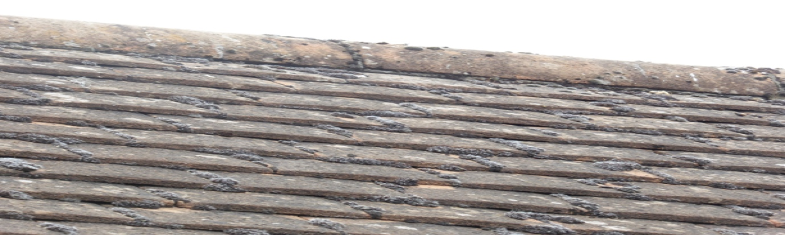

Figure 2. Showing hip tiles.
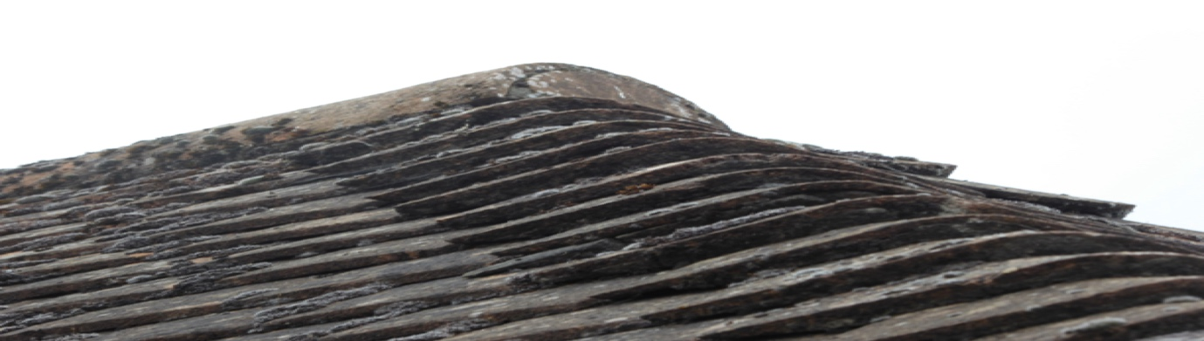
50 Oakley Road, Caversham, Reading, Berkshire RG4 7RN.
Figure 3. Example area of roof tiles.
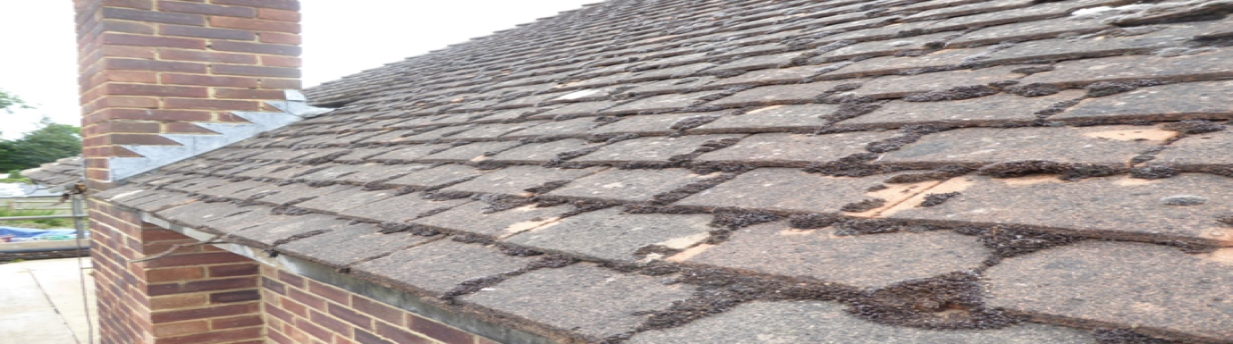
Figure 4. Wooden soffits and fascias.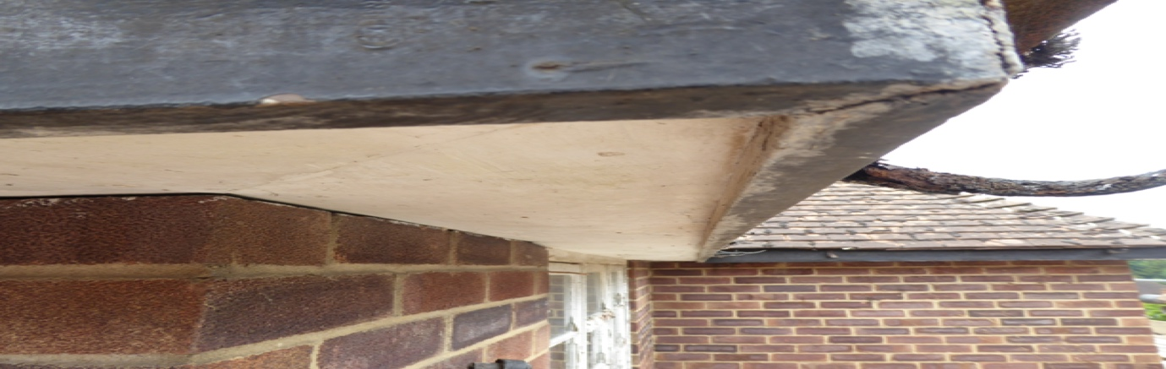

Figure 5. Example of close-fitting lead flashing.
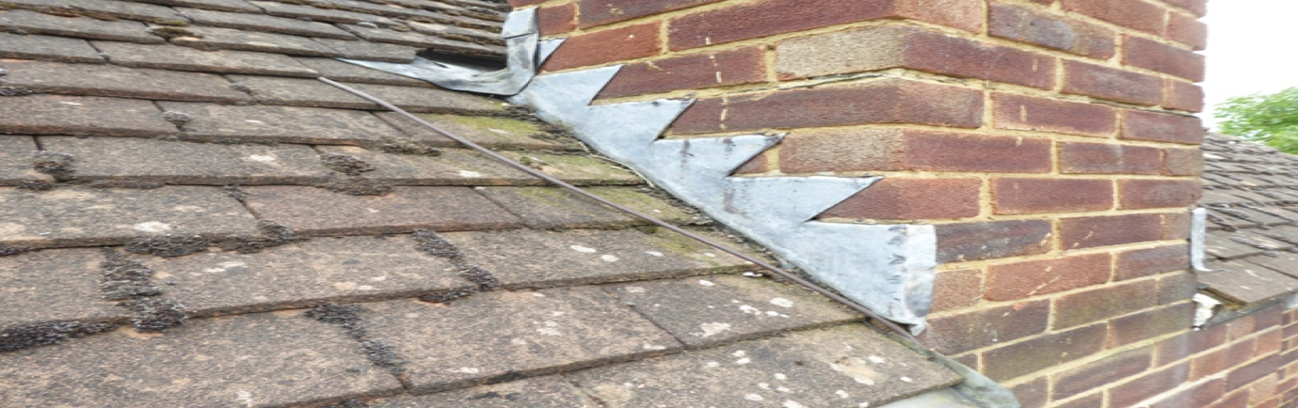

No bats or evidence of bats was recorded during the external inspection of the dwelling and there were no visible roosting opportunities for bats or access into the building for roosting bats.

50 Oakley Road, Caversham, Reading, Berkshire RG4 7RN.
5.2 Internal Inspection

An internal inspection of the property was undertaken and was examined for any signs of bats, (described in section 4.2)
The loft space was accessed via a ladder although it was visible from the first floor due to no ceilings. Figure 1.
The roof tiles were lined with a bitumen felt, and in some areas, black plastic. It was in poor condition with repairs to tears. Figure 2.
Areas where lining was missing showed close fitting tiles with no light ingress. Figure 3.
There was nothing significant to hinder the inspection.
No evidence of bats was recorded during the internal inspection of the property and internally there are limited opportunities for bats within the building.

Figure 1. Ceiling joists exposed due to no ceilings.
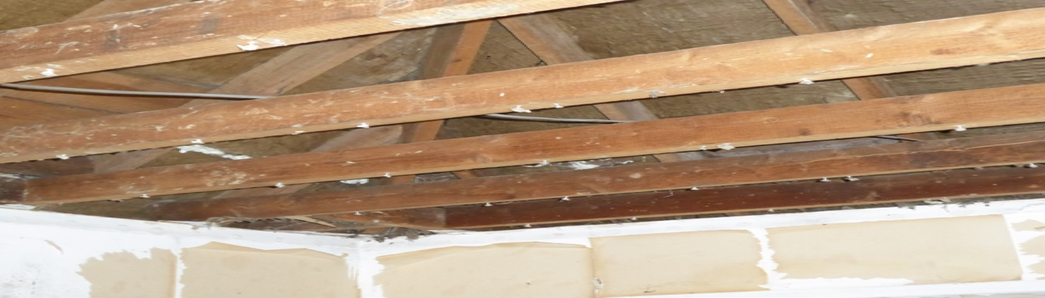

Figure 2. Bitumen felt and black plastic in poor condition.
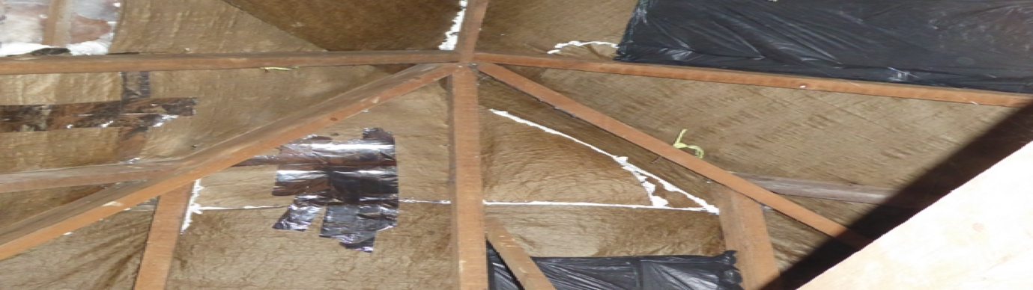
Figure 3. Internal view of unlined and close-fitting tiles.
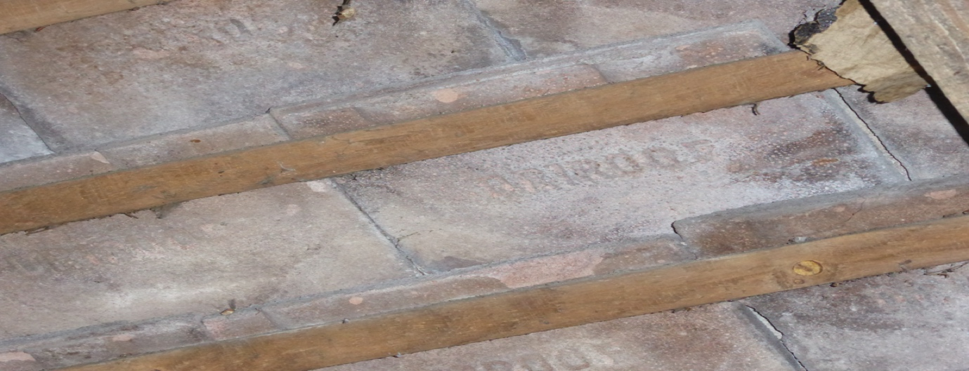
50 Oakley Road, Caversham, Reading, Berkshire RG4 7RN.
6. Evaluation
The bat roost potential of the features within the site have been assessed with reference to the following criteria and include seasonal variation where increased or decreased probability may arise. Where features are present, they are highlighted in bold.

The likelihood of bat roosts being present will be higher where structures:
• are of a pre-20th Century construction;
• are in a lowland rural setting;
• have woodland, mature trees, species-rich grassland and/or water nearby; •have large dimension roof timbers with cracks, joints and holes,
• have an uneven roof covering with gaps, though not too draughty;
have numerous crevices in stonework and structures;
• have hanging tiles or roof cladding, especially on south-facing walls;
• have a roof warmed by the sun;
• are disused or little used; largely undisturbed;
• provide appropriate hibernation conditions, such as abandoned mines, tunnels, kilns, or fortifications; or
• Recent and historical records of bat roosts in the general area.
The likelihood of bat roosts being present will be lower where structures:
• are in an urban setting with little green space;
• are subject to heavy disturbance (constant movement due to draughts and noise, also unstable microclimate);
• have a small, cluttered roof void (particularly for brown long-eared);
• are of a modern construction with few gaps or crevices that bats can fly or crawl through (though pipistrelle bats may still be present);
• are comprised of prefabricated steel or sheet materials; (some sections);
• are active industrial premises.

Please note that the above list provides generic screening criteria only and there are exceptions to consider.

50 Oakley Road, Caversham, Reading, Berkshire RG4 7RN.
7.Conclusion
7.1 Interpretation
The combined evidence from the desktop study and the external/internal inspection of the property provides a high level of confidence in support of the opinions set out in this report. There are no visible features externally on the main dwelling and building in which bats could access the building to roost.
House/dwelling- Informed by the results of the survey and the factors highlighted in Section 6, it is concluded that there is negligible potential for roosting bats within the building, based on recommendations in the Bat Workers Manual and the Bat Surveys Good Practice Guidelines, no further survey effort is required.
7.2 Contingency Plan
In the unlikely event that bats are found during the works within the buildings, all work must stop, and advice sought from BatCraft or another licensed bat ecologist.
If, for whatever reason, there is a time delay of greater than 12 months between this survey and the commencement of work, then the survey should be repeated as the condition of the buildings may change and bats may start roosting at the site.

50 Oakley Road, Caversham, Reading, Berkshire RG4 7RN.
8. References
Collins, J (ed.) (2023). Bat Surveys for Professional Ecologists: Good Practice Guidelines (4th Edition). The Bat Conservation Trust, London.
HM Government (2017) Conservation of Habitats and Species Regulations as (amended).
HM Government (1981) The Wildlife and Countryside Act (as amended). HM Government (2006) Natural Environment and Rural Communities Act.
Mitchell-Jones, A.J. & McLeish, A.P. (2004). Bat Workers' Manual (3rd Edition). Joint Nature Conservation Committee.

9.Queries
Any queries regarding this report should be addressed in the first instance to BatCraft.
Telephone; 07960 351558.

Email: info@batcraft.co.uk
1 The Chestnuts, East Grimstead, Salisbury, Wiltshire SP5 3RU.

50 Oakley Road, Caversham, Reading, Berkshire RG4 7RN.
APPENDIX 1
In summary, the legislation combined makes it an offence to:
- • Intentionally or recklessly damage, destroy or obstruct access to a structure or place used for shelter by a bat.
- • Intentionally or recklessly disturb bats; in particular any disturbance which is likely to impair the ability of bats to survive, breed or reproduce or nurture their young; or in the case of hibernating or migrating bats, to hibernate or migrate.
- • Intentionally or deliberately kill, injure or take any bat.
Planning Considerations:
Government guidance to Local Planning Authorities stipulates the need to consider biodiversity and protected species during the consideration of planning applications. The NPPF makes clear that the planning system should help minimise the impacts that development can have on biodiversity and provide net gains in biodiversity where possible. In addition, the ODPM Circular 04/2005 states “It is essential that the presence or otherwise of protected species, and the extent that they may be affected by the proposed development, is established before the planning permission is granted, otherwise all relevant material considerations may not have been addressed in making the decision”.
Developments that compromise the protection afforded to bats or roosts under the provisions of the Conservation of Habitats and Species Regulations 2017 and the Wildlife and Countryside Act 1981 will require a European Protected Species (EPS) licence from Natural England (NE).
NE, the government’s statutory conservation advisory organisation, is responsible for issuing EPS licences that would permit activities that would otherwise lead to an infringement of the Habitat Regulations.
Three tests must be satisfied before this licence (to permit otherwise prohibited acts) can be issued:
- • Reg 44(2)(e) – the derogation is “in the interests of public health and public safety, or for other imperative reasons of overriding public interest, including those of a social or economic nature and beneficial consequences of primary importance for the environment”.
- • Reg 44(3)(a) – there is “no satisfactory alternative” to the derogation.
- • Reg 44(3)(b) –the derogation is “not detrimental to the maintenance of the populations of the species concerned at a favourable conservation status in their natural range”.
Tests (a) and (e) can be met with the issue of planning permission for the proposed works. Test (b) is determined by NE’s ecology department that requires the development of a suitable mitigation strategy that would ensure that any bats present on site, are retained at the same population level or better.

