

DELEGATED APPLICATION REPORT

Ward: Whitley
App Ref: 240151/ADV
Address: 400 Longwater Avenue, Reading, RG2 6GF
Proposals: Internally illuminated fascia sign
Case Officer: Chukwudi Onwudinanti
Applicant: Wood Group
Date received (valid from): 4 March 2024
Target Decision date: 18 May 2024

1. SITE DESCRIPTION

The application site comprises of two five-story office blocks of the same design and height; one to the north and another to the south and car parks west and south of the site. West of the site across the road is undeveloped land and to the east is Foudry Brook beyond which are various office buildings and large open car parks. The area is predominantly comprised of multi-story office buildings of different types and sizes.

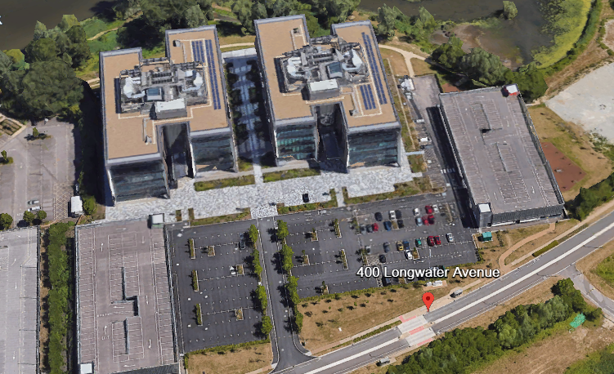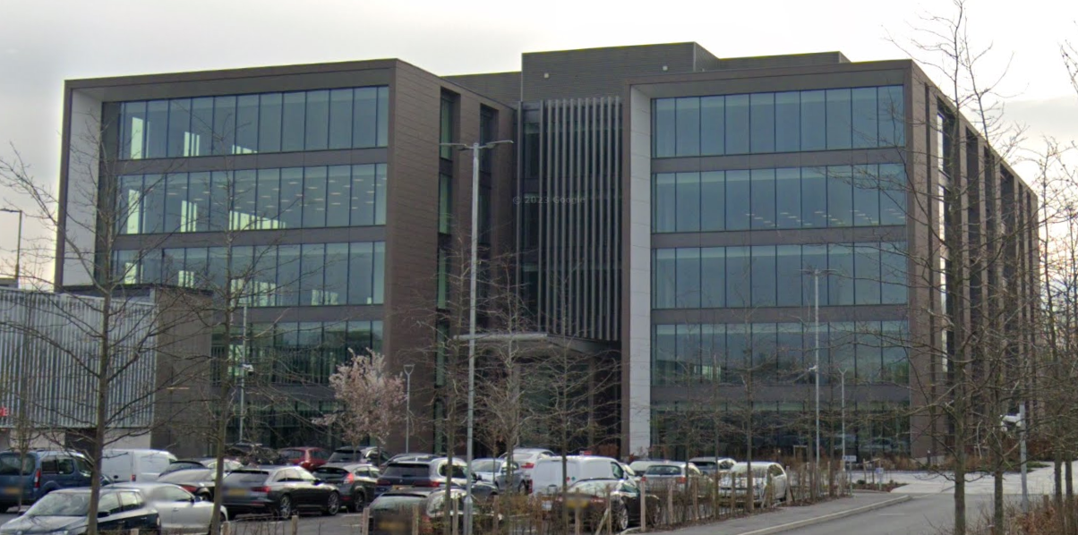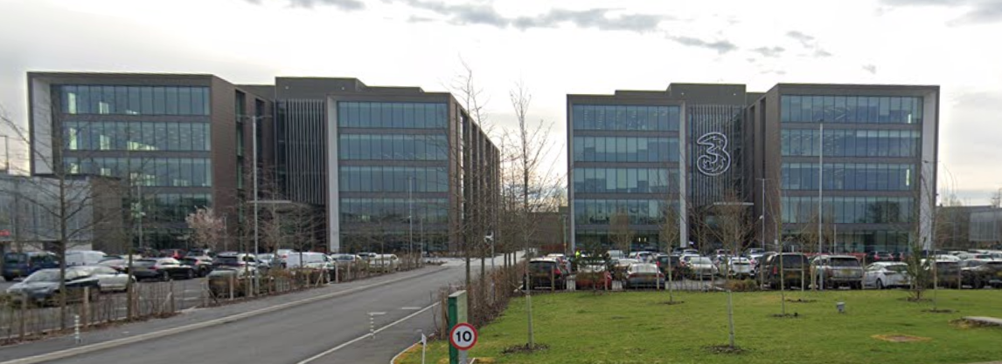

2. PROPOSAL AND SUPPORTING INFORMATION
The proposal is for an internally illuminated fascia sign measuring 1.72m in height, 5.67m in width and 0.12m in depth. It is to be hung 14.30m from the ground, projecting 0.15m from the face of the building, with letterings of maximum height 0.17m and illuminance levels of 20cd/m^{2.} The illumination is proposed to be static.

Plans considered dated 12/01/2024 and received 07/02/2024
Drawing No P001: Site Location Plan
Drawing No P002: Existing Elevation
Drawing No P001: Proposed Plan & Elevation

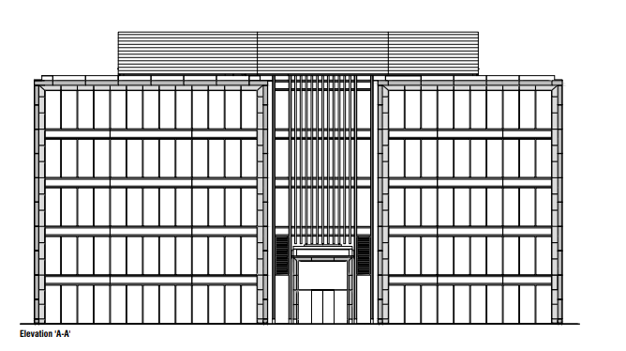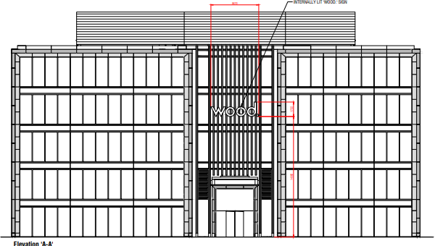
Existing Elevation Proposed Elevation

- RELEVANT PLANNING HISTORY

Application Ref: 160569
Description: Development of commercial office buildings (B1 Use Class), access, decked and surface car parking, cycle parking, landscaping, servicing, associated engineering and ancillary works
Decision: Permitted (Committee Decision)
Decision Date: 23/1/2017
Relevant Condition in Decision Notice: Condition No 4. Details of any external lighting of the site (to include type and luminance) shall be submitted to and approved in writing by the Local Planning Authority prior to its installation. The approved scheme shall be installed, maintained, and operated in accordance with the approved details.

Application Ref: 181718
Description: Discharge of conditions 3, 4, 12 & 13 of planning permission 160569
Decision: Conditions Discharged
Decision Date: 21/3/2019

4. CONSULTATIONS

A Notice was displayed on site.

Environmental Protection and Nuisance Team - no objections.

Equality Act 2010:
In determining this application the Council is required to have regard to its obligations under the Equality Act 2010. However, there is no indication or evidence (including from consultation on the application) that the protected groups identified by the Act have or will have different needs, experiences, issues and priorities in relation to this particular planning application. Therefore in terms of the key equalities protected characteristics it is considered there would be no significant adverse impacts as a result of the development.

- LEGAL AND PLANNING POLICY CONTEXT
Regulation 3 of the Town and Country Planning (Control of Advertisements) (England) Regulations 2007 requires the Local Planning Authority to exercise its powers under these regulations in the interests of amenity and public safety taking into account the provisions of the development plan, so far as they are material; and any other relevant factors. Regulation 3 states that factors relevant to amenity include the general characteristics of the locality, including the presence of any feature of historic, architectural, cultural, or similar interest.

Factors relevant to public safety include highway safety and whether the advert would hinder security or surveillance devices, including speed cameras.

Section 38(6) of the Planning and Compulsory Purchase Act 2004 requires that proposals be determined in accordance with the development plan unless material considerations indicate otherwise. Material considerations include relevant policies in the National Planning Policy framework (NPPF) - among them the 'presumption in favour of sustainable development'.

The following local and national planning policy and guidance is relevant to this application:

National Policy
National Planning Policy Framework
National Planning Practice Guidance

Reading Borough Local Plan (2019)

CC7: Design and the Public Realm
CC8: Safeguarding Amenity
TR3: Access, Traffic and Highway-Related Matters
OU4: Advertisements

6. APPRAISAL

The main issues for consideration are:
- Amenity; and
- Safety

- Amenity
The proposed signage is considered to be appropriate for the location and the building as it is on a largely industrial area, so would pose no adverse impacts on the amenity of any residential dwellings. Also, it is considered that the scale, material and colour would not be harmful to the wider area and would not have significant detrimental effects on visual amenity. No windows, or existing signs would be obstructed.

Therefore on the above basis, the proposed sign is considered to comply with Adopted Reading Borough Local Plan Policies CC7, CC8, TR3 and OU4.

b) Safety
The NPPG (in particular in this instance Paragraph: 068 Reference ID: 18b-068-20140306 & Paragraph: 078 Reference ID: 18b-078-20140306) provides guidance as to the considerations affecting public safety. The signage would not obscure any existing road signs, or sight lines of CCTV cameras. Therefore, it is concluded that there would be no detrimental effect with regard to highway safety and the signage is therefore, considered to accord with Adopted Reading Borough Local Plan Policies TR3 and OU4.

- CONCLUSION
The proposed development has been assessed as set out above and is considered to be acceptable on that basis, subject to the following conditions.

8. RECOMMENDATION: Grant

Recommended Conditions:
Approved Plans
Advert Luminance

