

DELEGATED HOUSEHOLDER APPLICATION REPORT

Ward: Caversham
App Ref: 240066/HOU
Address: 45 Balmore Drive, Caversham, Reading, RG4 8NL
Proposals: Erection of ground floor side and rear single storey extensions and alterations to the roof to accommodate habitable rooms comprising a hip to gable extension and rear facing dormer, with related internal alterations.
Case Officer: Chukwudi Onwudinanti
Applicant: Mr Sam Illsley
Date received (valid from): 18 January 2024
Target Decision date: 6 June 2024 (EXT)

1. SITE DESCRIPTION

The proposal site is a semi-detached two storey dwelling on the western side of the cul-de-sac. There is an existing single storey side projection and it has a splayed boundary. Balmore Drive comprises dwellings of similar style and size and there are a range of extensions within the street. The area is predominantly residential.

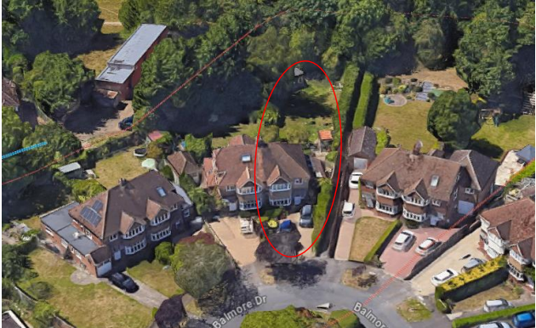
Google Photo
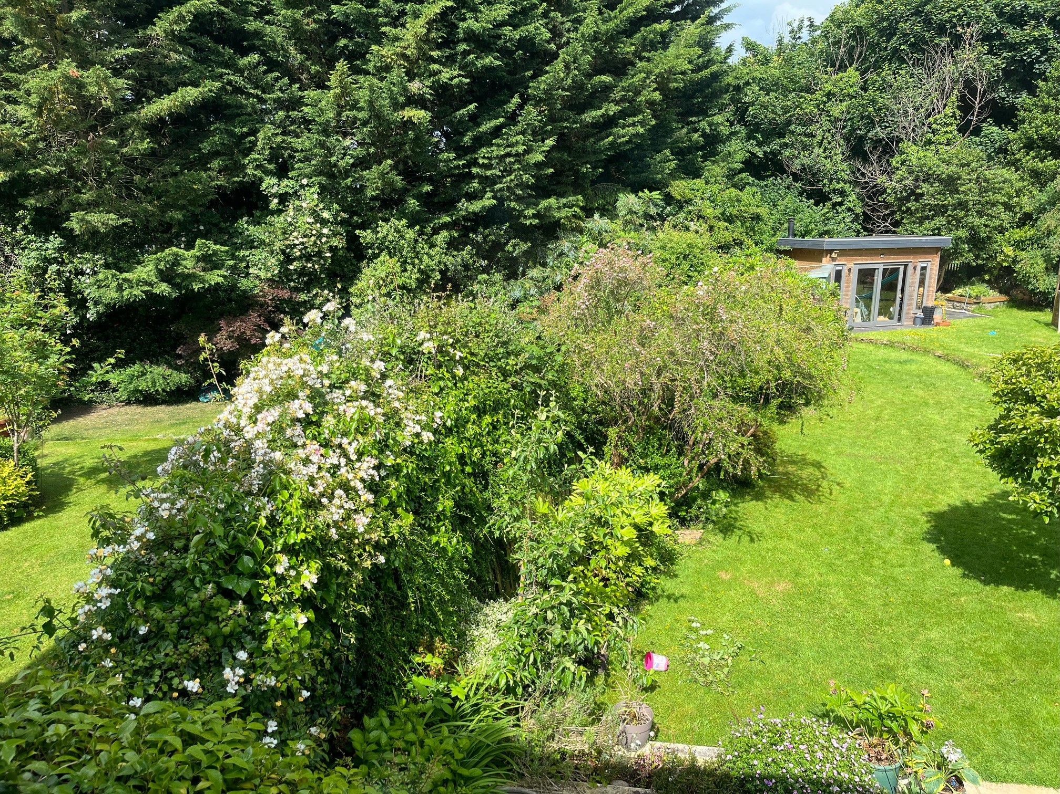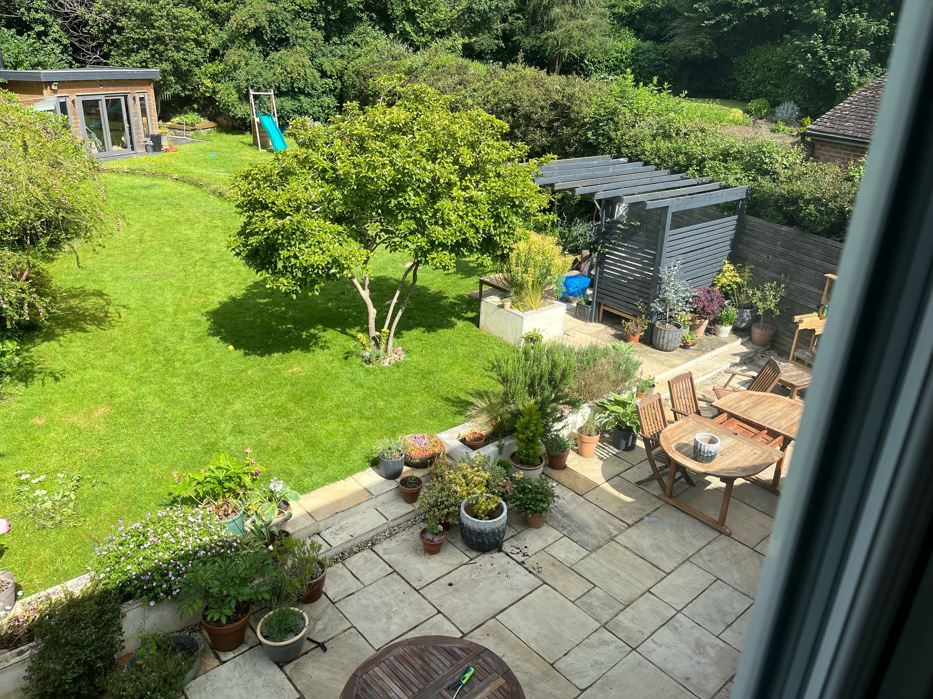
Site Visit Photos
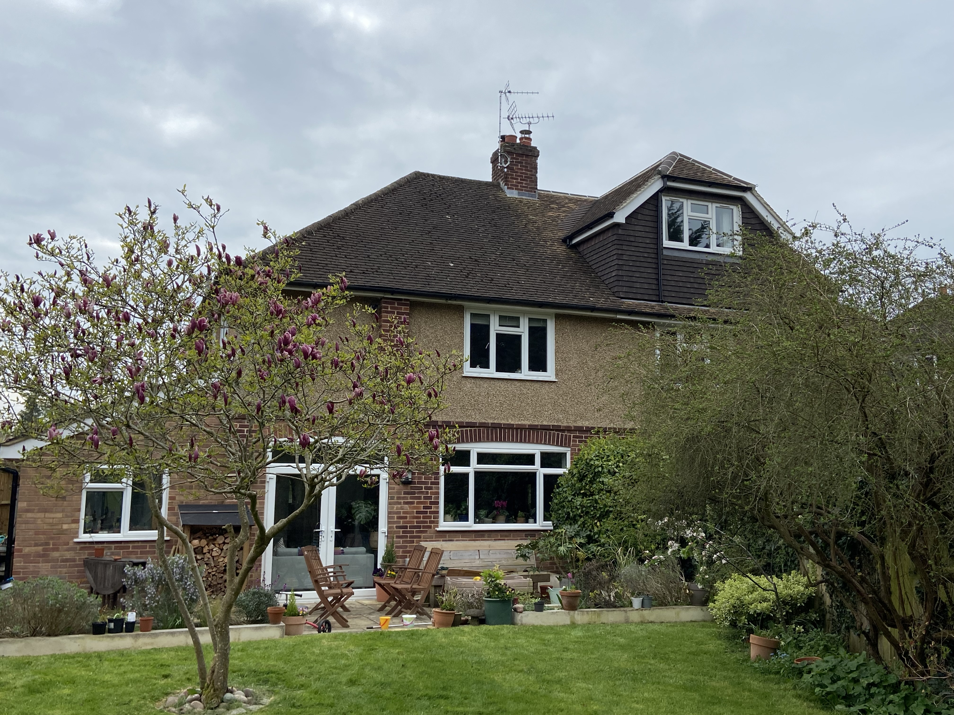

2. PROPOSAL AND SUPPORTING INFORMATION
The proposal comprises the following:
- Erection of ground floor side extension which increases the width of the dwelling by approximately 1.8m to the right side
- Rear single storey extensions measuring 4.6m deep, running across the full width of the existing dwelling to the rear
- Alterations to the roof to accommodate habitable rooms comprising a hip to gable extension and rear facing dormer measuring 6.4m by 6.2m and a height of 2.67m
- Related internal alterations.

Plans considered dated January 2024 received 18/01/2024
Drawing No 23-45BD-PL-00.1 Site Location Plans
Drawing No 23-45BD-PL-01.1 Existing Floor Plans
Drawing No 23-45BD-PL-01.2 Proposed Floor Plans
Drawing No 23-45BD-PL-02.1 Existing External Elevations
Drawing No 23-45BD-PL-02.2 Proposed External Elevations
Drawing No 23-45BD-PL-03.1 Rear Visual 1
Drawing No 23-45BD-PL-03.2 Rear Visual 2

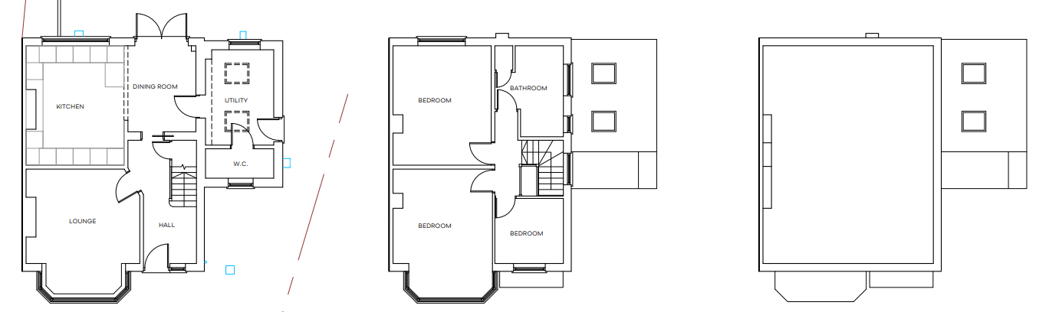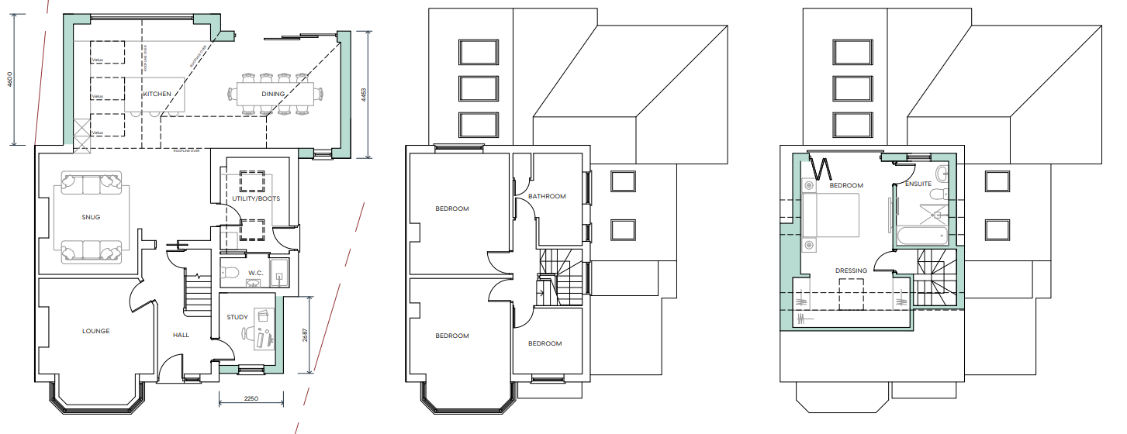

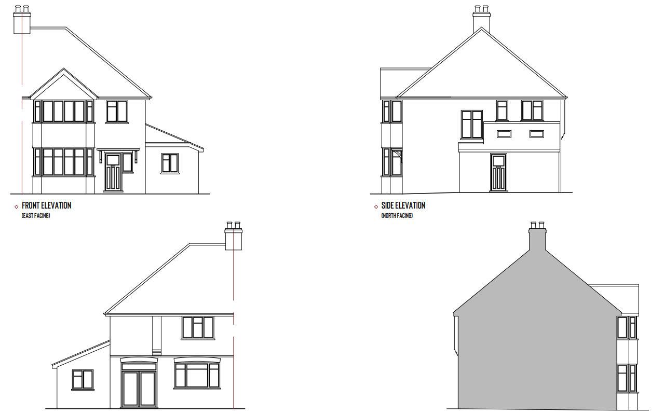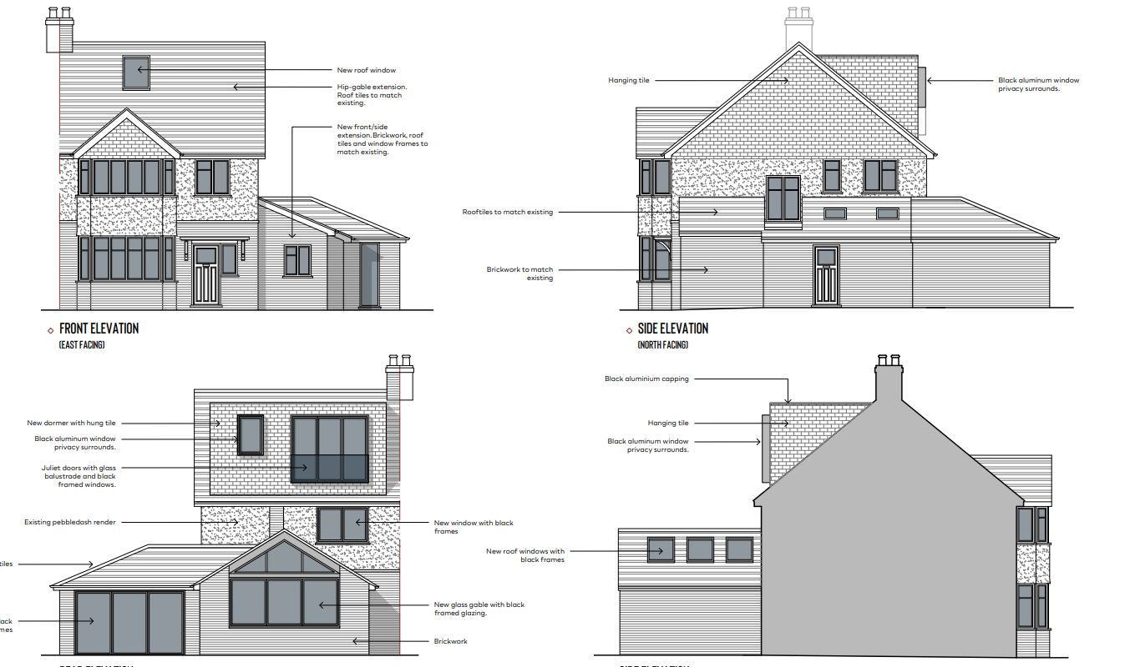

- RELEVANT PLANNING HISTORY
None

4. CONSULTATIONS

The following addresses were consulted by letter.

46 Balmore Drive, Caversham, Reading, RG4 8NL
44 Balmore Drive, Caversham, Reading, RG4 8NL

No letters of representation have been received.

Ecology requested for Part 2 Bat report and that has been submitted by the agent.

Discussions with Agent.

The agent was advised that the Juliet doors originally proposed for the rear facing dormer would not be permitted as it was viewed that these doors, at such a vantage position, would present at least some perceived impacts of overlooking on the adjoining properties. The agent subsequently made changes, as is captured below.

Equality Act 2010:
In determining this application the Council is required to have regard to its obligations under the Equality Act 2010. However, there is no indication or evidence (including from consultation on the application) that the protected groups identified by the Act have or will have different needs, experiences, issues and priorities in relation to this particular planning application. Therefore in terms of the key equalities protected characteristics it is considered there would be no significant adverse impacts as a result of the development.

- LEGAL AND PLANNING POLICY CONTEXT

Section 38(6) of the Planning and Compulsory Purchase Act 2004 requires that proposals be determined in accordance with the development plan unless material considerations indicate otherwise. Material considerations include relevant policies in the National Planning Policy framework (NPPF) - among them the 'presumption in favour of sustainable development'. The following local and national planning policy and guidance is relevant to this application:

National Policy
National Planning Policy Framework
National Planning Practice Guidance

Reading Borough Local Plan (2019)
CC7 (Design and the Public Realm)
CC8 (Safeguarding Amenity)
H9 (House Extensions and Ancillary Accommodation)
H10 (Private and Communal Outdoor Space)
EN14 (Trees, Hedges and Woodland)
SPD
Design Guide to House Extensions 2021

6. APPRAISAL
Character and Appearance

Policy H9 states that an extension to a house will be acceptable where it respects the character of the house in terms of scale, location, materials and design and respects the character and pattern of neighbouring properties and the street as a whole in terms of scale, location, materials and design, and any important existing building line. Policy CC7 also sets out relevant considerations for design.

The changes proposed in this application are mainly to the roof, on the front slope, the ground floor extension to the rear and side, as well as the flat roof dormer to the rear. The hip to gable roof conversion would alter the appearance of the dwelling on the front façade but that would still be in keeping with similar alterations on the street scene, including on Nos 44 and 47. The front slope roof window would be flush on the roof slope, so would not add any significant impact on the overall alterations proposed. Materials on the roof conversion, as well as the rear flat dormer would be to match existing materials on the walls and the roof of the original dwelling.

The proposed side and rear extensions would be single storey and would be appropriate in scale to the existing dwelling.

Whilst the changes proposed in this application are extensive, it is considered that in the context of the original size of the dwelling, the siting and the large size of the plot within which the dwelling is sited, the changes would still be respectful of the character, scale and pattern of the neighbouring properties.

Residential Amenity

Policy H9 states that an extension will be acceptable where it does not result in an overbearing impact on neighbours. Policy H10 seeks to ensure that the amenity of gardens and other outdoor areas are not compromised. Policy CC8 states an extension to a house will be acceptable where it will not cause a significant detrimental impact to the living environment of existing or new residential properties.

The dwelling as stated above sits on a large plot, with the separation from Nos 46 and 48 considerable and the angles splayed in such a way as to minimise any impacts the extensions on the side and rear would have on them. The extension on the ground floor has been pulled back considerably from the boundary with No 44, to mitigate any impacts the rear extension would have on the property in terms of overbearing effects and access to sunlight/daylight. The nearest access to daylight for No 44 to the proposed extension is for a combination of French doors and a window, and it is considered that the rear extension proposed would not adversely affect the kitchen behind these outlets to an unacceptable level.

The windows to the rear of the rear facing dormer has been amended on the advice of the LPA, replacing the original Juliet doors proposed to a window with same window sill level as a conventional window. It is also considered that the rear dormer would not present any overlooking or privacy issues as there are no properties within the immediate sight lines of the openings.

Therefore, it has been concluded that there are no adverse amenity issues that would be suffered by any properties on both sides of the application site.

- CONCLUSION
The proposed development has been assessed as set out above and is considered to be acceptable on that basis, subject to the following conditions.

8. RECOMMENDATION: Grant
Recommended Conditions:
Approved Plans
Time Limit Standards
Materials To Match Existing

