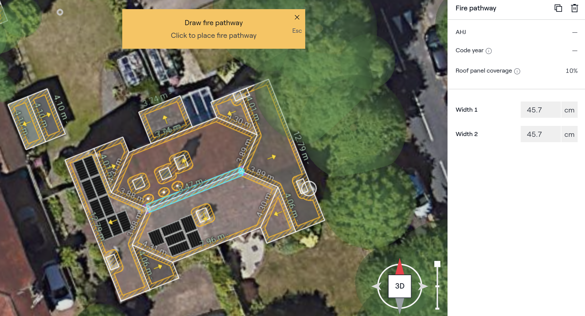

All panel setbacks set to 45.7cm as per hatched/shaded areas in above detailed 3D Modelling

