Heritage Statement for the partial re-roofing of Grove Cottage, Emmer Green, RG4 8LU
The work to partially re-roof Grove Cottage became essential as part of the general upkeep of the building. There was a critical failure of the existing flat roof in several places which resulted in substantial rain water entering the building during a sustained period of substantial rain. By completing this re-roofing it ensured the building remains water tight for the future and that the internal ceilings and other features were properly preserved. The condition of the roof meant that spot repairs were not possible.
Historically the house, which is Grade 2 listed, was originally listed on 14th December 1978. The description of the listing as follows:
SURLEY ROW 1. 5128 (West Side) Grove Cottage SU 7176 5/583 II 2. Circa 1830s. 'T'-plan. Tudor Gothic cottage, altered. 2 storeys painted brick with tiled roof and scalloped bargeboards to gable ends. South front 4 bays with 3 mullion windows on 1st floor and a round headed lancet in room over porch. Porch has label mould and set back ogee headed door with marginal glazing. Later flanking square bays. Later 2 storey bay added to rind gable and crenellated 2 storey extension with porch below. The gate to the road in the garden wall is probably contemporary. Described in 1843 as ' a neat red brick building in Elizabethan style'. Flint cannon balls have been found in the garden.
The house is also located within a conservation area which was declared in 1988.
Visual Images
Image from Historic England Website circa 2001:
GROVE COTTAGE, Non Civil Parish - 1113592 | Historic England
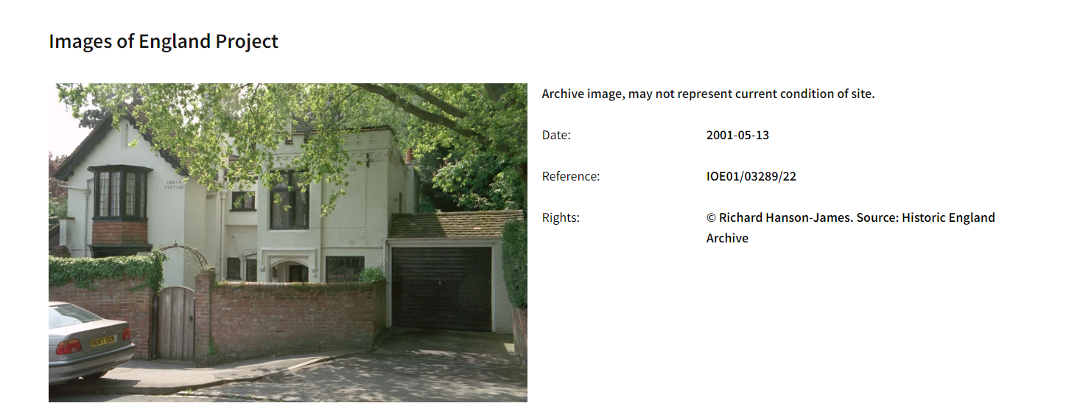
Current Image to demonstrate no visual impact from the replacement of the flat roof:
