

DELEGATED HOUSEHOLDER APPLICATION REPORT

Ward: Emmer Green
App Ref: 240129/HOU
Address: 177 Peppard Road, Emmer Green, Reading, RG4 8TS
Proposals: Front Porch Extension, Rear single storey extension, Loft conversion and fenestration changes
Case Officer: Chukwudi Onwudinanti
Applicant: Mr Duncan Kay
Date received (valid from): 1 February 2024
Target Decision date: 26th April 2024 (Ext)

1. SITE DESCRIPTION
The site is a detached two storey dwelling on the western side of Peppard Road, in a predominantly residential area, among a mix of semi-detached and detached dwellings of various styles and sizes, mostly on that same side of the road. On the other side of the road are a school, an open area and another institutional building.

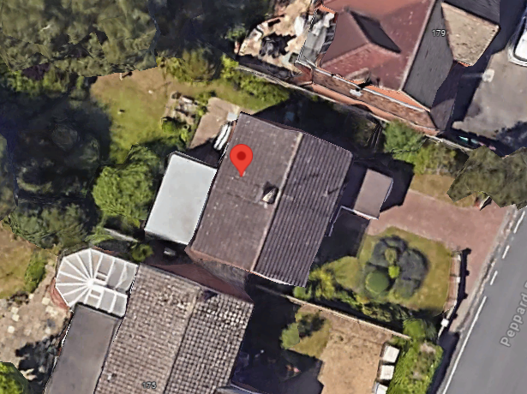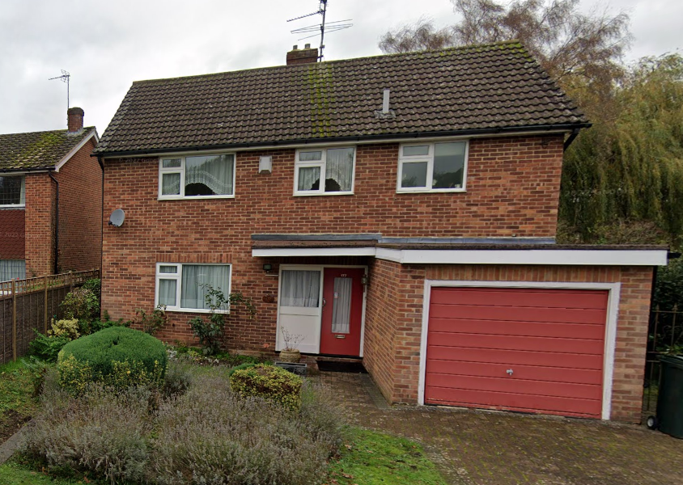
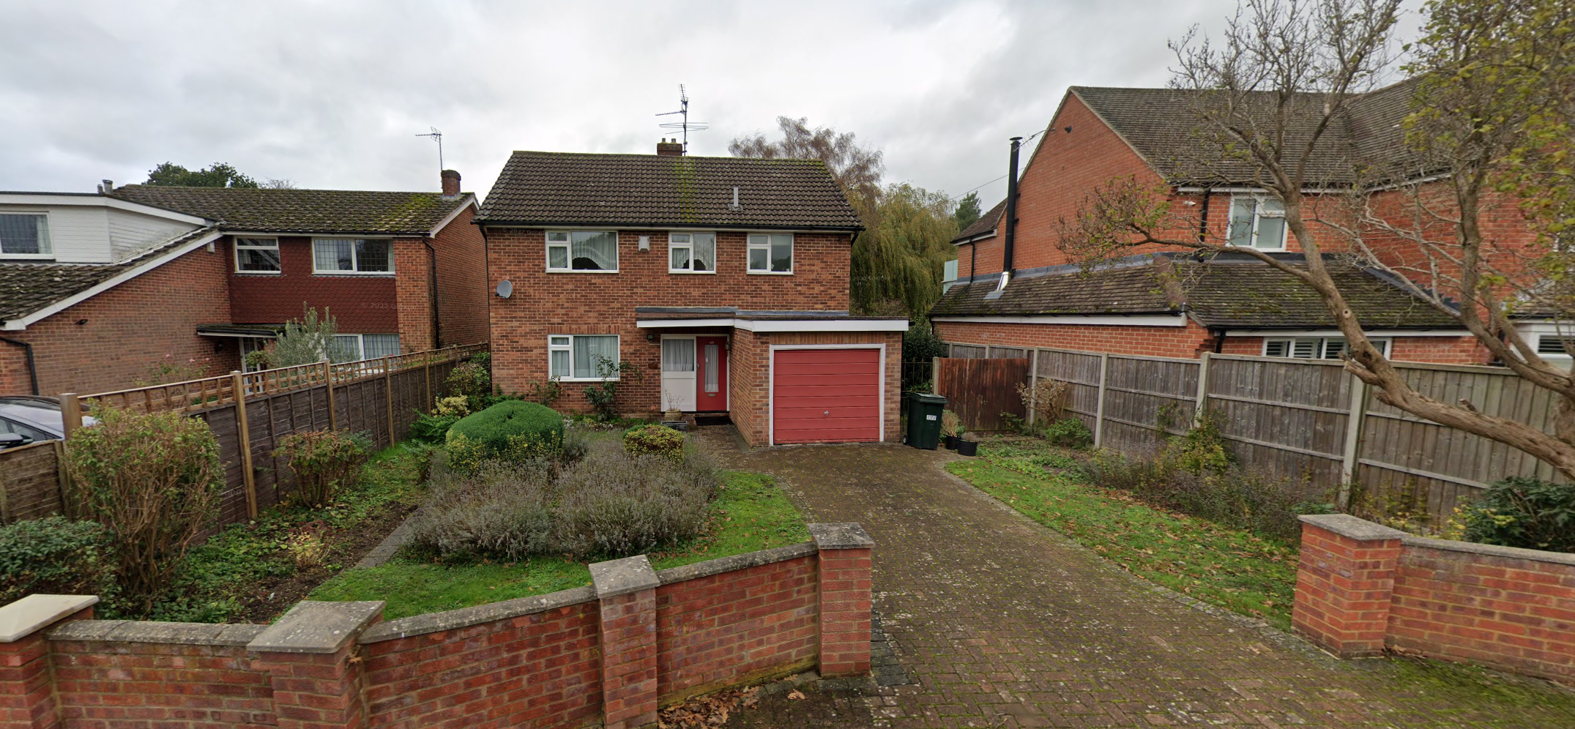
Google Map Photos

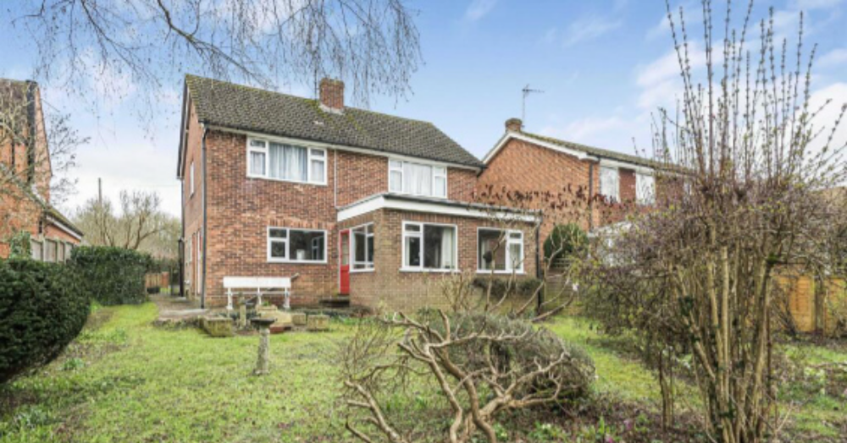
Site Photo

2. PROPOSAL AND SUPPORTING INFORMATION
The proposal presents:
- A front porch extension, increasing the width of the existing garage by 1.67m and the full depth of the garage (3.95m), to create a front porch over the existing front door.
- A rear single storey extension with a depth of approximately 6.1m and width of 6.7m, closing up the existing recess at the rear. This rear extension therefore effectively increases the overall backline of the dwelling to the rear by 2.5m.
- Side extension of the dwelling in part by 1.82m
- Loft conversion with new rear facing rooflights
- Fenestration changes

Plans considered received 01/02/2024
Drawing No 01: Location Plan
Drawing No E01: Existing Plans
Drawing No E02: Existing Elevations
Drawing No 02: Proposed Site Plan
Drawing No 03: Proposed Floor Plans
Drawing No 04: Proposed Elevations
Drawing No 05: Proposed Illustrative Front View
Drawing No 06: Proposed Illustrative Rear View

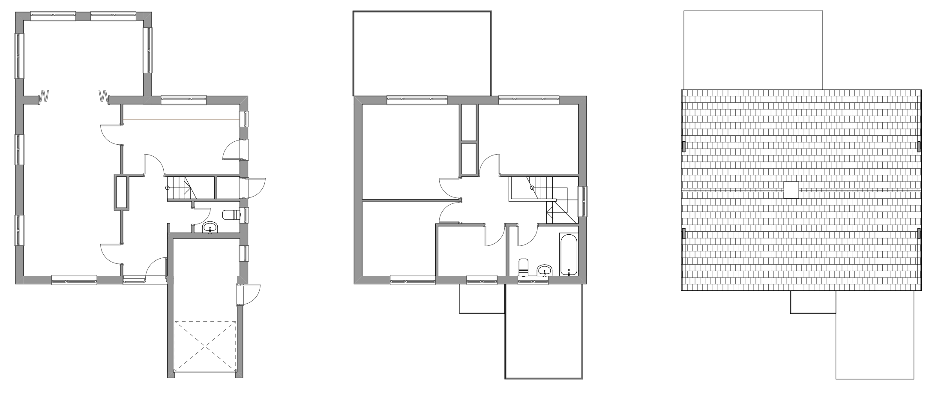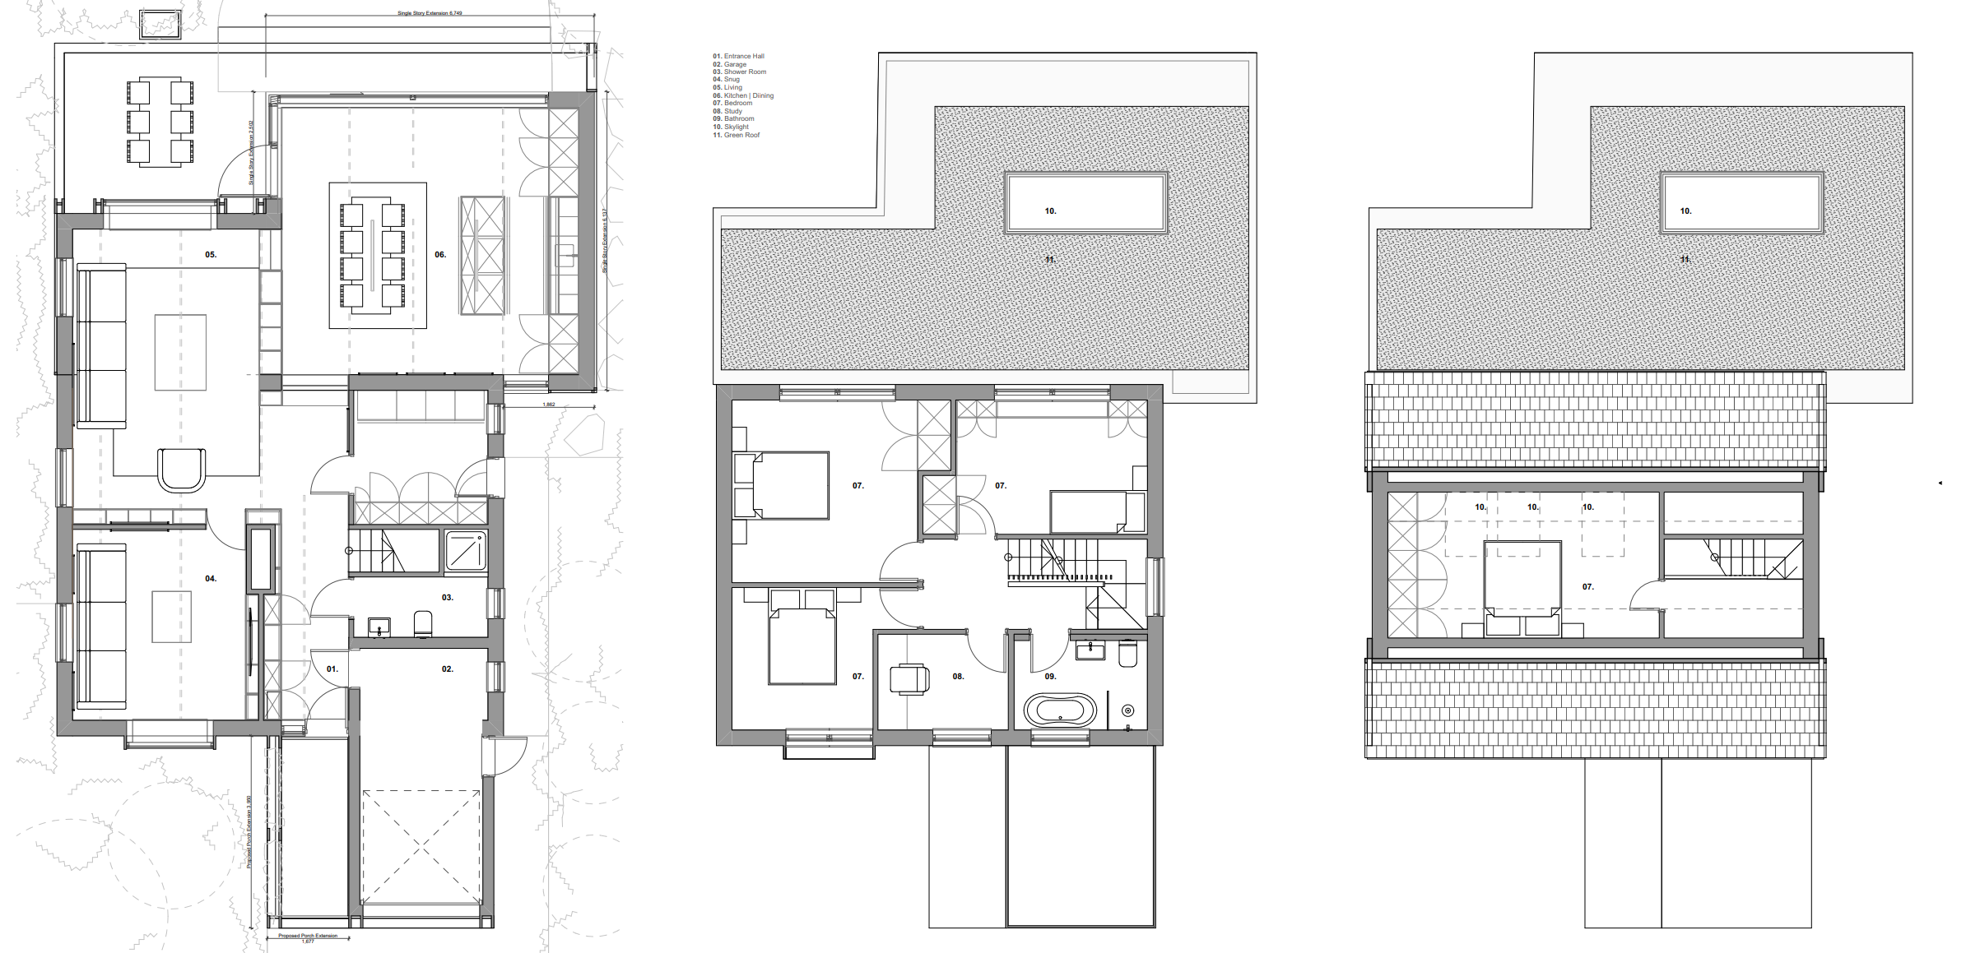
Existing Plans Proposed Plans

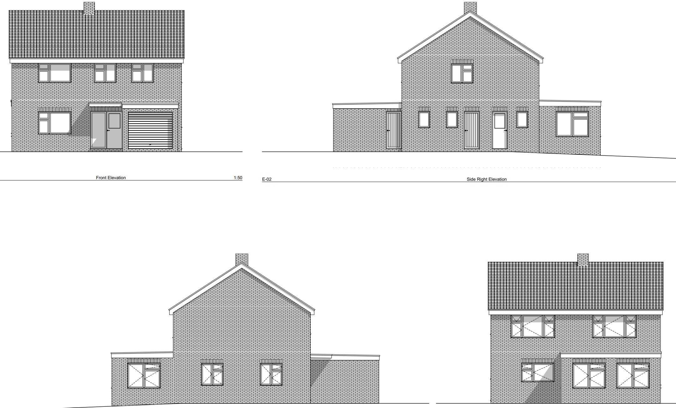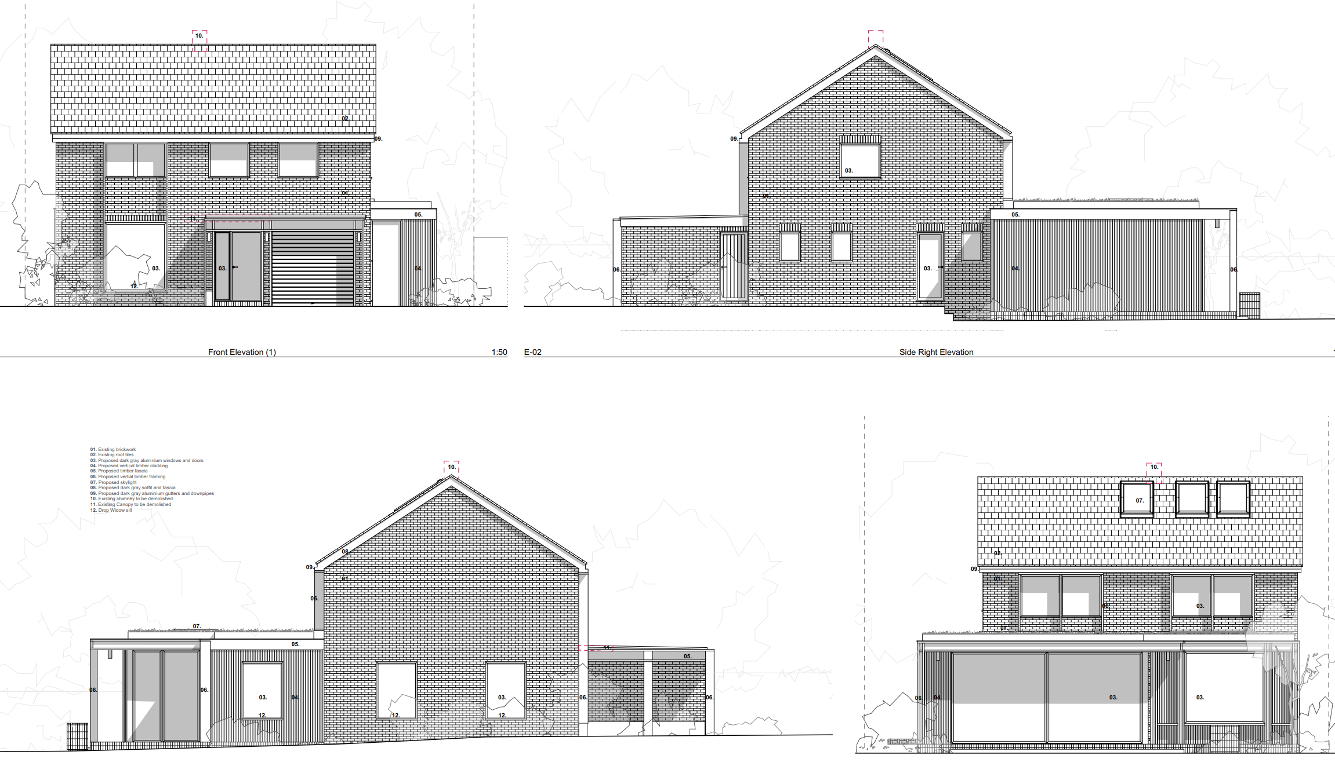

Existing Elevations Proposed Elevations

- RELEVANT PLANNING HISTORY
None

4. CONSULTATIONS

The following addresses were consulted by letter.

12 Langford Close, Emmer Green, Reading, Berkshire, RG4 8TD
175 Peppard Road, Emmer Green, Reading, RG4 8TS
179 Peppard Road, Emmer Green, Reading, RG4 8TS

No letters of representation have been received.

Discussions with Agent.

The agent was advised to submit the impact assessment of the proposal on the adjoining properties on Nos 175 and 179 Peppard Road. These were submitted by the agent in drawings that demonstrated that there were no negative impacts on these properties in terms of their continued access to sunlight and daylight.

Transport Comments.
Transport has raised no objections to the proposal as the proposal will retain the existing driveway parking and there will be no change to the existing access arrangements on the highway.

Equality Act 2010:
In determining this application the Council is required to have regard to its obligations under the Equality Act 2010. However, there is no indication or evidence (including from consultation on the application) that the protected groups identified by the Act have or will have different needs, experiences, issues and priorities in relation to this particular planning application. Therefore in terms of the key equalities protected characteristics it is considered there would be no significant adverse impacts as a result of the development.

- LEGAL AND PLANNING POLICY CONTEXT

Section 38(6) of the Planning and Compulsory Purchase Act 2004 requires that proposals be determined in accordance with the development plan unless material considerations indicate otherwise. Material considerations include relevant policies in the National Planning Policy framework (NPPF) - among them the 'presumption in favour of sustainable development'. The following local and national planning policy and guidance is relevant to this application:

National Policy
National Planning Policy Framework
National Planning Practice Guidance

Reading Borough Local Plan (2019)
CC7 (Design and the Public Realm)
CC8 (Safeguarding Amenity)
H9 (House Extensions and Ancillary Accommodation)
H10 (Private and Communal Outdoor Space)
TR3 (Access Traffic and Highway-related Matters)
TR5 (Car and Cycle Parking)

SPD
Design Guide to House Extensions 2021

6. APPRAISAL
Character and Appearance

Policy H9 states that an extension to a house will be acceptable where it respects the character of the house in terms of scale, location, materials and design and respects the character and pattern of neighbouring properties and the street as a whole in terms of scale, location, materials and design, and any important existing building line. Policy CC7 also sets out relevant considerations for design.

The extensions proposed in this application present changes to the front, rear and the sides of the existing dwelling. The installation of the new front porch and the rear extensions are both on the ground floor and limited to under 3m to the front and 4m to the rear. The loft conversion proposed is well hidden in the existing roof, with rear facing rooflights.

The scale of the changes proposed are in keeping with the size of the existing dwelling. The fenestration changes would be cumulatively extensive and would alter to some extent, the character of the dwelling, however as there is no overriding consistency in the form and use of fenestration on the dwellings within the immediate environment, these changes would not be considered damaging to the character and pattern of neighbouring properties to an unacceptable degree.

Residential Amenity

Policy H9 states that an extension will be acceptable where it does not result in an overbearing impact on neighbours. Policy H10 seeks to ensure that the amenity of gardens and other outdoor areas are not compromised. Policy CC8 states an extension to a house will be acceptable where it will not cause a significant detrimental impact to the living environment of existing or new residential properties.

The rear extension which projects beyond the existing back line of the dwelling is limited to the ground floor and a maximum height of 4m. The resultant new backline does not go beyond the line of the adjoining property on No 175, and while it goes much further than the backline of No 179, it is demonstrated in the documents submitted, that the 60 degree line assessment is not breached. As this rear extension goes up to 6m in parts, it has had to be justified. The considerable gap between the site and No 179 and the splayed angle means the effect on the adjoining property is sufficiently mitigated.

The application is not considered to be have any overbearing effects, privacy or overlooking issues as there are no side windows proposed, combined with the limited height. These have been demonstrated by the sunlight/daylight assessment submitted by the agent, on request. There would still remain a sufficiently sized garden at the rear of the property.

- CONCLUSION
The proposed development has been assessed as set out above and is considered to be acceptable on that basis, subject to the following conditions.

8. RECOMMENDATION
Recommended Conditions:
Approved Plans
Time Limits
Materials As Specified

