Discharge of Conditions St Peters avenue RG4 7DP
Application No. 150172

3.
a) Materials for external surfaces
Unit 1
Roof. Spanish slate as per picture 600 x 400 pic 1

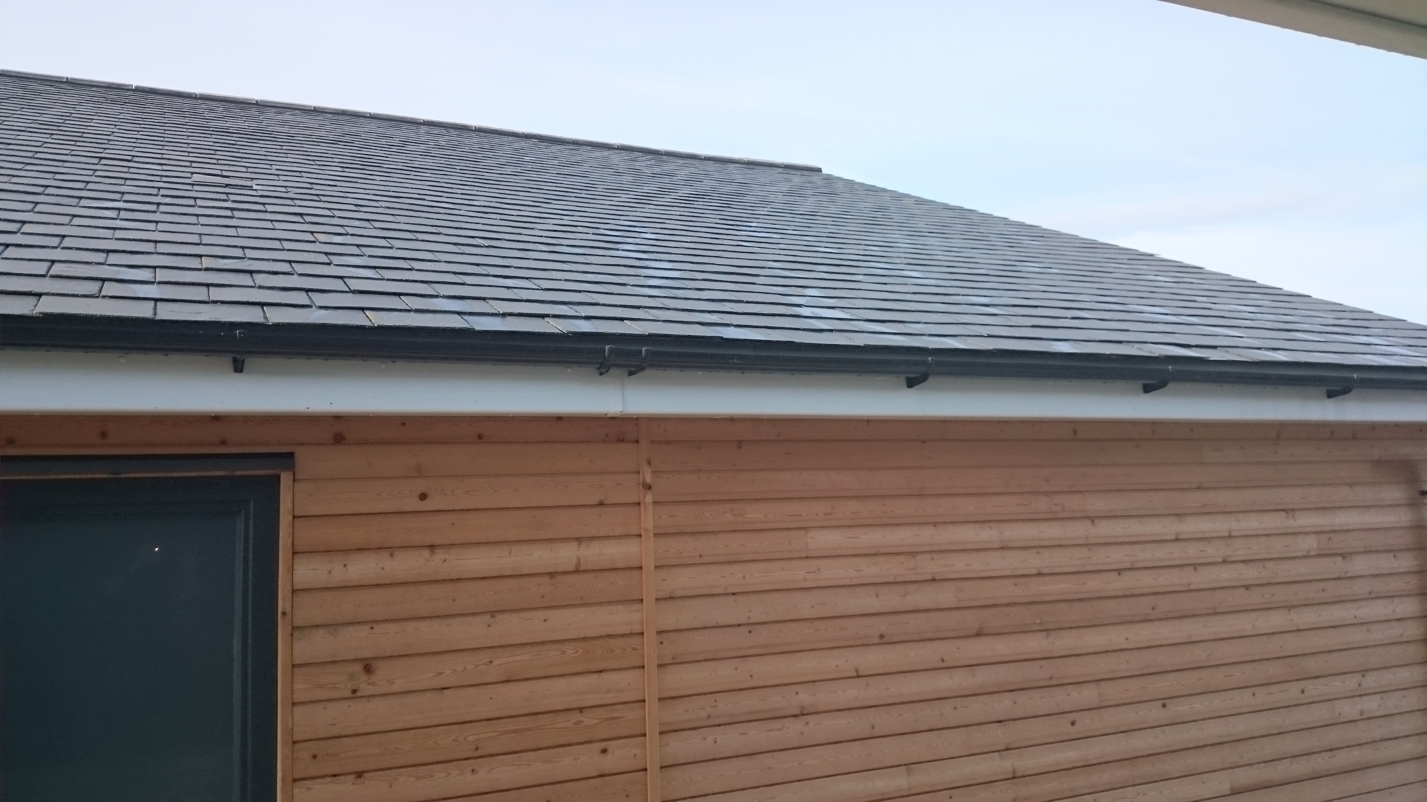

Ground floor , off white resin render ( pic 2 )

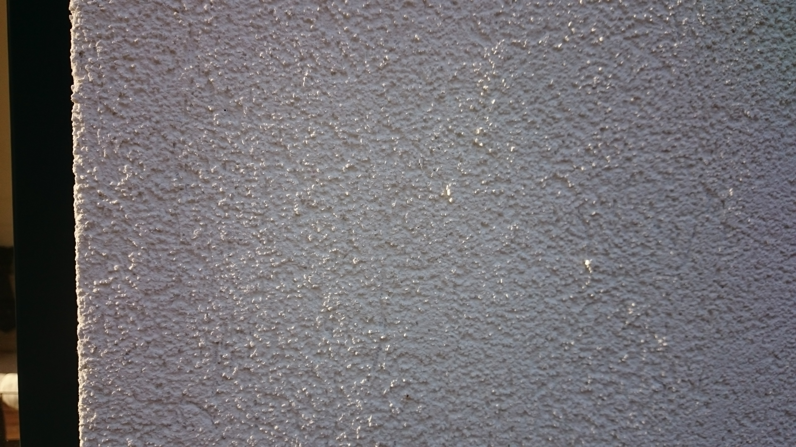
First floor , Natural Siberian lartch 120 x 19 mm tongue and groove pic 4
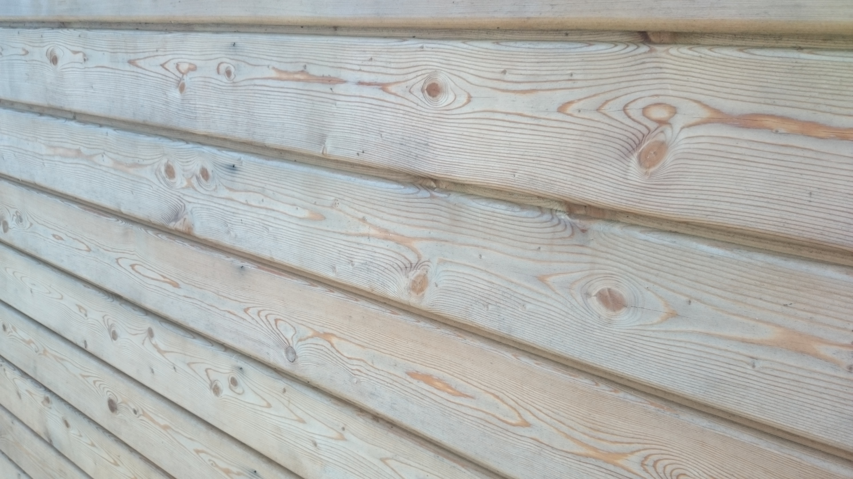

Unit 2
Roof. Spanish slate as per picture 600 x 400

Ground Floor , brick Hardwicke Minster Beckstone Mixture 65mm pic 3
Pic 2
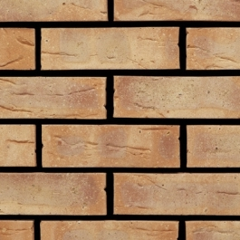
First floor. Off white resin render pic 2

