Proposed extension to kitchen at Shipnells Farm, Caversham, RG4 8QL
General description
A single-storey orangery-style extension to the kitchen at the rear of the house, in matching materials of red brick, oak, and terracotta roof tiles.

Dimensions
6.8m long by 3.0m deep by 3.1m high. Overhead plan:
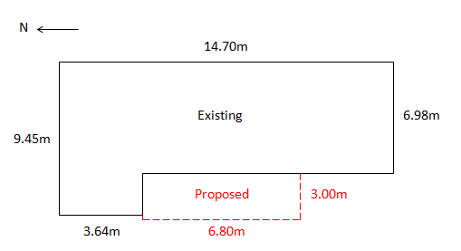
This picture shows the corner of the property into which the extension will fit:
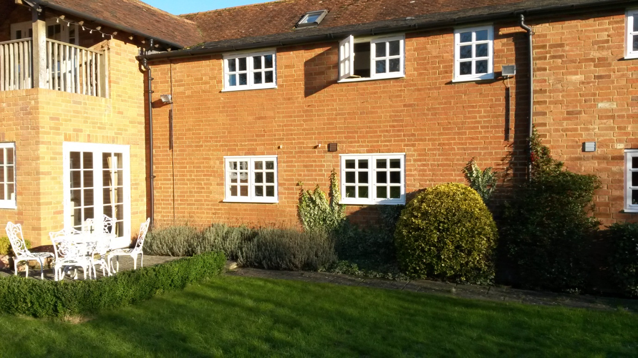

Design - view from the West:
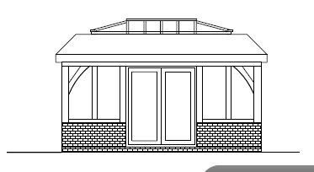

Design - view from the South:
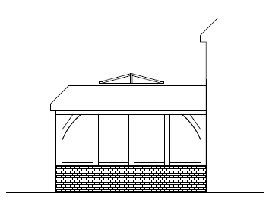

Similar project:
The construction will be as per this picture, but with matching materials as described below
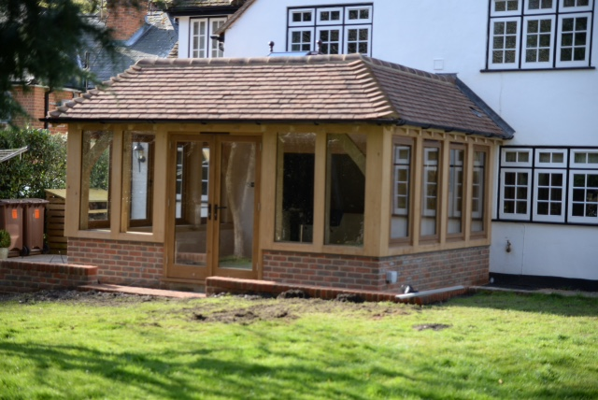
Materials
Brick – to closely match the existing. Hand cut rather than reclaimed will be used.
Oak – which is already used for the balcony above and the porch over the front door (see Appendices B and C below).
Roof tiles – reclaimed tiles to exactly match the existing.

Comparison with Permitted Development criteria
- No cladding etc. on designated land - pass
- No side extensions on designated land - pass
- <50% of land around house – total size of plot is 0.22 acres. Pass
- Extension may not front the highway – It does not. Pass
- Materials to be similar unless a conservatory. The extension is not a conservatory. This application is submitted with the intention of obtaining certainty re. this Point 5
- Width of side extension – pass
- Height of a side extension – pass
- Height is restricted if the extension is within 2 metres of the boundary – pass
- May not extend beyond 4m without consultation: Extension is 3.0m so pass
- Height must not exceed 4 metres: Estimated ridge height is c.3.1m. Pass.
- Ridge height must not exceed that of existing house – It does not. Pass

Is it overlooked?
I have answered ‘Yes’ to this question to be on the safe side. In fact the spot on an unofficial footpath, from which one would be able to see the extension, is about 100 yards away, through a gap in the tree line.
Existing oak features at the property
First floor balcony at rear (Appendix B); Porch over front door (Appendix C).

Appendix B:
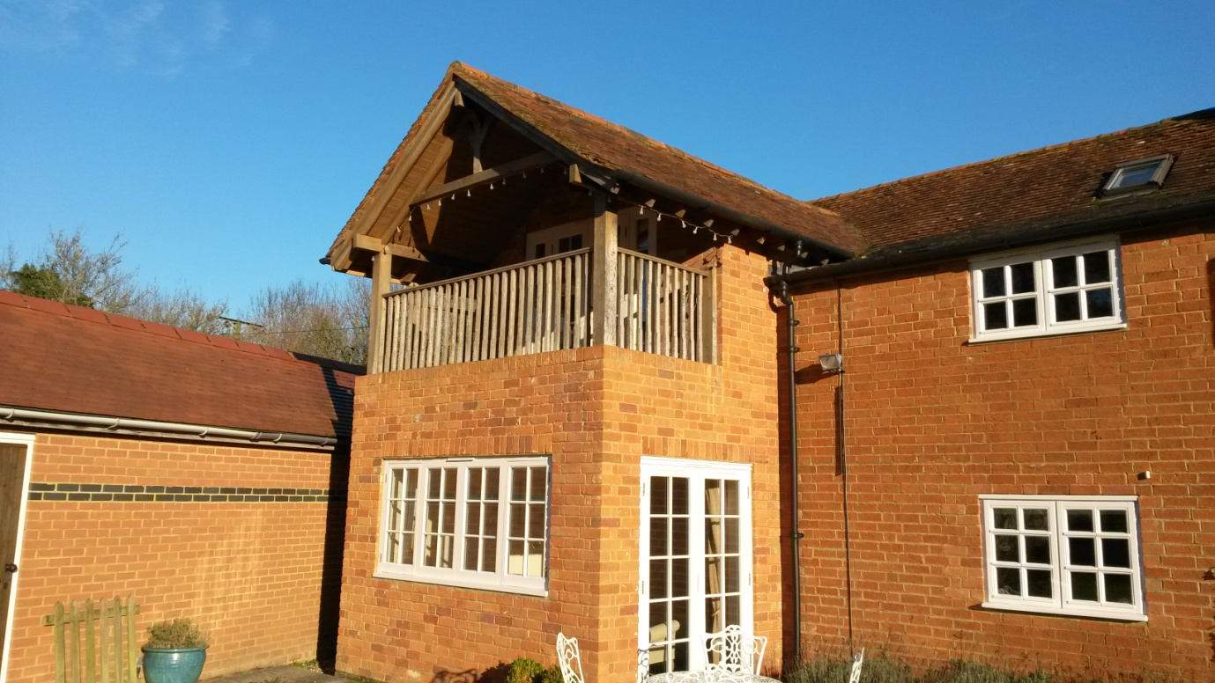

Appendix C:
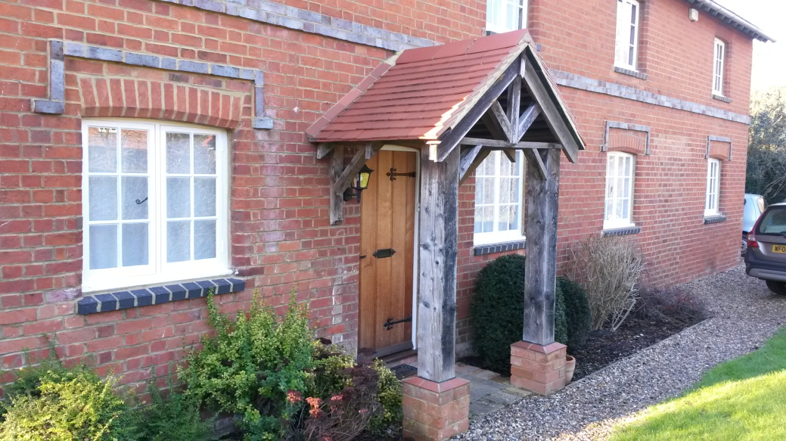
Further pictures

A view looking North along the back of the house:
