Supplementary Information – Design Statement

Background
37 Kendrick Road is a detached four bedroom Mediterranean-style villa, built in 1904. It is one of a group of villas built in the same style along the upper part of Kendrick Road.
The property was in extremely poor repair when we purchased it in 2007. Our objective was to restore it in a manner that was sympathetic to the original design while making it a family home. This has to a large extent been completed, with the single major outstanding issue being the front yard that borders Kendrick Road.
When we purchased the property in 2007, the front wall had partially fallen down and the previous owner had hastily replaced it with a poorly constructed yellow brick wall. While this was definitely not in keeping with the locale, we do not know what the original wall, if any, looked like.
Nonetheless, this wall has since disintegrated and needs to be replaced. In addition, with a bus stop located immediately outside our property, these are the two main factors prompting our request for permission to build a wall and install a gate. Reading Council has previously refused to move the bus stop ten meters back down the hill to a lay-by right outside Abbey School, so we need to have privacy from the road/bus stop while also dissuading people (bus passengers and others) from walking onto our property, using it as a urinal and sitting on our side wall waiting for the bus.

Design
Our original proposal was to install a Mediterranean-style wall and fence arrangement along Kendrick Road and along the side of the property with number 39. This style was in keeping with the “villa” style of our property.
Our amended proposal is to install automated wrought iron gates and a build a rendered wall, interspersed with wrought iron railings along the front of the property. The existing wall to number 39 will be rendered and topped with a traditional wood slatted fence as per 41 Kendrick Road and many other side fences located in Kendrick Road.
Proposed Gate
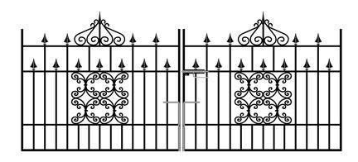
The gate is 3 meters wide supported by similar pillars to that above. This is in keeping with other Victorian walls in Kendrick Road and with the “balcony balustrades on the house.

Proposed Style of Wall
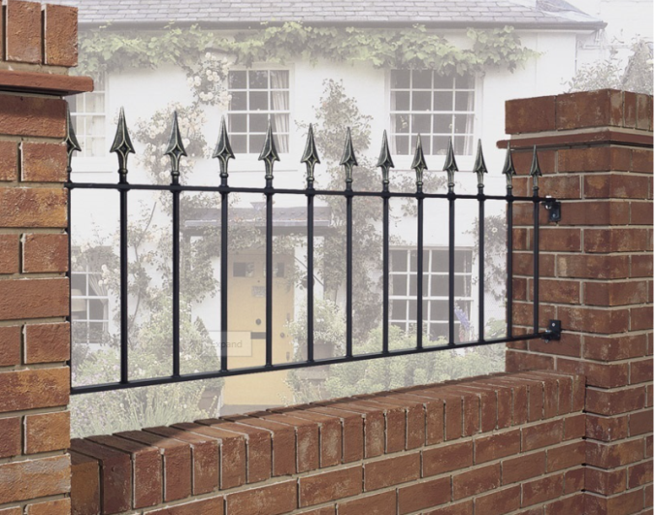
The railings will be in keeping with gate and balcony of the house thus this is for indication only and the style of the railings will change. The wall will be rendered to blend with the house.
With a height of 1540mm, this would provide the necessary security and privacy for the property, would not detract from the views of the house from the street, while satisfying our neighbours who are keen to see gates and railings of a more traditional nature.

