COMMITTEE REPORT

BY THE DIRECTOR OF ENVIRONMENT CULTURE & SPORT
READING BOROUGH COUNCIL ITEM NO.
PLANNING APPLICATIONS COMMITTEE: 27th April 2016

Ward: Thames
App No.: 160279/HOU
Address: 12 Oakley Road, Caversham, Reading, RG4 7RL
Proposal: Two storey side extension with extension to loft space above –
Renewal of 11-01833-FUL
Applicant: Mrs J Wilson
Date validated: 15th February 2016
Target Date: 8 weeks, 11th April 2016
Extension: 28th April 2016

RECOMMENDATION

GRANT

Conditions to include:

Standard
- Time limit for implementation
- Use of materials
- Approved plans
- Obscure glass to first floor side window
- Remove PD rights for first floor side windows

Informatives to include:
- Terms and conditions
- Need for building regulations
- Encroachment
- Construction and Demolition subject to Environmental Health
- Postive and proactive

1. INTRODUCTION

1.1 The application site is a detached, two storey house with garden fronting Oakley Road, Caversham. The property has been extended in the past and there is a conservatory to the rear, and a large single storey element that extends along the western elevation and into the rear garden. A gravel driveway provides parking. A previous permission for the same proposal has not been implemented and lapsed on 8th March 2015; this application is for the renewal of the previous permission

1.2 This minor application is reported to Planning Applications Committee for a decision as the applicant is a Member of Parliament, and a former Councillor.

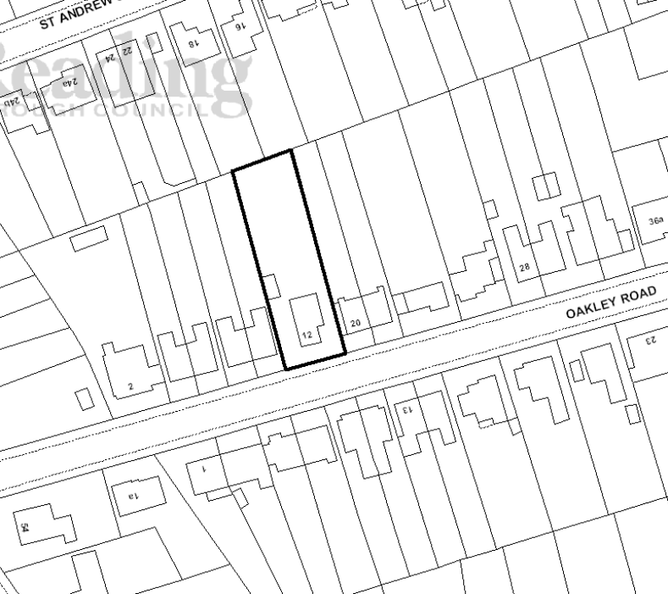

2. PROPOSALS

2.1 The proposal is to erect a two storey side extension with a hipped roof which will provide a cloakroom, WC and playroom on the ground floor, a bedroom and en-suite on the first floor, and additional floor space to the existing master bedroom which is situated within the roof. External materials proposed would match the existing.

3. PLANNING HISTORY

- 11/01833/FUL - Two storey side extension with extension to loft space
above. Permitted 08/03/2012
- 05/01144/FUL - Single storey side extension. Permitted 16/12/2005.
- 05/00961/FUL - Single storey side extension. Withdrawn 17/10/2005.
- 04/00432/FUL - Loft conversion with rear roof extension (changing hip end to gable end). Permitted 27/05/2004.
- 7237/30241 - Alterations to form kitchenette and bed - sitting room. Permitted 15/01/1960.
- 7133/30138 - Garage for private cars. Permitted 04/12/1959.

4. CONSULTATIONS

  - Statutory:

None

  - Non-statutory:

- RBC Transport Strategy state that there are no transport grounds for objection, as two parking spaces will remain on-site on the existing driveway after the proposed extension is completed, which complies with the standards required within the adopted Parking Standards SPD.

- The RBC Ecologist states that the risk of bats being affected by the proposals is minimal (the tiles are tightly fitted, there is no missing mortar under ridge / hip tiles, the soffits are cement, and the loft is converted). There are therefore no objections to this proposal on ecological grounds.

4.3 Public consultation:

Properties at 10A, 10B and 20 Oakley Road, and 16 and 18 St Andrews Road were notified by letter, and a site notice was posted on site. No letters of comment have been received.

5. RELEVANT PLANNING POLICY AND GUIDANCE

5.1 National Planning Policy Framework
Part 7 – Requiring good design

5.2 Reading Borough Local Development Framework Core Strategy (2008) (altered 2015)
CS7: Design and the Public Realm
CS24: Car/Cycle Parking
CS36: Biodiversity and Geology

5.3 Sites and Detailed Policies Document (2012)(Altered 2015)
DM4: Safeguarding Amenity
DM9: House Extensions and Ancillary Accommodation

5.4 Supplementary Planning Guidance “A Design Guide to House Extensions” (2003)

6. APPRAISAL – Planning Applications

(i) Legal context

Section 38(6) of the Planning and Compulsory Purchase Act 2004 requires that applications for planning permission be determined in accordance with the development plan unless material considerations indicate otherwise.

(ii) Main Issues

6.1 The main issues are considered to be:
(i) Design and impact on the character of the surrounding area
- Impact on neighbouring properties
- Other Matters

(i) Design and impact on the character of the surrounding area

6.2 The proposed two storey side extension follows general policy and guidance in that it is considered subservient in scale to the main dwelling, and acceptable in design. The two storey element of the extension is set back by 3.7 metres from the front elevation, and is 2.5 metres wide which is considered to be well proportioned. The ridge line of the extension is set down from the ridge line of the main roof by 0.3m.

6.3 The proposed extension would be visible from the road but the proposed hipped roof, to the front, side and rear of the extension and the significant set back enable the two storey extension to appear sufficiently subservient to the main house and in keeping with the character of the property.

6.4 A pitched roof single storey front extension is proposed to the existing single storey front porch and is considered in keeping with the appearance of the house.

6.5 The proposed materials are plain clay roof tiles and brick and pebbledash walls to match the existing house, which is acceptable and should be secured by condition.

(ii) Impact on neighbouring properties

6.6 The main concerns regarding the effect of the proposal on neighbouring properties are:
- Loss of light to neighbouring property and rear gardens
- Loss of privacy from proposed first floor side window

a) Loss of light to neighbouring property and rear gardens

  - The proposed extension will be 1.07m from the boundary with 20 Oakley Road whose single storey side sun lounge/conservatory runs directly along the boundary. The sun lounge/conservatory at 20 Oakley Road has no side windows fronting the application property but has an existing glass roof and windows to the front and rear elevations. The orientation of the sun lounge/conservatory, on the west side of 20 Oakley Road, would mean that although there will be some loss of light to the rear, it is not considered to be so significant as to be unacceptable and light will still reach this part of the property from the front windows and the glass roof.

  - 20 Oakley Road also has four first floor side windows to a bathroom, landing and bedroom. While there will be some loss of light to these rooms, as the landing and bathroom windows are not habitable rooms the loss is not considered to be so significant as to be unacceptable. The side bedroom window is a secondary window, with the main window to the front elevation. As the extension does not extend forward as far as the front window of the bedroom, the proposed extension is not considered to impact to an unacceptable extent on the light provided to this room.

  - In terms of loss of light to the rear gardens of 20 and 22 Oakley Road, the properties within the row have north facing rear gardens and direct sunlight is therefore already limited. The extension lies to the west of 20 and 22 Oakley Road so some additional shadow, and loss of light, may be cast in the afternoon to the rear garden of 20 Oakley Road. However, the hipped roof design helps to minimize the loss of light and overshadowing to a degree that is considered reasonable. The proposal is not considered to impact the rear garden of 22 Oakley Road due to the distance between the properties.

b) Loss of privacy from first floor side window

  - 12 Oakley Road currently has two first floor side windows to the landing and stairs. A first floor side window to a bedroom is proposed to the two storey side extension which will be within closer proximity to 20 Oakley Road than the existing side windows. However, this is a secondary window to this bedroom with the main window proposed in the front elevation. In order to protect the privacy of the residents of 20 Oakley Road, it is considered appropriate to impose conditions to obscure glaze the secondary first floor side window, and restrict any further first floor side windows.

  - The proposed ground floor side windows are not considered to cause any loss of privacy that is significantly worse than the existing ground floor window arrangement. One window in the flank elevation will be obscure glazed and serves a WC which looks onto the brick wall of the side sun lounge/conservatory at 20 Oakley Road. Two further side windows to the playroom will look onto the side elevation/garden area of 20 Oakley Road however, the views afforded from the new windows are not significantly different from the existing side window that is currently to the dining room.

6.12 In conclusion, as the majority of the proposal is adjacent to the side elevation of 20 Oakley Road, the extension is not considered overbearing to the detriment of the neighbouring property, and whilst there would be a change in outlook from the rear garden for the occupiers of 20 Oakley Road the changes are not so harmful as to breach the criteria set out in DM4: Safeguarding Amenity of the Sites and Detailed Policies Document (2012)(amended 2015), and the advice given in the Council’s Supplementary Planning Guidance – A Design Guide to House Extensions.

(iii) Other Matters

6.13 In determining this application the Council is required to have regard to its
obligations under the Equality Act 2010. The key equalities protected
characteristics including age and disability. There is no indication or
evidence (including from consultation on the application) that the protected groups have or will have different needs, experiences, issues and priorities in relation to the particular planning application. In terms of the key equalities protected characteristics it is considered there would be no significant adverse impacts as a result of the development.

7. CONCLUSION

The proposed development is considered acceptable in planning terms and for the reasons given above.

Plans:
Drawing No: 52/A2-01A Existing Plans and Elevations
Drawing No: 52/A2-02D Proposed Plans
Drawing No: 52/A2-03C Proposed Sections and elevations

Case Officer: Heather Banks

